Adult and Community Learning Services
with
Center for Educational Assessment
University of Massachusetts Amherst

MASSACHUSETTS ADULT PROFICIENCY TEST-COLLEGE AND CAREER READINESS (MAPT-CCR)

TEST ADMINISTRATOR
MANUAL

Resources for Help and Questions

There are several key resources available to help MAPT-CCR Test Administrators.

When test administrators complete the online MAPT-CCR Test Administrator training, they receive their MAPT-CCR Test Administrator Login and Password and they also receive a link to the PDF of this Manual by email.

Assessment Policies for the MAPT-CCR (and all other adult education assessments used by ACLS) are available in the Massachusetts Adult Education Assessment Policies document (http://www.doe.mass.edu/acls/assessment/AssessmentPolicies.docx).

Test administrators can also keep up to date with announcements on the ACLS Website and in the ACLS Monthly Mailings.

Contact Information

Policy-related questions
Dana Varzan-Parker, Curriculum, Instruction and Assessment Specialist, ESE/ACLS
dvarzan-parker@doe.mass.edu
781-338-3811

Technical questions
April Zenisky, Research Associate Professor, UMass Amherst, Center for Educational Assessment
aclstesthelp@educ.umass.edu
413-577-2180

Online Web-Based Learning (OWL)
mapt-owl-help@it.umass.edu

Massachusetts Adult Proficiency Test (MAPT) Test Administrator’s Manual, Updated October 2019
Massachusetts Department of Elementary and Secondary Education, Adult and Community Learning Services
TABLE OF CONTENTS

I. Background on the MAPT-CCR, What It Measures, and How it Works 1
MAPT-CCR Overview 1
What the MAPT-CCR Measures 1
How the MAPT-CCR Works 2
II. The Components of the MAPT 5
Computer Basics 6
Sample Questions 6
Practice Tests 6
MAPT-CCR for Reading / MAPT-CCR for Math 7
III. Getting Ready with the OWL System and the MAPT-CCR 8
Who Should Take the MAPT-CCR 8
MAPT-CCR Test Administrators 8
Student MAPT-CCR Logins and LACES IDs (MAPT) 8
MAPT-CCR Test Administration Conditions 9
Test Administrator Preparation 10
Computer Readiness, Screen Adjustment, and Troubleshooting Internet Connectivity 10
Administration Time for the MAPT-CCR 12
Requesting a Test Reset After 15 Days Have Passed 13
MAPT-CCR Accommodations 13
Pre-testing, Post-testing, and the Interval Between Testing 15
IV. Student Login Steps 16
Initial Screen 16
MAPT-CCR Login Screen 17
MAPT-CCR Login Error Screen 20
Login Error - Send Message 20
Successful Login – Welcome Screen to Confirm Name 23
Student Home 24
V. Sample Questions and Practice Tests 26
First Time Test-Takers and Sample Questions 26
Directions for Sample Questions 27
Math Sample Questions 27
Math Formula Page 32
Reading Sample Questions 33
Sample Questions Results 36
The MAPT-CCR Practice Tests 38
Choosing Practice Test Levels 38
Directions for the Practice Tests 39
Reminder: Do Not Use the Back Button 40
VI. Administration of the MAPT-CCR for Reading and the MAPT-CCR for Math 41
MAPT-CCR Level Selection for First Time Test-Takers 41
Students Who Have Taken the MAPT-CCT Before 44
Starting the MAPT 44
Using Send Message for Technical Support / Connection Help 46
Exiting Before Test Completed 48
MAPT-CCR Results Screen 49
Exiting the MAPT 50
Exiting OWL 50
Contacting UMass-OWL Technical Support for Help After Test Administration 51
VII. MAPT-CCR Results: Interpreting and Using MAPT-CCR Scores 52
Results Screen in OWL 52
Understanding MAPT-CCR Scores 54
Accessing MAPT-CCR Scores After Testing 55
MAPT-CCR Score Reports in LACES 55
Appendix A: Learner Information Sheet 56

I. Background on the MAPT-CCR, What It Measures, and How it Works

MAPT-CCR Overview
The MAPT-CCR is the Massachusetts Adult Proficiency Test - College and Career Readiness (MAPT-CCR). The federal government requires that federally-funded Adult Education (AE) programs report student outcomes. The MAPT-CCR for Math and the MAPT-CCR for Reading are the assessments that Massachusetts uses for this accountability purpose. The Adult and Community Learning Services (ACLS) unit of the Massachusetts Department of Elementary and Secondary Education (ESE) has had a contract with the Center for Educational Assessment at the University of Massachusetts Amherst (UMass) to develop and maintain the MAPT-CCR testing program since 2003.

The MAPT-CCR assessment has long been a collaboration between test developers at UMass, ESE/ACLS staff, and AE program staff. Many of the items are written by AE educators, and AE program staff from all over Massachusetts have been involved in many test development activities over the years, including developing test specifications, reviewing items for content and cognitive validity studies, setting standards, and carrying out sensitivity reviews.

What the MAPT-CCR Measures
The MAPT-CCR for Math and the MAPT-CCR for Reading measure the skills of students ranging from the National Reporting System’s Beginning Basic Literacy and Numeracy levels through High Adult Secondary Education (High ASE). The National Reporting System (NRS) is the reporting system used by the U.S. Department of Education’s Division of Adult Education and Literacy to track educational gains, among other outcomes. Federal gains are evaluated by student progression through a series of Educational Functioning Levels (EFLs). In the table below, the EFLs and grade level equivalents (GLEs) for Math are in the first and second columns, followed by the EFLs and GLEs for Reading in the third and fourth columns, and the final column provides the MAPT-CCR score range that corresponds to each EFL.

Math |  | Reading |  | MAPT-CCR Scale Range
EFL | GLE | EFL | GLE
Beginning Basic Numeracy | 2-3.9 | Beginning Basic Literacy | 2-3.9 | 200-299
Low Intermediate Adult Education | 4-5.9 | Low Intermediate Adult Education | 4-5.9 | 300-399
Middle Intermediate Adult Education | 6-7.9 | High Intermediate Adult Education | 6-8.9 | 400-499
High Intermediate Adult Education | 8.0-8.9 | Low Adult Secondary Education | 9-10.9 | 500-599
Adult Secondary Education | 9-12.9 | High Adult Secondary Education | 11-12.9 | 600-700

Students with a GLE of 0-1.9 in AE should not take the MAPT-CCR; students at that level should be administered the TABE 9/10 Level L.

The MAPT-CCR measures the College and Career Readiness Standards for Adult Education (CCRSAE; Pimentel, 2013), specifically the Reading Standards (the MAPT-CCR for Reading) and the Mathematics Standards (the MAPT-CCR for Math).

The MAPT-CCR for Math is defined using two dimensions. The first dimension is a content dimension comprising the seven content domain groups contained in the CCRSAE levels B through E. These domain groups are:
- Numbers and Operations: Base Ten (NBT)
- Operations and Algebraic Thinking (OA) and Expressions and Equations (EE)
- Numbers and Operations: Fractions (NF) and Ratios and Proportional Relationships (RP)
- The Number System (NS)
- Geometry (G)
- Measurement and Data (MD) and Statistics and Probability (SP)
- Functions (F)

The second dimension is a cognitive (reasoning) dimension referenced as Components of Rigor, and contains three levels: Recall, Skill/Concept, and Strategic Thinking.

The MAPT-CCR for Reading is structured as follows, with three Groups: Key Ideas and Details, Craft and Structure, and Integration of Knowledge and Ideas. There are several topics within each standard.
- Key Ideas and Details includes (a) locating explicit information in text, (b) determining central ideas/themes, (c) summarizing key supporting details and ideas, and (d) identifying and analyzing connections in text.
- Craft and Structure includes (a) identifying words, (b) using general academic vocabulary, (c) understanding figurative language, word relationships, and nuances in word meanings, (d) understanding author’s purpose and organization, and (e) identifying and analyzing literary structures, techniques, and styles.
- Integration of Knowledge and Ideas includes (a) using information & ideas from diverse media and formats, (b) evaluating content and claims, and (c) combining and comparing/contrasting themes, ideas, points of view, claims.
The Reading test is further specified with literary and informational passages.

How the MAPT-CCR Works
The MAPT-CCR is a computerized-adaptive test that measures the wide range of knowledge and skills present in the population of adult students in Massachusetts, which ranges from Beginning Basic (GLE 2.0) to High Adult Secondary (12.9). Computerized adaptive testing (CAT) uses the computer to select and deliver test items to test-takers. It is called adaptive because the computer selects the items to be administered to a specific test-taker based on his or her achievement level and the difficulty of the items. Unlike many traditional tests where everyone takes a single form of an exam, the computer tailors the exam to each student. This tailoring is done by keeping track of a student’s performance on a set of test questions and then using this information to select the next set of items to be administered.

The MAPT-CCR adapts by sets of items, so if a test taker does well on a set of items, the next set will be harder; if the test-taker has trouble with a set of items, the next set administered will be easier. By adjusting the difficulty of the test in this way while the test is in progress, individual students will not receive items that are far above or far below their skill level.

The figure below presents a schematic drawing of the adaptive design of the MAPT-CCR.

MAPT-CCR Adaptive Test Design
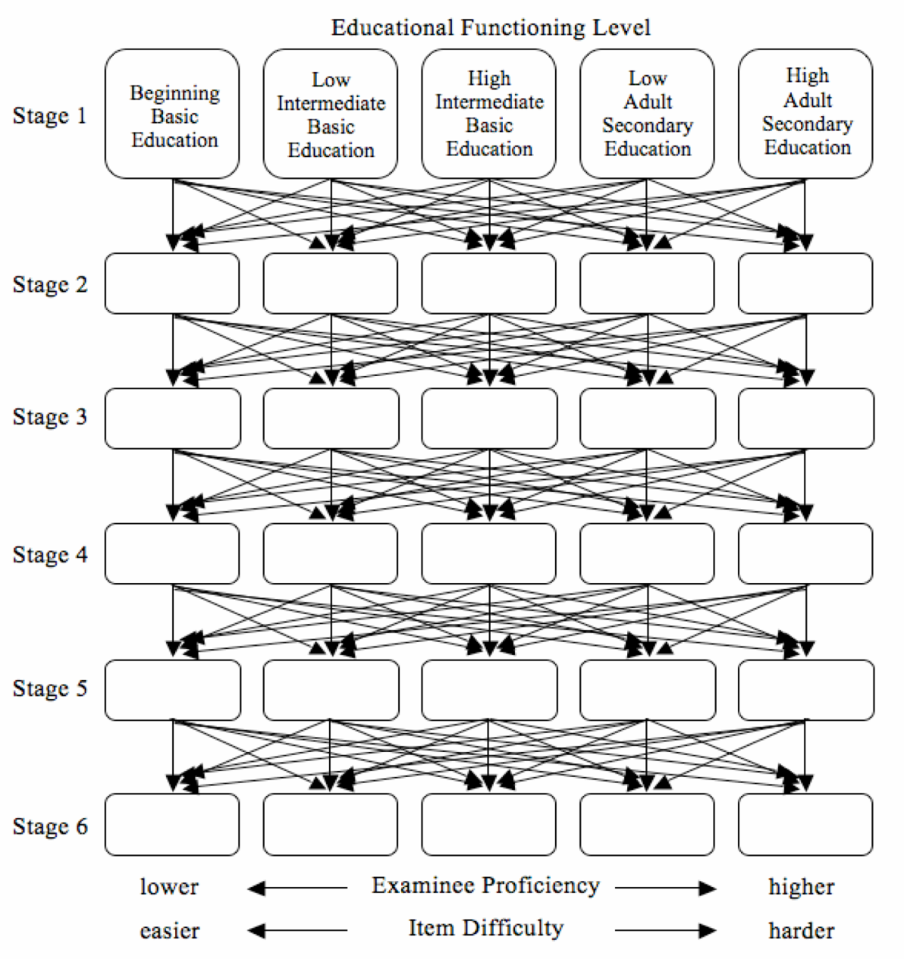

Each student who takes the MAPT-CCR receives 35 scored items and 5 pilot items for a total of 40 items. Those items are divided among six sets of items called “stages”, as shown to the left in the figure above. Items are scored as students answer them and the next set of items is selected and administered automatically without interrupting the flow of the test.

Students start the MAPT-CCR at one of five Educational Functioning Levels, ranging from Beginning Basic Education to High Adult Secondary Education in Reading and Beginning Basic Education through Adult Secondary in Math. As students progress through the test from stage to stage, the computer algorithm computes and updates the MAPT-CCR score estimate for each student, and that algorithm considers how students are doing and chooses the item set in the next stage that is at the most appropriate difficulty level for them. More proficient examinees will see harder item sets, and less proficient examinees will see easier item sets. It is common for examinees to see items that are of a similar difficulty level throughout their test, but any sequence of difficulty across six stages is possible.

Each student who takes the MAPT-CCR receives 35 scored items and 5 pilot items for a total of 40 items. Those items are divided among six sets of items called “stages”, as shown to the left in the figure above. Items are scored as students answer them and the next set of items is selected and administered automatically without interrupting the flow of the test.

Students start the MAPT-CCR at one of five Educational Functioning Levels, ranging from Beginning Basic Education to High Adult Secondary Education. As students progress through the test from stage to stage, the computer algorithm computes and updates the MAPT-CCR score estimate for each student, and that algorithm considers how students are doing and chooses the item set in the next stage that is at the most appropriate difficulty level for them. More proficient examinees will see harder item sets, and less proficient examinees will see easier item sets. It is common for examinees to see items that are of a similar difficulty level throughout their test, but any sequence of difficulty across six stages is possible.

II. The Components of the MAPT-CCR

The MAPT-CCR is delivered to students by computer over the Internet. The delivery platform is the Online Web-based Learning (OWL) system, which is run from the Office of Information Technology at the University of Massachusetts Amherst.

Adult Basic Education Programs should access the MAPT-CCR via the link on the ACLS web page: http:///www.doe.mass.edu/acls/assessment

Adult Education in Corrections Institutions (AECI) should access the MAPT-CCR via this link:
https://mapt-ccr-cf.owl.umass.edu/start/

Reminder: Informational Technology staff at AECI cites should whitelist the OWL server URL: http://mapt-ccr-cf.owl.umass.edu/

The MAPT-CCR testing program consists of four components. These are:
- Computer Basics (Required for students who are not comfortable with computers)
- Sample Questions (Required the first time a student takes a MAPT-CCR test)
- Practice Tests (Optional, but can be useful for students and teachers)
- MAPT-CCR for Reading or MAPT-CCR for Math (Required based on each student’s primary assessment area)

After completing MAPT-CCR training, teachers can access the first three components, but to ensure test security, they cannot log in and take an actual MAPT-CCR test.

As shown in the figure below, Computer Basics can be completed without a LACES ID (MAPT), but Sample Questions, the Practice Tests, and the MAPT-CCR for Math and the MAPT-CCR for Reading are accessed from within OWL via the MAPT-CCR Student Home menu.
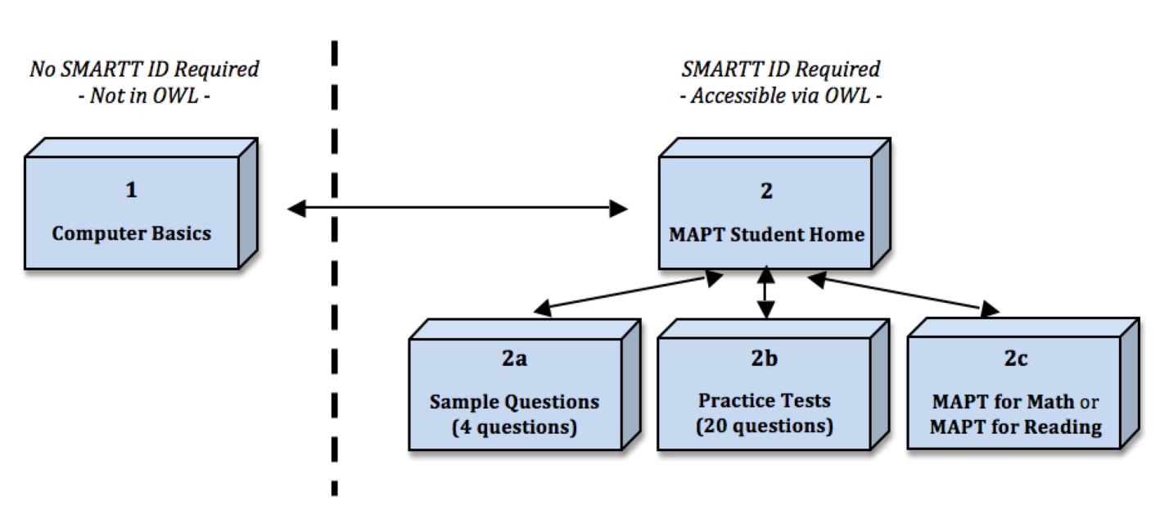
No LACES ID (MAPT) Required
LACES ID (MAPT) Required

Computer Basics
No LACES ID (MAPT) Required
Students may brush up on the basics of using a computer (e.g., how to use a mouse, scroll, go through the test instructions, and log on to the MAPT-CCR for Reading and MAPT-CCR for Math).
- Click on the link “Computer Basics” at http://www.doe.mass.edu/acls/assessment
- Alternatively, a direct link to “Computer Basics” is here: http://owl4.oit.umass.edu/Departments/CtrEdAssess/Tutorial/
- The Computer Basics tutorial can be done at any time, as part of a class or before accessing the MAPT-CCR for Reading or the MAPT-CCR for Math, and no login (e.g., LACES ID (MAPT)) is needed to access it.
- Students may go through Computer Basics more than once.
- Using Computer Basics is optional for test-takers; program staff may decide whether or not the student needs to go through it during their first time using the MAPT-CCR.
- At the end of Computer Basics, students may enter directly into the MAPT-CCR, using their LACES ID (MAPT)/Login.

Sample Questions
LACES ID (MAPT) Required
Students are required to complete the Sample Questions the first time they take the MAPT-CCR to ensure they understand the test directions and can use test components like the embedded calculator.
- After the first time students take the test, program staff and students may decide if students would benefit by completing the Sample Questions again the next time the MAPT-CCR is taken.
- To take the Sample Questions, select “Sample Questions - Math” or “Sample Questions - Reading” from the “Student Home” page.
- The questions include how to click on radio buttons, use the calculator and formula pages, and use reading selections and graphics.
- The sample questions take about five minutes to complete.
- After completing them, the student may choose to then move seamlessly to the MAPT-CCR for Math or MAPT-CCR for Reading.
- A LACES ID (MAPT) Login or test administrator login is needed to take the Sample Questions.

Practice Tests
LACES ID (MAPT) Required
Each level of the Practice Test has 20 questions, and mirrors the actual levels of the MAPT-CCR for Math and Reading. Before giving the MAPT-CCR to students, test administrators themselves are encouraged to take a Practice Test in Reading and/or Math first.
- Test administrators may use Practice Tests to get a sense of the relative difficulty of the different MAPT-CCR levels so as to place students in the right level of the MAPT-CCR.
- They may also use it to test the functionality of the MAPT-CCR to ensure there will be no Internet connectivity problems.
- Students also benefit by using the Practice Tests, and may take the Practice Tests more than once.
- The Practice Tests are optional.
- Students will receive a raw score in terms of number correct out of 20.
- This score is intended only to give a rough idea of what students know in the larger dimensions of math or reading. Test administrators can record these scores in their own records, but they will not be recorded in LACES.
- Each student’s pattern of responses to practice test questions is displayed on the results screen when a practice test is finished; programs can choose to print those and go over the practice tests with students. Note too that programs can access the Practice Tests as PDFs to carry out whole-group instructional activities with students as needed.
- A LACES ID (MAPT) Login or test administrator login is needed to take the Practice Tests.

MAPT-CCR for Reading / MAPT-CCR for Math
LACES ID (MAPT) Required
The MAPT-CCR for Reading and the MAPT-CCR for Math are administered individually on a computer, using the Internet.
- Each MAPT-CCR consists of 40 items total, of which 35 are scored and 5 are unscored.
- Unscored items are “pilot” items that are being tried out and evaluated for their statistical qualities for possible eventual use on the MAPT-CCR.
- On average, students complete either test in a little more than an hour.
- A student is required to have a LACES ID (MAPT) Login when taking the MAPT-CCR for either Reading or Math to measure his or her learning gains, so that the test can be linked to the student’s record in LACES.
Please note that the Practice Tests are meant to help test administrators become familiar with the functionality of the tests and the types of items students will encounter at the different levels. For security purposes, test administrators do not have direct access to the actual MAPT-CCR test questions for Reading and Math.

III. Getting Ready with the OWL System and the MAPT-CCR

Before students can take the MAPT-CCR or complete the Sample Questions or Practice Tests, there are several things test administrators must know.

Who Should Take the MAPT-CCR
The state’s assessment policy requires programs to use the MAPT-CCR for Reading and/or the MAPT-CCR for Math for all learners GLE 2-12.9 enrolled in AE classes, except for those listed below:

- AE Beginning Literacy Students: AE students reading below GLE 2 must be tested using the TABE Test, Forms 11/12 Level L (Literacy Level Reading only; the Level L Math may be administered but is not required);
- AE students GLE 2-12.9 whose goal is to improve their writing skills must be tested using the TABE Language Subtest, Forms 11/12, Levels E, M, D, and A;
- Students in AE Programs for Correctional Institutions (CI) that do not have access to computers must be tested using the TABE Reading, Math or Language Subtest, Forms 11/12, Levels E, M, D, and A;
- Students in Workplace Education (AE) programs that do not have access to computers must be tested using the TABE Reading, Math or Language Subtest, Forms 11/12, Levels E, M, D, and A;

MAPT-CCR Test Administrators
The MAPT-CCR can only be administered by certified MAPT-CCR Administrators. All MAPT-CCR test administrators in ESE/ACLS-funded sites must complete the online training and have record of completion of this training on file with UMass. Program staff may not train other program staff in MAPT-CCR Test Administration.

The MAPT-CCR Test Administrator Training is available online: https://umassamherst.co1.qualtrics.com/SE/?SID=SV_cOzTFuhOmYmilX7

Once test administrators have completed the MAPT-CCR Administrator training, Test Administrator Logins and passwords will be created and will be sent to the email address provided within two weeks.
Test administrators who have completed this training can administer the MAPT-CCR to their own students. A trained MAPT-CCR administrator must be present the entire time when the MAPT-CCR is administered.

Student MAPT-CCR Logins and LACES IDs (MAPT)
To take the MAPT-CCR, students must have a Site ID, their own LACES ID (MAPT), and their password to access OWL.
SITE ID: The Site ID is a 3 or 4 digit number that is the LACES site code.

LACES ID (MAPT): Students MUST have their LACES ID (MAPT) number. If students are currently enrolled in an AE program and class in the current fiscal year, they already have a LACES ID (MAPT). If a student has been exited from the program, or is new to the program, program staff must enter a student’s intake information into LACES and enroll the student in a class to obtain a LACES ID (MAPT) for that student. The LACES ID (MAPT) is generated when this information is entered into LACES.

Important! Always avoid duplicating/creating student IDs! Before creating a LACES ID (MAPT) for a student, test administrators or other program staff must check to make sure one does not already exist in the LACES system. Some reasons why a student may already have a student ID is that a student has current enrollment at more than one program, a student was enrolled at a different program in the past, or the student moved from an ESOL class to an AE class.

This check must happen on the data entry side. When students have more than one account, OWL staff move tests by hand and that is time-consuming (and costly) but necessary to ensure that ACLS has complete student records.

If a program is generating a new LACES ID (MAPT) for a new student, the process is not instantaneous:
- If a student’s intake information is entered into LACES before 4 p.m., an account for testing in OWL will be ready by 5 pm that same day.
- If a student’s intake information is entered into LACES after 4 p.m., an account for testing in OWL will be ready by 8 a.m. the following morning.

PASSWORD: The student’s password is always their last name as it was entered into LACES at intake, including multiple names, spacing or hyphens, apostrophes, etc. If a program enters Smith-Jones as Smith Jones in the last name field, that is what OWL will expect as the password (same with O’Reilly as O’Reilly, or Oreilly). If there are 4 names in the LACES Last Name field, then 4 names will be expected/required for the password.

If a student is taking a test under the wrong name, stop the test immediately and alert UMass-OWL Technical Support via “Send Message.” Technical Support Staff will reset the test within 24 hours, Monday through Friday.

MAPT-CCR Test Administration Conditions
The MAPT-CCR is available 24 hours a day, 7 days a week. The MAPT-CCR must be administered at program sites, during program hours, with a test administrator present.

For any tests that the OWL system records as having been taken between 10 pm to 7 am or on weekends, staff from UMass will follow up with programs to verify valid test administration. UMass OWL Technical Support will invalidate tests that are found to have been taken offsite without a test administrator present.

Test administrators should ensure that the testing location is quiet and comfortable. Students should not be distracted by their surroundings while taking the test. Learners may be tested in a computer lab, empty classroom, office, or other space. The MAPT-CCR should not be administered in a test in a classroom where other students are working (not taking the MAPT-CCR) or talking.

Test Administrator Preparation
Test administrators should be ready for testing. Test administrators should have the information regarding students’ individual LACES ID (MAPT), site ID, and test level ready before students sit down to take the test.

Test administrators should introduce the MAPT-CCR to students before they take the test. Before students take the MAPT-CCR, test administrators should briefly explain the test and score report, why students are being tested, and go over some test-taking strategies.

Computer Readiness, Screen Adjustment, and Troubleshooting Internet Connectivity
Test administrators should check to see if the computers that will be used for testing meet minimum requirements for testing (see the table below). Please note that if the available computer does not meet all the computer system requirements but passes the readiness test described below and has a large enough monitor, then the computer is most likely fine for MAPT-CCR testing.

Computer Feature | Minimum Requirement / Notes
Operating System | PC: Windows XP or newer  Mac: OS X
Computer Display | 1280 x 1084 pixels is best, though 1024 X 768 pixels is fine. Monitors should be at least 19" CRT's or 17" LCD's.
Computer RAM | 512 minimum if using Windows XP.  If programs are using Windows ‘98 or 2000, and have enough memory to run an up-to-date browser (Internet Explorer, Netscape, Mozilla), this also is sufficient.
Web Browser | Windows: An up to date version of Firefox, Chrome, or Internet Explorer  Mac: An up to date version of Firefox, Chrome or Safari
Internet Connection Speed | DSL, Cable or a T1 line all work
Laptops and hand- held mobile devices | System recommendations for laptops are the same as for desktops. Hand-held mobile devices are not appropriate for MAPT-CCR testing for various reasons, including small screen size.
Ensure the computers that students will be using are on and in good working order. Please perform a computer readiness test (below) on any computer that has not already been used successfully for MAPT-CCR prior to using it for actual testing.
To check how many pixels the screen is set at, go to the Windows “Start button” on the lower left part of the computer screen, click on “Settings,” and then “Control Panel.” From there select “Display,” then “Settings,” and “Screen Area.” Move the pointer to 1280 x 1084, and click okay. A message will pop up that states that Windows will apply the new settings.
Before students are scheduled to take the test, test administrators can use a MAPT-CCR test administrator login to log in to the OWL Testing System and access a Practice Test. The purpose of this is to test the site or program’s connectivity to the Internet (and to UMass). Poor connectivity could result in students being “kicked out” of the test while taking it, images or pages being slow to load, or students having difficulty logging back into the test.

Note that test administrators need an OWL account to log into OWL. If a program staff person does not have an OWL account or cannot recall the login information, send an email message to mapt-owl-help@it.umass.edu. Include name, site, email address and indicate that a test administrator account for testing the computer setup(s). Individuals must be certified MAPT-CCR Test Administrators in order to receive a Test Administrator login

Walk through the “Sample Questions - Reading” and the “Sample Questions - Math” tests and answer the following questions:

Are the pages loading within a few seconds? Is the calculator on Questions 2 and 3 of the “Sample Questions – Math” test visible? It looks like this:

- Are all the rows of buttons that appear in the above image present?
- Is the calculator functioning (try adding two numbers, for example)?
- Is the text in the “Sample Questions - Reading” easy to view (large enough, clear and undistorted)?
- Is it possible to submit answers to the four questions in each of those tests?
- Did everything (including the log in pages) appear to be displaying and functioning correctly?
If the answers is yes to all of these questions and nothing else occurs that would cause concerned, then the computer setup is most likely fine for MAPT-CCR testing.

If pages or images are very slow to load, or if a student’s computer cannot connect to the Internet at a web page that is refreshed often (e.g., http://www.cnn.com), then the problem may be with the program or site’s connection to the Internet. Some options to try include:
- Refreshing the browser
- Closing the browser, then re-opening it and logging back into the test
- Using a different browser or a different computer
- Contacting the Technical Support person for the site

If web pages such as http://www.cnn.com seem to work but the MAPT-CCR question or graphics are slow to load during the test, alert UMass-OWL Technical Support via “Send Message.” There may be a connection problem on the UMass end.

If students would like to adjust the size of the text on the screen, students or test administrators can adjust the display for readability. By clicking on Ctl+, it is possible to increase the size of the display (font, etc.), and clicking on Ctl- will decrease the size of the display.

If a student’s computer shuts down (e.g., due to a power outage) but then regains power, the student should log back into OWL, click on the test they were taking. Students may then click on the “Continue” link to begin the test where they left off.

Administration Time for the MAPT-CCR
The MAPT-CCR is un-timed. Most students will complete the 40 questions in the MAPT-CCR for Reading or the MAPT-CCR for Math in 60 to 75 minutes, but a two-hour time block for testing is recommended to allow students more time if needed.

All students should try to complete the test in one session for accurate test results as the test is intended to be taken in one sitting. Test administration should not be split into multiple sessions unless absolutely necessary.

However, if students do not finish in one sitting, they can exit the test and return to it within 15 days. When these students log in, they will return to the point in the test where they left off. Students do have 15 days from when they started the test to when they finish for the test to be considered valid. (For example, if a student begins a test on a Monday, he or she has two more Mondays to complete that test.)

Students must finish a MAPT-CCR for Math or MAPT-CCR for Reading test they began within 15 days or a test reset will be needed.

Requesting a Test Reset After 15 Days Have Passed
If the test is not finished within 15 days, the test is not considered valid and will expire.

When students log in after 15 days of starting a test, they will see “Contact Teacher.” The test administrator should click the “Make Test Available” radio button on this message to reset the test so students may restart a test back at question 1. When a test is reset, students begin back at question 1 with a new set of questions. This process must be done separately for each student requiring a test reset. Test resets will always be completed within 24 hours, Monday through Friday.

It is very important for test administrators to use their program or site’s email address (or their personal email address that they check often) so that UMass OWL Technical Support staff can contact them with a response. A response to a test reset request cannot be sent without an email address. If there is another person at the program who should be notified that a test reset has been completed, the email address for that person should also be included in the request.

Note: For the MAPT-CCR in AECI, there is no option for test administrators to input an email address. UMass CEA and OWL staff will use the originating site information embedded in the message and refer to our contact list with MAPT-CCR test administrators to follow up on support requests.

In scheduling MAPT-CCR administrations, programs should consider holidays, vacation weeks, or other possible delays that might affect students’ ability to finish tests within this time.

MAPT-CCR Accommodations
Although the MAPT-CCR was constructed to be as flexible as possible to accommodate learners with various disabilities, there may be many cases in which accommodations are necessary to get a more accurate measure of a particular learner’s knowledge and skills. The issues to consider in granting an accommodation on the MAPT-CCR are:
- whether the accommodation removes a barrier that may hinder a learner’s performance on the MAPT-CCR;
- whether the accommodation is consistent with accommodations provided to the learner in the classroom;
- whether the accommodation will change what the MAPT-CCR is measuring.

Given those issues, ACLS recommends the following accommodations be granted for students who may want them, because these accommodations are not considered to change the construct (math or reading proficiency) measured on the MAPT-CCR:

- extended time (see ACLS policy regarding resetting a test), including administering the test over two or more days
- separate testing room (away from other learners)
- increase font size (large print)
- touch screen technology for answering questions
- read-aloud presentation of instructions
- read-aloud presentation of the MAPT-CCR for Math test
- sign language presentation of instructions
- recording answers for learners
- use of manipulation equipment (e.g., a head-stick) for navigating through test and answering items

The above list of accommodations is not exhaustive and other accommodations may be requested in some circumstances. ACLS should be contacted for approval in such situations. A well-respected resource for learning more about test accommodations is the web site for the National Center for Educational Outcomes (http://www.education.umn.edu/NCEO/default.html), particularly their frequently asked questions and their test accommodations bibliography (http://education.umn.edu/NCEO/AccomStudies.htm).

Note that in some cases, students may request a read-aloud accommodation on the MAPT-CCR for Reading. This accommodation may change the construct measured (i.e., from reading comprehension to listening comprehension), and so should only be granted when it represents the typical way in which a learner accesses reading material.

To promote the most valid interpretations of MAPT-CCR scores, the accommodations granted to students should match their needs. Thus, accommodations should not be provided to anyone who wants one, just because they happen to be available or allowable. Rather, test accommodation decisions should be made in a careful and thoughtful manner, considering the issues of access and validity, and should be consistent with the accommodations a learner uses as part of their normal instruction.

Decisions regarding test accommodations are difficult to make and should be revisited after students have had experience taking the MAPT-CCR. One way to help decide whether accommodations are needed is to have students take the MAPT-CCR Practice Tests and observe how they interact with the material. Interviewing them about their experience on the Practice Tests, and other tests they have taken in the past may also be helpful. Decisions regarding whether to provide an accommodation, and which accommodations will promote valid score interpretation should be based on a comprehensive evaluation of the needs of specific learners and consideration of valid test score interpretation. Contact ACLS if you have further questions regarding how to accommodate students with disabilities on the MAPT-CCR.

Pre-testing, Post-testing, and the Interval Between Testing
Programs need to pre- and post-test enrolled students each fiscal year in their primary assessment area in order to capture student educational gain.

When a student has enrolled and has a LACES ID (MAPT), they can take the MAPT-CCR. All students must be pre-tested before reaching 18 hours of attendance. The MAPT-CCR is not a placement test and should not be used for that purpose by programs.

After a student takes the MAPT-CCR, the test automatically becomes available again for post-test in the OWL system after two months/60 days. The general recommendation is to post-test after an interval of four months or 65 hours of instruction, whichever comes first.

However, the intensity of classes varies among programs, and some adult learners in intensive classes may reach 65 hours of attended instruction before two months have elapsed. In this case, students with 65 hours of attended instruction may be tested sooner than two months (60 days) after their previous test. If students receive at least 65 hours of instruction before two months/60 days have passed, test administrators can send a message to UMass-OWL Technical Support to request that the test be made available.

To request that a test be made available sooner than 60 days, MAPT-CCR Test Administrators should contact UMass OWL Technical Support using a MAPT-CCR test administrator account, and provide the following information:

- student’s first and last name
- student’s LACES ID (MAPT)
- site
- hours of Attendance
- person requesting the test reset
- email address of the person requesting the reset
- reason (e.g., student has 65+ hours of attended hours and needs to be post-tested)

Students cannot take the MAPT-CCR more often than three times in each content area within a fiscal year.

IV. Student Login Steps
The screenshots below show what students will see when they are in the OWL system. Teachers are encouraged to go over these screen shots with learners so that all involved are comfortable with the test and its components before students take the MAPT-CCR. Teachers may project screen shots in the classroom as they discuss the test.

Programs should access the MAPT-CCR via the link on the ACLS web page: http:///www.doe.mass.edu/acls/assessment

Adult Education in Corrections Institutions (AECI) should access the MAPT-CCR via this link:
https://mapt-ccr-cf.owl.umass.edu/start/

Reminder: Informational Technology staff at AECI cites should whitelist the OWL server URL: http://mapt-ccr-cf.owl.umass.edu/
Below is the first screen that students will see. Students should click on the “MAPT-CCR Login Page” button to access the login page.

Initial Screen
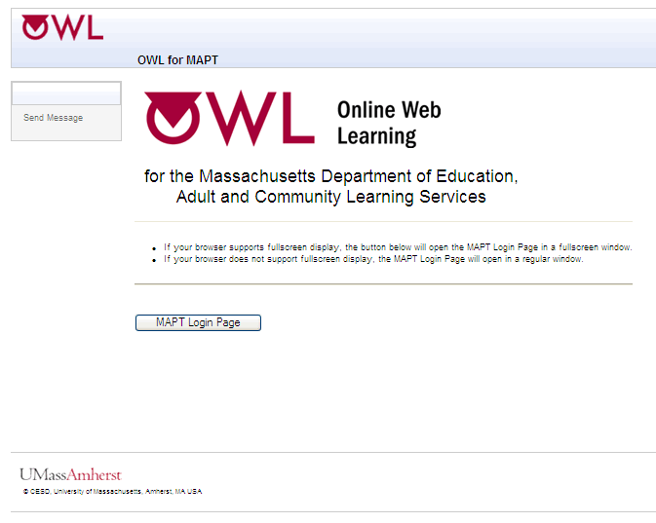

MAPT-CCR Login Screen
Next is the login screen. Students enter their 1) site and LACES ID (MAPT) combination and 2) their password. Site and LACES IDs (MAPT) are a two-part sequence of numbers, and the parts are separated by a dash.

- The first part is the Massachusetts site code (three or four digits long);
- The second part is the student’s own numerical LACES ID (MAPT)

The password for all students is their last name exactly as it entered in LACES. LACES data entry controls the password. If a student has a hyphenated last name or a space in their name in LACES, the last name must be typed exactly that way in the password field to access the MAPT-CCR. Likewise, if a student’s name is misspelled in LACES, test administrators may encounter difficulties in logging students into the MAPT-CCR.

Examples:

- If a program enters Smith-Jones as Smith Jones in the last name field, the password for OWL will be Smith-Jones.
- If O’Reilly is entered as O’Reilly, the password will be O’Reilly. Alternatively, if O’Reilly is entered as Oreilly, the password will be Oreilly.
- If there are three (3) names in LACES Last Name field, then three (3) names will be expected/required for the password.

Here is the login page:

Here is the login page:

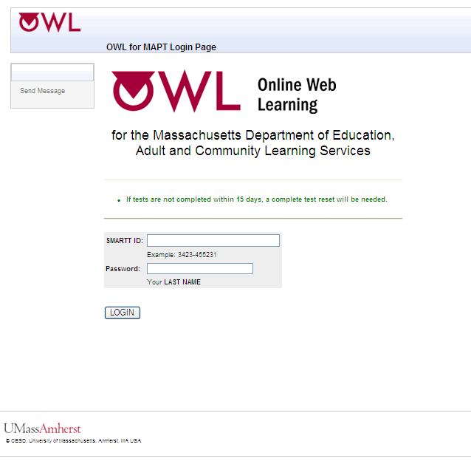

Locating the LACES ID (MAPT) in LACES
The MAPT-CCR integrates with LACES, but test administrators and program staff must access and use the LACES ID (MAPT) to log students into OWL to take any MAPT-CCR tests. Although LACES (MAPT) ID’s will display for the SMARTT enrollments from prior fiscal years, they cannot be used unless the class was in the current fiscal year, which means program staff will need to enroll students into a new class in LACES to generate the LACES (MAPT) ID in order to get the MAPT-CCR testing completed.

The LACES ID (MAPT) displays in the student Enrollments screen.

Note that in the image above, the 1- means the student is not yet assigned to a site. The LACES current FY class the student is enrolled in must have the 'Site' entered in the Class Data tab of the class record. If there is not a site included in the class record, the LACES ID (MAPT) will be 1- and it won't be recognized as valid (and a student account with that 1- designation will not be made active in OWL). For each of your Fiscal Year 18/19 classes, select the Site in the Class Data tab and this will update the LACES ID (MAPT) for each student enrolled in the class.

To easily view the LACES ID (MAPT) after class enrollment for ALL students, go to the green MORE menu at the top of the screen and select ALL STUDENT ENROLLMENTS.

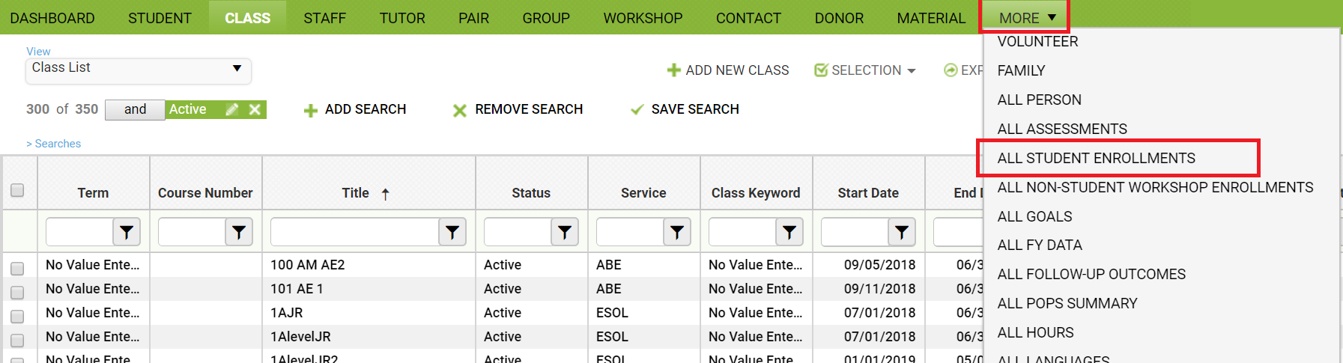

Create a Custom View containing the LACES ID (MAPT) and export that view to Excel, where you can deduplicate based on First and last Name in order to generate a full list of LACES (MAPT) ID’s for your students.

MAPT-CCR Login Error Screen
If students type in their LACES ID (MAPT) or password incorrectly or there is a problem with their login, then an error screen (below) will prompt the students to try again. Make sure the LACES ID (MAPT) is correct for each student, and that the password is the student’s last name exactly as it is recorded in LACES.

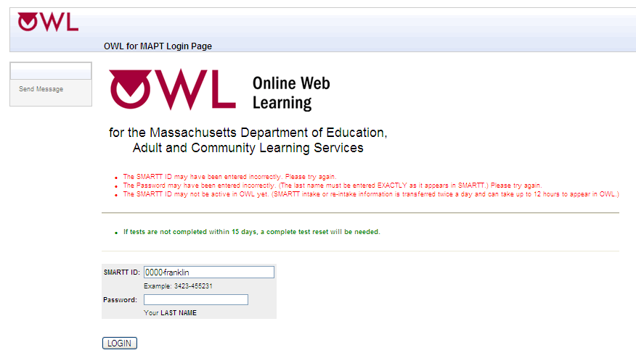

Login Error - Send Message
If a student is still unable to login, the test administrator should use the student’s computer to click on the “Send Message” link located on the left hand menu on the screen. The form below will then appear on their screen.
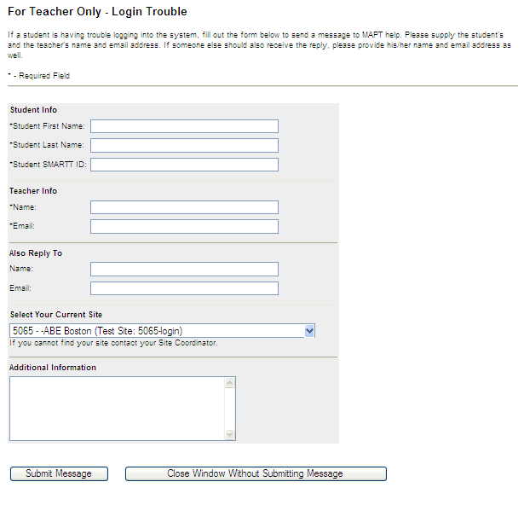
Test Administrators should fill out this form completely. They will receive login assistance for that student within 24 hours Monday through Friday.

Note: For the MAPT-CCR in AECI, there is no option for test administrators to input an email address. UMass CEA and OWL staff will use the originating site information embedded in the message and refer to our contact list with MAPT-CCR test administrators to follow up on support requests.

If there is one or more additional staff that could also be alerted to the response from UMass Technical Support, list name(s) and email(s) in the ‘Also Reply To’ space and separate different email addresses with a comma. Add any additional helpful information into the “Additional Information” box, or leave it blank.

If a test administrator contacts UMass-OWL Technical Support after a student has logged out of the test, use mapt-owl-help@it.umass.edu.

Successful Login – Welcome Screen to Confirm Name
When students log in successfully, they will be presented with a welcome screen (shown below).

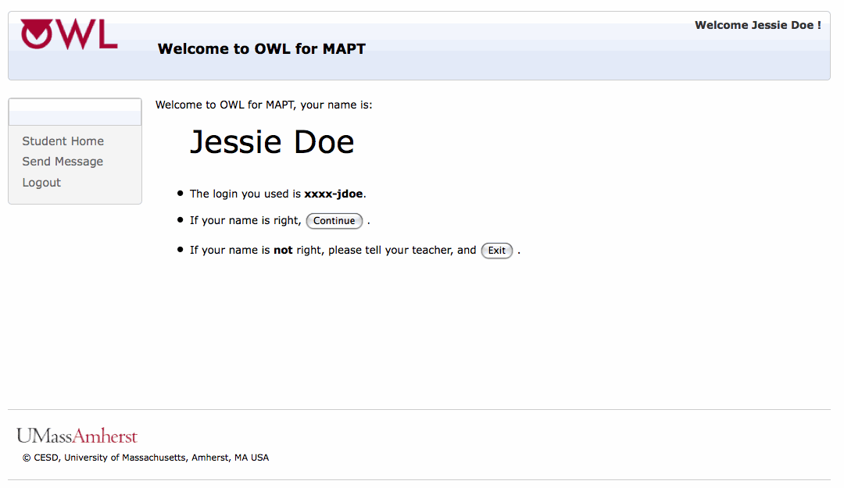

Students must verify that the first name and last name displayed are theirs and are correct, to avoid taking a test under another student’s login. One possible source of error in this regard includes students with similar names enrolled in the same program.

If the student’s name is not correct when a student logs in, the test administrator should stop the student from testing and contact UMass OWL Technical Support using their Test Administrator Login and the “Send Message” feature once logged into the MAPT-CCR. Test administrators need to give their direct email in order to receive a response within 24 hours Monday through Friday. If the person submitting the message will not be the person assisting the student later that day or the following day, the name and email of that person with whom Technical Support staff should follow up should also be included.

If the student’s name is correct, they should click "Continue", and on the next screen students should then check that the site listed is correct. Some students may not be familiar with the formal name of the program and site. To avoid any confusion, test administrators should tell the students the formal name of the site as they are all logging in to the computer.

Confirm Program/Site

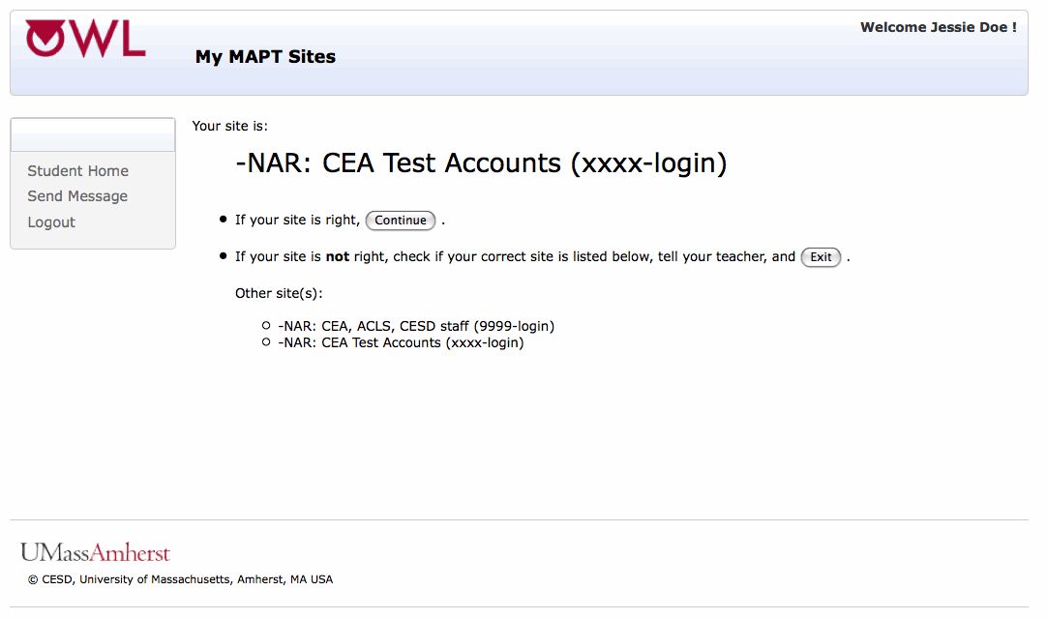

After students have confirmed the site, they will click on “Continue” to move on to Student Home.

Student Home
On the next screen (shown below), students are on the Student Home screen. They will see a table showing the different options available to students within the MAPT-CCR. Students may select among the following:

- Sample Questions – Math or Reading
- Practice Test – Math or Reading
- The MAPT-CCR for Math or Reading
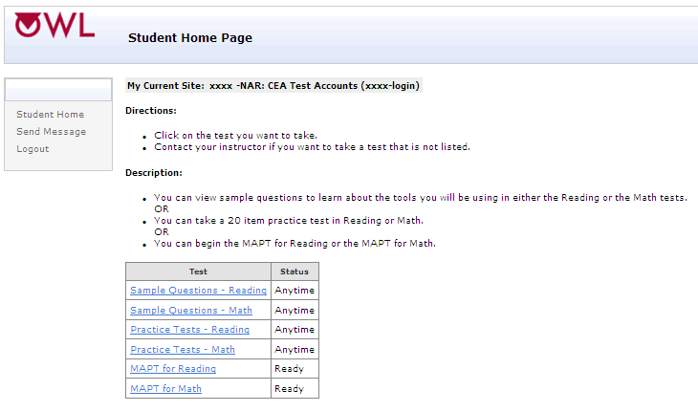
The status column in the chart indicates what test is available for students to take. When students first enter Student Home, the status for the options will either be Ready or Anytime.

- The Sample Questions and Practice Tests may be taken more than once. They will always have the “Anytime” status to indicate that they may be taken as many times as the student wishes when a test administrator is available and present. There is no time limit.
- The status “Anytime” also indicates that students or test administrators may take the Sample Questions and Practice Tests.
- “Ready” means that the MAPT-CCR is available for a student to take.
- The status “Now” means that a student is now able to complete a test or restart it.
- “Completed” is listed when a student has completed a test.
- “Contact Teacher” appears when the 15-day window for completing a test has expired and the student needs to contact a test administrator in the room for that test administrator to send a message to UMass-OWL Technical Support to request a reset.

V. Sample Questions and Practice Tests

As noted previously, students have the option of completing Sample Questions and Practice Tests prior to completing the MAPT-CCR for Math and the MAPT-CCR for Reading. These can be accessed from the Student Home Page, as seen in the screen below.

First Time Test-Takers and Sample Questions
Students are required to complete the Sample Questions the first time they take the MAPT-CCR to ensure they understand the test directions, are able to navigate through the test, and can use the test components like the embedded calculator.

Students are scored on these questions so they can receive feedback that they are able to click on a radio button and are moving through the questions correctly. The score will be the number correct out of four questions. Students may repeat the Sample Questions as often as they like, so they can continue to practice until they score four out of four correct. Ideally, students should not move forward until they answer all four questions correctly. There is no time limit. Both students and test administrators may take the Sample Questions.

Students should not use the back button in the browser. They should use the links in the Student Home Page and the direction buttons that are on the screen.

After the first time students take the test, program staff can decide if students would benefit by completing the Sample Questions again before the next time the MAPT-CCR is taken.

Directions for Sample Questions
Once students click on “Sample Questions - Math” or “Sample Questions - Reading,” they will see a directions screen. The directions screen for Sample Questions - Math is shown below, but the directions screen for Sample Questions - Reading is quite similar.

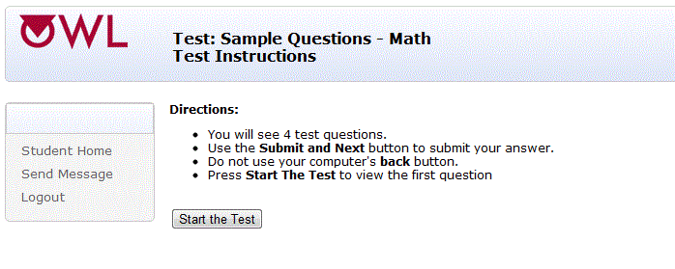

Math Sample Questions
The first three questions in the MAPT-CCR for Math Sample Questions walk students through problems and tell students the answer. The fourth question in the Math Sample Questions set is an opportunity for students to practice the skill reviewed on their own.
Some of the Sample Math Questions may seem challenging (e.g., the questions related to using the calculator and the Formula Page), and test administrators may think to skip these for their Level 2 students. However, as of July 1, 2018, the Formula Page is available on all questions and the calculator is available for most questions, so it is to the student’s benefit to go over them. Students may go over the Sample Questions individually or with their test administrator before they take the MAPT-CCR for Math.
The next four screens presented are the four Sample Questions - Math.
Sample Question One for Math teaches learners how to click on a radio button to answer a question. The answer is given to ensure the skill of clicking on a radio button is the focus.

The two screens shown below (the second and third Math Sample Questions) are items that demonstrate how to access and use the onscreen calculator, because most questions on the MAPT-CCR for Math allow students to use a calculator. This gives students a chance to familiarize themselves with how this calculator works.
Note that in the MAPT-CCR for Math, learners may use a calculator at any time except for the very few questions that do not have a calculator embedded onscreen.

The fourth and final Math Sample question (shown below) includes the link to the Formula Page, which is made available for all questions.
The link to access the Formula Page is shown above the fourth Sample Question - Math. The Formula Page can be printed so that students can access a hard copy during the test. The Formula Page is available for use with all questions.
Note that in this sample question, the goal is to ensure students understand how to open and use the “Math Formula” page link.

Math Formula Page

Reading Sample Questions
For the Reading sample questions, the goal is to provide practice with forward navigation, radio button use, the appearance of passages and graphics, and scrolling. Note that the test questions are bolded in the next four screens displayed as well as in the actual test.

The first Sample Question for Reading teaches students how to click on a radio button to answer a question.

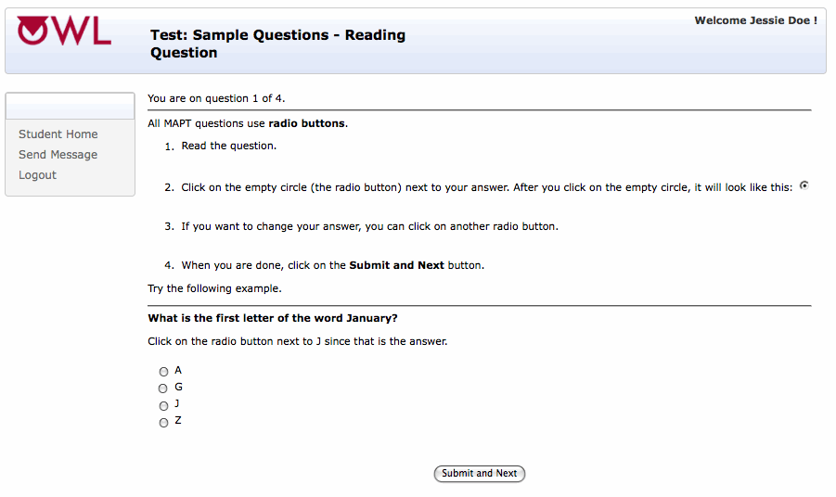

The second and third Sample Questions for Reading explain the type of reading selections learners will see on the MAPT-CCR. Students may encounter poetry, a long or short reading passage, a quotation, or even an advertisement. The term “Reading selection” refers to all of these types of print. Test-takers also learn that more than one question may be associated with one reading selection, but that selection will not change between questions. The test question is bolded to offset it from the reading selection.

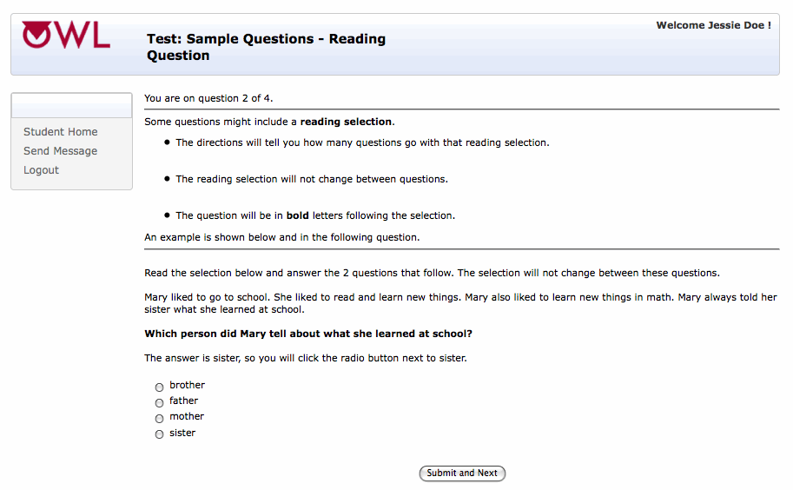

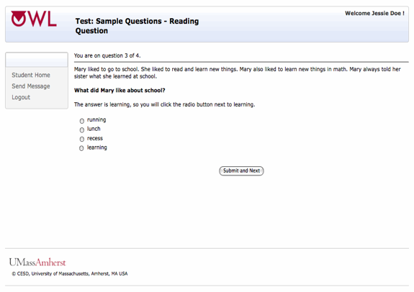

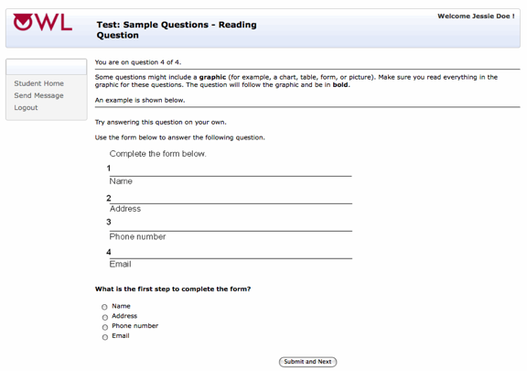

Sample Questions Results
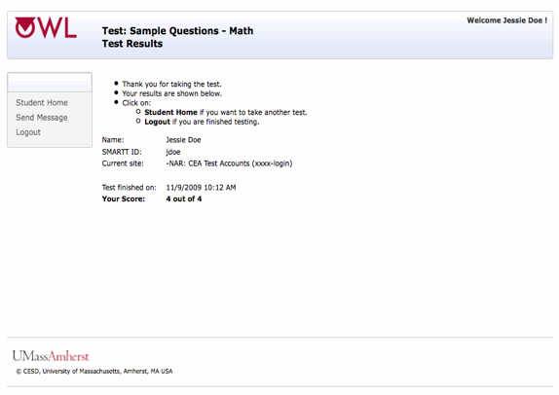
When students complete the Sample Questions - Math or the Sample Questions - Reading, they are presented with a test results screen, as shown below.
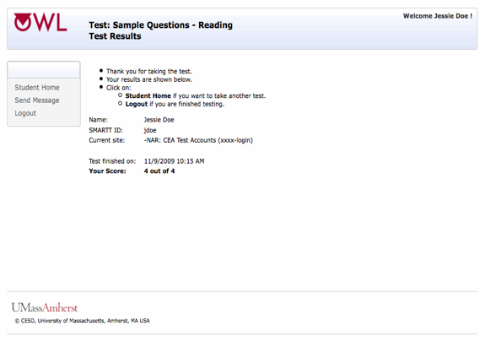

The MAPT-CCR Practice Tests
Practice tests are optional. They are available to give students a sense of what the test will be like. It is strongly urged for test administrators to go through practice tests to get a sense of levels and select the appropriate level for students taking the test for the first time.

The Practice Tests can be accessed from the Student Home Page (below).

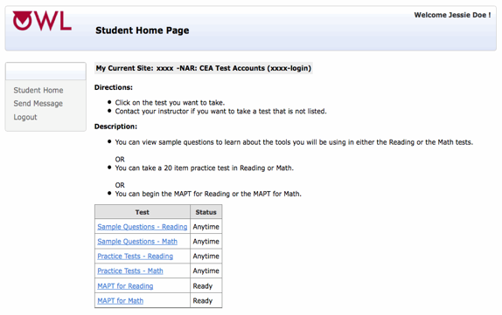

Choosing Practice Test Levels
The names of the Practice Test levels, as shown in the following two screens, mirror the CCRSAE and NRS levels. With these Practice Tests, test administrators and the students themselves can get a sense of how the levels differ from each other. Practice Tests test the functionality of the computer setup, and helps test administrators determine the correct level at which new students should start the test. There are 20 questions per level.
Reading Practice Tests

Directions for the Practice Tests
The directions for the Math and Reading practice tests are the same, and the directions for the Practice Tests - Math are displayed below as an example.

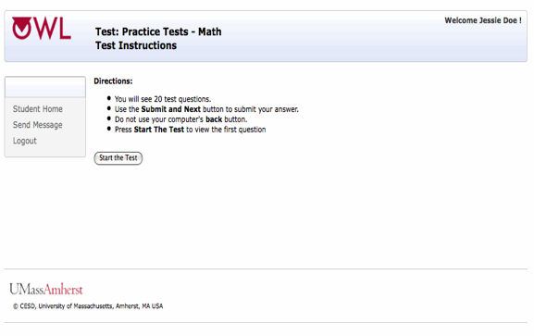

Reminder: Do Not Use the Back Button
Please note that students may NOT go back to review a question already answered. In the directions for taking the MAPT-CCR, students are asked not to use their computer’s “back” button. If they do, they will see the error message displayed in the screen below. Students may then click on “Return to the Test,” and they will continue where they left off.

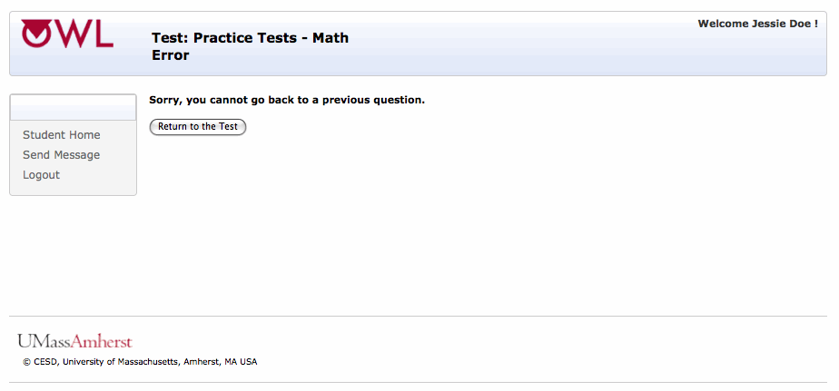

VI. Administration of the MAPT-CCR for Reading and the MAPT-CCR for Math

When students are ready, they can choose to take the MAPT-CCR for Reading and/or Math. The tests are accessed from the Student Home Page displayed below.

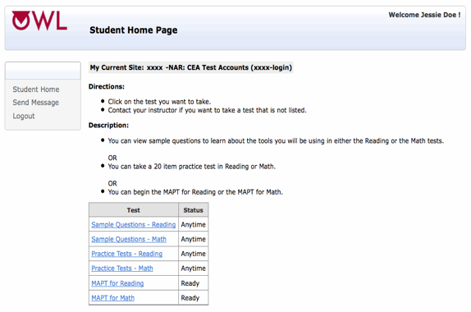

On the Student Home page, students can select either the MAPT-CCR for Math or the MAPT-CCR for Reading by clicking on the appropriate link from the table.

MAPT-CCR Level Selection for First Time Test-Takers
When students take the MAPT-CCR for Reading and/or a MAPT-CCR for Math for the first time ever, they will see the Test Selection screen once the MAPT-CCR for Reading or MAPT-CCR for Math link is clicked on. The Test Selection screen prompts the student, “Your teacher will tell you which test to select.”

To choose the test level for students: test administrators and program staff are urged to study the Reading Standards of the CCRSAE and/or the Math Standards of the CCRSAE before assigning a student a test level. The test questions are aligned with these two sets of benchmarks. Comparison tables are provided below. Teachers are also strongly advised to go through the MAPT-CCR for Math and/or MAPT-CCR for Reading Practice Questions at the appropriate level, as they will reflect the types and difficulty of the questions on the MAPT-CCR tests students will take.

MAPT-CCR for Math Test Name | MAPT-CCR Scale Score Range | CCRSAE  Level | GLE Range | NRS Level
N/A: No test available. Use TABE level L | N/A | N/A | GLE 0 – 1.9 | Beginning ABE Numeracy
MAPT-CCR for Math 2-Beginning Basic ABE | 200 – 299 | B | GLE 2 – 3.9 | Beginning Basic Education
MAPT-CCR for Math 3-Low Intermediate ABE | 300 – 399 | C | GLE 4 – 5.9 | Low Intermediate  Education
MAPT-CCR for Math 4-Middle Intermediate ABE | 400 – 499 | D | GLE 6 – 7.9 | High Intermediate  Education
MAPT-CCR for Math 5-High Adult Secondary Education | 500 – 599 | D | GLE 8 – 8.9 | Low Adult Secondary Education
MAPT-CCR for Math 6- Adult Secondary Education | 600 – 700* | E | GLE 9 – 12.9 | High Adult Secondary Education

MAPT-CCR for Reading Test Name | MAPT-CCR Scale Score  Range | CCRSAE  Level | GLE Range | NRS Level
N/A: Use TABE Level L | Use TABE Level L scale scores | N/A | GLE 0 – 1.9 | Beginning ABE Literacy
MAPT-CCR for Reading 2-  Beginning Basic ABE | 200 – 299 | B | GLE 2 – 3.9 | Beginning Basic Education
MAPT-CCR for Reading 3-  Low Intermediate ABE | 300 – 399 | C | GLE 4 – 5.9 | Low Intermediate Education
MAPT-CCR for Reading 4-  High Intermediate ABE | 400 – 499 | D | GLE 6 – 8.9 | High Intermediate  Education
MAPT-CCR for Reading 5-  Low Adult Secondary Education | 500 – 599 | E | GLE 9 – 10.9 | Low Adult Secondary Education
MAPT-CCR for Reading 6-  High Adult Secondary Education | 600-700* | E | GLE 11 – 12.9 | High Adult Secondary Education

Programs can use the Student Information Sheet shown below to provide login and starting test level information to first time test takers.

Example of the Student Information Sheet

Date: ___________

Learner’s Name: __________________________________________

LACES (MAPT) ID: _____________________________________

Test to take today: (Circle one): M2 M3 M4 M5

R2 R3 R4 R5

Once the test administrator have told students which level of the MAPT-CCR for Reading or the MAPT-CCR for Math to take, students must click on the test level link shown in the next two screens.

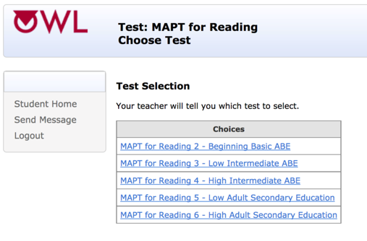

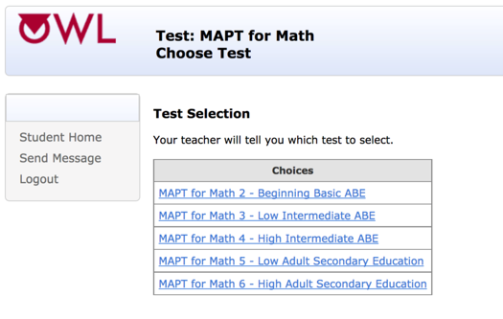

Students Who Have Taken the MAPT-CCT Before
If students have taken the MAPT-CCR before, they will be directly routed to directions for the test and asked to click on Start the Test. Test administrators do NOT choose a starting test level for these students. For these students, their first test question will be at the same test level as their previous MAPT-CCR test score. For example, a student obtaining a score between 300 and 399 at pre-test will start at Level 3 at the next administration. This level distinction will not be visible to the student.

Starting the MAPT-CCR
The next screen that appears is the Starting the MAPT-CCR Test Screen. This screen, as shown below, reflects the MAPT-CCR for Reading, but the screen is the same for the MAPT-CCR for Math. Students are instructed about the number of questions, how to move through the test, and how to begin.

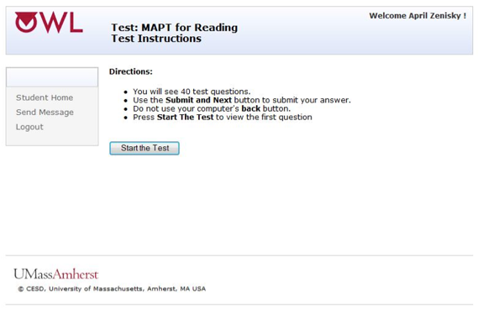

Students will complete 40 questions total in either the MAPT-CCR for Math or the MAPT-CCR for Reading. Of those 40 items, 35 are scored and 5 are pilot items. Test items are numbered so students know where they are in the test, and how many items they have left to complete (e.g., “You are on question 1 of 40”).

Test administrators should allow a full 2 hours for students to take the MAPT-CCR for Math or MAPT-CCR for Reading. While the average student takes between 60 to 75 minutes to complete either test, many students need 2 hours (or sometimes more) of uninterrupted time to complete it.

Unless students need to break up the testing as an accommodation, most students will perform best when they complete the test in one sitting.

After the test administrator has gone over the instructions with the students and they have confirmed they are ready to begin the test, the students can click on “Start the Test.”

The time will start when the students click on Start the Test, so ensure students do not begin the test until they are ready to start answering the questions.

Recall that students cannot use the Back button on the browser to navigate the MAPT-CCR. If they use the Back button, the screen shown below will appear, and students will be reminded to avoid use of the Back button.

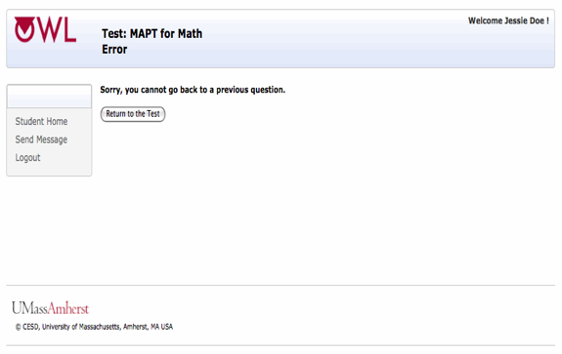

Students may then click on “Return to the Test,” and they will continue where they left off.

Using Send Message for Technical Support / Connection Help
If students have any technical trouble during the test taking process (e.g., graphics do not load, an answer will not submit), test administrators (not students) should click on “Send Message” from the students’ computers while the students are still logged in. When a message is sent from the students’ computers, all the necessary information about the test will be sent to UMass OWL Technical Support and a resolution to the problem can happen much more quickly. When communication is done via “Send Message,” these messages are entered in a log at UMass OWL Technical Support where several people will see it and be able to respond to it. UMass-OWL Technical Support staff will respond to all messages within 24 hours Monday-Friday.

“Send Message” is one of the left-hand menu choices. This link is on every screen once students log in to OWL. A screen capture of “Send Message” is shown below.
.
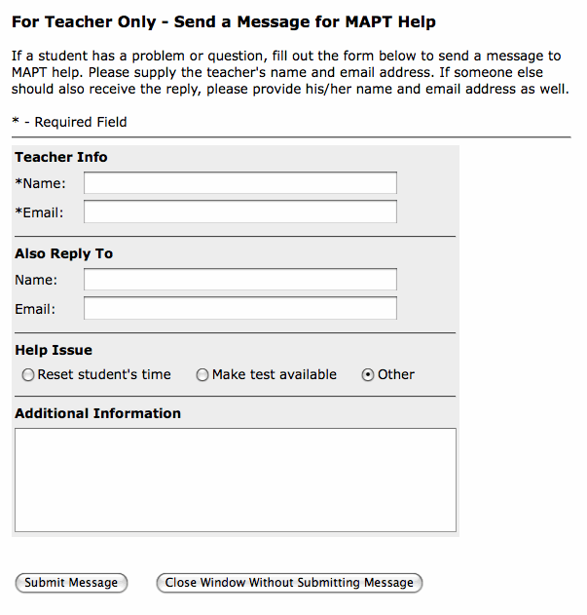

Test administrators should fill out the form completely, including one or more email addresses (separated by a comma) at which they can be reached or which is routinely monitored by program staff. If there are other staff who should also be alerted to the response from UMass-OWL Technical Support, list their names and email addresses under “Also Reply To.”

Add any additional information into the “Additional Information” box, or leave it blank.

Note: For the MAPT-CCR in AECI, there is no option for test administrators to input an email address. UMass CEA and OWL staff will use the originating site information embedded in the message and refer to our contact list with MAPT-CCR test administrators to follow up on support requests.

Test administrators will receive assistance for those students within 24 hours Monday through Friday. Email responses will go to all of the email addresses provided.

Exiting Before Test Completed
If students click on ‘Student Home’ or ‘Logout’ on the left side of the screen before a test is completed, the screen below will appear. It acts as a safeguard against accidentally logging out of the test. Students will not receive a score if the test is not completed.

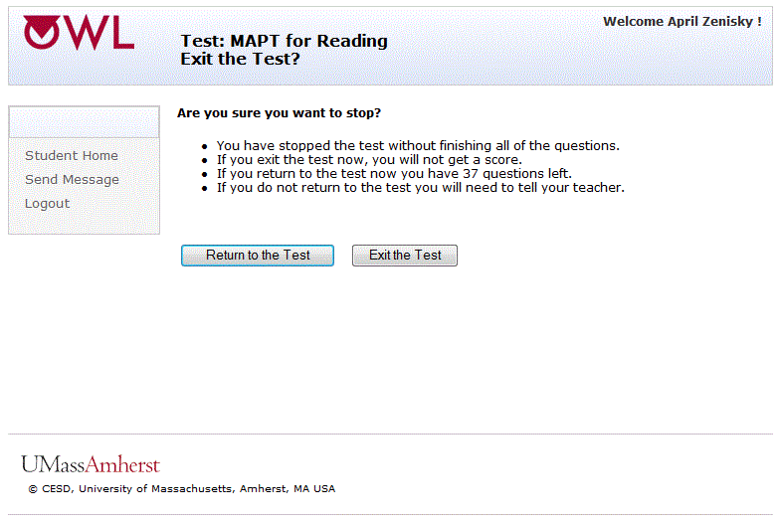

If any students must leave before the test is completed, ensure they click on the "Exit the Test" button on this screen to prevent other students from accessing those persons’ test.
The message on this screen shown above indicates the number of test questions left, and offers the following options: “Return to the Test” takes students back to where they left off. “Exit the Test” takes students back to “Student Home,” where they may choose a Practice Test or Sample Questions, or log out of the OWL system.
If any students’ computers shut down (due to a power outage, for example), those students should log back into OWL, and click on the test they want to take. From there, the students are instructed to click on the “Continue” link to return to the test, and they will be presented with the question that they were working on when the problem occurred.
MAPT-CCR Results Screen
The next screen (below) displays the Test Results screen that appears when students have completed all of the questions on a MAPT-CCR for Reading or MAPT-CCR for Math. For both content areas, the OWL results screen shows the students’ name, their LACES ID (MAPT), and their current site. In addition, it reports the date and time when the test was completed, the test score, and the score range.

Test administrators can print the results page and keep a hardcopy for program records, and/or to give to students. MAPT-CCR scores are also recorded in LACES automatically. Once students have taken the MAPT-CCR for Math and/or MAPT-CCR for Reading, their scores are viewable in both the Student "Assessments" screen and in the "OWL Results" screen in LACES within 24 hours.

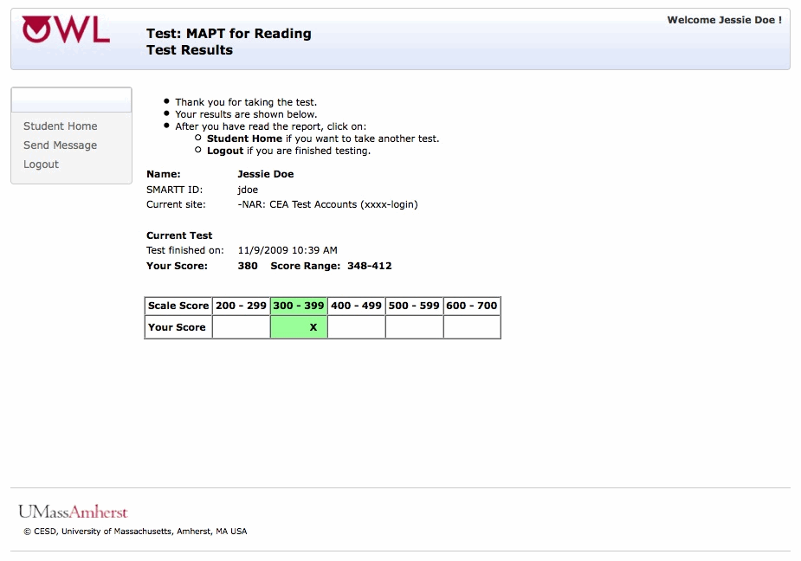

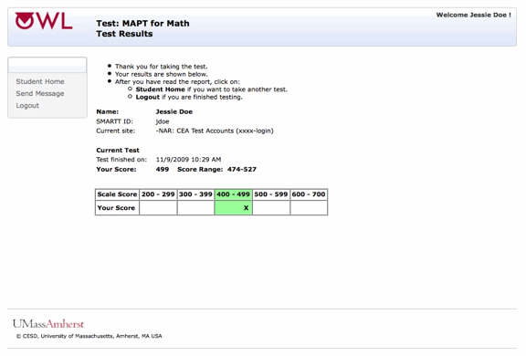

Before students exit the score report page, test administrators may wish to print out the score report page for a complete record of the students’ test results. The test scale scores are exported nightly from UMass/OWL into the LACES system.

Exiting the MAPT-CCR
At the end of a test, students will see the “Test Results” screen shown above, they will be thanked for taking the test, and may click on either:
- “Student Home” to take another test, or
- “Logout” to exit the test if they are finished testing.

Exiting OWL
Students must be reminded to logout when they complete a test session and leave the computer, whether or not all questions are completed. If students do not log out, the test will stay open and other students can access that student’s account.

Students can leave the computer logged in, and test administrators can then log them out, but it is better if students log out themselves so other students cannot access a student’s account.

Students should logout by clicking on the link shown on the left side of the screen. The screen below appears when a student has logged out of his or her account.
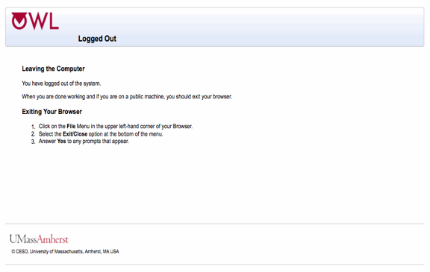

Contacting UMass-OWL Technical Support for Help After Test Administration
Test Administrators can contact UMass-OWL Technical Support anytime after a student’s test administration by logging in to the MAPT-CCR with a Test Administrator Login and clicking on the “Send Message” feature.

These help requests will be answered as quickly as possible, and within 24 hours, Monday - Friday.

VII. MAPT-CCR Results: Interpreting and Using MAPT-CCR Scores

When students successfully complete the MAPT-CCR, the Test Results screen appears after students submit the answer to the last question. The screens below show the MAPT-CCR for Math Test Results page followed by the MAPT-CCR for Reading Test Results Page.

Results Screen in OWL

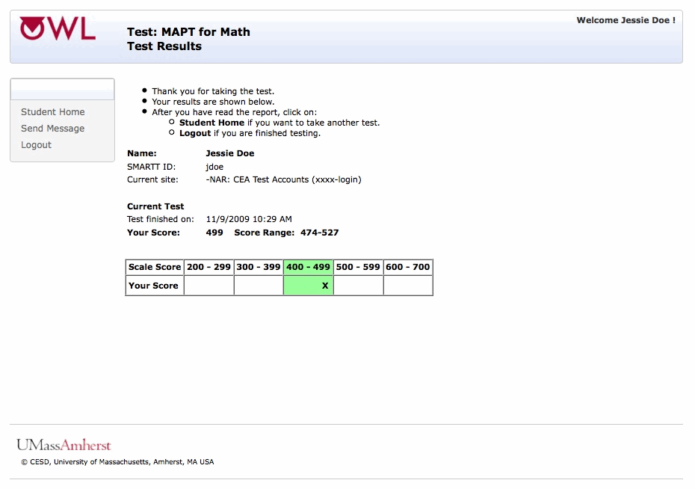

On the Test Results screen, students are thanked for taking the test. The Test Results page also lists the following information:

- the test they took, Math or Reading (“MAPT-CCR for Math” or “MAPT-CCR for Reading”)
- the student’s name, LACES ID (MAPT), and current AE program
- the results for the current test administration, including
  - date and time the test was finished
  - the student’s MAPT-CCR score (“Your Score”)
  - the score range, which reports the confidence band around a student’s score
  - a table showing the different test levels and where the student’s score appeared in a specific level.
The student’s scale score will be located within a cell of the table corresponding to a MAPT-CCR 100-point score interval, which is highlighted in green. The “X” representing the student’s score will be approximately situated within that cell relative to their MAPT-CCR scale score. For example, if a student obtains a score of 380 on the MAPT-CCR the “X” will be positioned close to the right-hand edge of the cell illustrating the 300-399 range. This table shows the score ranges for each test level. The test levels are aligned with the CCRSAE levels, indicating what students at this level are likely to know and be able to do.

Before students exit the score report page, test administrators may wish to print out the score report page for a complete record of the student’s test results. The test results are exported nightly from UMass/OWL into the ACLS LACES system.

Understanding MAPT-CCR Scores
Test administrators and program staff may still want to determine related information such as how the student’s score relates to the CCRSAE in Math or Reading, the GLE (Grade Level Equivalent) Level and NRS (National Reporting Service) Level. The MAPT-CCR score scale ranges from 200 to 700. A score of 200 is the lowest possible score and a score of 700 is the highest possible score as illustrated below.

200 700
(lowest possible score) (highest possible score)

After taking the MAPT-CCR for Reading or the MAPT-CCR for Math, all students are given a score on this scale. Scaled scores are based on the number and difficulty of the items that the student correctly answered. A student who answers many difficult items correctly will earn a higher score than a student who answers the same number of easier items correctly. Essentially, this method of scoring gives students more “credit” for answering a difficult item correctly than for correctly answering an easier item.] The mathematical details of this scoring, provided in the MAPT-CCR Technical Manual (Zenisky et al., 2018, https://www.umass.edu/remp/pdf/MAPT-CCR_TM_Final.pdf), are based on a statistical model called item response theory. For our current purposes, it is only important to bear in mind these two points:

- All students receive a score between 200 and 700;
- Students’ scores are determined by the number and the difficulty of the items they answer correctly.

MAPT-CCR scores represent an estimate of students’ proficiency in math or reading according to objectives listed in the CCRSAE and the skills listed in the NRS EFL descriptors. Educational tests, like all psychological measures, are imperfect. Therefore, it is possible that students’ true proficiencies may be above or below the estimate provided by MAPT-CCR. A score range around the scaled score is provided as well, and educators are encouraged to use the score range in discussing students’ performance on the MAPT-CCR. The student levels and EFLs associated with MAPT-CCR scores are very general descriptions of proficiency. Although these descriptions are useful for understanding students’ performance on the test and for a general description of their skills, other information should be used to determine the strengths and weaknesses of individual students. For example, the MAPT-CCR does not provide diagnostic information within either subject area. Such information would require a much longer exam to reliably measure subcomponents of the math and reading domains.

The MAPT-CCR is not a placement test and should not be used as the determinant of placement by programs. However, when used in conjunction with other information about students’ knowledge, skills, and abilities, programs may find MAPT-CCR scores helpful for such placement, particularly when both pre-test and post-test scores are available.

Educators who help adult students interpret their MAPT-CCR scores should stress that these scores are approximations of where the students stand on a continuum of content taught in various AE classes. They should also stress that any score gains on the MAPT-CCR scale are merely indicators of progress on this continuum.

Accessing MAPT-CCR Scores After Testing
MAPT-CCR scores are available in LACES within 12 hours of test completion.

If a test score is no longer showing up on a student’s Student Home page in OWL, it is because 60 days or more have passed. The test is a new set of questions and is ready for the student’s post-test (or a 2nd test if an optional mid-year test will be administered). After 60 days, test administrators can find the test score in LACES.

Programs are advised to also print out a hardcopy for students’ files.

MAPT-CCR Score Reports in LACES
A further way to understand student performance on the MAPT-CCR is to use the MAPT-CCR score reports available through LACES. There are two types of MAPT-CCR score reports available in LACES for each content area. The first report is the Individual Student Score Report, which provides information about how each individual student did on a particular MAPT-CCR test. The second is the Class Score Report, which is organized at the class level and gives AE teachers insight into the performance of groups of students.

Appendix A: Learner Information Sheet

The Massachusetts Adult Proficiency Test-CCR (MAPT-CCR) Learner Information Sheet

Date: ___________

Learner’s Name: __________________________________________

LACES (MAPT) ID: _____________________________________

Test to take today: (Circle one): M2 M3 M4 M5

R2 R3 R4 R5

The Massachusetts Adult Proficiency Test-CCR (MAPT-CCR) Learner Information Sheet

Date: ___________

Learner’s Name: __________________________________________

LACES (MAPT) ID: _____________________________________

Test to take today: (Circle one): M2 M3 M4 M5

R2 R3 R4 R5

The Massachusetts Adult Proficiency Test-CCR (MAPT-CCR) Learner Information Sheet

Date: ___________

Learner’s Name: __________________________________________

LACES (MAPT) ID: _____________________________________

Test to take today: (Circle one): M2 M3 M4 M5

R2 R3 R4 R5

