Updating Staff Records Instructions
First, please review your program’s current year staffing by going to the staff area and setting the view to NRS Key Data:
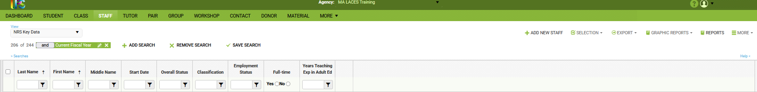
Then examine your LACES staff records to ensure that the status, classification, certificate (you can review each record individually or use the “All Staff Credentials” report under the More menu), and demographic information is correct and up to date.
Then add any missing team members, including those who worked this year and have left.
When adding new staff, you must select a status. Most programs use either “Active” or “Left.” “On Hold” may be used; it is similar to “Left” but some programs use “On Hold” to identify staff whom they expect to return, but it is not necessary because you can have a staff person go from “Active” to “Left” to “Active.”
When creating a record for someone who worked this year but has left, you must first save the record as “Active.” Then change the status to “Left” and save. Then go to the history tab and expand the staff history panel to edit the Active end date (see the steps below).
Select the classification that best matches their role. Staff can have multiple classifications, but only one can be full-time. Do not select any of the state classifications.
Employment status is also required. Select “Regular Staff” for full or part-time staff. “Contractors” will not populate Table 7.
There is no definitive definition of full-time employment. In general, staff who work less than 30 hours per week or 120 hours per month are considered part-time, however, it is up to your organization. If the weekly or monthly schedule is full-time for the program year (i.e., summers off), then we consider this to be full-time. Select full-time for staff who are full-time at your organization but part-time on the adult education grant.
The NRS requires that all teacher records include the number of years of teaching experience in adult education. Zero is an acceptable option for staff who don’t teach. This field should include only years of teaching experience in adult education; it should not include teaching in other settings or administrative or other experience. This field should be updated each year because the number of years does not automatically change from year to year.
States are required to report the following teacher certificates: Adult Education, Special Education, K12, and TESOL. Expand the Credentials panel in the data tab and select the certificate and enter the date earned. Enter the expiration date if you know it. UMDI and ACLS will use this information to determine the extent that minimum qualifications and credentials affect student outcomes and whether ACLS should reconsider salary and qualifications policies.
We are also asking that programs enter staff demographics. While not included in our federal tables, this information will enable UMDI and ACLS to consider the impact that race and ethnicity may have on student persistence and success.
After adding new team members, reviewing, and updating the records of active staff, please correct the records of staff who have not worked this year but are still listed for the current year, even if they have the status left. All the staff, including whose status is “Left,” in the image below will be reported as having been active in FY22.
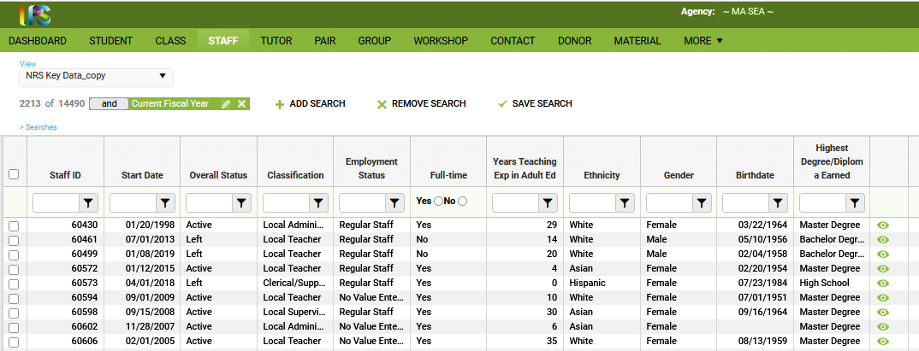
If you have staff who left before July 1, 2021, there are a couple of steps after you update their status.
Consider the following example. Angela Abar taught from September 2014 through June 2020. But her record was not updated and remains Active. The first step is to change the Overall Status to “Left” and save.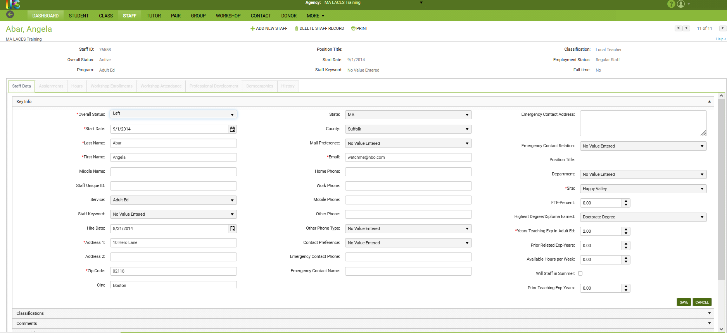
However, Dr. Abar will still be reported on Table 7 for FY22 even though she left two years earlier. In order to fully correct her record, you need to go to History tab and expand the Staff History Panel. Note that the Staff History shows that the Active status ends on the date you updated that field in Staff Data.

You must edit the end date of the Active record: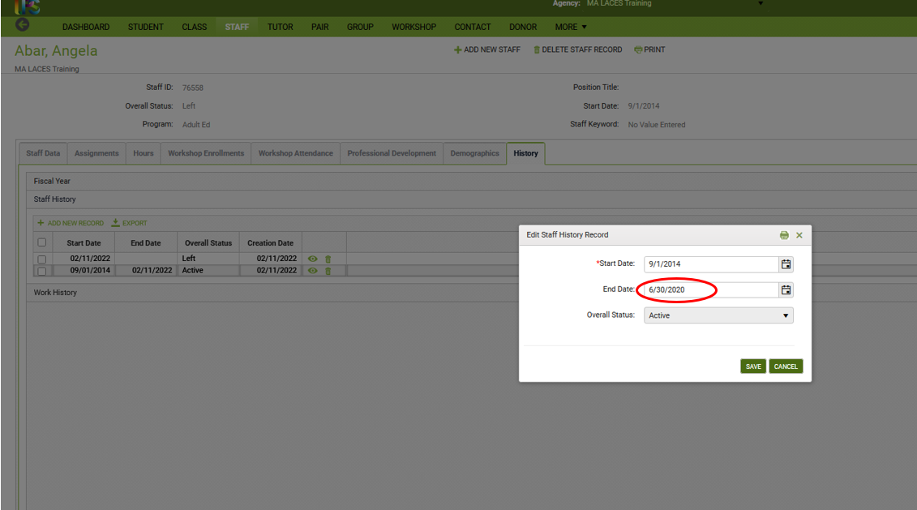
Then update the start date of the Left record: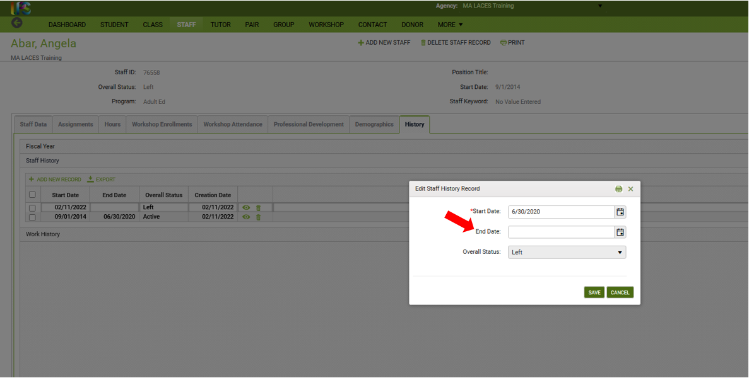
Here is the correctly updated record for Dr. Abar: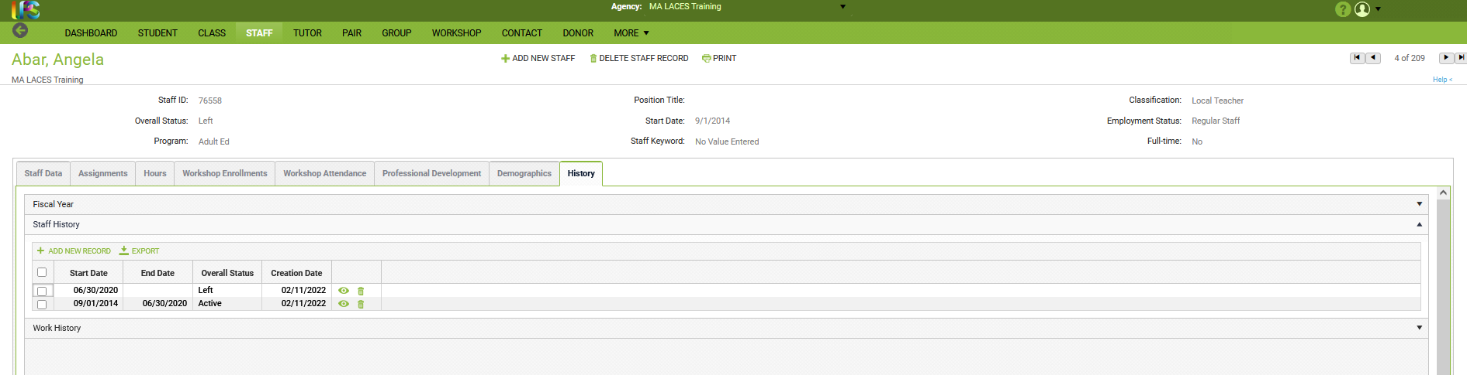
Update the fiscal year summary and she will be removed from the current year Table 7.

