Adult and Community Learning Services (ACLS)

To: Program Directors, Adult Basic Education Teachers, UMass Center for Educational Assessment Staff, SABES Directors, SABES Staff
From: Wyvonne Stevens-Carter, Adult Education State Director
Re: Revised Assessment Policy 4 - Moving Assessments Forward
Date: May 14, 2021

Due to COVID-19, ACLS will extend the relaxed requirements related to Assessment Policy 4 - Moving Assessments Forward into FY 2022.
Currently, this policy is (see page 9 of the ACLS Assessment Policies Manual):
- Any assessment administered in FY 2020 may be moved forward in FY 2021 and used as a pre-test until December 31, 2020. If a student has two previous assessments, the most recent assessment may be moved forward. For example, a student’s test administered in September 2019 (FY 2020) can be moved forward and used as a pre-test into the next fiscal year from July 1, 2020 (FY 2021) until December 31, 2020. If the student has an assessment administered in October 2019 and another assessment administered in January 2020, only the January 2020 assessment can be moved forward.

Effective July 1, 2021, the policy will be:
- Any assessment administered after April 1st in FY 2021 may be moved forward in FY 2022 and used as a pre-test until December 31, 2020. If a student has two previous assessments, the most recent assessment may be moved forward. For example, a student’s test administered in April 2021 (FY 2021) can be moved forward and used as a pre-test into the next fiscal year from July 1, 2021 (FY 2022) until December 31, 2021. If the student has an assessment administered in April 2021 and another assessment administered in June 2021, only the June 2021 assessment can be moved forward. If the student leaves before June 30, 2021 and returns after December 31, 2021, the student must be pre-tested again.

The table below summarizes the changes to assessment policy 4 as a result of the COVID-19 pandemic.
For questions related to NRS assessment policies, please contact Dana Varzan-Parker Curriculum, Instruction, and Assessment Specialist.

Moving Assessments Forward  Pre COVID-19 Policy | Moving Assessments Forward  COVID-19 Policy, May 2020 | Moving Assessments Forward  Updated COVID-19 Policy, May 2021
Any assessment administered after April 30 may be moved forward into the next fiscal year and used as a pre-test until December 31 of that calendar year. Any test administered within a fiscal year (July 1-June 30) may be used as a pre-test for students who leave and return during that year.  For example, a student’s test administered on May 2, 2018 (FY 2018) can be moved forward and used as a pre-test into the next fiscal year starting July 1, 2018 (FY 2019) until December 31, 2018. If the student leaves before June 30 and returns after December 31, the student must be pre-tested again.  However, for a student who was pre-tested any time during the fiscal year (July 1-June 30), leaves the program and returns within the same fiscal year, administering another pre-test upon the student’s return is not necessary as the student’s previous pre-test may be used again. LACES Student Alerts will identify students who require a new test. | Any assessment administered in FY 2020: | Any assessment administered after April 1 in FY 2021:
 | May be moved forward in FY 2021 and used as a pre-test until December 31, 2020. | May be moved forward in FY 2022 and used as a pre-test until December 31, 2020.
 | If a student has two previous assessments, the most recent assessment can be moved forward. | If a student has two previous assessments, the most recent assessment can be moved forward.
 | Example:  A student’s test administered in September 2019 (FY 2020) can be moved forward and used as a pre-test into the next fiscal year from July 1, 2020 (FY 2021) until December 31, 2020. If the student has an assessment administered in October 2019 and another assessment administered in January 2020, only the January 2020 assessment can be moved forward. | Example:  A student’s test administered in April 2021 (FY 2021) can be moved forward and used as a pre-test into the next fiscal year from July 1, 2021 (FY 2022) until December 31, 2021. If the student has an assessment administered in April 2021 and another assessment administered in June 2021, only the June 2021 assessment can be moved forward.
However:

If the student leaves before June 30, 2021 and returns after December 31, 2021, the student must be pre-tested again.

For a student who was pre-tested any time during FY 2021 (July 1, 2021-June 30), leaves the program and returns within the same fiscal year, administering another pre-test upon the student’s return is not necessary as the student’s previous pre-test may be used again. LACES Student Alerts will identify students who require a new test.

Important Reminders

- Tests that were moved forward from FY2020 into FY2021 cannot be further moved forward into FY2022. Tests administered in FY2021 and moved forward in FY2022 can be used as pre-tests in FY2022 only until December 31, 2021.

- ACLS has learned that the LACES dashboard functions differently than we expected. When tests are moved forward from the previous fiscal year, the dashboard student alert identifies students for eligible for posting based on the total instructional hours since the original test date, including hours from the previous year. For example, if a program moves forward a student’s assessment administered January 15, 2021 and records 63 hours of attendance for the student between the test date and end June, the LACES dashboard will show that the student is eligible for a post-test after only two hours of instruction in FY21. This is not the intent of the Massachusetts post-test policy.

The state assessment policy requires that students be post-tested after they have accumulated 65 instructional hours (for CALC) or 40 hours (for AECI) since the date of the pre-test administered in the current fiscal year.

Students whose tests were moved forward from the previous fiscal year must have at least 65 hours (40 for AECI) of instruction in the current year before being eligible for post-tests.

The easiest way to identify students who are eligible for a post-test as defined by ACLS policy is through the dashboard student alerts. Click on the number of students eligible for post-testing.

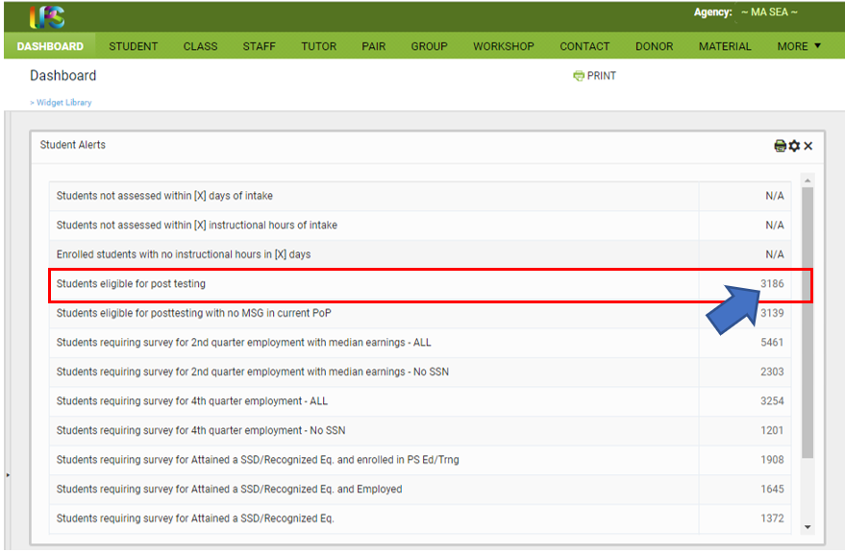

Then filter by current fiscal year instructional hours (40 for AECI and 65 for CALCs) to determine which students are eligible for a post test.
