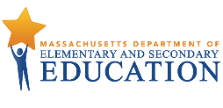
Use EWIS to improve students’ college readiness.
The challenge:  At least some college education is increasingly important for success in the workforce  &  there are deep gaps in college-going patterns when comparing groups of students statewide.  How can all students be set up for success?  DESE has developed the Postsecondary EWIS to help districts understand who is at risk of missing college readiness milestones so that they can intervene early and prepare all students for success after high school. | EWIS: A data-informed approach  With EWIS, educators can see exactly who is at risk of missing two important college readiness milestones.  College Enrollment: immediate enrollment in higher education  College Persistence: continuing to a second year of higher education  Educators use EWIS with local data and context to understand students’ strengths & needs and modify student supports. This data-driven approach may lead to interventions at the individual, small group, and school- or district-wide levels.
How does it work?  - Early in the year, review EWIS reports to understand who is at risk of not enrolling and persisting in college.  - Then, explore causes to determine why they are at risk. For example: Are students not taking higher-level courses because they do not recognize the options; or due to scheduling limitations; or for other reasons?  - After considering why students are at risk, develop and assign supports.  - Then, monitor risk through the year to ensure supports are having desired effects. By tracking ABCs (Attendance, Behavior and Course selection & performance) and monitoring FAFSA completion, educators can update their view of which students are still at risk and adjust supports.  See the reverse for more about a data inquiry cycle. | Here are some examples:  With the help of EWIS, school counselors in one district saw that at-risk students had not taken a second year of a foreign language, recommended in MassCore. Counselors scheduled the students in the appropriate courses, and could review their course selection processes to prevent this in the future.  Counselors in another district tracked FAFSA completion as part of their risk monitoring system. Noticing that FAFSA completion had stagnated in mid-winter, they offered a second springtime FAFSA Info Night for graduating seniors and their families.  Others combine EWIS with student survey insights, first-generation college-going and other local context, and look for ways to strengthen AP, dual enrollment and early college course offerings and other school-wide supports using MyCAP as a planning structure and process.
College Readiness can be defined in many ways:
Research by Melissa Roderick, Jenny Nagaoka, and Vanessa Coca identify four essential sets of skills: content knowledge and basic skills; core academic skills; non-cognitive, or behavioral, skills; and “college knowledge,” the ability to effectively search for and apply to college.

Earlier work by David Conley also stressed the importance of cognitive and academic readiness and preparation.

Use EWIS in an ongoing cycle of inquiry.
In Summer or the Beginning of the School Year
Step 1: Get Organized
Collect your teammates, line up access to Edwin and plan time to review EWIS and College Reports together. Districts control access to Edwin. Contact your district’s directory administrator for access. If there is a team already reviewing data and making decisions about how to support students, they may be able to incorporate early warning data into their scope.
Step 2: Review EWIS  Students’ EWIS risk levels are available every year in the late summer to coincide with the start of the school year. Use the EWIS reports to examine students’ strengths and weaknesses. If you work directly with students, the Student Roster is a good place to start. If you work with adults who work with students, you may find the Indicator Analysis most valuable. Either way, draw concrete conclusions about students’ indicators and begin to form hypotheses about causes of students’ risk. Also examine college going reports in Edwin to look at disaggregated and student level reports for your school or district for outcomes and trends. |  |  | 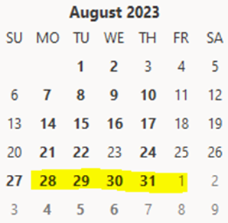
Step 3: Explore Underlying Causes  Continue to identify causes of risk, pulling in local data and context for a comprehensive picture. Note whether students across a district, school or grade have common needs for universal supports.  Step 4: Take Action  Compare students’ needs to the supports available, and assign interventions that will best meet their needs. Examine any gaps in support, and consider school-wide or universal efforts.  Step 5: Monitor  Monitor students’ ABCs to assess student progress, see who else may be at risk, and improve interventions. Monitor that seniors are applying to college and completing FAFSA, and other students are participating in college and career planning. Then, refer back to Steps 3 & 4 as the cycle is repeated. |  | 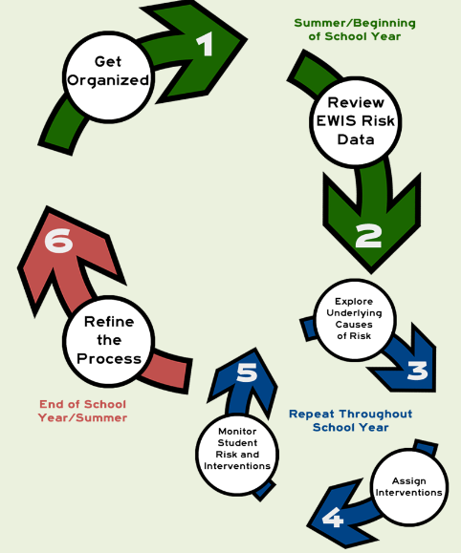
The End of the School Year or In Summer –
Step 6: Refine the Process
How did it go? What was easy, what was hard? Take time at the end of year to reflect on outcomes, your approach, and make plans to incorporate changes next year.
Would you like to get better at ‘using data’?

Many strategies work; choose one that feels right for you and your team. Periodically, reflect on what is working and what is not working, and adapt your strategies as needed. Start small, stay flexible and tap others for support.
For questions: Email EWIS@doe.mass.edu or see resources at https://www.doe.mass.edu/ccte/ccr/ewis/default.html .

According to Georgetown University’s Center for Education and the Workforce, nearly all of the jobs created since 2010 have gone to workers with at least some college education, while those with a high school diploma or less are being left behind.
Explore gaps in Edwin, at Success After High School DART or www.mass.gov/SuccessABCs.

