Massachusetts
State Equity Plan Update
2018

Center for Instructional Support

Massachusetts Department of Elementary and Secondary Education
75 Pleasant Street, Malden, MA 02148-4906
Phone 781-338-3000 TTY: N.E.T. Relay 800-439-2370
For more information and resources on equity:
http://www.doe.mass.edu/educators/equitableaccess/

Executive Summary
Our moral imperative is to ensure that all students have equitable access to high quality educators. Under the federal Every Student Succeeds Act (ESSA), states and districts must identify and address any disparities that result in historically disadvantaged student groups being taught at higher rates by teachers who are inexperienced, out-of-field, or lower rated. These disparities in educator assignment constitute equity gaps.

The Department of Elementary and Secondary Education (DESE) commissioned research in 2017 to investigate the effects of equity gaps on student outcomes in Massachusetts. The resulting policy brief showed that equity gaps can lead to gaps in student performance. Some highlights include findings that, on average:
- students of a third-year teacher gain one additional month of learning in a school year, compared to students of a first-year teacher; and
- students of a teacher with an evaluation rating of Exemplary gain about 18 to 24 additional weeks of learning in a school year, compared to students of a teacher rated Unsatisfactory.

Given this link between student performance and access to experienced, in-field, and effective educators, DESE has committed to a portfolio of work designed to support equitable access, including regular data analyses and reporting to make gaps transparent throughout the state. This 2018 Equity Update summarizes key findings on educator assignment. The data continue to suggest need for action in order to close persistent achievement gaps in the Commonwealth. Key findings include:

Access to highly rated educators:
- Students of color are 79 percent more likely than white students to be assigned to a class with a teacher rated Needs Improvement or Unsatisfactory.
  - In particular, Hispanic or Latino students are more than two times as likely as white students to be assigned to a teacher with these lower evaluation ratings.
- Similarly, economically disadvantaged students are 75 percent more likely, and English learners (ELs) are 73 percent more likely, to be assigned to a teacher rated Needs Improvement or Unsatisfactory, compared to their peers.
- High poverty schools are three times more likely to have a principal rated Needs Improvement or Unsatisfactory, compared to low poverty schools.

Access to experienced educators:
- Economically disadvantaged students, students of color, and ELs are about 30 to 40 percent more likely than their peers to be assigned to a class with a teacher with fewer than three years of experience.
- Additional data compares the quartiles of schools with the highest and lowest proportions of students of color or economically disadvantaged students. Schools with larger proportions of students of color or economically disadvantaged students employ first-year teachers at more than twice the rate of schools with small proportions of these student groups.

Teacher attrition rates in Massachusetts public schools are higher for teachers of color and for those serving special populations. Teacher turnover is certainly a factor in having fewer experienced educators in Massachusetts classrooms. The good news is that teachers and principals rated Exemplary or Proficient are more likely to stay in the profession, and in the same school and district. However, among English as a Second Language (ESL) teachers who returned to Massachusetts public schools, almost a quarter switched to a program area other than ESL the following year. Similarly, sixteen percent of retained special educators also switched program area.

These data tell a compelling story and can guide the actions we take to address inequities. In 2018, DESE will work with stakeholders to set timelines and progress goals for the closure of statewide gaps. Potential metrics can track both the magnitude and prevalence of disparities in access to educators across Massachusetts.

Also in 2018, districts will begin to report on how they identify any school- or district-level equity gaps, and explain how the district will address local gaps, in accordance with federal policy (ESSA). DESE will provide districts with resources to identify equity gaps. If students in a historically disadvantaged group are at least 1.5 times as likely as their peers to be assigned to a teacher who is inexperienced, out-of-field, or rated Needs Improvement or Unsatisfactory on the educator evaluation system, DESE will ask the district to report how they are addressing that gap. In 2017:
- 165 school districts in Massachusetts had one or more district-wide gaps meeting the 1.5 threshold.
- 786 schools had one or more school-wide gaps meeting the 1.5 threshold. These 786 schools represent 263 districts.
- Put in other words, 40.6 percent of districts and 42.4 percent of schools had one or more equity gaps (this includes charter schools and regional vocational technical high schools).

Closing student achievement gaps is the collective responsibility of DESE, districts, schools, and families. Addressing inequities in access to excellent educators is a key lever in this work. This 2018 Equity Update provides further information about the data, next steps for DESE and districts, and strategies for closing equity gaps.

Table of Contents
Executive Summary …………………………………………………………………………………………………….…………………………. 1
Introduction …………………………………………………………………………………………………………………………………………… 4
Equitable Access Data …………………………………………………………………………….................................................. 5
Equity Gap 1: Educator Evaluation Summative Ratings ……………………………………………………………………… 6
Equity Gap 2: Educator Experience ……………………………………………………………………………………………………7
Equity Gap 3: Educator Qualifications…………………………………………………………………………………………………. 7
Educator retention data ………………………………………………………………………………………………………………….…….. 7
Educator retention by evaluation ratings 8
Educator retention in hard-to-staff roles 9
Retention of educators of color 10
Strategies to Eliminate Equity Gaps ……………………………………………………………………………………………….…….. 12
Focus on data 12
Technical assistance for schools and districts 13
Equity-Impacting DESE Policies 14
Appendix A: Definitions ………………………………………………………………………………………………………..……………… 17
Appendix B: 2016–17 Statewide educator evaluation data .………………………………………………………………... 18
Appendix C: Stakeholder engagement and communications …………………………………................................ 19
Appendix D: Longitudinal data on equitable access to educators …………………………….............................. 20
Appendix D.1: Teachers with low ratings 21
Appendix D.2: Principals with low ratings 23
Appendix D.3: Inexperienced teachers 24
Appendix D.4: Inexperienced principals 25
Appendix D.5: Teacher absences and long-term substitutes 26
Appendix E: Data on educator retention……………………………………………………………………………………………... 27
Endnotes ……………………………………………………………………………………………………………………………………………… 28

Introduction
As the Massachusetts Department of Elementary and Secondary Education (DESE) celebrates the state’s continued achievement in public education, we also renew our commitment to supporting all students regardless of race, ethnicity, language status, disability, and other factors. Disparities in outcomes—such as test scores and graduation rates—continue to impact students who are economically disadvantaged, students of color, English learners, and students with disabilities. The state’s Every Student Succeeds Act (ESSA) Plan reflects this focus on ensuring equity and closing student outcome gaps.
Acting on this commitment means we must continue to identify and address gaps in educational opportunities—especially for historically disadvantaged student groups, and especially when these opportunities are about access to our most precious resource: strong teachers. Historically disadvantaged student groups experience equity gaps—disparities in exposure to quality educators. Evidence points to inequitable access to excellent educators as one root cause of student achievement gaps: in Massachusetts from fourth to eighth grades, the difference between having an average and an excellent teacher is about three weeks of student learning in math and about six weeks in English language arts (ELA).

This document provides an update to DESE’s 2015 Equity Plan and 2017 Equity Update, which described gaps in access to experienced, in-field, and highly rated educators for historically disadvantaged student groups. The 2018 Update first builds on prior years’ data analysis, and then examines new data. It lays out benchmark data for tracking changes in statewide equitable access data.
ESE’s role regarding equitable access is to:
- Clearly define and communicate the measures of excellent educators and the meaning of equitable access;
- Examine and make available the data on inequities in access to educators;
- Identify and share with districts the research and best practices in eliminating equity gaps;
- Implement state-level policies and strategies to support districts;
- Monitor, assess and report on progress in closing equity gaps;
- Support districts in analysis of access data, development of equity strategies, and progress monitoring of strategies; and
- Use our position as a state agency to communicate the importance of providing students—especially those with the greatest need—with access to the educators who will serve them best. This communication aims to catalyze action and reinforce the importance of equitable access.

Improving retention of high quality educators can help address disparities in assignment to effective educators. The 2018 Equity Update expands on prior years’ analysis of retention data. Massachusetts seeks to diversify its educator workforce, and maintain a sufficient pool of effective teachers in hard-to-staff roles such as special education and English as a Second Language (ESL). These efforts also require a focus on retention. Thus, the educator retention section offers analysis of relevant data.

Several equitable access strategies that the 2015 Equity Plan describes continue into 2018, such as tools to improve inclusive practices, and to identify disparities in teacher assignment. New equity-related initiatives are also in place. This update does not provide a comprehensive list of all DESE initiatives supporting educational equity, but provides updated information about several key state-level initiatives and their connections to root causes of equitable access gaps.

Equitable Access Data
The following section addresses equity gaps, or inequities in rates of access to educators, for four historically disadvantaged student groups: economically disadvantaged students, students of color, English learners (ELs), and students with disabilities. These student groups continue to experience gaps in key achievement metrics, such as MCAS performance and four-year graduation rates, when compared to their peers.

In understanding the data around equitable access in Massachusetts, there are a few things to know:
- Describing access relative to student experiences, not individual teachers: Rather than report on the number of educators in each category, Massachusetts has chosen instead to emphasize the number of unique instances a student has had with an educator who is inexperienced, is out-of-field, or has received lower performance ratings. A “student learning experience” refers to each time a student is assigned to a teacher of record in a Massachusetts public school. The figures below reflect the percentage of the total number of experiences that a group of students had with certain types of teachers, in the 2016–17 school year
- Establishing risk ratios: Risk ratios compare the rate of experiences between groups. In Table 1 below, the risk ratio 1.29 shows that economically disadvantaged students were assigned to inexperienced teachers 29 percent more often, or 1.29 times as often, compared to non-economically disadvantaged students. With the support of researchers and input from stakeholders, DESE flags any risk ratio greater than 1.5 as a possible equity gap, as this means that a particular subgroup of students is at least 50 percent more likely to be assigned to an inexperienced, out-of-field, or lower rated educator, compared to their peers.

Table 1: Statewide student assignment data of subgroups: 2016–17
 | % of experiences with teachers with <3 years of experience | Risk ratio | % of experiences with out-of-field teachers | Risk ratio | % of experiences with lower-rated teachers | Risk ratio
Non-eco. disadvantaged | 14.2% | 1.29 | * | * | 3.3% | 1.75
Eco. disadvantaged | 18.4% |  | * |  | 5.8%
White students | 13.3% | 1.43 | * | * | 3.1% | 1.79
Students of color | 19.0% |  | * |  | 5.5%
Non-English learners | 14.9% | 1.39 | * | * | 3.8% | 1.73
English learners | 20.8% |  | * |  | 6.5%
Students without disabilities | 15.4% | 1.01 | * | * | 3.9% | 1.11
Students with disabilities | 15.5% |  | * |  | 4.3%
* Due to the shift to a new method of calculating rates of assignment to in-field and out-of-field teachers, this data is not yet available statewide. See Educator Qualifications for details.

As Table 1 shows, economically disadvantaged students, students of color, and ELs were more likely than their peers to be assigned to inexperienced teachers and those rated Needs Improvement or Unsatisfactory. Notably, the disparities are significantly greater for these groups in the rates of assignment to teachers whose performance was rated lower than Exemplary or Proficient.

Closing equity gaps requires targeted efforts at the state and local levels. This document’s section on Strategies to Eliminate Equity Gaps provides an overview of DESE’s work to address equitable access gaps.

2018 will be the first year for all districts to analyze local data on equity gaps and, where applicable, develop their own equitable access strategies based on local needs. This identification and reporting will align with requirements under the 2015 Every Student Succeeds Act (ESSA).

DESE resources will support districts in equity work. Districts will use an Edwin data tool to identify substantial discrepancies in student subgroups’ rates of assignment to teachers who are experienced, in-field, and rated Exemplary or Proficient. Technical assistance opportunities, as well as equity-specific guidance resources, will facilitate development and implementation of strategies to address local inequities in access to educators.

Equity Gap 1: Educator Evaluation Summative Ratings
The Massachusetts Educator Evaluation Framework has four ratings: Exemplary, Proficient, Needs Improvement, and Unsatisfactory. In 2017, most teachers (84.2 percent) received summative ratings of Proficient. Exemplary ratings rose from 10.7 percent in 2016 to 11.8 percent, Needs Improvement rose slightly to 3.6 percent, and Unsatisfactory decreased slightly to 0.3 percent.
On average, Massachusetts students assigned to teachers rated Exemplary gain about 18 to 24 additional weeks of learning in a year, compared to students assigned to teachers rated Unsatisfactory. Even the difference between students assigned to Exemplary teachers and those assigned to Proficient teachers is still substantial, representing about nine to ten additional weeks of learning.

Massachusetts students face inequitable exposure to the benefits of learning from a higher rated teacher, because:
- Students who are economically disadvantaged, students of color, or English learners are more than 1.7 times as likely to be assigned to a teacher rated Needs Improvement/Unsatisfactory, compared to their peers (page 20, Appendix D); these students groups are also 1.6 times as likely to attend a school with a principal rated Needs Improvement/Unsatisfactory (page 23, Appendix D.2).
- Hispanic or Latino students are 2.2 times as likely to be assigned to a teacher rated Needs Improvement/Unsatisfactory, compared to white students.
- Students with disabilities are 11 percent more likely to be assigned to teachers rated Needs Improvement/Unsatisfactory (page 20, Appendix D).
- Schools with high proportions of students of color have more than three times as many teachers rated Needs Improvement/Unsatisfactory, compared to schools with low proportions of students of color (page 22, Appendix D.1).

While students in historically disadvantaged subgroups were substantially more likely to be assigned to courses with lower rated teachers in 2016–17, the sizes of these gaps decreased since 2015–16 (page 20, Appendix D). However, because these data are new, DESE cannot yet measure trends, but will look to do so in coming years. In 2018, we will begin the work of assessing trend data and, with our stakeholders, setting goals and targets towards closing these gaps.

Equity Gap 2: Educator Experience
On average, Massachusetts students of a third-year teacher achieve one additional month of math and ELA learning in a year, compared to students of a first-year teacher.
In 2016–17, 10 percent of Massachusetts teachers were in their first year of practice, and 25 percent of teachers had fewer than three years of experience. Though some teachers may be very effective in their first years of teaching, national and Massachusetts-specific research tends to indicate that on average, inexperienced teachers are less effective than their colleagues.

This trend has implications for disparities in students’ educational experiences:
- Economically disadvantaged students, students of color, and English learners (ELs) are disproportionately assigned to an inexperienced teacher (those with fewer than three years’ experience) compared to their peers—29 percent, 43 percent, and 39 percent more often, respectively (page 20, Appendix D).
- Hispanic or Latino students are 58 percent more likely than white students to be assigned to an inexperienced teacher.
- African American/black students are 47 percent more likely than white students to be assigned to an inexperienced teacher.
- First-year teachers—and principals—are more likely to work in lower performing schools and in schools with large proportions of economically disadvantaged students and students of color (page 24–25, Appendices D.3 and D.4).

Equity Gap 3: Educator Qualifications
The 2015 Massachusetts Equity Plan and 2017 Equity Update both provided statewide data on rates of access to out-of-field educators using the nationally accepted definition of a “Highly Qualified” educator. However, the federal Every Student Succeeds Act (ESSA) eliminated this term and definition, necessitating an alternative calculation for this category of equitable access reporting.

As a result, DESE has been working with content-area specialists and stakeholders to clearly map all existing teacher licenses to specific courses. This mapping will define future data on equitable access to courses taught by in-field and out-of-field teachers and is expected to be available for districts by July 2018.

Educator retention data
When effective teachers leave the school or district, newer or less effective teachers may take their place. DESE conducted additional analyses into the issue of retention, to better understand the following questions:
- Are educators rated Needs Improvement or Unsatisfactory leaving the profession at a higher rate than those rated Exemplary or Proficient—or are they just moving among schools?
- Are equity gaps exacerbated by low rates of retention in specific subject or program areas?
- Are schools retaining educators of color at lower rates than their white colleagues?

High teacher turnover has been found to negatively affect student outcomes and, importantly, is more frequent in low performing schools. Additionally, losing effective educators is costly for schools in terms of time, labor, and finances. The school also loses the expertise the teacher has gained in district culture and procedures, and in familiarity with the students, staff, and families.

Detailed findings related to these questions can be found below in the following sections. Key findings include:
- Teachers and principals rated Exemplary or Proficient are more likely to stay in the profession, and in the same school and district.
- Among English as a Second Language (ESL) teachers who return to Massachusetts public schools from one school year to the next, about 24 percent switch to a program area other than ESL. Sixteen percent of retained special education teachers also switch their program area.
- White teachers are more likely to remain in the profession, and in the same school and district, compared to teachers of color.

Educator retention by evaluation ratings
Consideration of educator retention rates must begin by acknowledging that efforts should focus on retaining effective educators. Schools and districts expect some attrition of educators from the profession. When developing strategies to improve retention, school and district leaders should prioritize educators who are effective and/or showing progress. Educator evaluation provides one measure of effectiveness, and the following data differentiates retention rates by summative evaluation ratings.

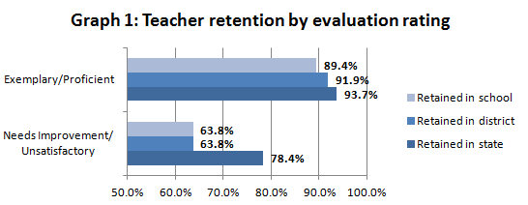

In 2015–16, the great majority (95.7 percent) of teachers received summative evaluation ratings of Exemplary or Proficient. The following school year, teachers who received lower ratings were:
- more than three times as likely to stop teaching in Massachusetts public schools; and
- more likely to change to a different school or district.

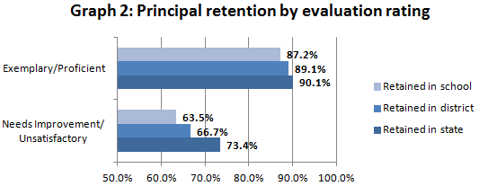

Similar to teachers, 95.5 percent of principals were rated Exemplary or Proficient in 2015–16. In the following school year, principals with Needs Improvement or Unsatisfactory ratings were about three times as likely to stop working as principals in Massachusetts public schools.

Research indicates that when effective principals leave high-need schools to work as principals elsewhere, they are more likely to move to schools that are higher performing, and/or have fewer economically disadvantaged students and students of color.

Educator retention in hard-to-staff roles
As has been discussed, English learners and students with disabilities face performance gaps in Massachusetts when compared to their peers. Massachusetts educator workforce shortages on the horizon threaten to compound those gaps; according to projections, Massachusetts schools will soon face a shortage of special education and English as a Second Language (ESL) teachers. The demand for these teachers will approximately double over ten years. We are already seeing evidence of this demand: among teacher preparation program completers in 2015, 75 percent of those in ESL, 74 percent of those in special education, and 73 percent of those in STEM fields were teaching in Massachusetts public schools the next year, compared to only 61 percent of program completers in all other teacher licensure areas.

Retention in the program area
Among teachers retained in Massachusetts public schools, those who teach ESL and special education are more likely to change to another program area, compared to general education teachers.
The following data compares retention rates across three program areas: special education, ESL teachers, and general education teachers. Retention of ESL and special education teachers is a focal point due to the projected workforce shortages in these areas.

Compared to general education teachers, ESL and special education teachers are substantially more likely to change program areas—that is, transfer from teaching ESL to teaching general education, as an example.
- Among the teachers who taught ESL in 2015–16 and continued to teach in Massachusetts public schools in 2016–17, 24 percent were no longer working as ESL teachers.
- Similarly, 16 percent of retained special education teachers were working in a different program area in 2016–17.
- Meanwhile, only about two percent of retained general education teachers switched program areas in 2016–17.

The following graph indicates a different set of data: the rates at which ESL, special education, and general education teachers returned to teach in the same program area, from 2015–16 to 2016–17. Graph 3 represents data from all 2015–16 teachers, including those who did not continue teaching.
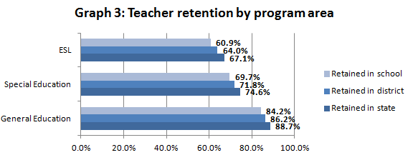

Although the rates of retention within the same program area vary (as shown in the above graph), ESL teachers, special education teachers, and general education teachers remain in the teaching profession overall at about the same rates (page 27, Appendix E), even if they switch program areas.

Retention in the subject area
At the state level, across major subject areas teachers continue as Massachusetts public school teachers at about the same rates. While other data indicates that STEM-field teachers are in greater demand, their rate of retention as STEM teachers—and in the same district and school—is comparable to that of most other subjects. In most subjects, about 85 percent of retained teachers continued teaching in the same subject.

Retention of educators of color
In Massachusetts public schools, the demographics of our workforce do not match those of our student populations and while our pipeline is increasingly diverse, attrition rates of educators of color are higher than that of their white colleagues.

This is worthy of attention as an increasing body of quantitative and qualitative research shows that students benefit from assignment to diverse teachers. The positive effects when students of color spend time in classrooms with teachers of color have been found to include higher reading and math test scores, higher graduation rates, lower dropout rates, fewer suspensions, and higher enrollment in advanced courses. Studies primarily focus on the impacts of white, black, and Latino teachers—and have shown that a more diverse teacher workforce has positive impacts for students of all races.

Table 2: Racial/ethnic diversity of teachers and students, 2016–17
 | White | Hispanic | African American/black | Asian | Other
Proportion of teachers | 92.3% | 2.8% | 2.8% | 1.4% | 0.6%
Proportion of students | 61.3% | 19.4% | 8.0% | 6.7% | 3.7%

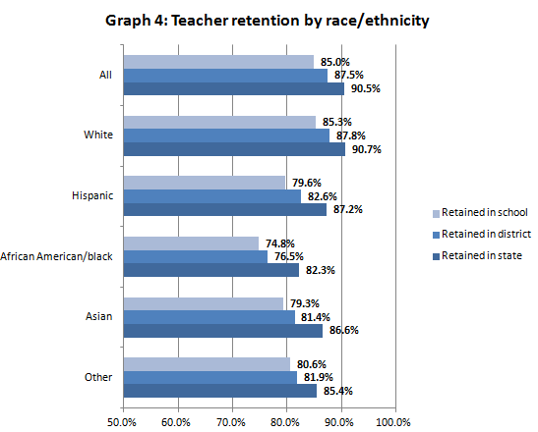

As Graph 4 shows, retention rates of teachers of color are lower than that of white teachers. This may be in part because teacher attrition is higher among newer teachers, and Massachusetts teachers in their first three years of teaching are more diverse, compared to more experienced teachers.

Additional analysis shows that:
- Across teacher racial/ethnic groups, retention rates are higher at schools with small proportions of students of color or students in poverty, compared to schools with the highest proportions of these student groups.
- Hispanic principals (n=34) in 2015–16 were more likely to stay on as principals, including in the same districts and schools, than were principals overall (n=1,754) (page 27, Appendix E).
- This contrasts with African American/black principals (n=46), about 22 percent of whom did not return to their schools in 2016–17 (page 27, Appendix E).
- When comparing all current Massachusetts teachers to all the state’s bachelor’s degree-holders, the proportions who are people of color are similar. However, data suggests that the state population of bachelor’s degree-holders is diversifying more quickly than the pool of new teachers.
About half of districts reported one or more strategies for the recruitment and retention of educators of color, and 76 percent reported strategies for educators in hard-to-staff roles, in the 2017 Massachusetts Induction and Mentoring Report. Districts shared approaches for recruiting and retaining educators of color and educators in hard-to-staff roles.

Strategies to Eliminate Equity Gaps
This equity update shifts now from describing the data to describing DESE’s approach to ensuring equitable access. Several of DESE’s ongoing programs support the closure of equitable access gaps, and address the gaps’ root causes. DESE’s work approaches equitable access to educators from various perspectives, including quality instruction for diverse learners; uniform, high quality standards to support instruction; and thoughtful development of new educators. The following descriptions provide an overview—though not a comprehensive list—of such DESE initiatives with particular emphasis on those with important updates over the past year.

Focus on data
Both internal DESE data tools and external analysis contribute to an understanding of statewide trends in access to educators and the impact on students. As discussed above, the Department commissioned a policy brief that showed that inequitable access to effective teachers for low-income students increases achievement gaps in Massachusetts by up to three weeks of learning per year in mathematics and six weeks per year in English language arts (ELA).

Student Learning Experience Report
The data in this 2018 Equity Update provides districts with information about educator assignment patterns and illuminates discrepancies in access to educators at the state level. To effectively address gaps, all districts and schools must understand local inequities in access to educators. The Student Learning Experience (SLE) Report shows users where and to what extent educator access gaps exist among student groups—including economically disadvantaged students, students of color, English learners, and students with disabilities.

The SLE report became available in September to district users on the Edwin Analytics platform. Previously, input from pilot districts contributed to the development of the report, helping it become more customizable, user-friendly, and effective in pinpointing equity gaps.

Resource Allocation and District Action Report
Beyond the SLE Report, districts can take additional approaches to examining access to teachers and other educational resources. Released in fall 2017 on the Department’s public website, the Resource Allocation and District Action Report (RADAR) Benchmarking allows districts access to data about the allocation of district staff, time, and money. Users can select ten comparison districts and see public data in a new, highly visual format. Comparisons across districts can raise questions and encourage discussions about resources. RADAR includes a report on district five-year trends as additional context for resource discussions.
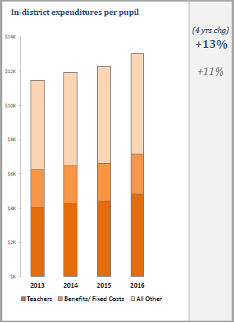
RADAR users can identify entry points for discussions of resource use, including equity questions. A district where students with disabilities have a persistent achievement gap may use the SLE Report to investigate whether those students have lower rates of access to highly effective educators, and use RADAR, among other tools, to see similarities and differences in staffing of special education teachers and paraprofessionals. RADAR data can inform plans for addressing gaps identified in the SLE Report.

The Department will update RADAR Benchmarking data twice a year, as new data about enrollment, staffing, classes, and spending becomes available.

Induction and Mentoring Report
District efforts to develop more effective educators, and thus expand access to quality educators, begin with induction and mentoring. From mentor selection to program evaluation, districts take diverse approaches to supporting new educators; the 2017 Statewide Induction and Mentoring Report captures quantitative and qualitative data about these approaches. The report disaggregates data by districts’ accountability levels; self-reported average amount of money spent per mentee; and proportions of new teachers. According to this data, supports for new teachers tend to be more frequent and structured than are supports for new administrators or Specialized Instructional Support Personnel. In some areas, supports are more common and structured in districts with larger proportions of new teachers, compared to those with small proportions of new teachers. Furthermore, districts at accountability Levels 3–5 are more likely to provide novice teachers with induction programs lasting only one year. These districts are less likely to provide three-year programs, compared to districts at Levels 1 and 2, where induction programs are more likely to be multi-year.
Example of a RADAR data display on district expenditures

Technical assistance for schools and districts

Equity Labs
To facilitate equity discussions with stakeholders, the Department convened representatives from the 25 largest urban districts on October 30 and November 6, 2017, for inaugural Massachusetts Equity Labs. The goals of these meetings were to: build familiarity with using and interpreting data from the Student Learning Experience (SLE) report (page 12); build a community of practice around questions of educational equity; and provide tools to assist districts in federal equity reporting requirements. Feedback from the labs was positive:
- 93 percent of participants agreed/strongly agreed with the statement: “I am confident in my ability to use and implement the tools presented at today’s meeting.”
- 100 percent of participants agreed/strongly agreed with the statement: “I am ready and willing to engage in a community of practice on this topic.”

DESE hosted a statewide webinar in February to disseminate information about the equity reporting requirements broadly, and followed up with two additional Equity Labs in March.

Educational equity courses
The Department is funding a series of courses on equity. Educational Equity is a course covering achievement, fairness, and opportunity in education with regards to currently and historically under supported groups: students of color, low-income students, and students with disabilities, among others. Topics covered include educator effectiveness and preparedness, inclusive practice, oppression, and cultural competence. Participants will complete a project in their district addressing inequity within their schools.

Inclusive practice initiatives
In Massachusetts, economically disadvantaged students with disabilities attend classes in substantially separate settings at twice the rate of students with disabilities who are not economically disadvantaged. The teachers in these substantially separate classrooms are typically teaching out-of-field for at least part of the day, according to a review of special education in Massachusetts.

The Educator Effectiveness Guidebook for Inclusive Practice aligns best practices in inclusive instruction, social and emotional learning, and positive behavior support with core aspects of the Educator Evaluation Framework. The Guidebook’s tools leverage educator evaluation to support more effective, inclusive teaching, while promoting more accurate evaluation of inclusive practice. This broadens exposure to quality teaching and enhances the capacity of educator evaluation data to identify effective teaching. A statewide survey showed that 68 percent of superintendents (n = 205 total responses) were using the Guidebook in their districts, with over 95 percent of those superintendents indicating that it was a useful resource.

The Department recently finished its first year of producing Foundations for Inclusive Practices courses for educators and administrators. Over 2,000 teachers have completed the courses, exceeding the program’s two-year target of 1,200. The Department is on track to meet its two-year target of 400 for the administrator courses, with over 290 administrators finishing the courses this past year. Among the completers, 97 percent of educators and 99 percent of administrators reported the course was useful or very useful. To date, over 5,000 educators and 850 administrators have registered for the courses.

The 2015 inclusion of students with disabilities and English learners in our state equity plan led the National Council on Teacher Quality to recognize Massachusetts for reporting equity gaps for students with disabilities in addition to other subgroups.

Sheltered English Immersion
Providing access to effective educators for all students includes ensuring that teachers of English learners have the capacity to provide quality language acquisition instruction. In summer 2018, DESE will publish Sheltered English Immersion (SEI) programmatic guidance for developing, structuring, implementing, and optimizing SEI programs. The guidance will provide information on SEI program options for various district contexts. Additionally, a program development continuum will allow districts to identify where they are in the development and implementation of SEI, and which guidance, resources, or next steps would be most useful to them. The resource will include guidance for optimally scheduling English learners. Moving forward, DESE will take advantage of opportunities produced by the 2017 Massachusetts Language Opportunities for Our Kids (LOOK) Act, which expands options for educating English learners by allowing more flexibility in choosing to implement bilingual education.

DESE policies that advance equity
Educator Evaluation Framework
Accurate, well-calibrated educator evaluation data, reported at the state level, is essential to addressing equitable access. DESE supports districts in calibrating expectations and feedback, while recognizing the importance of local control over evaluation systems. Two resources encourage consistent application of the Educator Evaluation Framework:

- “What to Look For” observation guides describe the practices and student actions that observers should expect to see in classrooms at particular grade levels and subject areas. In 2017, DESE significantly expanded and updated these guides to reflect updates to the Massachusetts Curriculum Frameworks for English language arts (ELA)/literacy, mathematics, and science, technology, and engineering, and to include a broader range of grade levels.
- DESE built an interactive Online Calibration Training Tool that can help observers reach common expectations of practice. Through the tool, evaluators practice providing high quality ratings and feedback in response to a selected lesson. Real-time data displays allow participants to calibrate their assessments of practice and written feedback with one another, as well as with educators throughout the state.

Learning standards
2018 marks the 25th anniversary of the Massachusetts Education Reform Act of 1993, and standards-based reforms continue to guide Massachusetts as a national education leader. Among the core provisions, the Act required that the state establish high standards that each student would be expected to meet. Decades of Massachusetts students’ high performance is often attributed to the Commonwealth’s commitment to maintaining rigorous standards. Standards-based learning continues to be a core element of educational equity in Massachusetts.

The Massachusetts learning standards provide teachers, students, and families with clear and shared expectations for what all students should know and be able to do at the end of each year, and the standards thus promote equitable education. They formalize the expectation that all students in the Commonwealth have access to the same academic content, regardless of their zip code, background, or abilities. Learning standards also articulate learning progressions that bring coherence to students’ experiences as they move from grade to grade, even if the students change schools or districts. Schools must implement standards so they are equally accessible to all students. However, this does not mean that all students will or should receive an identical experience. 2017–18 instructional support networks promote implementation of the learning standards, including a focus on historically disadvantaged student groups such as English learners. New and revised curriculum frameworks also support differentiation for English learners and students with disabilities.

Educator preparation
By continuing to enhance educator preparation, Massachusetts can ensure that novice teachers are ready from day one to effectively serve students. This is especially pertinent to closing achievement gaps, as novice teachers are more likely to work in higher need schools and more likely to teach students from historically underserved backgrounds. Through the educator preparation program formal review process, the Department reviews how preparation programs are working to recruit, admit, retain, and graduate a diverse candidate pool. Reviews also set an expectation that educator candidates are engaging in coursework that explicitly prepares them to be effective in cultural proficiency, Sheltered English Immersion, and social-emotional learning, among other areas.

To further promote candidate readiness to serve diverse learners, the Department partnered with 12 organizations across Massachusetts to offer mixed reality classroom simulations to 1500 educator candidates between 2016 and 2018. These programs helped develop and pilot new Massachusetts-specific avatars for the simulations, including an English learner and two students with disabilities.

• • •

Closing student achievement gaps is the collective responsibility of DESE, districts, schools, and families. Students bring many strengths and assets, no matter their background. Great educators can help them build upon those assets and grow as people and scholars. Access to quality educators can lead t several additional weeks’ worth of learning. Thus, addressing inequities in access to excellent educators is a key lever in the work to ensure a high quality education for all. We hope this 2018 Equity Update has given you good context about the data, next steps for DESE, and ideas for how to begin addressing equity gaps in your schools and districts.

Appendix A: Definitions

Economically Disadvantaged Students:
- Prior to the 2014–15 school year, “low income students” referred to students enrolled in or eligible for free or reduced price lunch.
- In the 2014–15 school year and beyond: “economically disadvantaged students” are students who are participating in one or more of the following state-administered programs: the Supplemental Nutrition Assistance Program (SNAP); the Transitional Assistance for Families with Dependent Children (TAFDC); the Department of Children and Families’ (DCF) foster care program; and eligible MassHealth programs (Medicaid).

Educator: Any person employed by a school or school district in a position requiring a license (603 CMR 7.02), including teachers and administrators (603 CMR 35.02).

Educator Preparation: All steps involved in the ways in which prospective teachers and administrators can be prepared for a career in education. This includes Institutes of Higher Education and other educator preparation programs (EPPs); multiple pathways to the profession; and licensure.

English learners are children who:
- have indicated a language other than English on the Home Language Survey; AND
- are less than proficient on an English language proficiency assessment; AND
- are unable to perform ordinary classroom work in English.

Evaluation Ratings: The Massachusetts Evaluation Framework leads to a Summative Performance Rating. The two higher ratings are Exemplary and Proficient, while the two lower ratings are Needs Improvement and Unsatisfactory. The roll-out for implementation of the Evaluation Framework is now complete. All districts are expected to be evaluating all educators, including teachers and administrators.

Out-of-Field Teacher: A teacher without the appropriate license/s for a particular course. Licensed teachers may work for up to 20 percent of their time in a course for which they do not hold a license, and still comply with regulations (603 CMR 7.15(9)(a)). Students assigned to those courses for which the teacher does not hold a license are experiencing an out-of-field teacher in that course.

Student Growth Percentile (SGP): Each student with at least two consecutive years of MCAS scores receives an SGP, which measures how much the student changed relative to other students statewide with similar scores in previous years. SGPs range from 1 to 99, where higher numbers represent higher growth and lower numbers represent lower growth. SGPs are calculated in English language arts and math for students in grades four through eight, and for grade 10.

Students of Color: Students who are African American or black; American Indian or Alaska Native; Asian, Native Hawaiian or Pacific Islander; Hispanic or Latino; or two or more races. The term “students of color” is used interchangeably with the term “minority.”

Appendix B: 2016–17 statewide educator evaluation data
The public reporting of aggregated educator evaluation ratings is an essential mechanism for DESE to assess the implementation of the Educator Evaluation Framework at a statewide level. Public reporting of educator evaluation data is established by statute (M.G.L. c.69, §1B ) to enable DESE to assess the effectiveness of educator evaluation implementation statewide. DESE strives to ensure that schools and districts have robust educator evaluation systems in place that promote professional learning and growth as a means to close gaps in equitable access.

Table 3 includes aggregated educator evaluation data for the 2016–17 school year. This data should not be considered as comparative across districts, but rather as evidence of robust educator effectiveness systems functioning in districts. While viewing local educator evaluation data, districts should consider how to use the data to inform strategies to address local equity gaps, and to pursue other district priorities.

Table 3: Rates of educator evaluation and summative ratings
 | # of educators | # of educators evaluated | % of educators evaluated | Summative Rating
 |  |  |  | Exemplary | Proficient | Needs Improvement | Unsatisfactory
All teachers & administrators | 86,629 | 81,639 | 94.2% | 12.7% | 83.6% | 3.4% | 0.3%
All administrators | 6,579 | 5,736 | 87.2% | 18.6% | 78.6% | 2.6% | 0.2%
All teachers | 71,375 | 68,178 | 95.5% | 11.8% | 84.2% | 3.6% | 0.3%
Teachers without Professional Teacher Status | 18,036 | 16,555 | 91.8% | 4.8% | 85.3% | 9.5% | 0.5%
Teachers with Professional Teacher Status | 52,173 | 50,499 | 96.8% | 14.1% | 84.1% | 1.5% | 0.2%

Appendix C: Stakeholder engagement and communications

Engaging with stakeholders has aided the Department in the refinement and implementation of equity initiatives, as well as in planning ahead for future state- and district-level equity work. The content and strategies described in the 2018 Equity Update reflect stakeholder engagement activities that include:

- Equity Labs for the 25 largest urban districts to access and interpret Student Learning Experience Report data; discuss questions of educational equity; and prepare for local-level equity analysis and reporting
- Webinar on using, analyzing, and applying data from the Student Learning Experience Report
- Sessions about the Student Learning Experience Report and about induction and mentoring programs in statewide conferences
- Interviews with about 30 administrators, teachers, and district leaders to learn about challenges to and strategies for retention of hard-to-staff educators and educators of color
- Discussions with the Teacher Advisory Council, Principal Advisory Council, and Racial Imbalance Advisory Council on strategies for retention of hard-to-staff educators and educators of color
- Pilot of the Resource Allocation and District Action Reports
- Convening of Inclusive Practices Steering Committee, including diverse stakeholders; includes training a group of “Inclusion Mobilizers”
- Inclusive Practice Ambassadors’ visits with 940 principals and more than 1,200 other district leaders
- Sheltered English Immersion working group, with input from a student panel

Appendix D: Longitudinal data on equitable access to educators
The tables below show the last two years of data for the state overall for each teacher category: inexperienced, out-of-field, and lower rated.

Overall rates of student assignment

Table 4: Statewide student assignment data of subgroups: 2016–17
 | % of experiences with teachers with <3 years of experience | Risk ratio | % of experiences with out-of-field teachers | Risk ratio | % of experiences with lower-rated teachers | Risk ratio
Non-eco. disadvantaged | 14.2% | 1.29 | * | * | 3.3% | 1.75
Eco. disadvantaged | 18.4% |  | * |  | 5.8%
White students | 13.3% | 1.43 | * | * | 3.1% | 1.79
Students of color | 19.0% |  | * |  | 5.5%
Non-English learners | 14.9% | 1.39 | * | * | 3.8% | 1.73
English learners | 20.8% |  | * |  | 6.5%
Students without disabilities | 15.4% | 1.01 | * | * | 3.9% | 1.11
Students with disabilities | 15.5% |  | * |  | 4.3%
* Due to a shift to a new method of calculating rates of assignment to in-field and out-of-field teachers, this data is not yet available statewide. See Educator Qualifications for details.

Table 5: Statewide student assignment data of subgroups: 2015–16
 | % of experiences with teachers with <3 years of experience | Risk ratio | % of experiences with non-Highly Qualified teachers | Risk ratio | % of experiences with lower rated teachers | Risk ratio
Non-eco. disadvantaged | 14.7% | 1.28 | 2.3% | 2.47 | 3.7% | 1.91
Eco. disadvantaged | 18.8% |  | 5.6% |  | 7.1%
White students | 13.8% | 1.41 | 1.6% | 3.61 | 3.4% | 1.98
Students of color | 19.5% |  | 5.9% |  | 6.8%
Non-English learners | 15.5% | 1.34 | 2.9% | 2.56 | 4.4% | 1.77
English learners | 20.8% |  | 7.3% |  | 7.8%
Students without disabilities | 15.8% | 1.01 | 2.9% | 1.55 | 4.5% | 1.14
Students with disabilities | 16.0% |  | 4.6% |  | 5.1%

Appendix D.1: Teachers with low ratings
Graphs 5 and 6 show the proportion of students assigned to at least one teacher rated Needs Improvement/Unsatisfactory in a given year. Unlike the data on page 20, these graphs show the percent of students with lower rated teachers, not of course assignments with lower rated teachers. As an example, the first bar indicates that among all non-economically disadvantaged students, 11.2 percent of the students had one or more teachers rated Needs Improvement/Unsatisfactory in 2016–17.

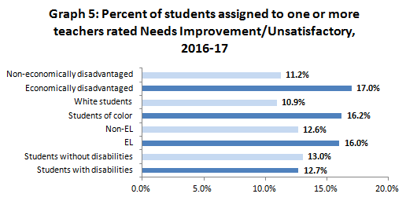
N size =953,748 total students
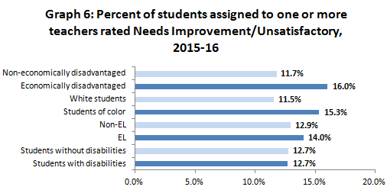

N size =953,428 total students

Appendix D.1, cont’d.: Teachers with low ratings
Table 6 indicates differences across schools by demographics. “High poverty quartile” schools are in the 25 percent of schools with the highest percentage of students in poverty, while “low poverty quartile” schools are in the 25 percent of schools with the lowest percentage of students in poverty.

Table 6: Percent teachers rated Needs Improvement/Unsatisfactory, by school demographic quartile
 | MA All | High poverty quartile | Low poverty quartile | High minority quartile | Low minority quartile
2016–17 | 4.0 | 6.8 | 2.6 | 7.5 | 2.2
2015–16 | 3.8 | 6.6 | 2.1 | 5.9 | 3.1
2014–15 | 5.3 | 9.7 | 2.9 | 9.1 | 3.4

Appendix D.2: Principals with low ratings
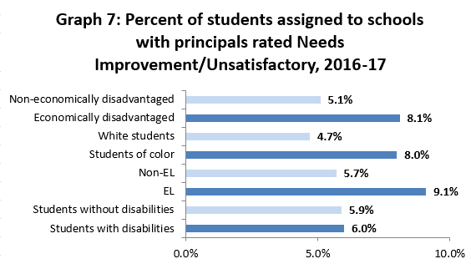

N size =953,748 total students
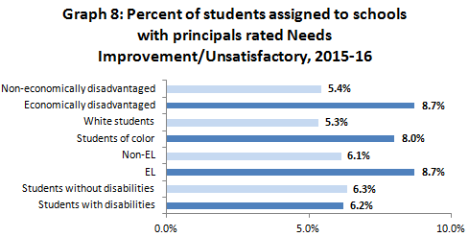

N size =953,428 total students

Table 7: Percent of principals rated Needs Improvement/Unsatisfactory, by school demographic quartile
 | MA All | High poverty quartile | Low poverty quartile | High minority quartile | Low minority quartile
2016–17 | 3.5 | 6.5 | 2.1 | 5.9 | 2.2
2015–16 | 4.6 | 8.6 | 2.7 | 9.1 | 2.4
2014–15 | 5.3 | 9.7 | 2.9 | 9.1 | 3.4

Appendix D.3: Inexperienced teachers
Graphs 9 and 10 show the proportion of students in a subgroup assigned to at least one first-year teacher in a given school year. Unlike the data on page 20, these graphs show the percent of students with first-year teachers, not the percent of course assignments with first-year teachers. As an example, the first bar in the graph below indicates that among all non-economically disadvantaged students, 28.5 percent of the students had one or more first-year teachers in the 2016–17 school year.

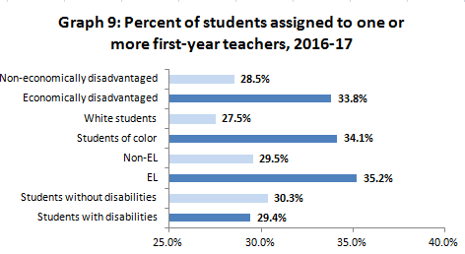
N size =953,748 total students
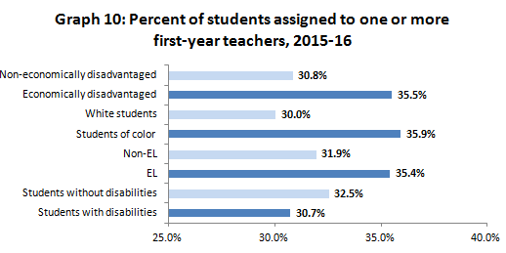
N size =953,428 total students

Table 8: Percent of first-year teachers, by school demographic quartile
 | MA All | High poverty quartile | Low poverty quartile | High minority quartile | Low minority quartile
2016–17 | 6.6 | 11.5 | 4.6 | 10.8 | 4.4
2015–16 | 7.0 | 11.4 | 5.3 | 11.1 | 5.0
2014–15 | 7.0 | 10.4 | 5.8 | 10.2 | 5.2

Appendix D.4: Inexperienced principals

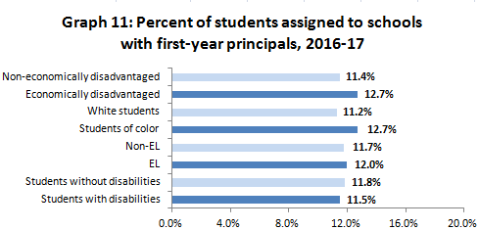
N size =953,748 total students
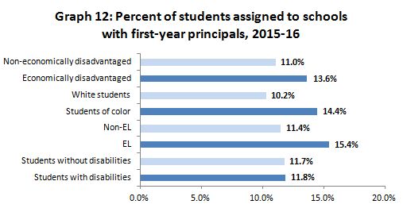
N size =953,428 total students

Table 9: Percent of first-year principals, by school demographic quartile
 | MA All | High poverty quartile | Low poverty quartile | High minority quartile | Low minority quartile
2016–17 | 5.9 | 7.3 | 4.5 | 6.9 | 4.3
2015–16 | 7.0 | 8.9 | 4.8 | 9.1 | 5.5
2014–15 | 12.8 | 18.9 | 8.8 | 18.8 | 9.4

Appendix D.5: Teacher absences and long-term substitutes
When teachers are absent, students instead learn from short-term or long-term substitutes. National studies show reduced learning among students who frequently learn from substitutes. Thus, Massachusetts tracks the rate of student subgroups’ assignment to long-term substitutes and frequently-absent teachers. The tables below show that different student subgroups experience relatively similar rates of assignment to educators in these categories.

Table 10: Statewide student assignment data of subgroups: 2016–17
 | Substitutes | Teacher attendance
 | % of experiences with long-term substitutes | % of experiences with teachers absent 10+ days | Risk ratio
Non-eco. disadvantaged | 1.1% | 32.4% | 1.01
Eco. disadvantaged | 1.0% | 32.6%
White students | 1.1% | 32.8% | 0.98
Students of color | 1.1% | 31.9%
Non-English learners | 1.1% | 32.5% | 0.97
English learners | 1.3% | 31.4%
Students without disabilities | 1.1% | 32.2% | 1.04
Students with disabilities | 1.0% | 33.4%

Table 11: Statewide student assignment data of subgroups: 2015–16
 | Substitutes | Teacher attendance
 | % of experiences with long-term substitutes | % of experiences with teachers absent 10+ days | Risk ratio
Non-eco. disadvantaged |  | 31.8% | 1.01
Eco. disadvantaged | 1.5% | 32.0%
White students | 1.2% | 32.3% | 0.96
Students of color | 1.5% | 31.1%
Non-English learners | 1.2% | 32.1% | 0.91
English learners | 2.6% | 29.3%
Students without disabilities | 1.4% | 31.7% | 1.03
Students with disabilities | 1.2% | 32.7%

Appendix E: Data on educator retention
For more information on teacher retention by program area, see page 9. For more information on educator retention by race and ethnicity, see page 10.

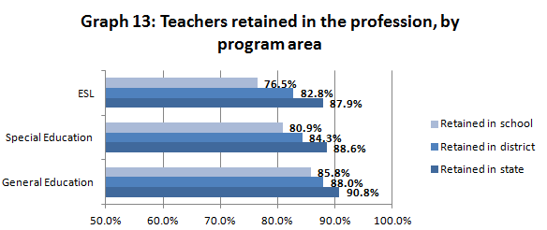
N size = 70,900 total teachers
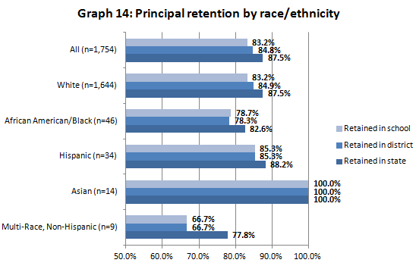

Endnotes

ESSA Section 1111(g)(1)(B)
Administrator ratings were reported at lower rates than teacher ratings: 95.5 percent of Massachusetts teachers were evaluated last school year compared to 87.2 percent of administrators.
Students of color include students who are: Asian; Hispanic/Latino; African American/black; American Indian/Alaskan Native; Multi-race, non-Hispanic or Latino; and Native Hawaiian or Pacific Islander. Additional definitions of student groups are available in Appendix A.
An educator teaching a core academic subject area who: 1) possesses a Bachelor’s degree; 2) holds an active Massachusetts teaching license; and 3) demonstrates subject matter competency in each of the core subject areas he or she teaches.
Note that this data comes from districts who reported October 2015–16 EPIMS data; about 0.7 percent of districts did not report.
The 2014–15 data combines educator evaluation data of teachers and principals.
Cowan, J., Goldhaber, D., & Theobald, R. (2017). DESE Policy Brief: Teacher Equity Gaps in Massachusetts. http://www.doe.mass.edu/research/reports/2017/10teacher–equity.pdf.
Cowan, Goldhaber & Theobald. (2017).
Ibid.
³ Rice, J.K. (2010). The impact of teacher experience: Examining the evidence and policy implications. National Center for the Analysis of Longitudinal Data in Education Research (CALDER), Urban Institute. Working Paper 12155.
Cowan, Goldhaber & Theobald. (2017).
Massachusetts Department of Elementary and Secondary Education (MA DESE). (2013). Status of the Massachusetts Educator Workforce: Focus on First-Year Teachers. http://www.doe.mass.edu/research/reports/2013-12EducatorReport.pdf.
Raue, K., & Gray, L. (2015). Career paths of beginning public school teachers: Results from the first through fifth waves of the 2017–18 Beginning Teacher Longitudinal Study (NCES 2015-196).
Gary, B., Crowe, D. & Schaefer, B. (2007). The Cost of Teacher Turnover in Five School Districts: A Pilot Study. National Commission on Teaching & America’s Future.
Ibid.; Ingersoll, R. (2014). On the Path to Equity: Improving the Effectiveness of Beginning Teachers. Alliance for Excellent Education.
Gary, Crowe & Schaefer (2007).
Beteille, T., Kalogrides, D., and Loeb, S. (2011). Stepping Stones: Principal career paths and school outcomes. National Bureau of Economic Research. Working Paper 17243. http://www.nber.org/papers/w17243.pdf.
Levin, J., et. al. (2015). Massachusetts Study of Teacher Supply and Demand: Trends and Projections. American Institutes for Research. http://www.air.org/sites/default/files/downloads/report/Massachusetts-Study-of-Teacher-Supply-and-Demand-December-2015_rev.pdf.
Ibid.
Edwin Analytics. MA Public Employment Summary (EP702).
Levin, J., et. al. (2015). Massachusetts Study of Teacher Supply and Demand: Trends and Projections. American Institutes for Research. http://www.air.org/sites/default/files/downloads/report/Massachusetts-Study-of-Teacher-Supply-and-Demand-December-2015_rev.pdf.
Villegas, A.M. and Irvine, J.J. (2010). Diversifying the Teaching Force: An Examination of Major Arguments. Urban Review, 42: 175–192.; Holt, S.B. and Gershenson, S. (2015). The Impact of Teacher Demographic Representation on Student Attendance and Suspensions. IZA Discussion Paper No. 9554.
Hanushek, E.A., et al. (2005). The Market for Teacher Quality. National Bureau of Economic Research Working Paper No. 11154.; Bond, B. (2015). The Role of Teacher Diversity in Improving the Academic Performance of Students of Color. Albert Shanker Institute.
Villegas and Irvine. (2010).
MA DESE (2013).
Edwin Analytics. Staff by Length of Service (ED209).
US Census Bureau: American Fact Finder. Massachusetts Educational Attainment.
National Center for Education Statistics (2017). The Integrated Postsecondary Education Data System.
From ELAR data, not including educator candidates who did not report race/ethnicity
Hehir, T., et al. (2014). Review of Special Education in the Commonwealth of Massachusetts: A Synthesis Report. http://www.doe.mass.edu/sped/hehir/2014-09synthesis.pdf.
Cowan, Goldhaber, & Theobald. (2017).; Herrmann, M.A. & Rockoff, J.E. (2012). Worker absence and productivity: Evidence from teaching. Journal of Labor Economics, 30(4), 749–782.

