|  |  |  |
| --- | --- | --- |
| Massachusetts Department of Elementary and Secondary Education Logo | | |
|  | Guide to Understanding the Title III Reporting Elements for English Learners in Massachusetts for 2017 and Beyond |
|  |
| April 2019  [Massachusetts Department of Elementary and Secondary Education](http://www.doe.mass.edu)  75 Pleasant Street, Malden, MA 02148  Phone 781-338-3000 TTY: N.E.T. Relay 800-439-2370 |

|  |
| --- |
| Massachusetts Department of Elementary and Secondary Education Logo  This document was prepared by the  Massachusetts Department of Elementary and Secondary Education  Jeffrey C. Riley  Commissioner  **State Seal of Massachusetts**  The Massachusetts Department of Elementary and Secondary Education, an affirmative action employer, is committed to ensuring that all of its programs and facilities are accessible to all members of the public.  We do not discriminate on the basis of age, color, disability, gender identity, national origin, race, religion, sex or sexual orientation.  Inquiries regarding the Department’s compliance with Title IX and other civil rights laws may be directed to the  Human Resources Director, 75 Pleasant St., Malden, MA 02148 781-338-6105.  © 2019 Massachusetts Department of Elementary and Secondary Education  Permission is hereby granted to copy any or all parts of this document for non-commercial educational purposes. Please credit the “Massachusetts Department of Elementary and Secondary Education.”  Massachusetts Department of Elementary and Secondary Education  75 Pleasant Street, Malden, MA 02148-4906  Phone 781-338-3000 TTY: N.E.T. Relay 800-439-2370 |

|  |  |
| --- | --- |
| DESE Logo | Guide to Understanding the Title III Reporting Elements for English Learners in Massachusetts for 2017­­­­ and Beyond |

**Summary**

This document describes the Department’s methods for reporting the information listed below for students who are English learners:

* English learners (ELs) making progress toward English proficiency (Reporting Element 1)
* ELs attaining English language proficiency (Reporting Element 2)
* ELs exiting EL status based on attainment of proficiency (Reporting Element 3)
* Former ELs meeting challenging academic standards (Reporting Element 4)
* ELs who have not attained English proficiency within six years of initial classification (Reporting Element 5)

These Reporting Elements are reported annually by Massachusetts in accordance with Title III of the federal Every Student Succeeds Act (ESSA) and the Massachusetts Language Opportunity for Our Kids (LOOK) Act. The five Reporting Elements have replaced the reporting of the three Annual Measurable Achievement Objectives (AMAOs) previously required by the federal No Child Left Behind Act.

Beginning in summer 2018, the Massachusetts Department of Elementary and Secondary Education provided schools, districts, and consortia with information on Reporting Elements 2, 3, and 5 for the 2016−2017 school year; and all reporting elements for the 2017−2018 school year.

# **Title III Districts in Massachusetts**

Title III is a federal grant program under ESSA that provides eligible districts and consortia with supplemental funding to support English learners in attaining English proficiency. In 2017–2018, there were 93 public school districts and 10 district consortia that qualified for Title III grants allocated by the Department.

**Background: ACCESS for ELLs Assessments**

Massachusetts has administered the ACCESS for ELLs (“ACCESS”) tests since 2013 to English learners who attend Massachusetts schools and whose education is publicly funded. ACCESS assessments are developed by the World-class Instructional Design and Assessment (WIDA), a consortium of 39 member states based at the Wisconsin Center for Educational Research (WCER) at the University of Wisconsin. The assessments measure achievement of the WIDA English Language Development standards. Massachusetts also administers the Alternate ACCESS assessment to measure the English proficiency of students who are ELs with significant cognitive disabilities. The ACCESS assessment are administered during January and February each year to all EL students in grades K–12, as required by ESSA and Massachusetts Chapter 71A, including students who have “opted out” of receiving English language services. Massachusetts has been a member of the World-class Instructional Design and Assessment (WIDA) consortium since

May 2012. Beginning in 2016, new ACCESS for ELLs 2.0 tests were administered for the first time on computer, with a paper-based accommodation for certain students. Currently, the vast majority of students are tested on computer.

ACCESS tests are administered in the four *subdomains* of speaking, listening, reading, and writing. Scores are reported in each subdomain, plus *composite* *scores* for comprehension (listening and reading), oral language (speaking and listening), literacy (reading and writing); and an *overall composite* *score*.

**Reporting Element 1: Progress Determinations and Targets**

# **Overview**

Title III of ESSA requires states to report the number and percentage of students who are making progress toward achieving English proficiency. In Massachusetts, “making progress” means that a student is on track to attain English proficiency within six years of entering a Massachusetts school. Students are considered *English* *proficient* when they have achieved an overall composite score of Level 4.2 and a composite literacy score of Level 3.9 on the ACCESS test, based on a score scale between Level 1.0 (the lowest level of proficiency) to Level 6.0.

In 2018, the Department adopted an approach entitled “Pathways to Proficiency” that uses a student’s current year ACCESS score as the basis for determining a target for the following year. The target is the minimum score needed by the student the following year to remain on track to attain English proficiency. Students in kindergarten through grade 11 will receive a target for as long as they are classified as English learners. Progress targets are not provided for students in grade 12 since it is anticipated that they will no longer be enrolled in a K−12 program the following year.

After the Department reports annual ACCESS scores in late May−early June, each EL student will receive a *future progress target* and a *difficulty index* for the following school year. If the student has taken the ACCESS test for at least two consecutive years, they will also receive a *student* *growth percentile for ACCESS* (SGPA) and a *progress indicator* (expressed as “1” if the student made progress during the past year or “0” if the student did not make progress).

Students who were eligible to take the ACCESS test, but did not participate because they were absent will receive a progress indicator of “0” and an estimated future progress target and difficulty index based on the student’s most recent ACCESS test score, or based on the minimum test score if the student has no prior score. Students with a test status of *Absent* the prior year, but who have an ACCESS score for the current year, will receive a future progress target, difficulty index, and progress indicator, but not an SGPA.

An explanation of each of the features used by the Department to determine progress is provided below:

* **Future progress target** represents the minimum ACCESS proficiency level score needed on following year’s ACCESS test to remain on track to reach English proficiency within a total of six years in a Massachusetts school (one baseline year plus five years to demonstrate progress toward proficiency). Future progress targets are reported as an overall ACCESS proficiency level, ranging from Level 1.0 to Level 4.2 (lowest to highest).[1]

Each year, future progress targets are reset based on a) the number of years remaining for the student to reach proficiency, and b) the current year’s ACCESS score. Students who have fewer years to reach proficiency and/or are further from proficiency will tend to have future progress targets that are more difficult to reach than students who have more years to reach proficiency and/or are closer to proficiency.

* **Difficulty index** shows an estimate of how difficult it will be to reach next year’s target relative to the student’s current proficiency level and number of years in Massachusetts. The difficulty index ranges from 1–99, with one being the lowest difficulty (i.e., least difficult to achieve the target) and 99 the highest (i.e., most difficult to achieve the target). Students with difficulty indices greater than 70 will have a high degree of difficulty in achieving their future targets. The difficulty index should serve as an indicator of which students may need additional instructional assistance to meet their future targets.

For example, a student who has been classified as an English learner for three years with a comparatively low ACCESS score (e.g., Level 1.5) would receive a high difficulty index (e.g., 75) because it would be more difficult for them to meet their future target. A student with a higher proficiency level after the same number of years in a program (e.g., a student in an EL program for three years with an ACCESS level of 3.7) would likely receive a lower difficulty index (e.g., 35). A higher difficulty index should serve as an indicator that a student may require additional resources and hours per week in a language program to accelerate their language proficiency.

Future progress targets and difficulty indices were adjusted in the following situations:

* Grade 8 progress targets and difficulty indices were substituted for students in grades 9 through 11 who would not have a full five years to achieve proficiency and would therefore have difficult-to-achieve progress targets.
* Progress targets and difficulty indices were estimated for students who were eligible to take the ACCESS tests but were absent for the test. If absent students had a prior score, the estimates were based on that; if not, the estimates were based on other students’ ACCESS test results in that grade, English proficiency level, and number of years in Massachusetts.
* Students who scored Level 4.2 in a prior year received a progress target of 4.2 for subsequent years in which they remained eligible to take the ACCESS test.
* Since future progress targets are informed by the current year’s ACCESS results, a small percentage of students will receive future targets that are lower than the prior year’s targets, for example, in situations where students performed lower-than-expected overall in the current year.
* Students in their fifth year in MA all have future progress targets of 4.2.
* **Student Growth Percentile for ACCESS** **(SGPA)** indicates the amount of progress made by a student on the ACCESS test from one year to the next, relative to other EL grade-level students who earned similar ACCESS scores the prior year and who have attended Massachusetts schools for the same number of years. In general, SGPA indicates whether a student has made low, moderate, or high gains in their ACCESS test scores from one year to the next, compared with other ELs at the same grade level who took the ACCESS test in two consecutive years and who scored similarly the year before. Like the difficulty index, the SGPA is a number from 1‒99, with 40‒59 representing *average* growth. Unlike the difficulty index, however, higher SGPA numbers indicate *more* growth, compared with higher numbers on the difficulty index that indicate a higher degree of difficulty in reaching the future year’s target.[2] SGPA allows each student a nearly equal opportunity with other ELs in their grade level to demonstrate their progress in learning English.
  + **Progress indicator**, either “1” (Yes) or “0” (No), shows whether the student has met last year’s progress target in the current year. If the student’s current ACCESS proficiency level score is equal to or greater than their future target from the previous year, then the student is considered to have made progress. For example:
    - A student with a prior year’s target of 2.8 will have made progress if his or her current year’s overall ACCESS score is at or above Level 2.8;
    - A student with a prior year’s target of 3.2 will *not* have made progress if his or her current year’s overall ACCESS score is below Level 3.2.

For EL students taking the [Alternate ACCESS](https://www.wida.us/assessment/alternateaccess.aspx), the Department will determine progress based on a comparison of the prior year’s results and the current year’s results to see whether the scores have increased by at least one proficiency level in one or more subdomains of the test (i.e., either in listening, speaking, reading, or writing) from one year to the next.[3] Because a score of Level 4.2 is not technically possible for students taking the Alternate ACCESS, their progress indicators should be interpreted with caution.

**Rules for Calculating Progress**

SGPA calculations of progress toward English proficiency are based on the same Student Growth Percentile (SGP) model used to report MCAS scores. SGPAs for each student are based on the results of two administrations of the ACCESS tests including the current and most recent years of administration. The requirements for calculating SGPAs are that a student must have two consecutive years of results on the ACCESS tests and be enrolled in consecutive grades for those years. As noted above, all students in grades K−11 eligible to take the ACCESS tests will receive future progress targets and difficulty indices, even when they do not meet the requirements for receiving an SGPA.

All students who are eligible[4] to take either the ACCESS tests or the Alternate ACCESS for two or more years will receive a progress indicator (either “1” or “0”).

It is important to note that while the SGPA methodology provides students a nearly-equal opportunity to demonstrate their growth toward proficiency, there will be different rates of progress for some student groups than for others. For example, students in lower grades typically demonstrate higher rates of progress than students in higher grades, as shown in Table 1. Additionally, students with disabilities generally demonstrate lower rates of progress than non-disabled students, as shown in Table 2. In 2018, across all grades, about 57 percent of non-disabled students made progress while about 30 percent of students with disabilities made progress.

**Table 1**

**Number and Percent of ELs Making Progress by Grade (2018)**

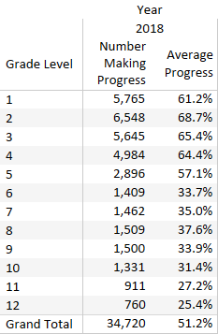

**Table 2.**

**Number and Percent of ELs Making Progress by Grade and Disability Status (2018)**

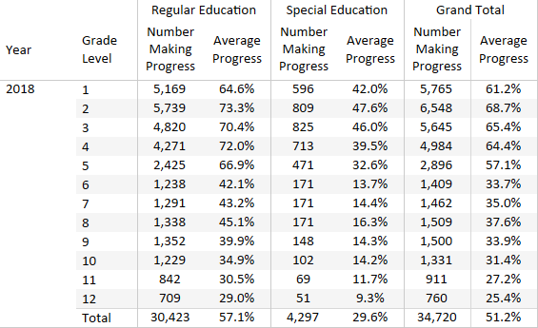

**Progress Determinations and Targets for Districts, Consortia, and Schools**

Progress determinations for Massachusetts districts, consortia, and schools are based on the “Pathways to Proficiency” model, which uses the Student Growth Percentile method to establish yearly progress targets and SGPAs. Starting in 2018, Massachusetts schools and districts were assigned progress targets informed by that entity’s average difficulty index from the prior year. Districts will meet their target when the percentage of students in the district that met their individual targets is the same or greater than the district target.

Progress determinations and targets for districts and consortia are based on the aggregated results for entities with at least 20 students receiving a progress indicator for the current year (although progress targets and indicators will be informally reported, rather than publicly reported, for entities with fewer than 20 students). Progress determinations and targets for schools, districts, and consortia are calculated differently for K–8 entities than for 9–12 entities due to the considerable variation in rates of progress among elementary, middle, and high school students, with ELs in high school making progress toward English proficiency at a slower pace.

District/consortia progress determinations and targets are also informed by *difficulty indices.* Districts with higher difficulty indices will tend to have lower rates of students meeting their progress determinations. To adjust for these differences in difficulty in meeting targets, districts and consortia with higher average difficulty indices in the prior year will have proportionally lower progress targets than those with lower prior difficulty indices.

Progress targets for schools and districts are based on the difficulty index *quartile* from the prior year, as shown in Table 3. District difficulty indices from the prior year are divided into four approximately equal *quartiles*, from lowest to highest difficulty index. Schools and districts were assigned a progress target based on the median progress rate of schools or districts within each quartile. If the percentage of students in each school or district met or exceeded the progress target shown in Table 3, that entity will have met their progress target.[5]

**Table 3.**

**School and District Progress Targets for 2018 by Difficulty Index Quartile**

Table

Consortia targets were based on the formula for calculating district targets. This is the same method used in the State’s Accountability System for establishing aggregate progress targets and determinations.

Table 4 shows the number and percent of K–8 and high schools in Massachusetts that met their district/consortia progress targets in 2018.

**Table 4.**

**Districts and Consortia Meeting Progress Targets in 2018**

|  |  |  |  |
| --- | --- | --- | --- |
| **K-8 Schools** | | **High Schools** | |
| Number | % Meeting | Number | % Meeting |
| 168 | 40.5% | 85 | 38.8% |

**Reporting Element 2: Attainment of English Language Proficiency**

The ACCESS for ELLs test scores are reported as one of six English language proficiency levels:

1 = Entering 4 = Expanding

2 = Beginning 5 = Bridging

3 = Developing 6 = Reaching

Prior to 2017, Massachusetts had considered students who attained Level 5.0 on the ACCESS for ELLs assessments to have “attained English proficiency” and be eligible for consideration to transition from EL to non-EL status. However, changes in the rigor of the new computer-based ACCESS for ELLs tests introduced in 2016 and the transition to a new score scale in 2017 led to a re-examination and recalibration of the proficiency standard in Massachusetts. As a result, new *exit criteria* for Massachusetts EL students were announced in June 2017 and are described below.

**Transition to New Exit Criteria in June 2017**

When the score scale used to report the ACCESS 2.0 scores changed in 2017 based on a standard setting process conducted by WIDA, it became substantially more difficult for students to attain the same proficiency level they had attained on the earlier ACCESS 1.0 tests, and the 2017 (and subsequent) scores were markedly lower overall.

In June 2017, the Department of Elementary and Secondary Education announced [new EL exit criteria](http://www.doe.mass.edu/news/news.aspx?id=24444) for Massachusetts students, based on research conducted by the Department that determined that an overall score of at least Level 4.2 and a literacy composite score of at least Level 3.9 on the ACCESS 2.0 test was equivalent to an overall score of Level 5.0 and a composite literacy score of Level 4.5 on the prior ACCESS 1.0 test.

**Revised Criteria for a student to exit EL status, beginning with the 2017−2018 school year:**

To be eligible to exit EL status, beginning in the 2017**−**2018 school year, a student must have attained at least the following scores on ACCESS for ELLs 2.0:

* Overall Score of Level 4.2; and
* Composite Literacy Score of 3.9

Table 5 shows the percentages of students statewide who attained an overall score of Level 4.2 and a composite literacy score of 3.9 in 2017 and 2018.

**Table 5.**

**Number and Percent of students who attained English proficiency in 2017 and 2018**

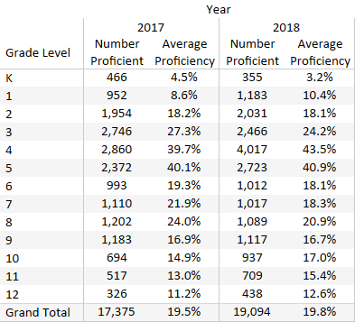

**Reporting Element 3: The number and percentage of ELs who exit English learner classification based on their attainment of English proficiency**

Reporting Element 3 indicates the number and percentage of students who have attained English proficiency (i.e., who received an overall score of at least Level 4.2 and a composite literacy score of at least Level 3.9 on the ACCESS for ELLs test) and who were reported as having exited EL status by the following October in the Student Information Management System (SIMS). Statewide data from 2017 indicated that about half of the proficient students were exited from EL status in time for the following school year; and in 2018, about 60 percent of proficient students had exited EL status, as shown in Table 6.

**Table 6.**

**English Learners Who Exited EL Status Based on Attainment of Proficiency**

**in 2017 and 2018**

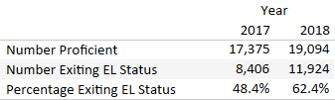

**Reporting Element 4: The number and percentage of former ELs (FELs) who have met challenging state academic standards for each of the four years after exiting EL status**

For EL students who have been exited from EL status for up to four years, “meeting challenging state academic standards” is defined as earning a score of *Meeting Expectations* or *Exceeding Expectations* on the next-generation MCAS English language arts (ELA) and mathematics tests for the grade in which the student was enrolled and reported. Students who participated in the MCAS-Alt have been removed from this analysis since they did not participate in the next-generation tests.

In Table 7, ELs who exited EL status were combined into and reported in one “Former EL” category in 2018 to avoid suppressing results for fewer than 10 students. Current ELs were included with other students in the “Not Former EL” category. Note that in 2019, results for FELs will be disaggregated by the number of years of FEL status, as indicated below:

* Students who were FEL in 2015 will be counted as 4 FEL years in 2019
* Students who were FEL in 2016 will be counted as 3 FEL years in 2019
* Students who were FEL in 2017 will be counted as 2 FEL years in 2019
* Students who were FEL in 2018 will be counted as 1 FEL year in 2019
* Students who will be FEL in 2019 will be counted as 0 FEL years in 2019.

**Table 7.**

**FELs Who Have Met Challenging Academic Standards on the 2018 next-generation MCAS by Grade and Subject**

Table

The 2018 MCAS participation rate and achievement of former ELs is reported in [MCAS Profiles](http://profiles.doe.mass.edu/statereport/nextgenmcas.aspx) together with the participation and achievement of subgroups, as shown in the excerpted report for grade 3 in Table 8.

**Table 8.**

**2018 MCAS participation rate and achievement of former ELs**

**(Example from Profiles for Grade 3)**

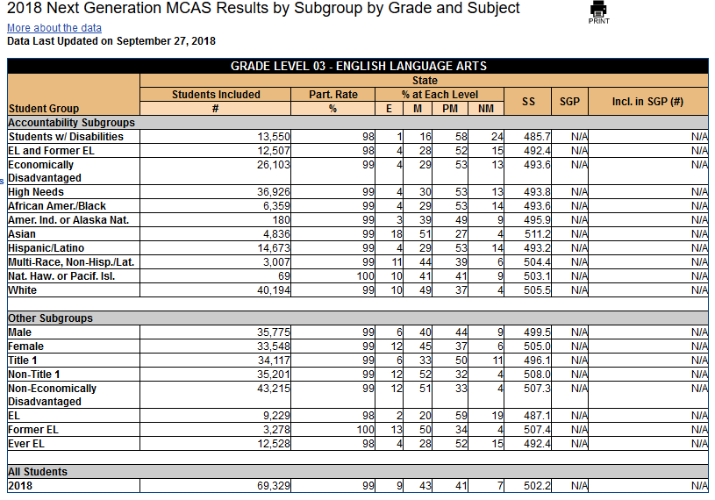

**Reporting Element 5: The number and percentage of ELs who have not attained English proficiency within six years of initial classification as an English learner**

To calculate the percentage of ELs not attaining proficiency within six years, the total number of students enrolled in ACCESS testing within each school or district is considered. While the total number of EL students in Massachusetts has increased, the percentage of students NOT attaining proficiency statewide within six years has remained fairly constant at about 15–16 percent, as shown in Table 9.

**Table 9.**

**Number and Percent of ELs Not Attaining Proficiency within Six Years in a Massachusetts School in 2017 and 2018**

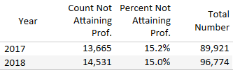

**REFERENCES**

Betebenner, D. (Winter 2009). Norm- and criterion-referenced student growth. *Educational Measurement: Issues and Practice, 28*:4, pp. 42-51.

Betebenner, D. (2012). *An Overview of the Student Growth Percentile Methodology*. Presentation given to the MCAS Technical Assistance Committee, October 25, 2012.

Cook, G. H., Boals, T., Wilmes, C., & Santos, M. (2008). *Issues in the Development of Annual Measurable Achievement Objectives for WIDA Consortium States.* Wisconsin Center for Education Research, Working Paper No. 2008-2. Retrieved from: <http://www.wcer.wisc.edu/publications/workingpapers/working_paper_no_2008_02.pdf>

Cook, G., Linquanti, R., Chinen M., & Jung, H. (2012). *National Evaluation of Title III Implementation Supplemental Report: Exploring Approaches to Setting English Language Proficiency Performance Criteria and Monitoring English Learner Progress*. Manuscript Submitted to: U.S. Department of Education, Office of Planning, Evaluation, and Policy Development. Retrieved from: <http://www.air.org/sites/default/files/downloads/report/Final_version_for_Release_Title_III_Exploratory_Report_020112_630pm_0.pdf>

Cook, G. H. (2015). *What Does Alt ACCESS Growth Look Like Across WIDA?* Research presented at WIDA Consortium Board Meeting. The Board of Regents of the University of Wisconsin System, on behalf of the WIDA Consortium.

Massachusetts Department of Elementary and Secondary Education. (2019). *Guidance on Identification, Assessment, Placement, and Reclassification of English Language Learners*

Retrieved from:

<http://www.doe.mass.edu/ele/guidance/default.html?section=guidance>

Massachusetts Department of Elementary and Secondary Education. (2018). English Language Learners: LOOK Act. Retrieved from: <http://www.doe.mass.edu/ele/look-act.html>

WIDA Consortium. (2016). *Summary of the ACCESS 2.0 2016 Standard Setting Study*.

Retrieved from: <https://wida.wisc.edu/grow/pl/us-based-pl/wida-screener-online-training>

Massachusetts Department of Elementary and Secondary Education. (2017) *ELL Assessment Update: New Exit Criteria, Equivalent Proficiency Levels, and Recommended Amount of Language Instruction*. Retrieved from: <http://www.doe.mass.edu/news/news.aspx?id=24444>

1. Future progress targets are calculated using ACCESS for ELLs scaled scores, and then translated into ACCESS proficiency levels for reporting.
2. The difficulty index is related to the SGPA for the subsequent year. Students who reach their future target, will have an SGPA in that year that is similar to the difficulty index for the prior year.
3. For students who switched between the regular ACCESS test and the Alternate ACCESS, increases in subdomain and overall levels were identified via the ACCESS to Alternate ACCESS crosswalk available at <http://www.doe.mass.edu/mcas/access/>.
4. Students who are eligible to participate in the ACCESS assessments have one of the following test statuses: T=Tested on the Standard ACCESS test, ABS=Absent, or ALT=Tested on the Alternate ACCESS.
5. 2018 aggregate targets were set using the method described in this document. However, the method for setting targets for 2019 may vary slightly.