Districts should not expect to be able to request payments until after the Initial Payment is received from Grants Management. The Initial Payment will be sent automatically to the district the grant has been financially approved and funds have been set up on the state’s accounting system. To see if your initial payment has been processed, log in to Front Office and check the Project Record Card. For instructions on how to access the Project Record Card, see page 14 of this document.
The district is responsible for logging in to EdGrants each month (or as needed) to request payment during the payment windows. The payment request window will be open each month from the 20th through the last day of the month. During accounts payable (7/1 – 8/31) the payment windows will shift slightly for year-end accounting purposes.
Logging In
- Log on to the front office: https://edgrants.eoe.mass.edu/grantium/frontOffice.jsf
- Enter Username and password provided by ESE
- Click login button
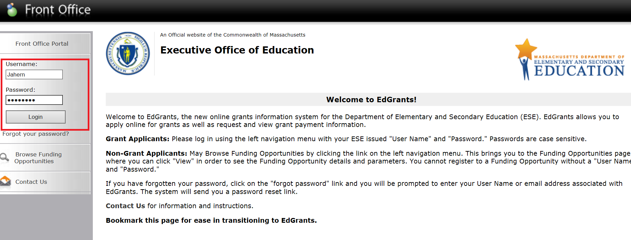
Once the login button is hit, the left hand menu will expand and the system will recognize that your user name is logged in.

Requesting Funds
- Click Submissions on the navigation menu on the left

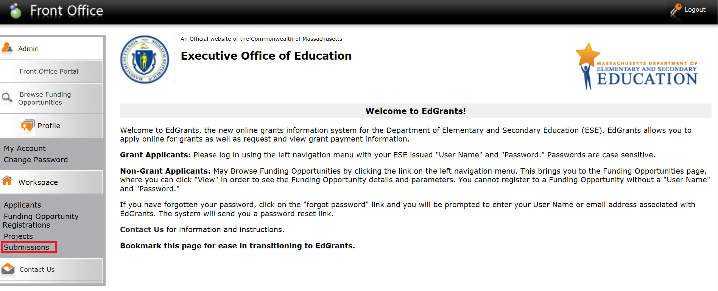

- Use the Filter Applicant Project Name to view the grant you are requesting funds for. To use this filter, click the arrow to the right of the box to reveal a dropdown feature listing all of the grants for your district.
- Scroll down to the project you’re looking for. Once you have found the Applicant Project Name you must click the filter button to see results.
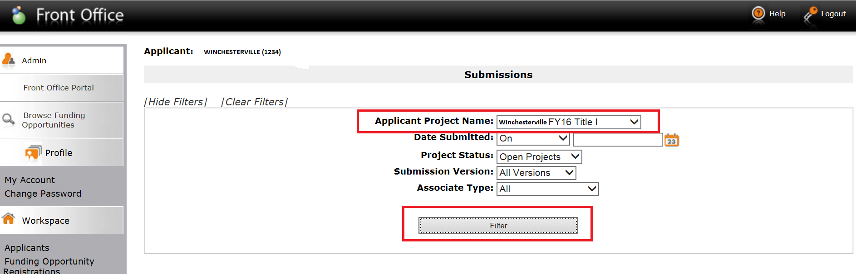

- Once filtered, all submissions are displayed. Submissions include Application submission, Request for Funds submissions (payments), Multi-Year Form and Final Reports. Project Record Card is also found in this section. Headers can be clicked to re-order the submissions in multiple ways.

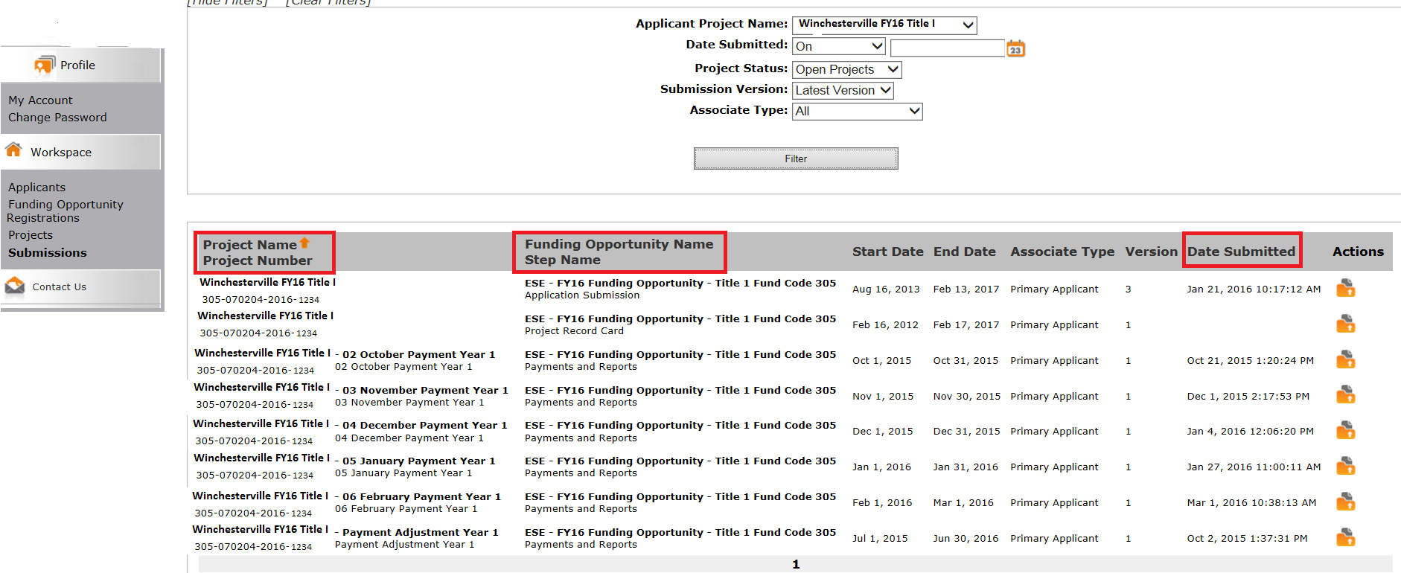

- Select the orange folder to open the submission you would like to complete. In the example below, the February request window is open so we are using the February Payment Year 1 Request for Funds Form.

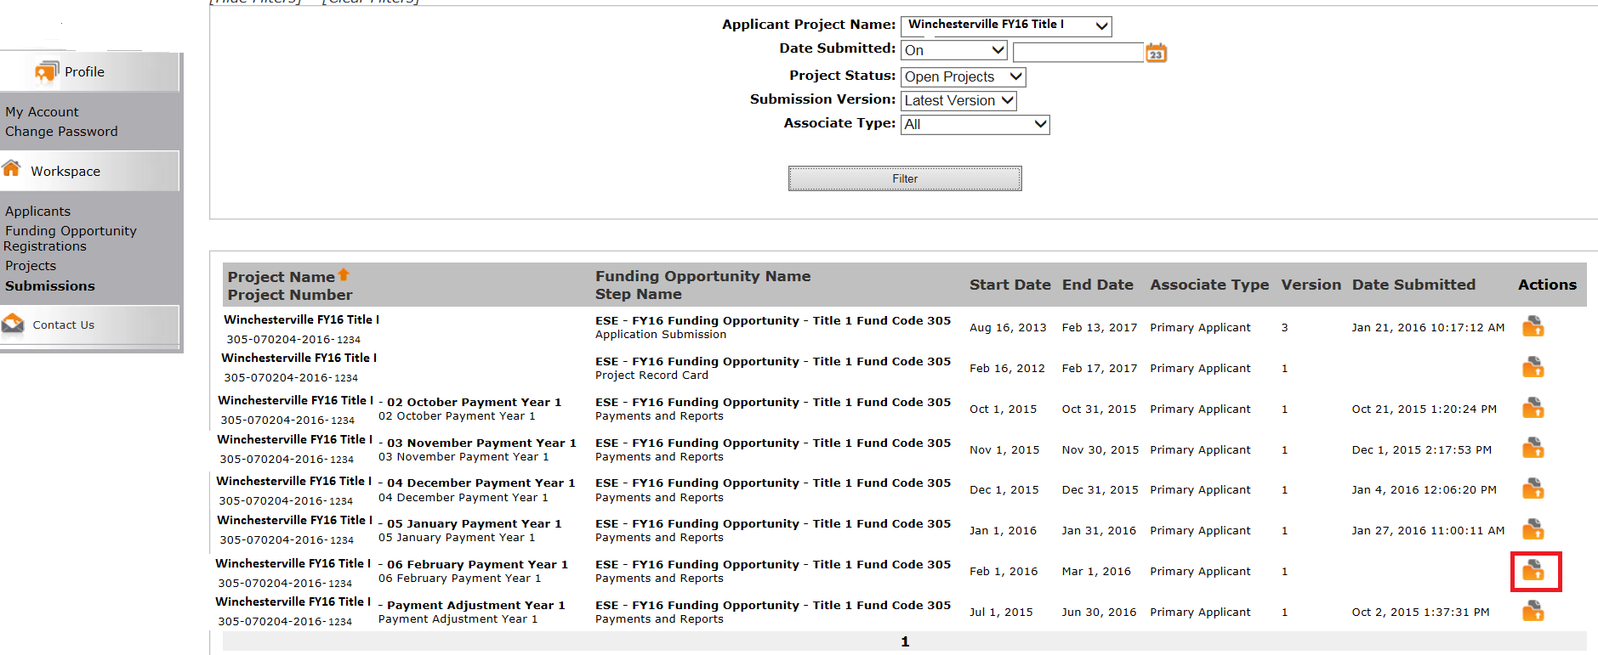

- After clicking the orange folder the Request for Funds Form opens up. This is similar to the Excel document that has been sent to districts to request funds for grants housed in the EdGrants system.
On this form, you will see the current financial information for your grant. Please review the information and ensure it is correct. All fields on this form are locked except for three input boxes. These input boxes are required fields in order to submit the payment request.
The three input fields are:
- Total Funds Expended to Date
- Anticipated Expenditures (Next 30 days), and
- Funds Requested

The allotment amount is the maximum amount of funds that can be requested at this time. The allotment calculation prevents you from having too much cash on hand and being in violation of the Cash Management Act (CMA). The allotment is calculated based on what you report in Total Funds Expended to Date and Anticipated Expenditures (Next 30 days). This form will take the amount you report as spent, and the amount that has been paid to date to figure out your cash balance. Your cash balance is then added or subtracted to the amount you anticipate needing over the next 30 days.

The picture below shows the fields used to calculate the allotment (the red boxes) as well as the input fields required in order to submit the payment request (highlighted yellow).

In this example, the district has a cash balance of $7,380, so that amount is subtracted from their “anticipated…” amount in order to get the allotment amount of $9,620.

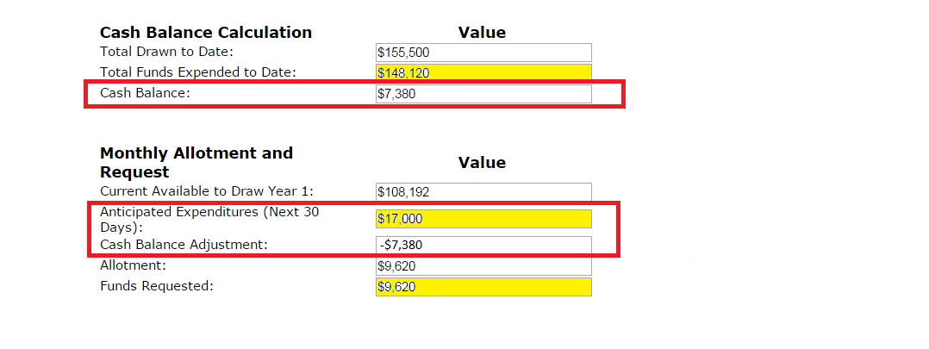

- After reviewing the form and entering in the Total Funds Expended to Date and the Anticipated Expenditures (Next 30 Days) fields, click Save. Clicking save will re-calculate your Cash Balance, Cash Balance Adjustment, and will calculate your Allotment.
- Fill in the amount you are requesting in the Funds Requested field (allotment amount, or less).
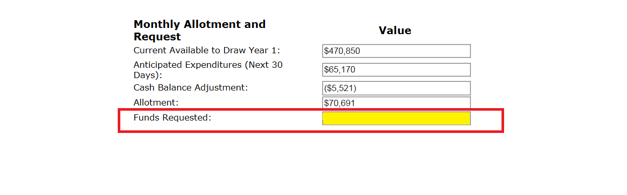
The form will prevent submission if you try to request more than your Allotment amount. The justification box that was previously on the request for funds forms has been removed. If you need more than your Allotment amount, revisit/revise your anticipated expenditures. Make sure to SAVE changes to see your re-calculated Allotment.

- Click Save & Next.
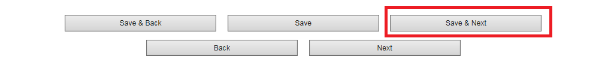
- This brings user to the Verification and Certification formlet. Review the data presented to ensure there are no typos prior to submission. Once verified, click the “I have verified…” box. Read the Payment Request Certification and click the box next to the certification statement.
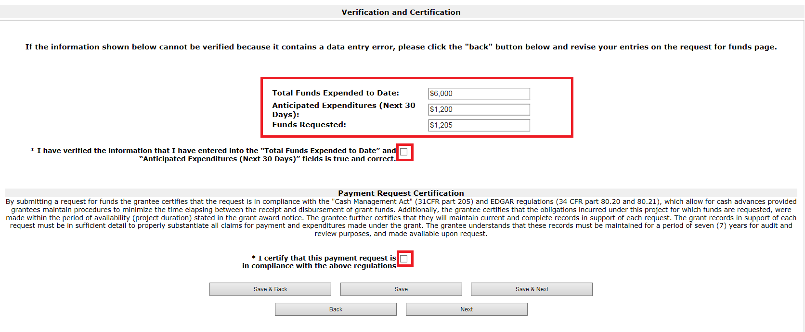

If the Payment Request Certification font is too small for you to read (PC users), hold down the control button and simultaneously use your mouse scroll wheel to enlarge. You could also enlarge the view by holding control button down and the plus sign until it is the size you need to be able to read it comfortably. To shrink back down, control and scroll wheel in the opposite direction OR control and minus sign.

- Click Save & Next

- Clicking Save & Next brings you to the Submission Summary page. Click Submit on this page to submit the payment.
(Hint: Green check mark and date filled in means it can be submitted).

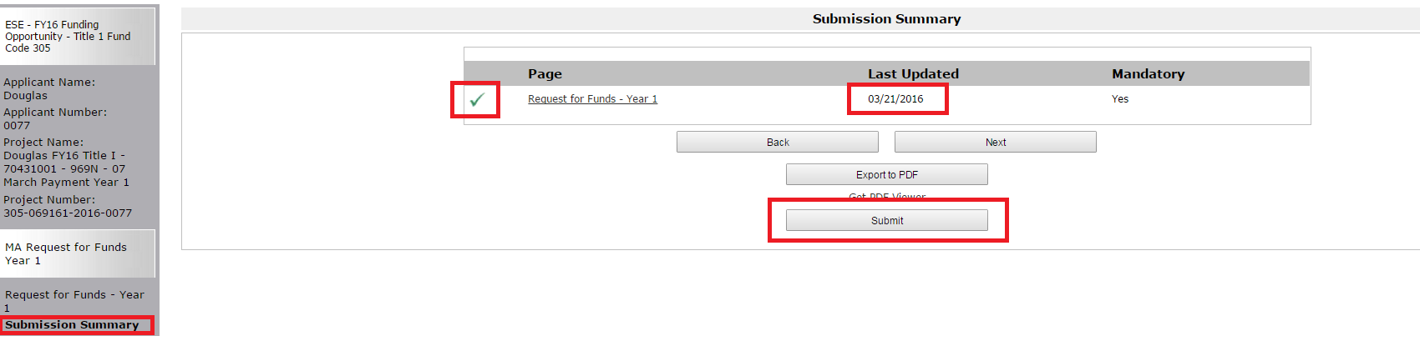

- On the Submission Summary page, if you see “Please Complete” and the submit button is deactivated this is because one of the input fields is missing, the Verification or Certification boxes are not checked, or the Funds Requested amount is more than the allotment. 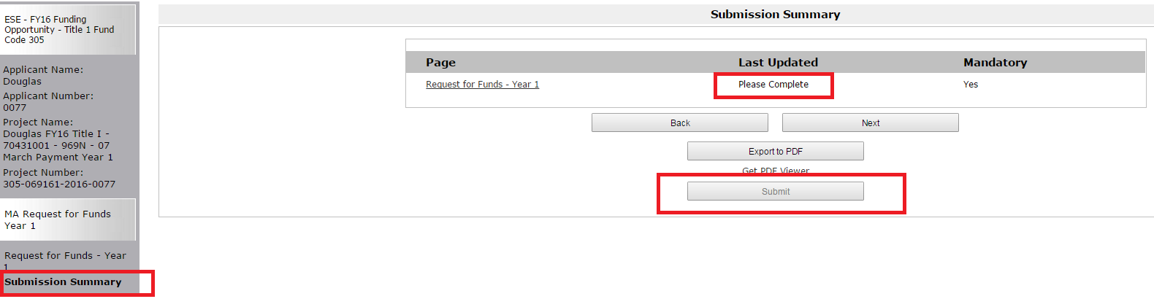

- Go back to the Request for Funds formlet itself, or to the Verification and Certification formlet to see what is missing or incorrect by clicking the back button that is above the submit button.
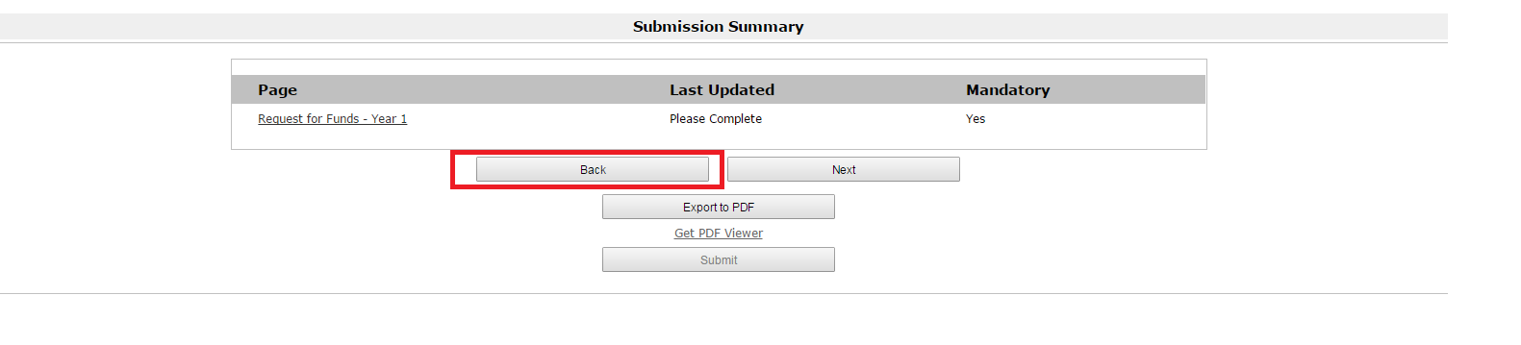

ALWAYS use the back button embedded in the forms - NEVER use the back button on your browser
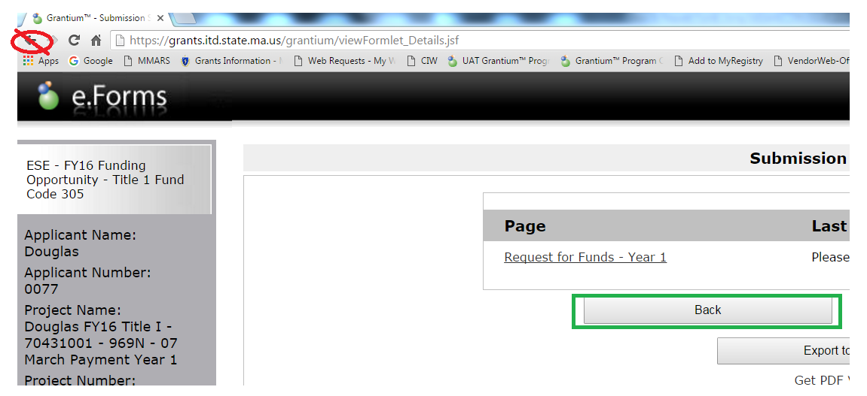

- If you want to print out your payment request, go back in to the payment request by clicking the orange folder (you should now see a date and time stamp since it has been submitted).
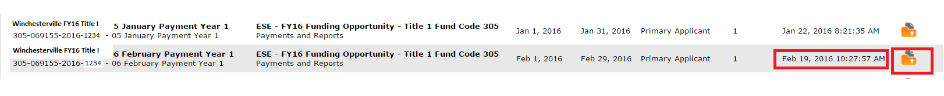
- Once the request opens up, click Export to PDF on the left hand menu.
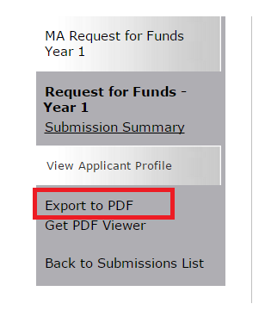
Depending on how your PC is set up, you may be prompted to save and name the PDF export file before it will open for you. Otherwise, the PDF will download and you can view it and print from there.
Once the Request for Funds is submitted, it goes through a review/approval step internally at the Department. Once the payment approval step is complete, it gets sent to a transactions queue. The transaction is sent, and sends the file to the state accounting system as a payment. It can take 1-10 business days from when you submit the request to when it is paid and hits your account.

Project Record Card
The Project Record Card shows an up to date summary of the total funds requested, paid and balance to pay. It also shows the MTRS payment amount and date (once the MTRS payments have occurred; this field is blank prior to the Department sending MTRS). It also shows a listing of each payment that has been sent to the district, the amount, the date approved, the DOC ID transaction number on the state’s accounting system as well as the payment notice attached to each payment.
As soon as the payment review/approval step is processed internally at the Department, the payment will appear on the district Project Record Card.
This does not mean the payment has cleared and hit your account, it means that the payment has been approved by the Department and is one step closer to hitting your account.
- To view the Project Record Card, go to Submissions and look for step name Project Record Card.
- Click the orange folder
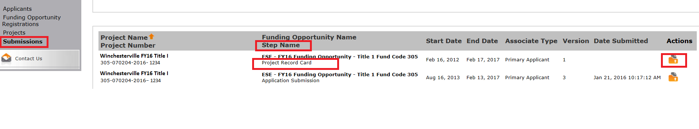

Submit button is deactivated here because you will never need to submit this form. The Project Record Card is updated each time a new payment is approved.
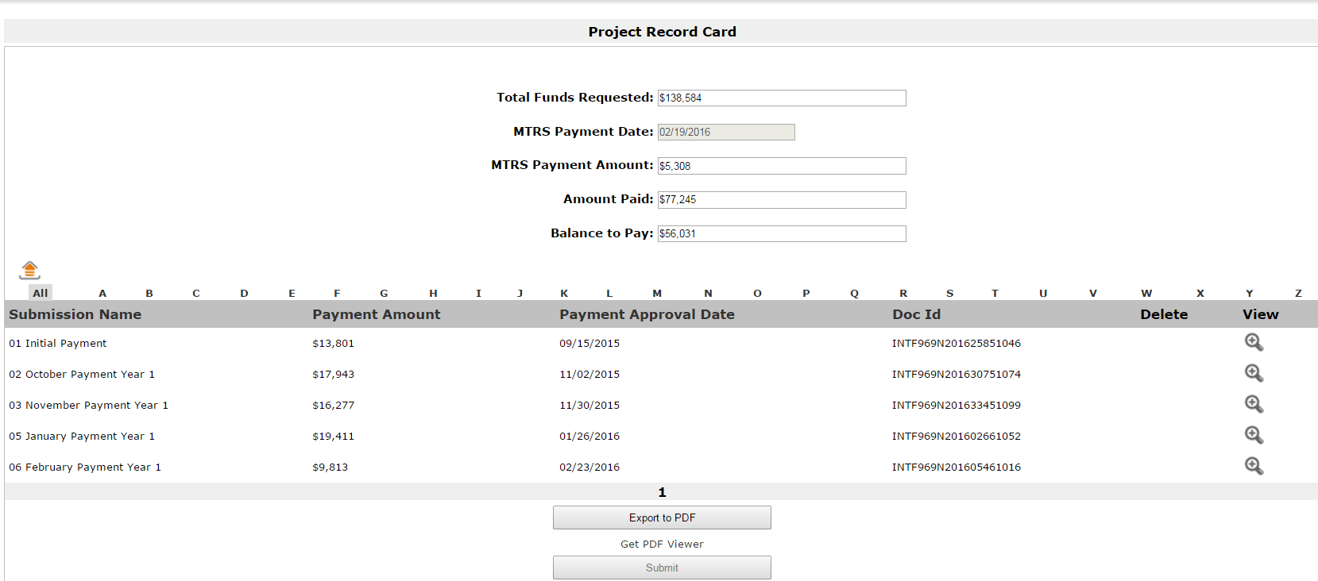

- To review and/or print a payment notice click on the magnifying glass next to the payment under view.
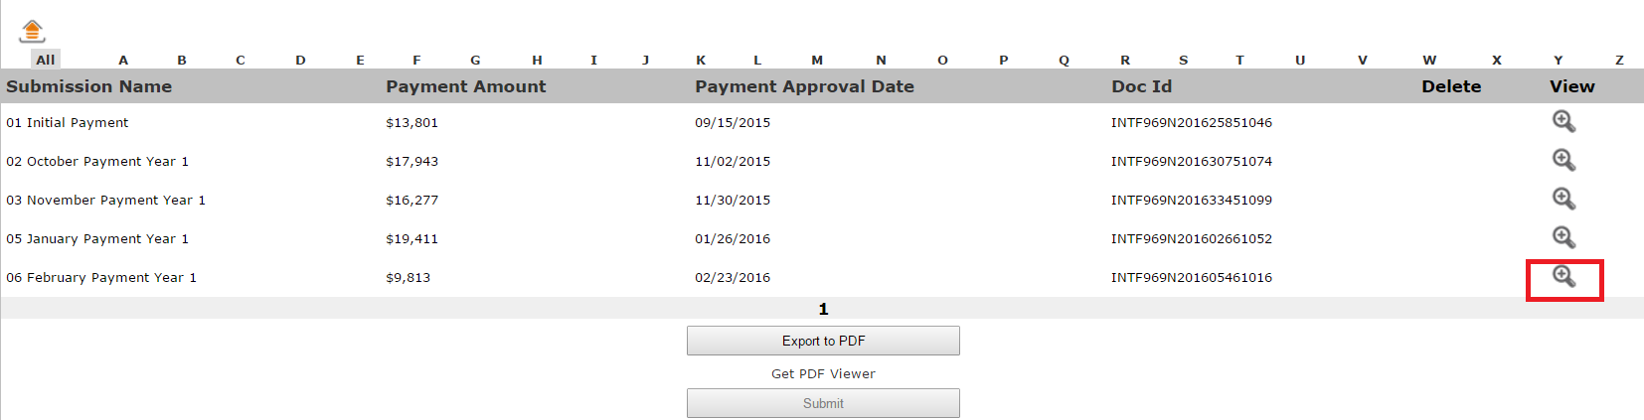
The payment notice associated with that payment will open up.
These are the notices that the Department currently sends to district control users via emailed PDF documents.

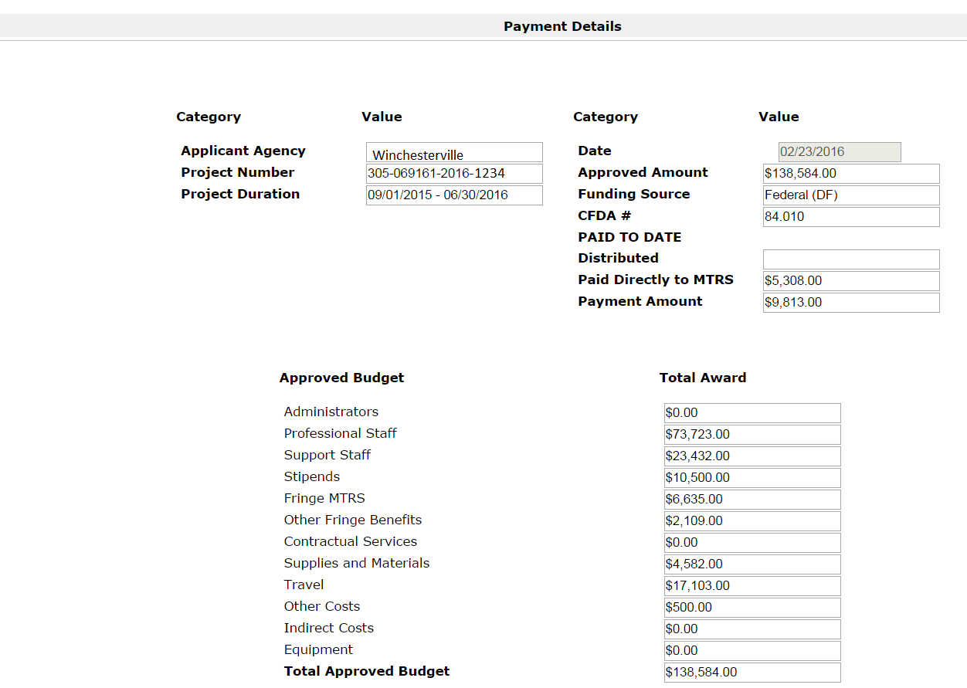
- To print the payment notice, click Export to PDF on the left side menu.
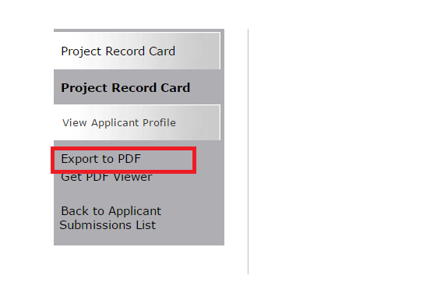

- It will prompt you to Configure the PDF Export – you do not need to change anything here just click the Export to PDF button.
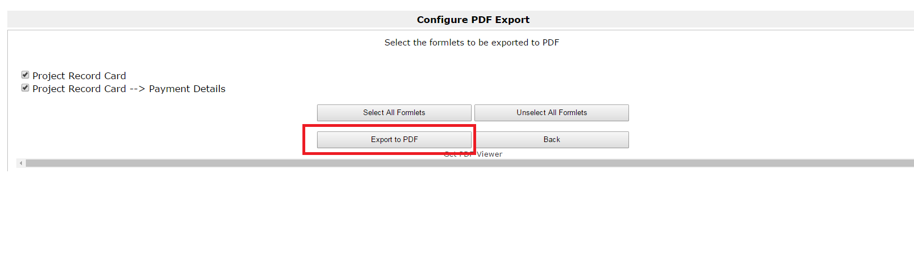
The payment notices are cumulative so when you export the latest one, the Project Record Card as well as each payment notice will export. There is currently no way to just export one at a time. Once exported you can print or save to your files.
Depending on how your PC is set up, there may be a prompt to save and name the PDF export file before it will open/download. Otherwise, the PDF will download and can be viewed and printed from there.

