Uploading Documents - Guide
- Make sure the file that you are going to attach is saved to your computer, and make a mental note of where you have saved it (e.g. desktop, your Documents file, etc.). Also be sure that the file is in a compatible form (e.g., .pdf, .jpg, .docx).
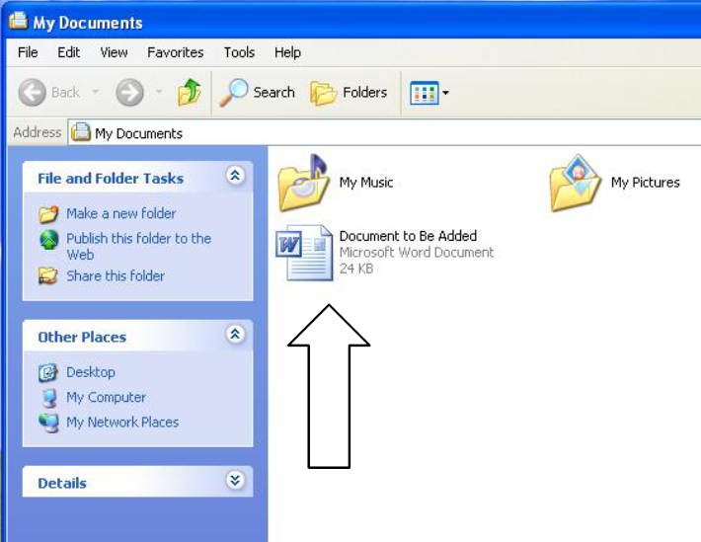
- Click on the “Browse” button
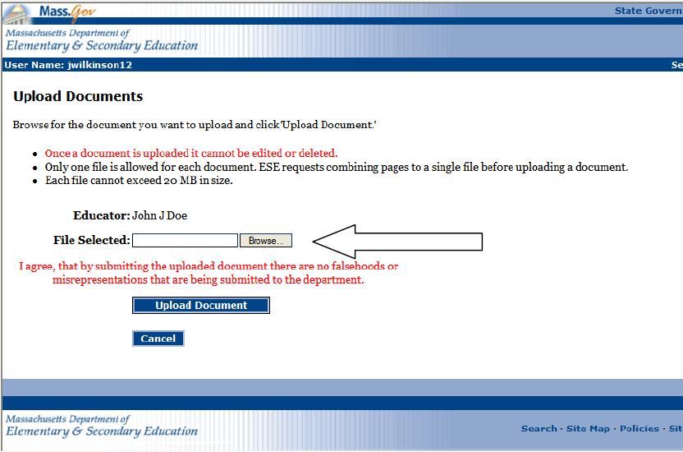
- Locate the file you have saved to your computer, and double click the name of the file (or highlight) and click on the “Open” button.
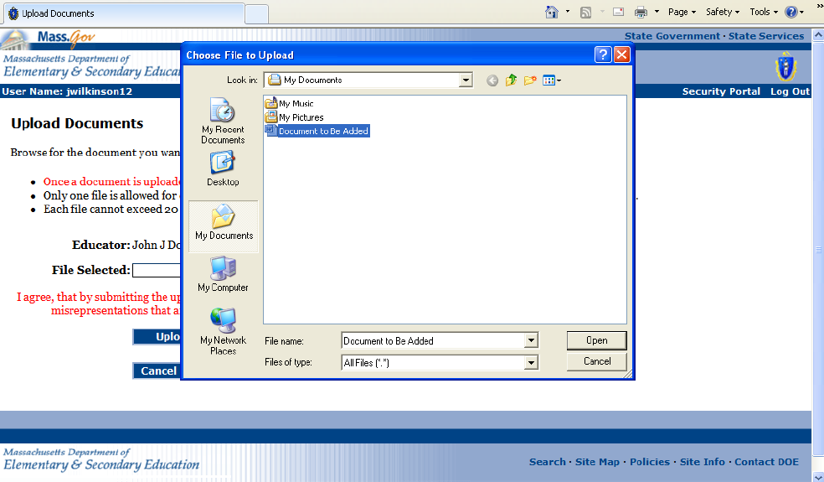
- Click the “Upload Document” button
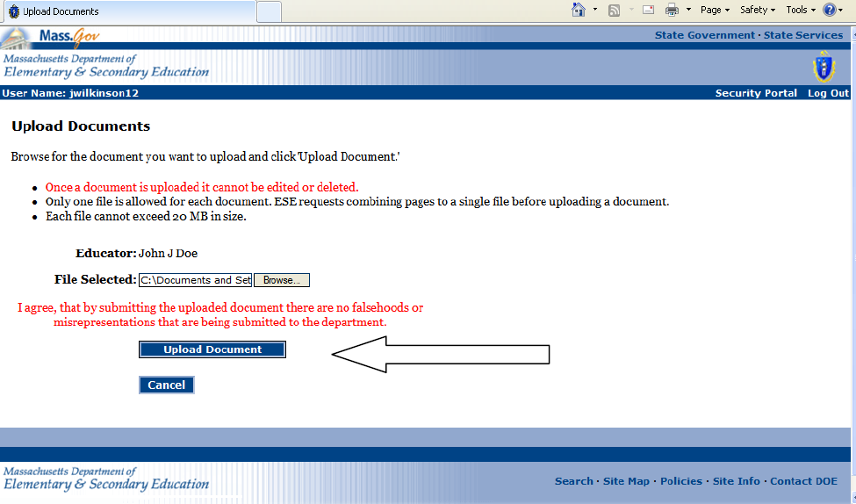
- Select the document type being uploaded from the dropdown menu (please note that types beginning with “Voc” should only be selected when the related application is for a Vocational license.
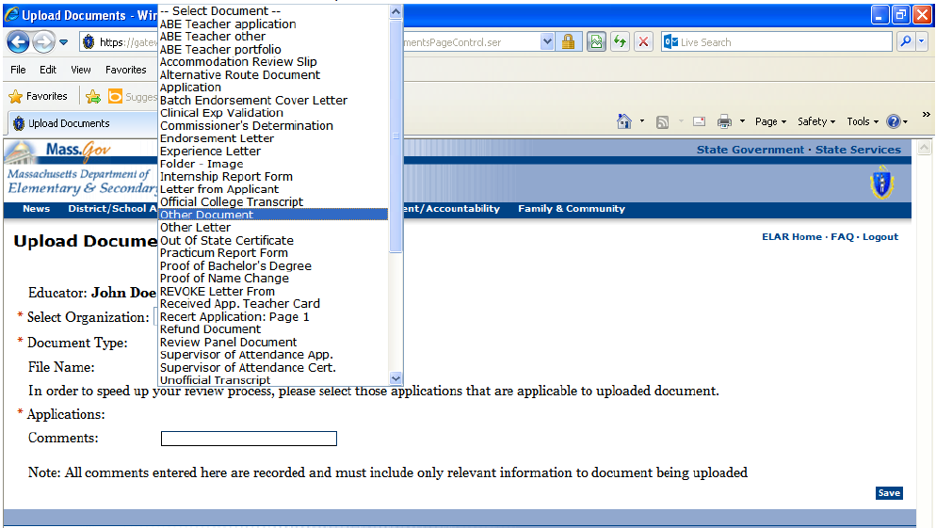
- Select which open License Application you wish the document to apply to. You may choose “All”, “None”, or individually select all applications that apply.
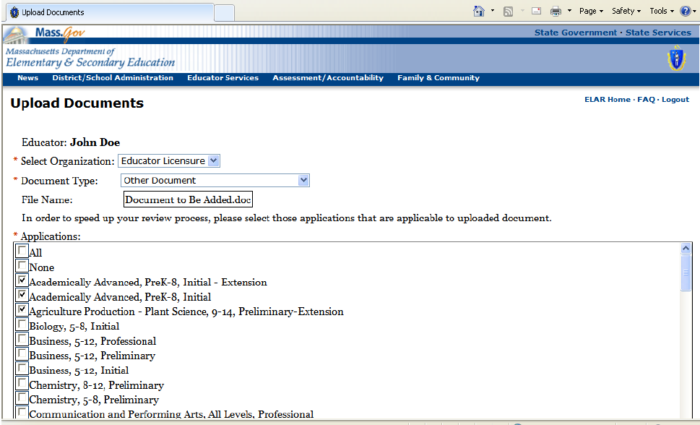
- Add short comment relevant to document being uploaded (optional). Click on “Save” button
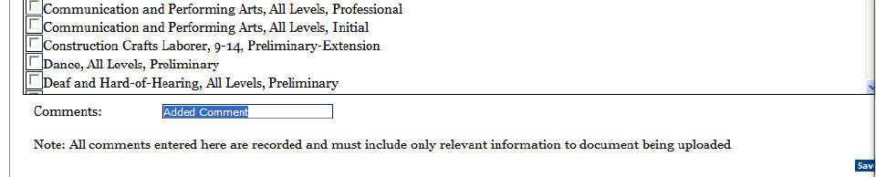
- Click “Done” button to return to the Activity Summary Page or click “Upload More Documents” to continue to add documents to the file.
