Work Description cover sheet for Math Grade 4 NBT A 3.

4 digit rounding problems


Directions for rounding exercise

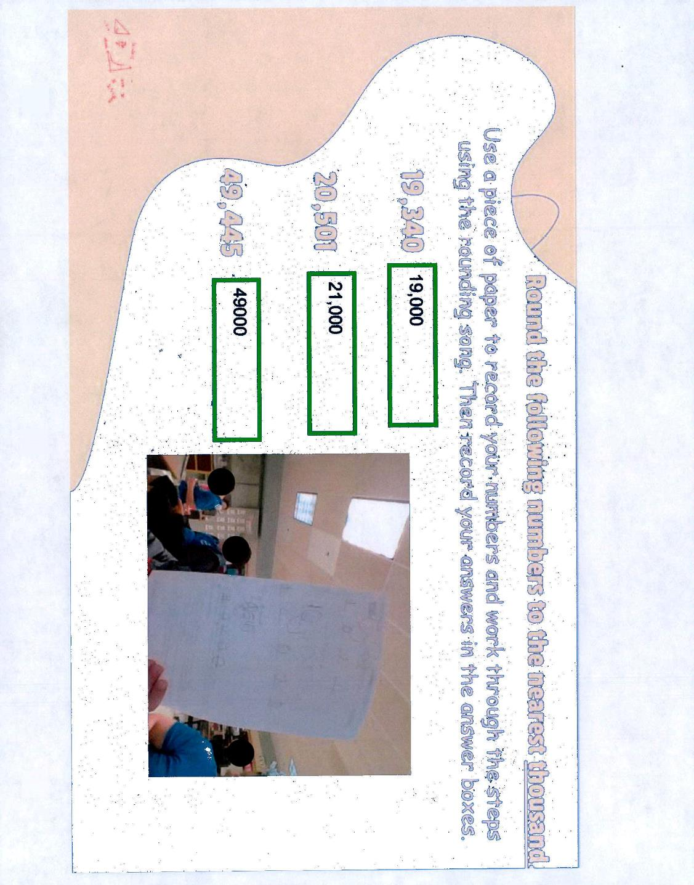student work sample of Rounding Problems
Student work sample of 2 and 4 digit rounding problems.

