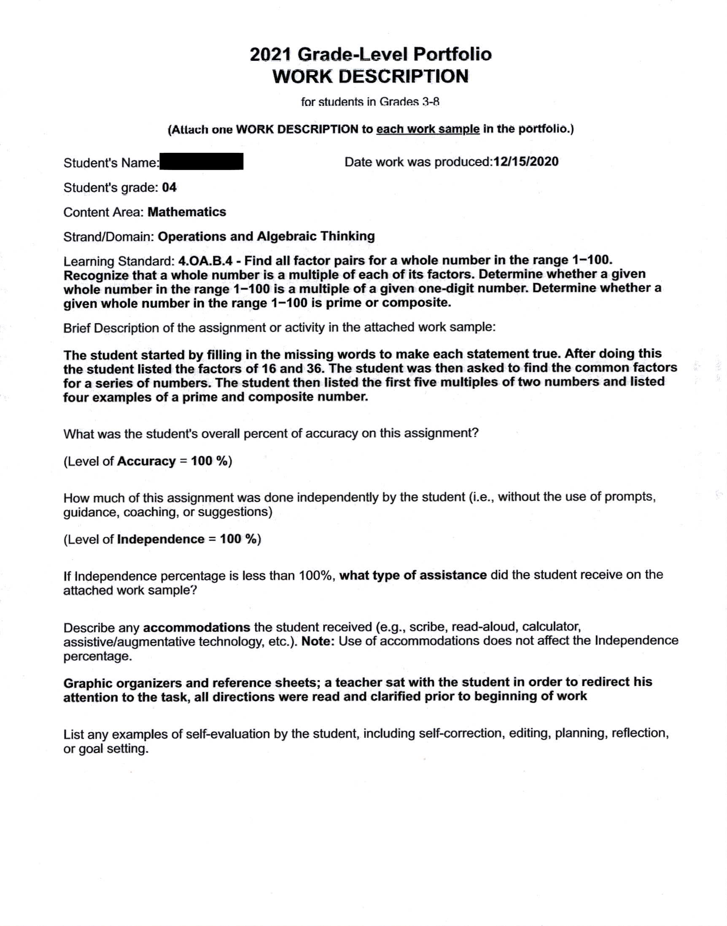student work sample -factors, multiples, prime and composite numbers
Student work sample- factors, multiple, prime and composite numbers
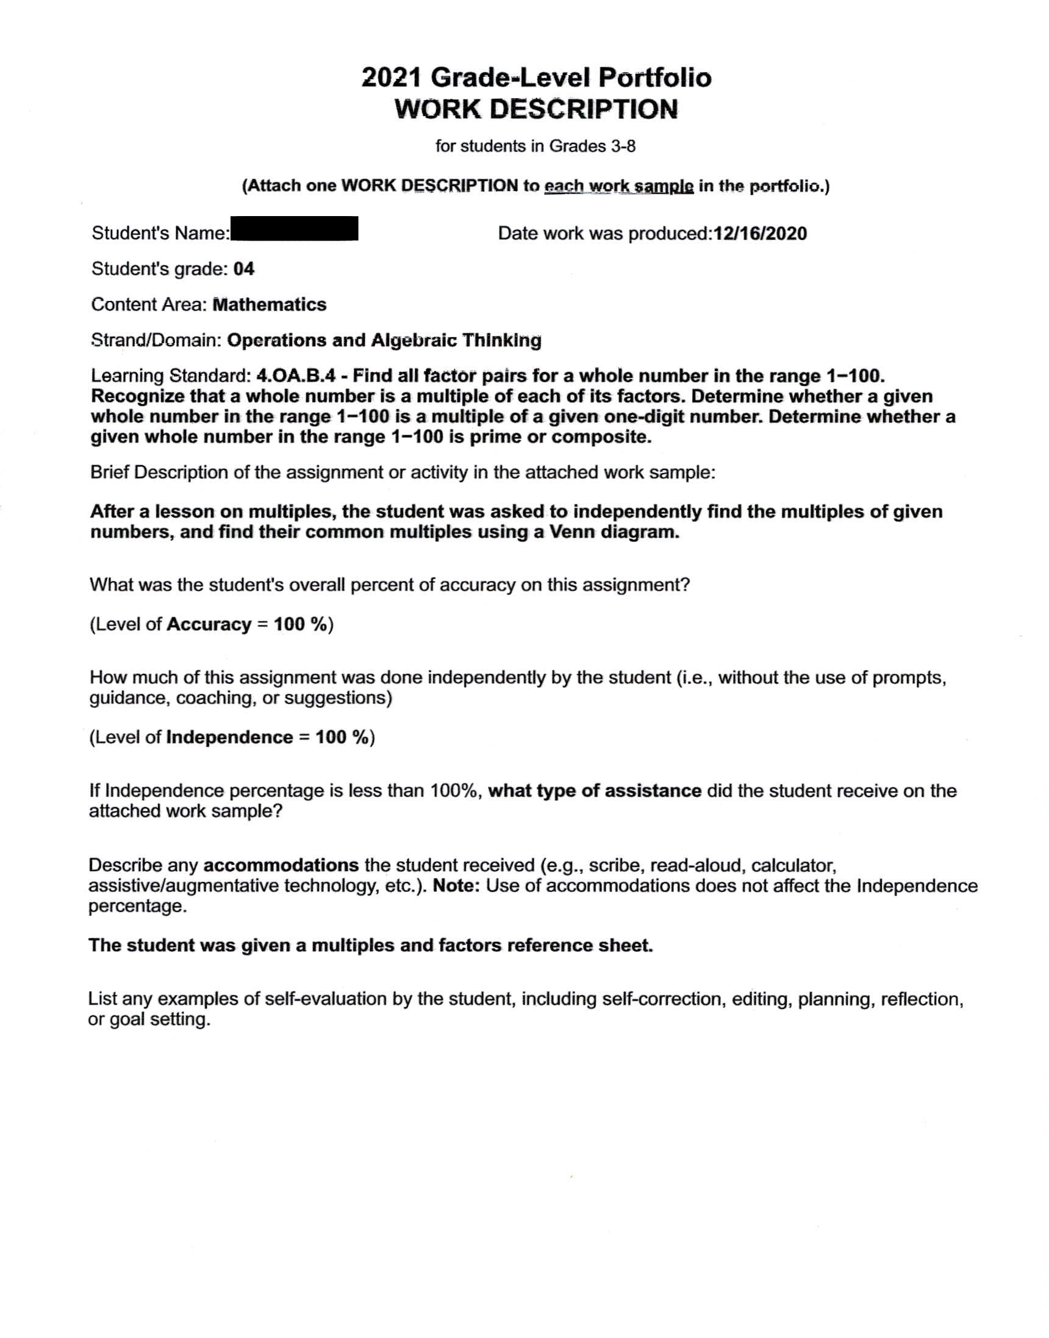student work sample - identify common multiples using venn diagram
