MA Approved World Language Assessment Instruments and Minimum Required Scores or Levels to the World Language Criteria for the State Seal of Biliteracy
Updated 03/11/2024

What Assessments Are Available?
Complete-Domain Assessments
When a Complete-domain assessment is available for the desired language, districts must choose Complete-domain assessments. Exceptions may be made for individual students who require accommodations that the Complete-domain assessments may be unable to provide. In such cases, districts should first contact the Complete-domain assessment vendor to determine if they can make accommodations for the student. If not, the student may require an Alternative assessment.
Partial-Domain Assessments
If a student wishes to demonstrate proficiency in a language for which no Complete-domain assessment is available, districts may consult the list of Partial-domain assessments. Partial-domain assessments are to be used only when Complete-domain assessments are not available for the desired language.
Alternative Assessments
Districts should use Alternative assessments only in the following circumstances:
- The Department does not approve any Complete or Partial-domain assessments for the language in question, or
- The district determines that a student’s disability precludes them from fully accessing Complete or Partial-domain assessments.

Additional Assessments
Students who have already taken a language test in international or community-based language programs may already have satisfied the world language criteria for the State Seal of Biliteracy. While districts are not asked or advised to seek out testing companies under this category, students who already have qualifying scores from these approved assessments do not need to complete further world language assessment.

Which Type of Assessment Should I Choose?

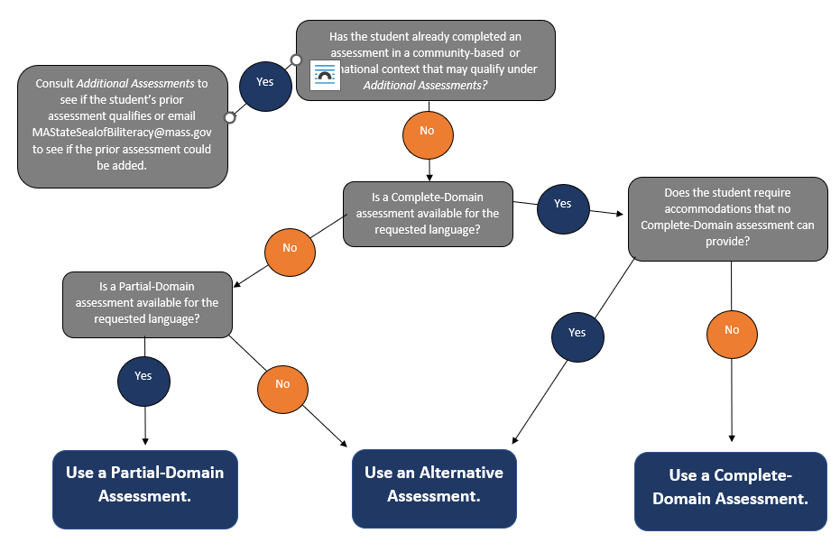

Complete-Domain Assessments
Complete-domain assessments are nationally recognized and readily available assessments that fully satisfy the criteria for the State Seal of Biliteracy. Districts should use Complete-domain assessments for all languages unless the needed language does not have a corresponding Complete-domain assessment. If students require accommodations that Complete-domain assessments cannot provide, please see Alternative Assessments.
World Language Assessments Administered to Students in High School | Source | Language(s) | Domain(s) Assessed | MA State Seal of Biliteracy – Minimum score or level to qualify: | MA State Seal of Biliteracy with Distinction – Minimum score or level to qualify:
AAPPL (ACTFL Assessment of Performance toward Proficiency in Languages) Measure | Language Testing International | Arabic  French  German  Italian  Japanese  Korean  Mandarin Chinese  Portuguese  Russian  Spanish | Listening  Speaking  Reading  Writing | I-5 in all domains (Form B) | A-1 in all domains (Form B)
ALIRA (ACTFL Latin Interpretive Reading Assessment) | Language Testing International | Latin | Reading | I5 in all domains | A1 in all domains
AP©(Advanced Placement) Language and Culture exam | College Board | Chinese  French  German  Italian  Japanese  Spanish | Listening  Speaking  Reading  Writing | 4 | 5
AP©(Advanced Placement) Latin | College Board | Latin | Reading | 4 | 5
ASLFAI American Sign Language Functional Ability Interview | ASLFAI | American Sign Language (ASL) | Holistic | Emerging High | Accelerating Low
ASLPI American Sign Language Proficiency Interview | Gallaudet University | American Sign Language (ASL) | Holistic | 3+ | 4
IB International Baccalaureate | IB | Chinese  French  German  Classical Greek  Latin  Spanish | Listening  Speaking  Reading  Writing | 5 on a Higher-Level exam  6 on a Standard-Level exam | 6 on a Higher-Level exam
Idioma Seal of Biliteracy Assessment | Idioma Education & Consulting | Armenian  Slovak  Greek (modern)  Luganda  Bahasa Indonesian  Bulgarian  Bosnian/Serbian/Croatian  Darija (Moroccan Arabic)  Thai  Nepali | Listening  Speaking  Reading  Writing | Intermediate High on all 4 sections | Advanced Low on all four sections
NEWL National Examinations in World Languages | American Councils for International Education | Arabic  Korean  Portuguese  Russian | Listening  Speaking  Reading  Writing | 4/5
SLPI Sign Language Proficiency Interview | Rochester Institute of Technology | American Sign Language (ASL) | Signing  Attending (Listening) | Intermediate Plus | Advanced
STAMPTM (Standards-based Measurement of Proficiency 4S) | Avant Assessment | American Sign Language (ASL)  Arabic (bilingual)  Arabic (monolingual)  French  German  Hebrew  Hindi  Italian  Japanese  Korean  Latin  Mandarin  Polish  Portuguese (Brazilian)  Russian  Spanish (bilingual)  Spanish (monolingual) | ASL  - Receptive  - Expressive  All other STAMP Languages  - Listening  - Speaking  - Reading  - Writing | Level 6 (Intermediate High) in all domains | Level 7 (Advanced Low) in all domains

Partial-Domain Assessments
Partial-domain assessments are nationally recognized assessments that measure proficiency in speaking and writing. They may be used to demonstrate the levels of proficiency necessary to earn the Seal of Biliteracy until a Complete-domain assessment is approved and listed above. Districts should not use Partial-domain assessments for languages for which Complete-domain assessments are available.

Assessment | Source | Domains | Minimum Score
 |  |  | Seal of Biliteracy | Seal with Distinction
ALTA | ALTA Language Testing | Speaking  Writing | 8 | 9
OPI/WPT | Language Testing International | Speaking  Writing | Intermediate High in each domain | Advanced Low in each domain
Stamp WS | Avant/CASLS | Speaking  Writing | 6 in each domain | 7 in each domain

Language | ALTA | Idioma | OPI/WPT | Stamp WS
Afrikaans
Albanian
Amharic
Arabic (various dialects)
Armenian
Azerbaijani
Baluchi (Western)
Bambara
Bengali/Bangla
Burmese
Cabo Verdean
Cambodian
Chin (Hakha)
Chinese (Cantonese)
Chuukese
Croatian
Czech
Danish
Dari
Darija
Dutch
Ewe
Fante (Akan)
Farsi (Persian)
Finnish
French Canadian
Ga
Georgian
Gujarati
Haitian Creole
Hausa
Hawaiian ('Ōlelo Hawai'i)
Hmong
Hungarian
Ibo
Ilocano
Indonesian
Jamaican Patois
Kannada
Karenni
Kazakh
Kinyarwanda
Kurdish
Laotian
Latvian
Lithuanian
Macedonian
Malay
Malayalam
Marathi
Marshallese
Mongolian
Navajo
Norwegian
Oromo
Pashto
Pashto (Pakistani)
Punjabi
Romanian
Samoan
Serbian
Sinhala
Slovenian
Somali
Swahili (3 skills)
Swedish
Tagalog
Tajik
Telugu
Tibetan
Tigrinya
Turkish
Turkmen
Twi (Akan)
Ukrainian
Urdu
Uzbek
Vietnamese
Wolof
Yoruba (3 skills)
Yup'ik
Zomi

Alternative Assessments
Districts should use Alternative assessments only in the following circumstances:
- The Department does not approve any complete-domain or partial-domain assessments for the language in question, or
- The district determines that a student’s disability precludes them from fully accessing approved complete-domain or partial-domain assessments.

The following vendors are approved by the Department to provide personalized language assessments for students in languages that have no approved complete-domain or partial-domain assessments and for students who require accommodations that approved complete-domain and partial-domain assessments may not be able to provide. Contact the vendors below for more information. Vendors are listed alphabetically.
Approved Vendor/Website | Phone | Email
Idioma Education & Consulting | 978-494-6430 | info@idiomaconsulting.com
Lexikeet | 844-374-6767 | info@lexikeet.com

Additional Assessments*

Language | Assessment | Assessment Provider | Domains | Minimum Score: Seal of Biliteracy | Minimum Score: Seal of Biliteracy with Distinction
Bulgarian | Bulgarian Standardized Test | Sofia University | Listening  Speaking  Reading  Writing | B1 | B1+
French | DALF/DELF/ DELF Scolaire | French Ministry of Education | Listening  Speaking  Reading  Writing | B1 | B2 (DELF, DELF scolaire)  C1 (DALF)  C2 (DALF)
German | Deutsches Sprachdiplom Stufe (I or II) | ZfA – Central Agency for Schools Abroad (Germany) | Listening  Speaking  Reading  Writing | B1 (DSD I) | B2 (DSD II)
Greek (Modern) | Certificate of Attainment in Greek | Center for the Greek Language | Listening  Speaking  Reading  Writing | B1 | B1+
Greek (Modern) | Ellinomatheia | Hellenic Language Center (Greece) | Listening  Speaking  Reading  Writing | B1 | B2
Latvian | Latvian National Language Proficiency Test | Latvian State Educational Content Center | Listening  Speaking  Reading  Writing | B1 | B2
Lithuanian | Lithuanian Language Assessment | Boston Lithuanian School | Listening  Speaking  Reading  Writing | B1 | B2
Swedish | Tisus | Department of Swedish Language and Multilingualism | Reading  Speaking  Writing | Pass (C1) | Department of Swedish Language and Multilingualism
Tamil | AJA Tamil Language Proficiency Assessment | AJA Assessment | Listening  Speaking  Reading  Writing | Equivalent ACTFL Score of Intermediate High in all domains | Equivalent ACTFL Score of Advanced Low in all domains
*If you don’t see your student’s prior language assessment on the list, contact MAStateSealofBiliteracy@mass.gov to inquire.

In response to the COVID-19 crisis in 2020, the AP Language and Culture exams for modern languages reformatted their assessments to facilitate in-home testing. These adjusted exams did not meet the Department’s criteria for World Language Assessments. The 2020 AP exams for Chinese, French, German, Italian, Japanese, and Spanish may not count toward the Massachusetts Seal of Biliteracy. The status of the 2021 AP exams remains unclear. The Department advises districts relying on the 2021 AP Language and Culture exams for Chinese, French, German, Italian, Japanese, and Spanish to prepare contingency plans.

