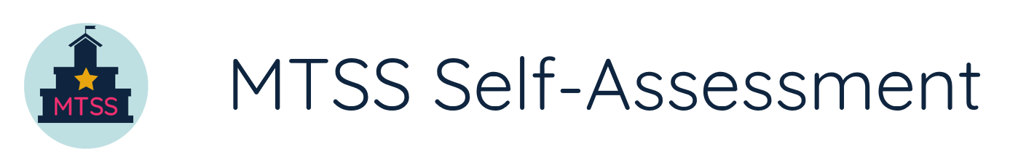
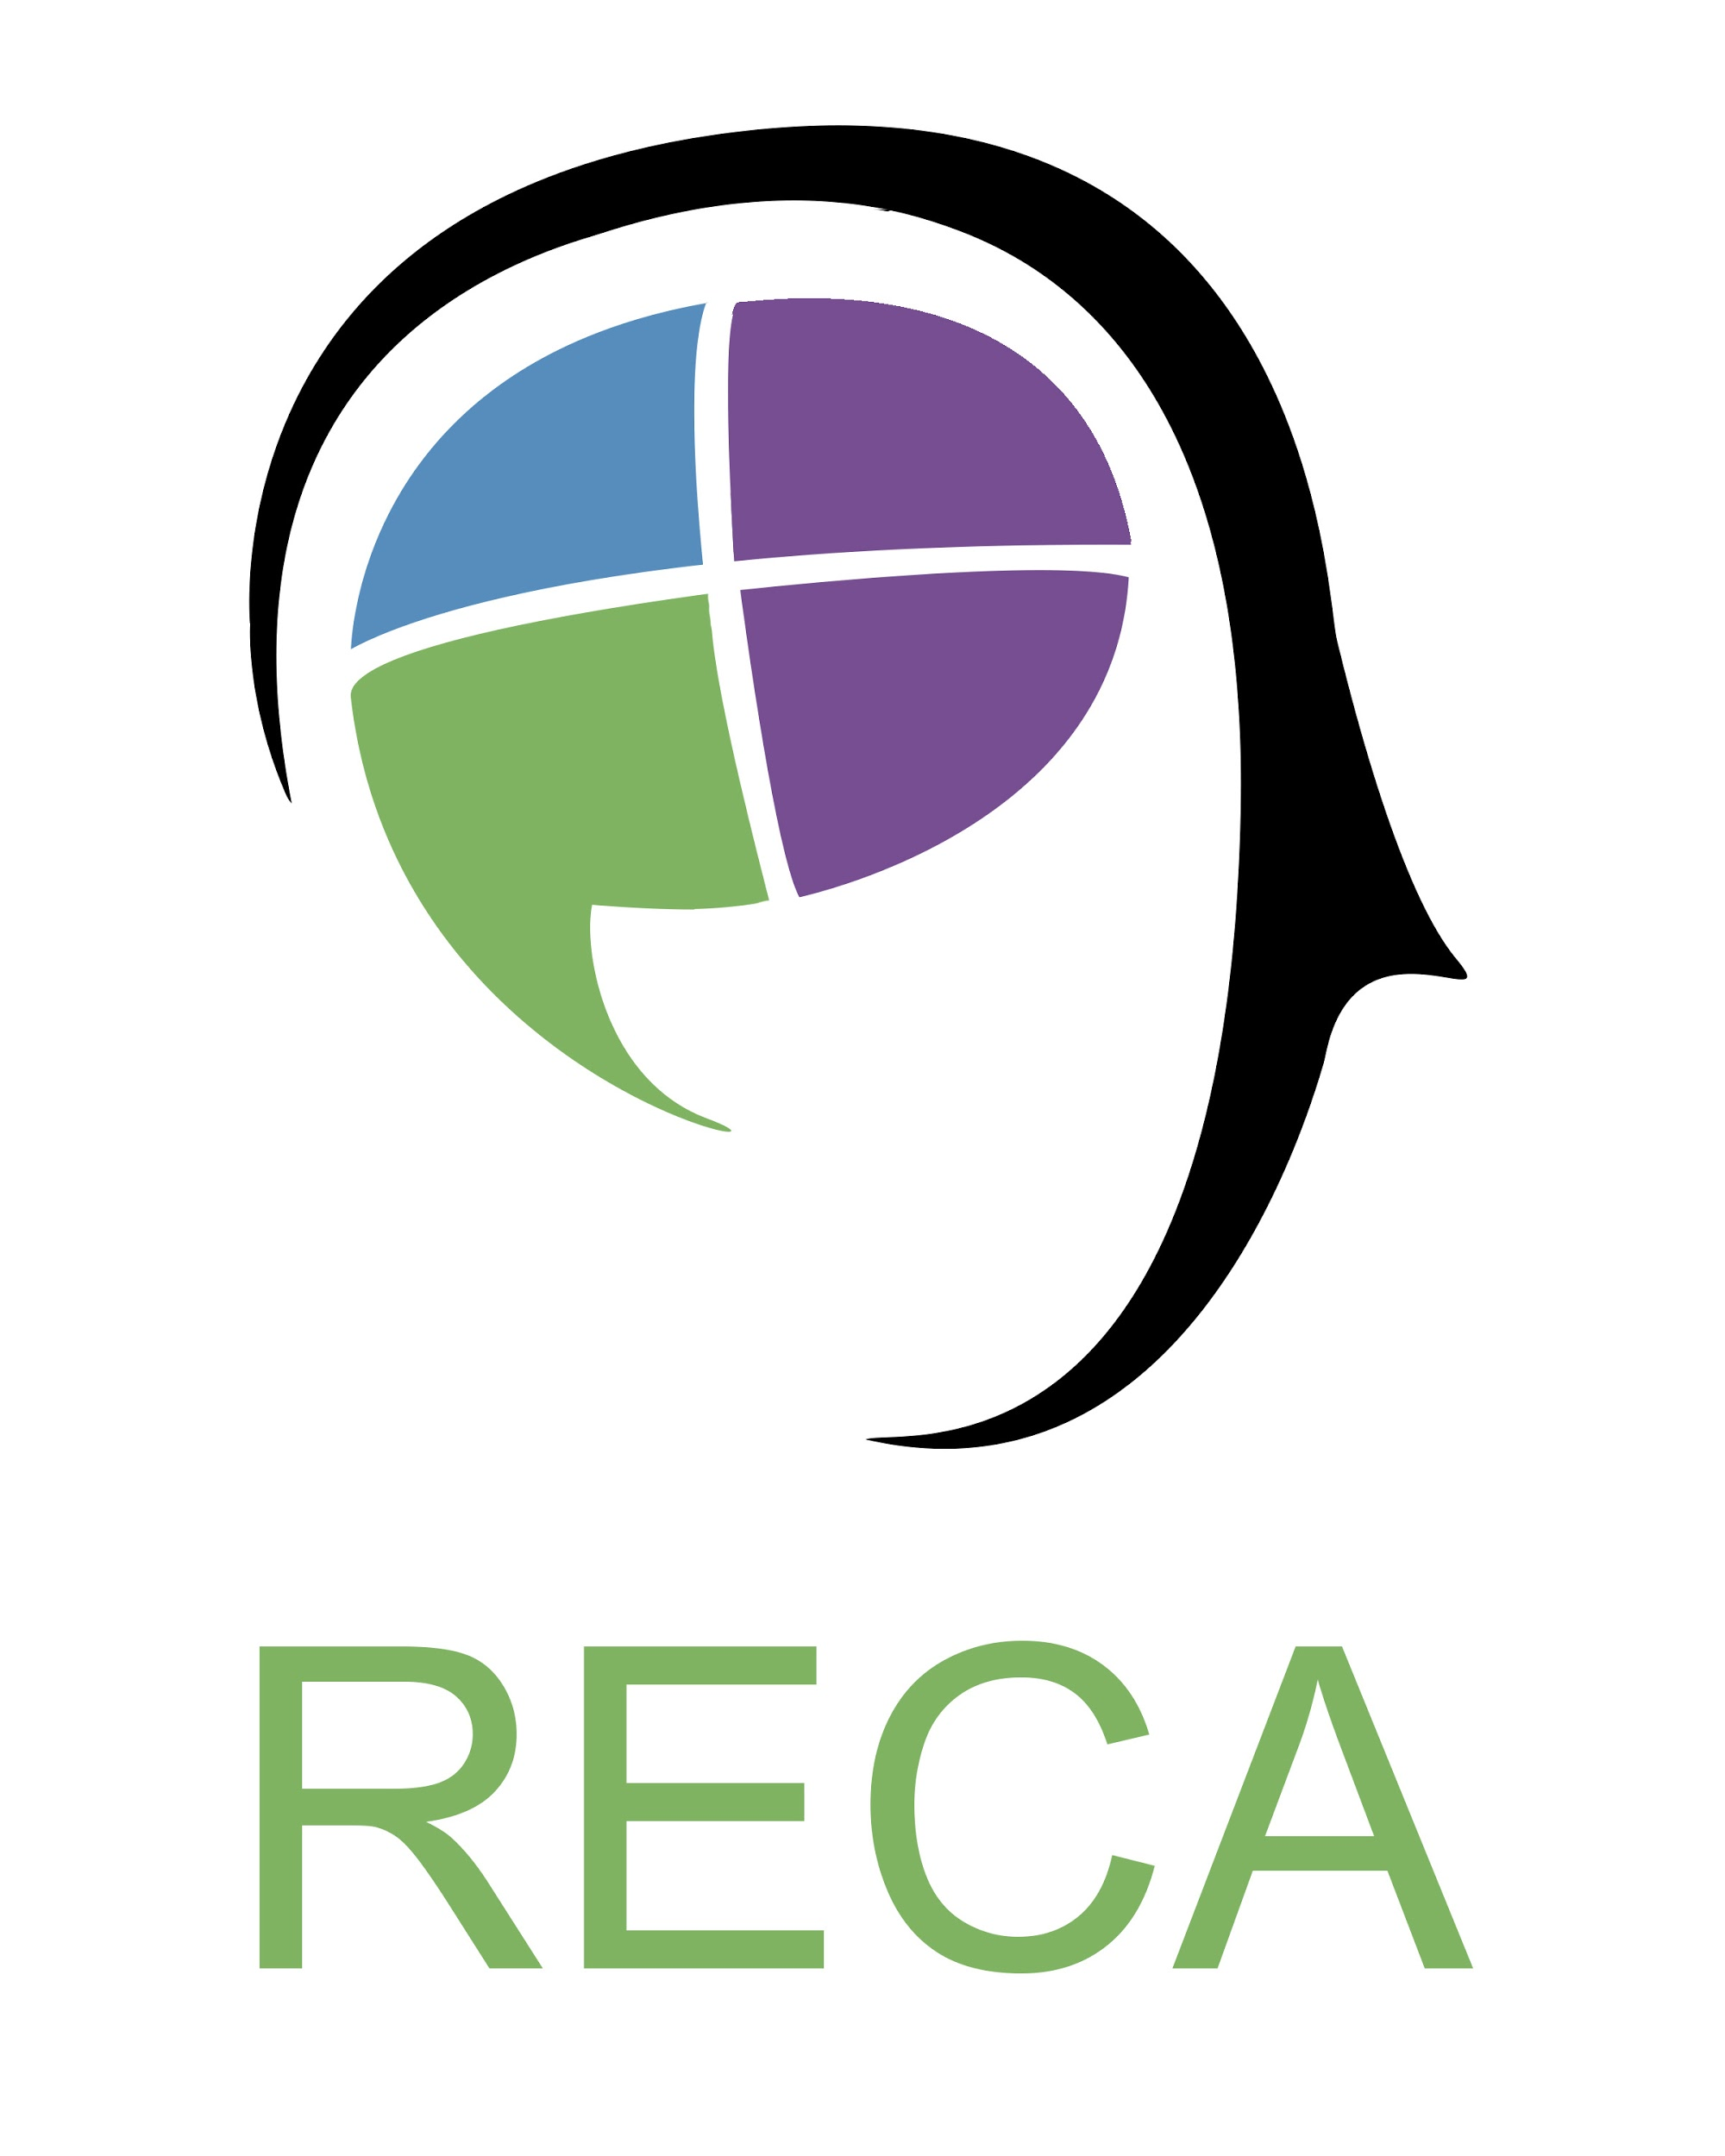
This document was developed in collaboration with Novak Education Consulting and Rodriguez Educational Consulting Agency (RECA).

Directions

This tool is designed to help district teams assess the systems and structures that they have (or do not have) in place to foster an effective multi-tiered system of support (MTSS). The results of the self-assessment will help illuminate current gaps and strengths and can be used for prioritization and planning purposes. This tool was designed to give a district-level perspective and should be used by a team consisting of a range of stakeholders (i.e., representation from different departments, roles, etc.). There are items in this self-assessment that may be utilized by a school to inform their school improvement process, yet the concept of MTSS acknowledges the need for centralized support and thus there are system-level items that may not be applicable to an individual school.

Overall Structure

The self-assessment is divided up by the MTSS Blueprint’s 3 Drivers (Leadership, Competency, and Implementation). Under each driver are a set of indicators and then specific readiness elements under each indicator. The time it takes to complete each section (driver) may vary depending on your team’s size, approach, and style. On average, it is likely to take teams roughly one hour to complete each section thoughtfully. After finishing each section or the entire self-assessment, your team may use additional time to identify short- and longer-term priorities using the prioritization worksheet at the end of this document.
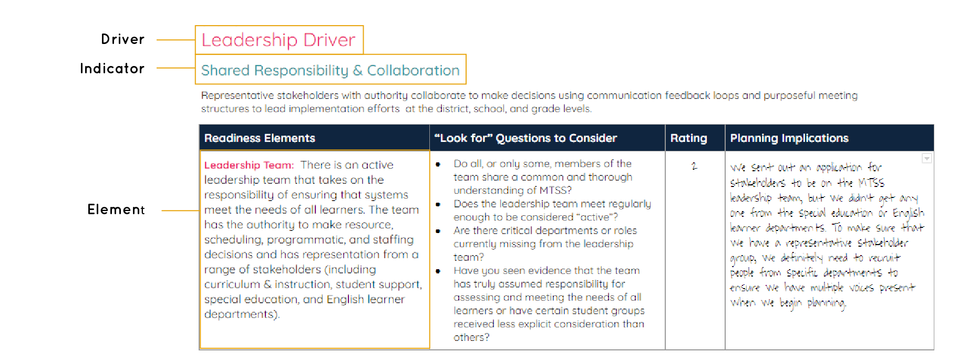
Use this note taking sheet to record the work of your group. Make a copy of this sheet and type your answers below.

For each readiness element, the team is given questions to consider (to guide their thinking), a box to record a rating (0 through 3), and a box to record planning implications. You can see these heading pictured below.

Please read each element thoroughly. Ensure that all terms and vocabulary are clear to all members of the team. For each element, next review the “Look for” Questions to Consider section. The team is not expected to “answer” these questions and record their responses. Rather, these questions are available as a guidepost for team discussions. They should help your team understand the scope of each element and better gauge whether it is not, partially, mostly, or fully in place.

The team is encouraged to rate each element using the defined rating system below. You may choose to have each team member first individually rate each item and then follow up with a discussion to determine an overall group rating - or - you may choose to begin by discussing as a group, without first making individual assessments.

Rating Definitions
0 | Not in place We do not have any parts of this element in place.
1 | Partially in place We are working toward having this element in place but are just at the beginning stages.
2 | Mostly in place We have many parts of this element in place but not all of them are planned for or implemented yet.
3 | Fully in place All components of this element are in place in terms of planning and implementation.

As a result of this rating, the team can put notes into the Planning Implications section. For example, if all leadership team members do not have a common understanding of MTSS, one of the planning implications may be to train them in MTSS.

Table of Self-Assessment Contents
(click the links below to get started on the section you prefer)
Leadership Drivers
Shared Responsibility & Collaboration
Resource Allocation
Student Family & Community Engagement
Competency Drivers
Staff Recruitment, Selection, & Onboarding
PD & Coaching
Feedback & Evaluation
Implementation Drivers
Tiered Continuum of Evidence Based Interventions & Supports
Implementation Fidelity
Data-based Decision Making
High Quality Curriculum & Instruction
Prioritization Worksheet

SECTION 1

Leadership Driver

Shared Responsibility & Collaboration
Representative stakeholders with authority collaborate to make decisions using communication feedback loops and purposeful meeting structures to lead implementation efforts at the district, school, and grade levels.
Readiness Elements | “Look for” Questions to Consider | Rating | Planning Implications
Leadership Team: There is an active leadership team that takes on the responsibility of ensuring that systems meet the needs of all learners. The team has the authority to make resource, scheduling, programmatic, and staffing decisions and has representation from a range of stakeholders (including curriculum & instruction, student support, special education, and English learner departments). | - Do all, or only some, members of the team share a common and thorough understanding of MTSS?  - Does the leadership team meet regularly enough to be considered “active”?  - Are there critical departments or roles currently missing from the leadership team?  - Have you seen evidence that the team has truly assumed responsibility for assessing and meeting the needs of all learners or have certain student groups received less explicit consideration than others?
Administrative Support: All leaders (leadership team, central office, and building level) have a firm understanding of the components and value of MTSS. Central office and building level administration are both committed to providing the time, energy, and resources needed to establish an effective MTSS. | - Do all leaders, or only some leaders, have a firm understanding of MTSS?  - Do leaders’ decisions and actions consistently reflect a belief and commitment to MTSS?  - Do time, energy, and resources all get allocated according to this commitment?  - Do we have a structure so that we will maintain a focus on MTSS through transitions in leadership?
Communication & Collaboration Structures: The leadership team uses effective mechanisms to not only collaborate internally (e.g., agendas, protocols), but to regularly seek input and feedback from key stakeholders (including staff, students, families, and the community) and to communicate important information and decisions. All stakeholders are committed to the work and regularly participate in planning and implementation activities. | - Is there a clear process for seeking stakeholder input on key decisions? Is this process clear to team members and stakeholders? Is it inclusive of staff, students, families, and the community?  - Is there a clear process for communicating decisions made by the leadership team? Is the process effective at reaching all key stakeholders?  - Is meeting participation and membership recorded and reviewed on a regular basis?  - Are meetings used effectively or would they benefit from additional collaboration/facilitation mechanisms?
Policies and Procedures:` Policies are established by the school committee to support equity (e.g, ensuring the annual budget funds schools equitably according to need; requiring an equity audit to be conducted on a regular basis to determine factors such as institutional bias). Similarly, administration defines procedures to ensure that all students can be successful in the school system (e.g. proportional scheduling is used to ensure that all students have access to higher level courses; codes of conduct are developed with an equity lens). All policies and procedures are followed with fidelity. | - Have district policies ever been audited or reviewed through an equity lens?  - Has the district completed an equity audit or an institutional self-evaluation? If so, were student, family, and community voices included?  - Are procedures consistently reviewed for bias and inequity?  - Have we looked closely at the level of implementation fidelity of policies and procedures? If we identified areas of inconsistent implementation, have we done anything to address them?
Scientifically-Based Planning Model: A multi-year planning process is used to thoughtfully examine data and identify priorities, conduct a root cause analysis and develop a logic model for how to address those priorities, and create an action plan to sustainably roll out, implement, and monitor the required systems and strategies identified through the logic model. The action plan is integrated into existing district and school improvement/strategic plans and details who is responsible for what, by when, and what foundational actions need to be taken so that the work can occur. | - Has the team conducted a thorough needs assessment and reviewed research/evidence based models to determine what changes are necessary to meet the needs of all students?  - How did we determine the root causes behind the data we want to address? Are we confident in that process or was it largely based on subjective perceptions and/or assumptions?  - Have we clearly defined how to measure success (both in terms of implementation and the subsequent outcomes)?  - Is our action plan integrated into existing planning documents to streamline improvement efforts or does it feel siloed?  - Have we considered all of the foundational supports necessary to make the action plan successful?

Resource Allocation
The district completes a thorough resource mapping process and prioritizes time/schedules, funding, staffing, and other materials to equitably support the schools, classrooms, and students.
Readiness Elements | “Look for” Questions to Consider | Rating | Planning Implications
Tiered Scheduling: The schedule allows time for evidence-based instruction and interventions to be delivered across all three tiers in order to meet the academic, social emotional, and behavioral needs of students. In addition, the schedule does not remove students from the school’s educational program to receive intervention (i.e., schools are supplementing and not supplanting tier 1 services and are not removing students from lunch/recess and specials like physical education and music). The schedule allows for time to administer assessments to determine the specific needs of all students. | - Has the necessary groundwork been laid to make schedule changes (e.g. does collective bargaining need to occur?)?  - Are school schedules created with the goal of meeting all students’ needs? Have we deliberately examined the schedules from this lens?  - Are key staff/personnel included in creating the schedule?  - Is the schedule reviewed on a regular basis (quarterly/bi-annnually) to ensure necessary adjustments can be made to meet students’ needs?  - Does the district have an assessment calendar that is clearly communicated to all necessary stakeholders?
Common Planning Time: Time is scheduled for department-, grade-, and student-level team collaboration and critical follow-up activities. Common planning times allow for planning across grade levels and content teams and are inclusive of interventionists, special educators, English learner teachers, and student support staff. There are effective protocols to guide these meetings. There is also time allotted for staff to analyze assessment data and determine the appropriate supports for each student (e.g., who needs support in intervention blocks; time for the prereferral process) and what monitoring is needed. | - Is sufficient common planning time built into staff schedules across schools, departments, and grade levels?  - Are common planning times supported with the guidance, professional development, and feedback needed to ensure that they are used effectively?  - Is there time to effectively use data to identify student needs and progress indicators?  - Are key individuals (e.g., student support staff, interventionists) often missing from common planning time?
Fiscal Support: The budget provides appropriate levels of funding for intervention materials and assessments, as well as for key positions (e.g. intervention staff, instructional coaches). Prior to budgeting, the district maps current resources and then considers internal funding mechanisms and reallocation of resources (e.g. the general fund), community partnerships (e.g. resources garnered through community organizations or foundations), and external funding mechanisms (e.g. federal and state grants) to fund budget priorities aligned with tiered systems of support. | - Does the district commit to using A-ROI (Academic Return on Investment) to determine the effectiveness of resource allocation?  - Does the budget guidance focus on designing a multi-tiered system of support that supports all students?  - Does the district actively seek additional funding through grant applications, community partnerships, and reallocation?
Inclusive and Equitable Resources: The budget, staffing models, and master schedule are reviewed with a lens of inclusion and equity (e.g., do we ask questions like, “What is the typical proportion of learners with diverse needs in the general education classroom—for example, students who are English learners (ELs) or students with individualized education programs (IEPs)?” and “What is the composition of students enrolled in advanced, honors, and AP courses?”). Based on answers to those questions, the team makes decisions to modify the schedule and allocation of resources to move toward a more inclusive learning environment. Student needs and performance data drive the fiscal and asset management process. | - How is staffing prioritized to support tiered systems of support?  - Have we not only looked at the equitable use of resources within a school, but also across schools in the district?  - How have we organized our schedules to support tiered instruction? Are specific groups of students receiving inequitable access to inclusive environments or advanced courses?  - If we have uncovered inequities in resource allocation, have we actively identified ways to address them?

Student, Family & Community Engagement
Effective systems and practices are used to foster two-way communication and collaboration between administration, staff, students, families/caregivers, and community partners.
Readiness Elements | “Look for” Questions to Consider | Rating | Planning Implications
Welcoming Environment & Relationships: The district and schools create a welcoming culture and environment for all families/caregivers, students, school staff, and community members. Stakeholders are valued and connected to each other in support of high academic expectations, achievement, and healthy development and wellbeing. | - Do school environments actively embrace and reflect the communities that they serve?  - Do all staff and administrators have positive regard for students, families, and the community? Do they believe that all students can succeed at high levels and view their cultures/backgrounds as an asset to success?  - Do we proactively train and support staff in building strong relationships?  - Are there multiple opportunities and mechanisms for all families to engage in the school community?
Effective Communication: Families/caregivers, school/district staff, and administration engage in regular, meaningful dialogue about learning, high academic expectations, and the healthy development of students. Schools systematically share information using multiple communication pathways and solicit input about school goals and initiatives with students, families, and the broader community. | - How often do we engage with families/caregivers about student learning? Through what mechanisms?  - Is feedback usually initiated when a challenge arises or are there proactive, planned opportunities to share positive progress as well?  - Is there frequent two-way communication where families are encouraged to share their voices, strengths, and feedback with the school community?  - Are communications made accessible to all families/caregivers (e.g., properly translated, delivered in a preferable medium, etc.)?
Shared Power & Responsibility: Families/caregivers, students, school staff, and community partners have equal access, voice and value in informing, influencing, and creating policies, practices, and programs affecting children, youth and families. | - Are there outreach efforts to ensure that families and the community have meaningful opportunities to learn about and weigh in on district/school improvement efforts?  - Are the members of leadership councils/teams representative of the school community?  - Are there outlets for student and family leadership outside of the traditional/mandatory opportunities (e.g., student council, PTA, etc.)?  - Do school/district goals reflect the priorities of students, families, and the community?
Engagement in Student Support: Families/Caregivers and students are actively engaged in student support processes/decisions and regularly informed about progress. Families/caregivers receive the information they need to advocate for their children and are informed of their rights to request a special education evaluation at any time during the tiered support process. | - Do students and families play an active role in identifying their strengths and needs and determining what approaches will be used to support them?  - Are we communicating student progress to families/caregivers across all three tiers?  - Is the district transparent about family/caregiver rights? How are these rights communicated to all families?  - Do families/caregivers understand the components and value of MTSS and how it differs from special education?  - Are administrators and educators committed to supporting and interacting with the Special Education Parent Advisory Council?
Community Partnerships: Community partners are actively engaged to better support students and families/caregivers and to connect them to social services related to health, social, recreational, and supplemental educational services. | - Do we proactively leverage the skills, capacities, and assets within our community as we design learning experiences that meet the needs of all students?”  - Do we use data to deliberately determine our partnership needs and identify the appropriate partners to support them?  - Do we have an effective system for managing partnerships (e.g., identifying partners, articulating clear roles and responsibilities, monitoring their effectiveness, etc.)?  - Are partnerships allocated equitably across schools or are they largely established based on geography, pre-existing relationships, or the entrepreneurialism of school leadership?  - Have we examined all types of partnerships to meet our student and family needs (e.g., wraparound, enrichment, higher ed, etc.)?

SECTION 2

Competency Driver

Staff Recruitment, Selection, & Onboarding
Administrators, teachers, and other staff are recruited and selected for their specific knowledge, skills, and experience as well as their shared belief that all students can succeed. Effective onboarding strategies are used to ensure that staff (across all three tiers) have the information and support they need to be successful in their respective schools and roles.
Readiness Elements | “Look for” Questions to Consider | Rating | Planning Implications
Core Understanding and Beliefs: All staff have a firm understanding of the components and value of MTSS and believe that all students can be successful with appropriate levels of support. | - Do all staff understand the value and importance of an MTSS approach or only some staff members?  - How are the core beliefs of MTSS continually shared with staff and integrated into other school initiatives?
Hiring and Onboarding: Hiring criteria, recruitment, and selection for all district/school administrators, educators, and other staff include knowledge, skill, and experience implementing MTSS. Onboarding programs and strategies support the building of MTSS expertise and skill sets. | - Are the beliefs and principles of MTSS embedded in job descriptions, interview questions, performance tasks, or other hiring criteria?  - Does the teacher induction/onboarding program specifically focus on supporting all new hires in implementing inclusive practice in a multi tiered system of support?
Staffing Design: The staffing model and staff roles are designed to support implementation of MTSS based on students’ needs. Careful consideration is given to staff titles and duties to foster a positive approach to meeting the needs of all students. In addition, staff are (re)allocated based on student need annually and throughout the year (e.g., if additional tier 2 supports are identified as a need, staff schedules should be adapted to offer the necessary supports). | - Are staffing models reviewed on an ongoing basis to ensure that all students receive support when they need it from highly qualified educators?  - Are staff role descriptions designed to ensure success for all students (including position titles and duties)?

PD & Coaching
The district establishes a sustainable professional development plan that offers high-quality, ongoing support as well as individualized and team-specific coaching, and builds staff’s ability to support the academic, behavioral, and social emotional needs of students at all three tiers.
Readiness Elements | “Look for” Questions to Consider | Rating | Planning Implications
High Quality PD: Adequate time is provided for professional development to support the foundations of MTSS (such as PD on Universal Design for Learning and culturally sustaining practices) and those professional learning options are embedded into the district and school PD plans. Staff actively participate in high-quality, universally designed, and ongoing PD with the goal of improving instructional practice and student outcomes. The PD meets the Massachusetts Standards for Professional Development and focuses on student academics as well as the social emotional/behavioral/mental health dimensions of learning. | - Does the school calendar include adequate time for teacher professional development?  - Is our PD universally designed to meet the varying needs of staff (e.g., due to differences in roles, experience levels, preferred learning approaches, etc.)?  - What early professional learning needs to occur to build the foundation for more advanced training?  - Have we determined how to scale up the professional learning options to meet the needs of the early adopters as well as those just beginning?
Adult Learning Culture: District and school culture is conducive to adult learning, where all staff hold themselves jointly responsible for student outcomes and regularly share their strengths and struggles in the spirit of helping each other continually improve practice. Professional development offerings are guided by data and student outcomes. | - Do we provide the time and space for educators to collaborate and reflect on their new practice?  - Do leaders model the ability to self-reflect, receive constructive feedback, and actively work on their practice?  - Are we thoughtful and deliberate about prioritizing PD that is aligned to our student needs?  - Is there evidence that all educators, regardless of role, share ownership for students’ success?
Coaching: Specific staff are identified for advanced training in meeting the academic, social emotional, and behavioral needs of students (i.e., coaches). Coaches use multiple points of evidence to identify potential professional development priorities for teachers. Both teachers and their coaches work to draw out the connections between teacher actions, student actions, and student outcomes. Coaches work with teachers to determine the most appropriate professional development activities to efficiently close gaps in their practice or to build upon existing strengths. Coaching needs and functions are identified at both the district and school-levels and are reviewed at least annually. | - Is there a distributed leadership model where educators have the opportunity to support their colleagues?  - Do coaches not only have sufficient expertise in their content area, but also the knowledge and skills to successfully coach other educators?  - Is instructional coaching personalized based on the needs of teachers? Do teachers receive sufficient coaching support to have a meaningful impact on practice?

Feedback & Evaluation
The district establishes structures to provide staff with meaningful feedback about how to continually improve their practice. When part of a formal evaluation process, the feedback mechanisms are aligned and integrated with the Massachusetts Educator Evaluation Framework. Feedback and evaluation data are used to inform the district’s ongoing plans for professional development and implementation support.

Readiness Elements | “Look for” Questions to Consider | Rating | Planning Implications
Feedback to Support Implementation: The district utilizes feedback data (e.g., learning walk data; evaluation ratings) to inform ongoing PD, planning, and implementation support. | - Are multiple data points used to determine the effectiveness of district programs, practices, and initiatives?  - How often is this data analyzed and shared with all stakeholders?  - Is the data actively used to change PD, planning, and implementation support?
Academic Focused Feedback & Evaluation: The educator evaluation process is used to provide formal and informal feedback related to meeting the academic needs of students. The feedback is used to develop meaningful, actionable goals to improve practice and impact student achievement. Academic and social emotional/behavioral practice goals are integrated where appropriate. | - Are all educators supported to create meaningful student learning and professional practice goals that align to the district commitment to MTSS?  - Do all educators receive targeted, constructive feedback through informal and formal evaluations that helps them to scale academic inclusive practices through MTSS?
Social Emotional & Behavioral Focused Feedback & Evaluation: The educator evaluation process is used to provide formal and informal feedback related to meeting the social emotional and behavioral needs of students. The feedback is used to develop meaningful, actionable goals to improve practice and impact student outcomes. Social emotional/behavioral and academic practice goals are integrated where appropriate. | - Are all educators supported to create meaningful student learning and professional practice goals that align to the district commitment to MTSS?  - Do all educators receive targeted, constructive feedback through informal and formal evaluations that helps them to scale behavioral, social and emotional inclusive practices through MTSS?

SECTION 3

Implementation Driver

Tiered Continuum of Evidence Based Interventions and Supports
The district provides a tiered continuum of evidence-based practices, interventions, and supports that are culturally sustaining and universally designed. All students have access to Tier 1 instruction and supports. Tier 2 and Tier 3 interventions and supports are delivered with increasing levels of intensity based on student need and do no supplant Tier 1 instruction.
Readiness Elements | “Look for” Questions to Consider | Rating | Planning Implications
Academic Supports & Interventions: Tier 1 academic expectations are articulated and known by all. Within tier 1 there is a range of supports to meet the needs of all learners. In addition, there is a range of tier 2 and 3 academic interventions (supplemental to tier 1) targeted to specific skills/needs of the student and identified by assessment data. All instruction, interventions, and supports are evidence-based, culturally sustaining, and universally designed. Data is used to monitor the effectiveness of interventions regularly. | - Is the district DCAP used to ensure that all students have access to academic accommodations and support when they need them?  - Have all instruction, interventions, and supports been evaluated to ensure they are evidence-based, culturally sustaining, and universally designed?  - Do all students have access to a high quality curriculum in tier 1?  - When students need tier 2 and tier 3 support, does it supplement tier 1 instruction or supplant it?
Social Emotional and Behavioral Supports & Interventions: Tier 1 social emotional and behavioral supports are articulated and known by all. Within tier 1 there is a range of supports to meet the needs of all learners. In addition, there is a range of tier 2 and 3 social emotional and behavioral interventions (supplemental to tier 1) targeted to specific needs of the student and identified by data. All instruction, interventions, and supports are evidence-based, culturally sustaining, and universally designed. Data is used to monitor the effectiveness of the interventions regularly | - Is the district DCAP used to ensure that all students have access to behavioral and social emotional accommodations and support when they need them?  - Have all instruction, interventions, and supports been evaluated to ensure they are evidence-based, culturally sustaining, and universally designed?  - Are tier 1 behavioral and social emotional supports integrated with and reinforced through core academic instruction?  - When students need tier 2 and tier 3 behavioral and/or social emotional supports, does it supplement tier 1 instruction or supplant it?
Supporting Students with Disabilities: IEPs are designed to enable the student to progress effectively in the content area of the general curriculum and within the life of the school. This ensures the student has access to the least restrictive environment and tiered supports as appropriate. Inclusive practice and inclusion are cornerstones of educational programming. | - Do all administrators and educators understand the continuum of services available for students with disabilities?  - Does the district provide professional development focused on meeting the needs of students with disabilities?  - Is there a shared commitment to removing the barriers that can make a general education classroom too “restrictive”?  - Are tiered supports available to all students when they need them, including students with disabilities?
Supporting English Learners: The district and schools ensure English learners are able to access the general curriculum and the tiered system of support. Data (e.g., ACCESS) is used to measure student proficiency in reading, writing, listening, and speaking English, as well as the progress they are making in learning English. This data is used to inform supports provided to students. | - Does the district provide professional development focused on meeting the needs of English learners?  - Are tiered supports available to all students when they need them, including English learners?

Implementation Fidelity
The district and schools utilize processes and feedback loops to regularly monitor whether strategies, structures, and programs are consistently being implemented as designed and having the desired effect. Based on the feedback, there are processes to make midcourse corrections and strengthen supports as needed.
Readiness Elements | “Look for” Questions to Consider | Rating | Planning Implications
Measures & Processes to Monitor Fidelity: Fidelity measures are identified to assess the implementation of evidence-based strategies, instruction, and interventions. Measures can be at the district, school, and classroom levels and build a common understanding of what success looks like (e.g., you might regularly assess that evidenced-based curriculum and instructional systems exist through curriculum reviews and classroom observations). Clear processes are in place to determine how, when, and who will assess the fidelity measures. | - Are there procedures in place to ensure that curriculum, instruction, and interventions achieve district/school achievement goals?  - Are there procedures (i.e, coaching, educator evaluation) to ensure that educators consistently follow key principles and inclusive teaching practices?  - Does everyone share the same understanding/vision of what successful implementation looks like?  - Are educators encouraged to share their challenges and successes in implementing evidence-based strategies?
Midcourse Corrections & Continuous Improvement: Based on the data collected through the fidelity monitoring and feedback loops, decisions are made about how to enhance the effectiveness of the work (e.g., shifting approaches, providing additional professional development and support, etc.). These processes are designed to support open communication and productive feedback to ensure the work can be successfully implemented and sustained. | - Is implementation and fidelity data collected and analyzed at regular intervals?  - Is that data used to make shifts in practice/support?  - How often do teams make data-based decisions to ensure that implementation improves the outcomes of all learners?

Data-Based Decision Making
District and school leadership teams regularly use formative and summative data to evaluate systems, strategies, policies, and student outcomes. This data is used to inform action plans at the district, school, classroom, and individual student levels. Decisions about student instruction/interventions are made using universal screeners, diagnostic assessments, and progress monitoring and teams engage in a strategic problem solving process in order to identify students’ needs and determine next steps.
Readiness Elements | “Look for” Questions to Consider | Rating | Planning Implications
Data Culture and Competency: A culture exists that supports the use of data not solely for accountability purposes, but to drive instructional decisions and identify and address inequities. Staff can articulate the value of using aggregated and disaggregated data to support all students and professional development time is dedicated to help staff learn how to use data to drive instruction and monitor interventions. Data is used to assess systems in the district and schools that may be impacting equity and outcomes for all students. For example, regular equity audits are conducted at the school and district levels to identify where students are disproportionately impacted by policies, practices, and/or instruction. | - Do we use both aggregated and disaggregated data to uncover inequities and inform our work?  - Do all staff have the time and support they need to effectively use data?  - How often is data used to make classroom, school, and district level decisions?
District and School Data Systems: District and school-level data systems are used to track student performance over time. These data systems are used to provide regular performance feedback to school teams, coaches, and individual staff for problem solving, professional development, and action planning. Data systems are not only inclusive of the data sets/platforms, but the meeting times and protocols needed to utilize the data effectively. | - Do we have the data systems/platforms we need to effectively track student performance over time and across multiple measures?  - Do all staff have appropriate access to the data they need?  - Do our data systems effectively “talk to one another” and allow us to get a holistic picture of student strengths and needs?  - Does the system set aside time and have defined protocols to ensure data meetings run effectively?
Assessment Maps: The district and schools have annual assessment maps. The assessment map includes universal screeners, diagnostic assessments, and progress monitoring tools focused on academic skill development as well as social emotional and behavioral development. | - Are the the assessment maps consistent across the system within grades?  - Are assessment maps reviewed regularly to ensure they provide effective data to support students across all tiers and domains (i.e., social emotional/behavioral in addition to academics)?  - Do the assessment maps articulate the audience, scope, and timing for each assessment?  - Are pertinent staff trained in assessment protocols and analysis for all adopted assessments articulated on the map?

High Quality Curriculum and Instruction
Tiered instructional models work best when high quality curriculum materials are used and instructional pedagogy is universally designed and culturally sustaining.
Readiness Elements | “Look for” Questions to Consider | Rating | Planning Implications
Universally Designed and Culturally Sustaining Instruction: The district has a process to review instructional methods and strategies to ensure that they are universally designed (e.g. to determine accessibility and engagement) with a lens of equitable access (e.g. materials are free of bias). In turn, teachers’ pedagogy reflects the principles of UDL and is culturally sustaining. | - Is there a process for reviewing instruction to ensure it is universally designed?  - Do all educators receive the professional development and support they need to ensure that their classrooms and instruction are culturally sustaining?
Standards Incorporated Into Tiers: State standards are addressed across all three tiers. For example, the instructional goals and resources used at all three tiers are reviewed and assessed for their alignment to the standards (grade level, access, or entry points). | - Are there articulated curriculum maps for instruction across all three tiers that demonstrate standards alignment?  - Do intervention plans and correlated student learning goals clearly align with grade level, access, or entry point standards?
High Quality Materials: Materials across all three tiers exhibit a coherent sequence of target skills and knowledge (i.e., they are vertically and horizontally aligned), have an empirical evidence of efficacy, and include engaging content and inclusive design. | - Do all teachers have access to high-quality curricular materials?  - Is there a process to assess current or new materials using the high quality standards?  - Have we audited our curriculum materials to ensure they are vertically and horizontally aligned and culturally sustaining?

Prioritization Worksheet

 | Short Term Priorities | Longer Term Priorities
Leadership Driver
Competency Driver
Implementation Driver

