Massachusetts Department of
Elementary and Secondary Education (MA DESE)

State Systemic Improvement Plan (SSIP)
Phase III, Year 3 Report

FFY 2017
Submitted March 29, 2019

Table of Contents
Acronyms and Abbreviations 1
A. Summary of Phase III Year 3 2
1. Massachusetts SIMR and Theory of Action 3
2. Summary of Improvement Strategies 5
3. Evidence-Based Practices Implemented to Date 7
4. Evaluation Activities, Measures, and Outcomes 8
5. Highlights of Changes to Implementation and Improvement Strategies 10
B. Progress in Implementing the SSIP 12
1. Description of the State’s SSIP Implementation Progress 12
2. Stakeholder Involvement in SSIP Implementation 21
C. Data on Implementation and Outcomes 24
1. How the State Monitored and Measured Outputs to Assess Effectiveness 24
2. How the State has Demonstrated Progress and Made Modifications to the SSIP 31
3. Stakeholder Involvement in the SSIP Evaluation 34
D. Data Quality Issues 36
1. Data Limitations, Implications, and Plans for Improving Data Quality 36
E. Progress in Achieving Intended Improvements 38
1. Assessment of Progress toward Achieving Intended Improvements 38
F. Plans for Next Year 58
1. Additional Activities to be Implemented Next Year (with timeline) 58
2. Planned Evaluation Activities Including Data Collection, Measures, Expected Outcomes 60
3. Anticipated Barriers and Solutions 63
4. State’s Need for Additional Support/TA 63
APPENDIX 64

Tables and Figures
TABLES
Table 1. Indicator 7A Reported Data and Targets 3
Table 2. MA SSIP Evaluation Plan 25
Table 3. Data Collection Plan 29
Table 4. Data Limitations, Implications, and Plans for Improvement 36
Table 5. Year 3 Training and Supports for Practitioners and Coaches 39
Table 6. Participant Pre/Post Ratings of Learning Objectives across Statewide Events 40
Table 7. EC-PBS/Pyramid Participation among Districts, Schools, and Classrooms: 2017 to 2019 46
Table 8. EC-BoQ v2.0 Ratings of Critical Elements 1 through 7 and Overall 47
Table 9. Mid-Year Leadership Team Survey: Greatest Challenges to Implementation 49
Table 10. Aggregate TPOT Results Across the Key Practices and Overall 51
Table 11. Teachers’ Self-Rating of Key Practices Before the Initiative and Now 52
Table 12. SPP Indicator 7 Data: Summary Statement 2 (Statewide) 55
Table 13. SPP Indicator 7 Data: Summary Statement 1 (Statewide) 56
Table 14. FFY 2016 Indicator 7A Data: 12 Cohort 1 Districts 57
Table 15. FFY 2017 Indicator 7A Data: 16 Cohort 1 and 2 Districts 57
Table 16. SSIP Implementation: February 2019 – Spring 2020 59
Table 17. SSIP Evaluation Plan: March 2019 – February 2020 61
Table 18. Anticipated Barriers and Solutions 63

FIGURES
Figure 1. MA SSIP Theory of Action 5
Figure 2. Massachusetts EC-PBS/Pyramid Model Sequence and Supports 14
Figure 3. Interagency Initiatives Related to EC-PBS/Pyramid Model 15
Figure 4. Statewide Progress Aligned with EC-PBS/Pyramid Training and Implementation 17
Figure 5. Participant Pre/Post Ratings of Learning Objectives across Statewide Events 41
Figure 6. Types of Support Provided by External Coaches 42
Figure 7. Mid-Year Leadership Team Survey Responses Related to Positive Solutions for Families Training 44
Figure 8. Types of Assistance Needed to Expand Implementation 50
Figure 9. Individual TPOT Results on Key Practices 52
Figure 10. Benefits of Pyramid Model Classrooms 54

Acronyms and Abbreviations
COS Child Outcomes Summary
CSEFEL Center on the Social and Emotional Foundations for Early Learning
EC-BoQ Early Childhood PBS Benchmarks of Quality
ECE Early Childhood Education
EC-PBS Early Childhood - Positive Behavior Supports
ECSE Early Childhood Special Education
IEP Individualized Education Program
MA DESE Massachusetts Department of Elementary and Secondary Education
MA EEC Massachusetts Department of Early Education and Care
PBC Practice Based Coaching
PMC Pyramid Model Consortium
PTR-YC Prevent, Teach, Reinforce - Young Children
SEAP Special Education Advisory Panel
SIMR State-Identified Measurable Result
SLT State Leadership Team
SSIP State Systemic Improvement Plan
TOA Theory of Action
TPOT Teaching Pyramid Observation Tool

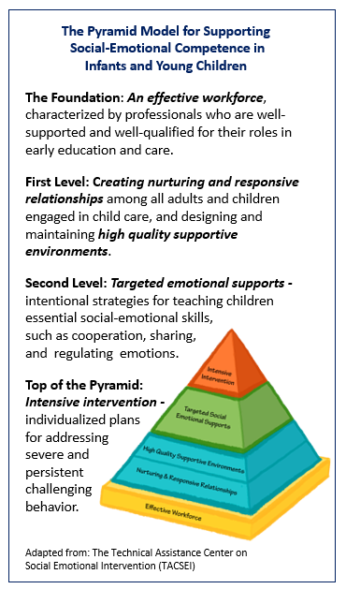
A. Summary of Phase III Year 3
Massachusetts’ State Systemic Improvement Plan (SSIP) is devoted to improved social emotional outcomes for preschool children with Individual Education Programs (IEPs). In collaboration with key stakeholders, the Massachusetts Department of Elementary and Secondary Education (MA DESE) selected the implementation of Early Childhood Positive Behavior Supports through Pyramid Model strategies (EC-PBS/Pyramid) as its evidence-based practice (EBP) to achieve this goal, and to help prepare all students for success.
As the SSIP work expands during the third year of Phase III, MA DESE continues to collaborate with other state agencies to broaden its system of supports, to offer new professional development opportunities in areas that include equity in education and trauma informed care, and to create linkages across district- and community-based programs.
In particular, MA DESE works closely with the Massachusetts Department of Early Education and Care (MA EEC) on core components of the SSIP, and on related initiatives with the shared goal of providing cohesive services for children and stronger networks for families. Collectively, these agencies are supporting the development of nearly 70 EC-PBS Pyramid Model implementation sites across the Commonwealth (see the Appendix for the Massachusetts Early Childhood Positive Behavior Supports Pyramid Model Community Overview).
During FFY 2017, MA DESE has been directly engaged in supporting implementation of the EC-PBS/Pyramid Model with 26 school districts. This includes 20 school districts that have been on board for two years or more (Cohorts 1 and 2), and six districts that joined early in the 2018-2019 school year (Cohort 3). At present, work toward implementation in these districts extends to 43 schools and 194 classrooms, representing an 83% increase in classrooms over last year. The SSIP evaluation plan is largely designed around these districts, and is the focus of the evaluation findings in this report (Section E).
MA DESE has an ongoing collaboration with national experts from the Pyramid Model Consortium (PMC) to support implementation and scale-up of EC-PBS/Pyramid strategies in these districts and in the community-based sites, and to continue to build statewide infrastructure. PMC staff, in coordination with state personnel, design and provide training geared toward building capacity among practitioners, internal coaches, behavioral specialists, and other educators for implementing the model with fidelity. PMC also facilitates the SSIP external coaches’ monthly professional learning community (PLC) meetings to support coaches in their work with districts toward fidelity of Pyramid Model implementation. As of this year, PMC is providing a series of new offerings to support internal (classroom-based) coaches, and a webinar training series designed for school and district leaders to identify fiscal and operational components needed to build and sustain successful Practice Based Coaching. Additionally, MA DESE, MA EEC, PMC, and external coaches work together to design and deliver statewide leadership meetings twice a year with topics driven by data, evaluation findings, and stakeholder feedback.
In addition to the targeted work within these school districts, MA DESE continues to collaborate with other state agencies to broaden the scope and reach of Pyramid Model adoption through several related statewide initiatives. These initiatives include community-based EC-PBS/Pyramid implementation sites sponsored by MA EEC as described above, other related statewide training opportunities and learning forums (i.e., MA EEC Trauma Informed Care initiative, the annual Pyramid Model summit), and parent involvement activities conducted by the Federation for Children with Special Needs, among others. MA DESE continues to build the foundation for this infrastructure through an array of department initiatives related to positive social emotional outcomes for all students.
Finally, MA DESE is working in partnership with an external evaluator to assess implementation and outcomes, to provide timely information to assist in program improvement, and to assist in communicating results to stakeholders. During FFY 2017, the evaluator’s role was expanded to include management of all data collection activities related to the evaluation, development of new instruments and data collection processes, and statewide support for Indicator 7 reporting of child outcomes.

1. Massachusetts SIMR and Theory of Action
SIMR Targets and Results
To assess progress toward its State-identified Measurable Result (SIMR), MA DESE uses statewide results obtained for Indicator 7: Preschool Outcomes; Outcome A: Percent of preschool children aged 3 through 5 with IEPs who demonstrate improved positive social-emotional skills (including social relationships). To address Indicator 7, child level data are collected via the Child Outcomes Summary (COS) process. Results are then analyzed to address two Summary Statements.
- Summary Statement 1: Of those preschool children who entered the preschool program below age expectations in Outcome A, the percent who substantially increased their rate of growth by the time they turned 6 years of age or exited the program.
- Summary Statement 2: The percent of preschool children who were functioning within age expectations in Outcome A by the time they turned 6 years of age or exited the program.
Table 1. Indicator 7A Reported Data and Targets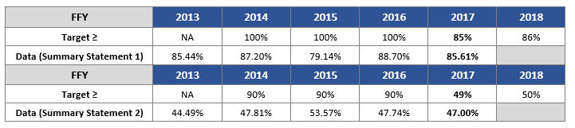
Table 1 above shows statewide SIMR results for FFY 2017 in comparison to the four prior years. As shown, outcomes for Massachusetts preschool children with disabilities have increased since the baseline in FFY 2013 for both summary statements. During the most recent reporting period (FFY 2016 to FFY 2017) there was a slight decrease of 3 percentage points (88.70% to 85.61%) for Outcome A, Summary Statement 1. However, this proportional year-to-year difference was not found to be significant suggesting that gains observed from FFY 2015 to FFY 2016 were sustained. Results were essentially unchanged for Summary Statement 2 over the most recent reporting period (47.74% to 47.00%). It is worth noting that the data submitted for FFY 2017 represents 651 children, a 64% increase in the number of usable records over last year. This increase reflects MA DESE’s continued focus on supporting districts in collecting and reporting Indicator 7 data.
While the state has observed improvements since the baseline in FFY 2013 across these outcome measures, in particular for Summary Statement 1, the rigorous targets established for FFY 2013 and beyond have not yet been achieved. This year, MA DESE, and its stakeholders reexamined and revised the targets for Indicator 7, including 7A related to social emotional development. The objective was to shift to establishing targets that could be used to monitor annual progress, rather than to view the targets as the overall goal.
Massachusetts, based on the recommendation of the U.S. Department of Education's Office of Special Education Programs (OSEP), looked to reset future targets, beginning with FFY 2017. MA DESE reviewed and analyzed available data for Indicator 7 (FFYs 2008 through 2017). As part of this process, MA DESE received guidance from the IDEA Data Center (IDC) regarding how to approach this process most effectively. During the Fall of 2018, MA DESE, along with the Massachusetts Special Education Advisory Panel (MA SEAP), worked to reframe and reset the targets, striving to make them more realistic on a year-to-year basis while still being rigorous. The revised targets are reflected in the table above. The rigorous targets that have been in place through FFY 2016 reflect the state’s overall goals for this indicator, and these new targets continue to maintain high expectations for all preschool students with disabilities.
Based on the revised targets for FFY 2017, the state met its goal of 85% for Summary Statement 1, and fell short of its goal of achieving 49% for Summary Statement 2 by two percentage points. As described later in this report (Section C 2a), MA DESE is engaged in several activities to continue to increase districts’ capacity for collecting and reporting valid and reliable Indicator 7 data, and for increased use of the data for program improvement at the local level.
MA SSIP Theory of Action
MA DESE continues to use the SSIP Theory of Action (TOA) as a guide for its work toward implementation of the SSIP. The TOA, shown in Figure 1 below, is based on a cascading structure of collaboration and support that flows from the state level (interagency initiatives, MA DESE Early Childhood Special Education (ECSE) initiatives), to programs, classrooms, and students. Family engagement is a focus throughout, as is an ongoing process of inquiry and improvement. Figure 4 on page 17 provides a graphic summary of statewide SSIP progress as it aligns with this Theory of Action.
Figure 1. MA SSIP Theory of Action
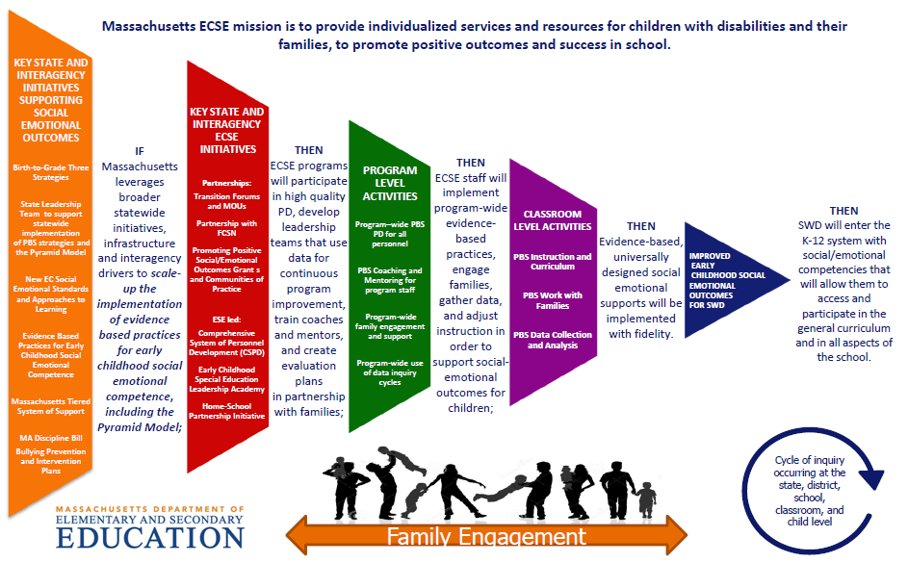

2. Summary of Improvement Strategies
Principal Activities for Implementation of Evidence-Based Practices
The principal activities related to EC-PBS/Pyramid Strategies implementation with Massachusetts school districts began in spring 2015 and continue to be conducted and expanded across the state, district, school, and community levels as they align with MA DESE’s Theory of Action. These activities include building state infrastructure through collaborating with national experts to prepare and support district leadership teams for implementing the EC-PBS/Pyramid Model, supporting external coaches to help guide district efforts, supporting internal coaches, training practitioners, and providing support for implementation and family involvement at the local level.
It is important to note that the activities described below are also reflective of the EC-PBS/Pyramid work being supported by MA EEC across an additional 41 implementation sites, situated in community-based early childhood education (ECE) programs. The MA EEC Pyramid Model initiative is also being spearheaded by PMC, and most of the activities described below are now being offered across these two contexts: in school districts, and ECE programs. As such, most of the statewide training opportunities and coach support events are available to personnel across both initiatives, leading to greater integration of the work and more opportunities for collaboration. The external coaches are also common to both projects. As described throughout this report and in Section F. Plans for Next Year, Massachusetts will continue to work toward a community-wide model of infrastructure and supports for implementation to ensure improved outcomes for all students entering the K-12 system, regardless of their entry point into early childhood education.
Updates on the principal activities since last year’s report include the following.
- National Expert Support: MA DESE continues to partner with the Pyramid Model Consortium to guide implementation efforts across the participating districts by working directly with external coaches who, in turn, support district and school staff. New this year, PMC is offering a four-part Leadership webinar series intended for leaders at the district and school levels to assist them in planning and sustaining professional development and coaching to support the Pyramid Model.
- Statewide Coaching: MA DESE continues to fund external coaches to support participating districts’ program-wide implementation of the Pyramid Model in their schools and classrooms – there are currently seven coaches working with the MA DESE districts. Coaches bring expertise in EC-PBS Pyramid Model strategies, and all seven coaches also work with the MA EEC EC-Pyramid Model sites. (There are 16 external coaches across the MA DESE and MA EEC initiatives at this time).
- District Leadership Teams: District leadership teams have been formed among the six Cohort 3 districts that joined the initiative in the 2018-19 school year. Like Cohorts 1 and 2, these leadership teams plan and guide EC-PBS/Pyramid Model implementation in their districts and schools, with ongoing support from external coaches.
- Training Practitioners: External coaches continue to provide regional trainings in EC-PBS/Pyramid Model practices to participating districts. PMC hosts statewide trainings in the Teaching Pyramid Observation Tool (TPOT), and Prevent, Teach, Reinforce – Young Children (PTR-YC). Additionally, online training in Pyramid Model practices is now available through the PMC website via the ePyramid Modules. This year, training opportunities have been expanded directly through the SSIP (e.g., leadership training series mentioned above), and well as through events sponsored by MA EEC (e.g., events related to trauma informed care, culturally responsive practices, and connections between early literacy and the Pyramid Model).
- Training District-Based Internal Coaches: As in prior years, district-based internal coaches attended a two-day Practice Based Coaching (PBC) training event to help prepare them for working with teachers to implement EC-PBS/Pyramid strategies with fidelity. New this year, PMC added a training event devoted to group coaching (i.e., PBC in a Group) to help alleviate the time constraints and challenges around coaching capacity at the school level. PMC is also organizing virtual meetings with internal coaches, “Community of Practice” (COP) events, to provide further guidance for PBC among school-based staff.
Interagency Initiatives and Broader Statewide Infrastructure
MA DESE is engaged in numerous statewide initiatives and activities related to the implementation of the EC-PBS/Pyramid Model more broadly across Massachusetts, as well as initiatives designed to strengthen Early Childhood Special Education across the Commonwealth. Key activities are listed below, and are described in Section B.
EC-PBS/Pyramid Initiatives Related to the TOA
- Massachusetts PBS Pyramid Model State Leadership Team (SLT)
- MA EEC EC-PBS/Pyramid Model Training Initiative
- EC-PBS/Pyramid Model Learning Communities (PMLC)
- EC-PBS/Pyramid Model Summit
- MA EEC Trauma Informed Care Initiative
- Positive Solutions for Families training
Broader Statewide Infrastructure Related to the TOA
Early Childhood Special Education Initiatives:
- Preschool Development Grant Birth-Five (PDG B-5) Planning Grant (New in FFY 2017)
- Building Inclusive Communities in Preschool (BIC) Initiative
- Early Childhood Leadership Institute
- Early Childhood Transitions
- Early Literacy and ECSE
- Early Learning Network Regional Meetings
- Massachusetts Commission for Deaf and Hard of Hearing Early Education (MCDHH)/ MA DESE/MA EEC Task Force
Department of Elementary and Secondary Education Initiatives:
- 2018 Special Education Professional Development Series
- Early Childhood Special Education Discretionary Federal Program Improvement (298) Grant
- Early Reading
- Family Engagement Consortium
- Promoting Racial Equity and Dismantling Racism
- Rethinking Discipline
- Social and Emotional Learning

3. Evidence-Based Practices Implemented to Date
Implementation of EC-PBS through Pyramid Strategies is built upon evidence-based practices, namely the EC-PBS/Pyramid Model framework, to support the social and emotional development of preschool students. The project is aligned with the principles of implementation science as characterized by the following: a systems approach for establishing the program culture and individualized supports for supporting social emotional competence, measurable outcomes, data decision making, evidence-based interventions, and ongoing systems support for scale-up and sustainability.
With respect to the fidelity of implementation of EBPs at the program level, results on the EC-PBS Program-wide Benchmarks of Quality (EC-BoQ) have consistently shown district-level progress over time over the past two years; the EC-BoQ is a measure of progress toward program-wide implementation. This year, an updated version, the EC-BoQ v2.0, was introduced to district leadership teams during statewide meetings in the fall, and built into team planning this school year. The new version incorporates quality indicators for culturally responsive practices to help ensure equity within programs, as well as other updates. As such, this year’s EC-BoQ data represent the first measure using this new tool. While there are no prior data for comparison, results across Cohorts 1, 2, and 3 (n=20 districts in total) show that districts who have been participating longer are more likely to report the seven Critical Elements are “in place”, suggesting progress over time. See the Appendix for the EC-BoQ v2.0 for the full list of Critical Elements and associated quality indicators.
With respect to EBPs at the classroom level, processes were put in place this year which allowed external coaches to report de-identified Teaching Pyramid Observation Tool (TPOT) results for teachers within their support districts. The TPOT is a research-based measure of Pyramid Model implementation fidelity at the practitioner level. While the TPOT results shared with the state evaluator do not identify district or teacher, the coding system allows for assessing the number of unique districts and teachers represented in the data, and for identifying the SSIP cohort for each teacher. The coding system also allows for tracking individual teachers over time, which will be used to “match” teacher results going forward. This year’s data represent the first measure at the state level, and included 31 teachers across 11 Cohort 1 and 2 districts. On average, results suggest these teachers are moving toward fidelity (i.e., 80%) on many of the key practices, and overall across the assessment. Results of the EC-BoQ v2.0 and the TPOT are referenced below and discussed in Section E.

4. Evaluation Activities, Measures, and Outcomes
During Phase II, MA DESE worked closely with internal partners and key stakeholders to develop an evaluation plan for the SSIP that is well-aligned with its Theory of Action. At the outset of Phase III, the plan was refined with input from key stakeholders. Over the past year, this plan was reviewed and revised further with MA DESE and its partners, in coordination with the evaluator, to allow for updates as the project has evolved. Further updates are planned for the coming year related specifically to measuring student outcomes, as described later in this report.
The external evaluator collaborates with project personnel to implement this plan through refining data collection tools, designing new instruments and data collection processes, managing data collection and supporting stakeholders, and analyzing and summarizing data for formative updates and for the annual report.
The evaluation questions address both implementation and outcomes, and can be summarized as follows:
- To what extent was the SSIP implementation carried out as planned?
(i.e., Trainings delivered, adequate participation levels, integration with other related initiatives, district-level planning and implementation, classroom implementation of EC-PBS/Pyramid strategies.)
- To what extent have intended outcomes have been achieved?
(i.e., High-quality training to increase coach and practitioner knowledge and skills, increased district capacity to implement, fidelity of implementation at the classroom level, increased numbers of classrooms implementing, perceived benefits for children and families, and improved student outcomes as aligned with the SIMR/Indicator 7.)
The data collection activities to support the evaluation, including those new in FFY 2017, are listed below. A full description of each data source, its purpose, and relevance within the overall evaluation plan is provided in Section C. Data on Implementation and Outcomes.
- Extant review of project documentation
- Statewide Training Evaluation Feedback Forms
- External Coach Contact Records
- EC-PBS Program-wide Benchmarks of Quality Assessment v2.0
- Mid-year Leadership Team Survey
- Pyramid Model Teacher Survey (New)
- External Coach Survey (New)
- Teaching Pyramid Observation Tool (TPOT) (New reporting process)
- Indicator 7A data via the Child Outcomes Summary (COS) process
With respect to outcomes for the SSIP districts in the third year of Phase III, Key Findings prepared by the external evaluator are shown below. Section E of this report presents the findings in detail.
KEY FINDING: SSIP project leaders, in collaboration with national experts, continue to deliver high-quality statewide training events, leadership team meetings, and ongoing external coach supports to advance the implementation and sustainability of the EC-PBS/Pyramid Model in Massachusetts schools.
KEY FINDING: Professional development events to support EC-PBS/Pyramid Model strategies have been high-quality, relevant, and useful for participants. The majority of participants indicated having met the learning objectives for each session, and where a retrospective pre/post measure was used, substantial gains were reported.
KEY FINDING: External coaches continue to provide individualized support to districts, which is most frequently provided through site visits. Support is most often focused on supporting leadership teams, but also extends to Pyramid Model practices training sessions, and building capacity for internal coaching and TPOT administration.
KEY FINDING: MA DESE is providing several avenues of support to districts for their work with families, and for increasing family engagement. This approach includes both partnering with community organizations, especially the state’s Parent Training and Information Center (PTI), and external coaches’ work with districts to support Positive Solutions for Families. District participation has been modest to date, though leadership team members are interested in additional information and support going forward.
KEY FINDING: MA DESE continues to integrate the work of the SSIP across interagency initiatives related to early childhood special education, moving toward a community-wide vision for the work. In particular, MA DESE is collaborating with MA EEC on multiple initiatives that support implementation of the Pyramid Model framework, equity, and inclusion across school district and community contexts.
KEY FINDING: As planned, MA DESE has put in place additional professional development events and support structures for building internal coach capacity, and for broadening the support it provides to districts and schools. Some benefits have been documented, though greater awareness of several of these improvements is needed among participating districts.
KEY FINDING: The MA DESE initiative continues to expand, as the numbers of districts, schools, and classrooms implementing EC-PBS through Pyramid strategies have all increased substantially over the past year. There are currently 43 schools and 194 classrooms that have adopted EC-PBS/Pyramid, representing an 83% increase in classrooms over last year.
KEY FINDING: District results on the EC-BoQ v2.0 across Cohorts 1, 2, and 3 suggest that participation in the initiative is contributing to the development of systems to support program-wide implementation fidelity.
KEY FINDING: District leadership teams identified several factors that are contributing to their progress that include a combination of ongoing efforts by school staff, as well as district- and state-level supports.
KEY FINDING: The primary challenge to implementation is common across all cohorts – lack of time and/or availably for classroom-based coaching. Other top challenges include developing internal coach capacity, and access to substitutes for training. Cohort 3 in particular cited lack of knowledge/understanding of the Pyramid Model, pointing to the need for additional training opportunities.
KEY FINDING: District leadership teams indicate needing assistance in several areas to expand implementation efforts. The greatest need is related to district-based Pyramid Model practices training for teachers, administrators, and other staff, followed by guidance on how to build internal coach capacity.
KEY FINDING: The TPOT has been used to assess fidelity of implementation with approximately a third of teachers in Cohorts 1 and 2 so far this school year. Results received at the state level suggest that on average, teachers are demonstrating implementation fidelity on many of the key practices.
KEY FINDING: Based on individual teacher TPOT results, nearly half of teachers demonstrated fidelity on the overall key practices scale, while the vast majority scored at 60% or above.
KEY FINDING: Teacher self-ratings in key practices associated with Pyramid Model implementation reveal their confidence in their own growth toward fidelity over time. The reported gains were statistically significant.
KEY FINDING: Many school and district personnel indicate that as a result of EC-PBS/Pyramid strategies, children are demonstrating improved social emotional competencies. Some personnel have also noticed academic benefits, and decreased rates of suspension and expulsion.
KEY FINDING: The statewide percentage of preschool children with disabilities functioning within age expectations by the time they turned 6 or exited the program remained consistent over the past year.
KEY FINDING: The statewide percentage of students with disabilities who substantially increased their rate of growth by the time they turned 6 or exited the program decreased by three percentage points from FFY 2016 to FFY 2017. The proportional difference year-to-year was not found to be significant, suggesting results have remained consistent over the past year.
5. Highlights of Changes to Implementation and Improvement Strategies
Over the past year, MA DESE continued to build upon last year’s work by making several improvements to its SSIP implementation strategy. These changes have been based on a process of continuous improvement in which evaluation data and feedback are reviewed and discussed with key stakeholders on an ongoing basis to help strengthen the initiative. A full description of each is presented in Section C.
- Indicator 7 Data Collection and Use – MA DESE has provided and is planning future professional development and technical assistance activities to support the Child Outcome Summary process and Indicator 7 data collection, supporting SSIP leadership teams through statewide meetings devoted to the functional assessment, and continuing to provide outreach and support to all districts.
- Building Internal Coach Capacity – Activities include new statewide trainings in Practice Based Coaching in a Group, an alternative approach to coaching; and internal coach Community of Practice virtual meetings, designed for coaches to collaborate with their peers and national experts as they work toward implementation fidelity
- Assessing Implementation Fidelity – A new coding and reporting system for collecting TPOT results to assess progress toward fidelity was put in place.
- Increased Communication for Districts from MA DESE and Partners – New approaches this year include communication via a monthly eNewsletter devoted to EC-PBS/Pyramid, and increased site visits by MA DESE staff and partners.
- More Collaborative Leadership Team Meetings – Statewide Leadership Team meetings have been redesigned to allow for more peer-to-peer learning and networking. One approach has been the use of “role-alikes”, in which staff from different districts/schools who share the same professional roles learn from each other on selected topics within a small group setting.

B. Progress in Implementing the SSIP

1. Description of the State’s SSIP Implementation Progress
- Description of extent to which the State has carried out its planned activities with fidelity; accomplishments and milestones; and adherence to intended timeline, and
- Intended outputs that have been accomplished as a result of the activities
This section is organized around three major areas of SSIP activities:
First, Principal Activities for Implementation of Evidence-Based Practices – These are the primary implementation activities currently underway with 26 school districts. This section includes a summary of accomplishments and adherence to the timeline set out for this year. These activities are indicated in the green and red bars of the MA SSIP Theory of Action (TOA).
Second, EC-PBS/Pyramid Interagency Initiatives Related to the TOA – This section highlights interagency collaboration and activities underway to support and expand the use of EC-PBS/Pyramid Model strategies statewide. These activities are indicated in the red and orange bars of the TOA.
And third, Broader Statewide Infrastructure Related to the TOA – This section includes other state-level inter- and intra-agency initiatives designed to strengthen early childhood special education across the Commonwealth. These SSIP activities are also indicated in the red and orange bars of the TOA.
Principal Activities for Implementation of Evidence-Based Practices
There are presently 26 school districts participating in the initiative, receiving direct support from MA DESE and its partners. This number is up from 21 last year and includes 20 Cohort 1 and 2 districts that continued implementation into the 2018-19 school year, and six new districts that joined this year (Cohort 3). Across the 26 districts there are 43 schools, 194 classrooms, and 174 lead teachers engaged in implementing the EC-PBS/Pyramid Model. This represents a 34% and 83% increase in schools and classrooms, respectively. The principal activities that are being carried out with these districts are described below, with a focus on updates since last year.
With respect to the timeline established for this year as presented in the FFY 2016 SSIP Report (p. 50), the vast majority of coaching, training, and support activities have been carried out as planned. One exception was the coaches’ virtual convening, which was shifted from spring 2018 to fall 2018. At the same time, as the year’s plan was refined there were additional state-level activities and supports provided that were not captured in the established timeline, such as the Practice Based Coaching in a Group training event and the Leadership webinar series, both of which are described below. These activities were developed based on feedback from district leadership teams and external coaches in response to project needs.
National Expert Support
MA DESE continues to partner with the Pyramid Model Consortium (PMC) to guide implementation efforts across the 26 participating districts by working directly with external coaches who support districts, and with internal coaches through monthly virtual meetings. Also new this year, PMC is offering a four-part Leadership webinar series intended for school and district leaders to identify fiscal and operational components needed to build and sustain successful Practice Based Coaching to support the Pyramid Model. External coaches will provide support in between webinars for participating leadership teams.
Statewide Coaching
MA DESE continues to fund seven external coaches with EC-PBS/Pyramid Model experience to support districts’ program-wide implementation of the Pyramid Model in their schools and classrooms. These coaches also provide support to community-based early childhood programs through the MA EEC Pyramid Model initiatives, which has allowed linkages between district- and community-based efforts, and sharing of information across program contexts. (There are 16 external coaches across the MA DESE and MA EEC initiatives at this time). External coaches continue to participate in statewide training activities with their districts and support them in using fidelity measures such as the EC-BoQ and TPOT, and are helping to build local capacity by delivering Pyramid Model practices training to school and district personnel.
District Leadership Teams
District leadership teams have been formed among the six Cohort 3 districts that joined this past year. Like Cohorts 1 and 2, these leadership teams plan and guide EC-PBS/Pyramid Model implementation in their districts and schools with ongoing support from external coaches. Each team ideally consists of a district-based administrator, a special education administrator, an early childhood administrator or principal, a teacher, an educator with behavior expertise, and an internal (i.e., classroom) coach for the district. During the current reporting period, leadership teams were invited to participate in three statewide events with MA DESE and PMC. Meeting activities have included a review of statewide progress, introduction to the revised EC-BoQ, work on action plans for implementing the EC-PBS/Pyramid Model, and sharing knowledge and experience across districts on topics such as internal coaching, TPOT, and Indicator 7 data collection and use.
Training Practitioners
At the core of building statewide infrastructure for implementing EC-PBS through Pyramid strategies is the provision of high-quality trainings to build capacity at the local level. The SSIP continues to offer regional trainings in Pyramid Model practices offered by external coaches; and statewide trainings in TPOT and Prevent, Teach, Reinforce - Young Children (PTR-YC), or “top of the Pyramid” practices, provided by PMC.
Additionally, a self-paced online training series in Pyramid Model practices is now available through the PMC website – the ePyramid Modules – which is being used by school and district staff in at least seven districts. Training opportunities have also been expanded directly through the SSIP (e.g., leadership webinar series described above), and well as through events sponsored by MA EEC (e.g., events related to trauma informed care, culturally responsive practices for ensuring equity, and connections between early literacy and the Pyramid Model). More information about training events and attendees is presented in Section E.
Training District-Based Internal Coaches
Based on feedback from stakeholders last year about the need to further support coaching efforts at the local level, MA DESE and its partners named FFY 2017 “The Year of Fidelity: Building Coaching Capacity”. As part of this focus, professional development events for coaches were expanded from prior years. New this year, PMC added a training event devoted to group coaching – PBC in a Group – to help further alleviate time constraints and challenges around coaching capacity at the school level; approximately 35 internal and external coaches attended. Additionally, PMC has begun offering virtual monthly meetings with internal coaches, called “Community of Practice” (COP) events, to provide further guidance to these individuals who are supporting practitioners working toward implementation fidelity.
As in prior years, PMC hosted another two-day Practices-Based Coaching (PBC) event geared toward external and internal coaches; 23 coaches attended. External coaches also continue to provide on-site support to internal coaches including co-scoring TPOTs and guiding TPOT planning efforts, working on implementation plans, and creating coaching plans.
Sequence of Trainings and Supports
Figure 2 below was created by PMC as a guide for project participants, which shows the design and role of leadership teams, and the sequence of trainings and supports for EC-PBS/Pyramid Model implementation at the local level. The data identified for progress monitoring, including implementation fidelity and child outcome progress measures, are also indicated. Ultimately, the goal of the SSIP at the state and local levels is geared toward classroom implementation of EC-PBS through Pyramid strategies, with a focus on fidelity to the model.
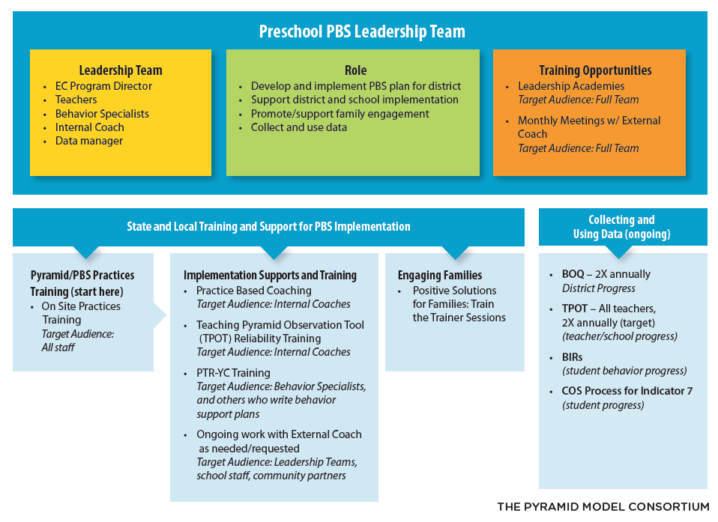
Figure 2. Massachusetts EC-PBS/Pyramid Model Sequence and Supports
EC-PBS/Pyramid Interagency Initiatives Related to the TOA
MA DESE continues to leverage and extend a range of statewide activities to promote and support the EC-PBS/Pyramid Model in Massachusetts. Of particular note, MA DESE and MA EEC are currently collaborating across several new and continuing initiatives to support the Pyramid Model framework and child development more generally across both district- and community-based programs. Additionally, the PBS/Pyramid Model Statewide Leadership Team (SLT), which had been meeting monthly through spring 2018, recently went through a process of review and restructuring in an effort to align the multiple initiatives that are underway.
MA DESE also continues build infrastructure through an array of department initiatives related to positive social emotional outcomes for all students, with and without disabilities. These initiatives, coupled with the EC-PBS/Pyramid Model, provide various entry points for local school districts and community-based early childhood education programs to promote improved outcomes for children with disabilities. The status of each initiative is described in this section.
Figure 3 shows several key interagency initiatives devoted to improving early childhood special education through the EC-PBS/Pyramid inclusive of the MA DESE work with 26 districts. As shown in the figure, between the MA DESE and MA EEC EC-PBS/Pyramid initiatives, there are 67 “implementation sites”, as well as a variety of other activities all contributing to a community-wide vision of the Pyramid Model framework and related content being offered statewide.
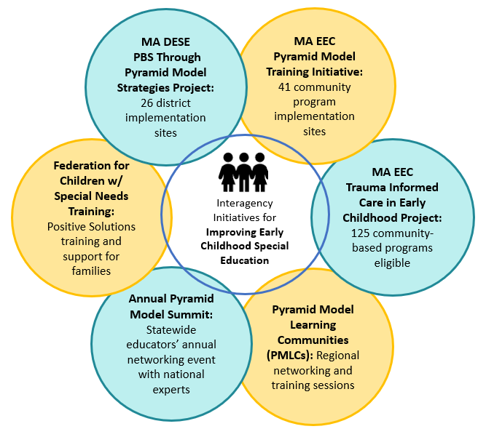
Figure 3. Interagency Initiatives Related to EC-PBS/Pyramid Model
Massachusetts PBS/Pyramid Model State Leadership Team (SLT)
While MA DESE staff continue to play a significant role on the state’s PBS/Pyramid Model State Leadership Team (SLT), substantial effort was made this year to recalibrate the approach of this team. A core team, including MA DESE, met to review the approach of the State Leadership Team to consider ways to enhance the effectiveness and efficiency of the team. As an outgrowth of this effort, new team members were added, including staff from an MA DESE public school district implementing EC-PBS/Pyramid Model. This newly reconstituted team also includes representatives from the MA Department of Public Health (MA DPH) which is the lead agency for IDEA Part C, MA EEC, the Department of Mental Health (MA DMH), Connected Beginnings Training Institute (CBTI), University of Massachusetts (UMASS) Boston, the Federation for Children with Special Needs, and the Head Start Training and Technical Assistance agency.
MA EEC EC-PBS/Pyramid Model Training Initiative
MA EEC is working with the Pyramid Model Consortium to provide EC-PBS/Pyramid Model training and external coach supports to 41 early education and care (ECE) programs across Massachusetts, and to support scale-up of Pyramid Model implementation. The 41 participating ECE programs include two Demonstration sites established by the SLT in 2017, 18 ECE programs that began the initiative in spring 2018, and 21 ECE programs that launched in December 2018. This initiative is similar to the SSIP in its principal activities, which include the provision of statewide trainings, regional Pyramid Model practices trainings, and individualized external coach supports for each program. As mentioned above, this project further supports SSIP in that SSIP district and school personnel have access to trainings where space permits, and external coaches common to both projects are helping to help build connections for the EC-PBS/Pyramid Model between community programs and public schools. The executive summary from the Year 1 Evaluation Report is attached in the Appendix.
EC-PBS/Pyramid Model Learning Communities (PMLC)
EC-PBS/Pyramid Model Learning Communities (PMLC) have been offered throughout the state since 2016, funded historically by DPH and MA DESE, and currently being funded by MA EEC. These regional training and networking events are conducted across the five regions of the Commonwealth approximately five times each year, and are intended to further support implementation of the EC-PBS Pyramid Model. As of the 2018-19 school year the overall management of the PMLCs has shifted to the Pyramid Model Consortium. Approximately 123 individuals have participated in the PMLCs since last year’s report. Going forward, the vision for the PMLCs is to move toward a model of regional/community-based teams to support EC-PBS/Pyramid implementation and scale-up.
EC-PBS/Pyramid Model Summit
The SLT organizes an annual EC-PBS/Pyramid Model Summit to foster education and networking among practitioners across the state. Since the last report, the April 2018 Summit was conducted with a community-building theme of Building the Massachusetts PBS/Pyramid Together. The event included a keynote from PMC, PMLC regional meetings promoting community networking, and data collection around community needs. There were 120 attendees. This year, the 8th annual Summit is devoted to Trauma Informed Care and the Pyramid Model, to continue building upon themes presented in the regional PMLCs during December 2018 and January 2019.
MA EEC Trauma Informed Care Initiative
MA EEC and Pyramid Model Consortium recently offered five regional training sessions devoted to Trauma Informed Care in Early Childhood. The learning objectives included: recognizing the signs and symptoms of trauma, understanding how trauma impacts children’s learning and development, and considerations for supporting children and families when trauma occurs. This opportunity was extended to 125 early education and care programs and/or school districts (two staff members per program) and includes an on-site follow up visit from national experts to provide individualized support to each participating program.
Positive Solutions for Families
Positive Solutions for Families is an evidence-based training series that has been developed to provide families and caregivers information and strategies to promote children’s social and emotional skills using positive approaches. Positive Solutions can be used independent of any district adopted program or as a companion to the Positive Behavioral Support: Pyramid Model. MA DESE works with external coaches and the Federation for Children with Special Needs (FCSN) to provide Positive Solutions: Train the Trainer opportunities for professionals interested in implementing Positive Solutions for Families in their schools and districts. The FCSN has developed a professional development series that provides strategies for establishing effective family and community partnerships as well as the Train the Trainer curriculum. Additionally, the external coaches work with the leadership team of identified Pyramid pilot districts to train staff and assist in implementing the Positive Solutions for Families modules as well as other family engagement initiatives related to the Pyramid Model. The Positive Solutions for Families model and effective Family Engagement principles have also been introduced to district representatives at Pyramid Model trainings and at the MA DESE Early Childhood Special Education Leadership Institute. In addition to working with external coaches and the FCSN, MA DESE continues to collaborate with MA EEC to provide opportunities for discussion and training on Positive Solutions for Families to providers through networking meetings and professional learning groups.
Figure 4 below provides a summary of these activities as they align with the TOA elements and progress across each element. Note, this graphic is meant only as a “snapshot” of project activities and should be viewed in the larger context of the details and findings presented throughout this report.
Figure 4. Statewide Progress Aligned with EC-PBS/Pyramid Training and Implementation
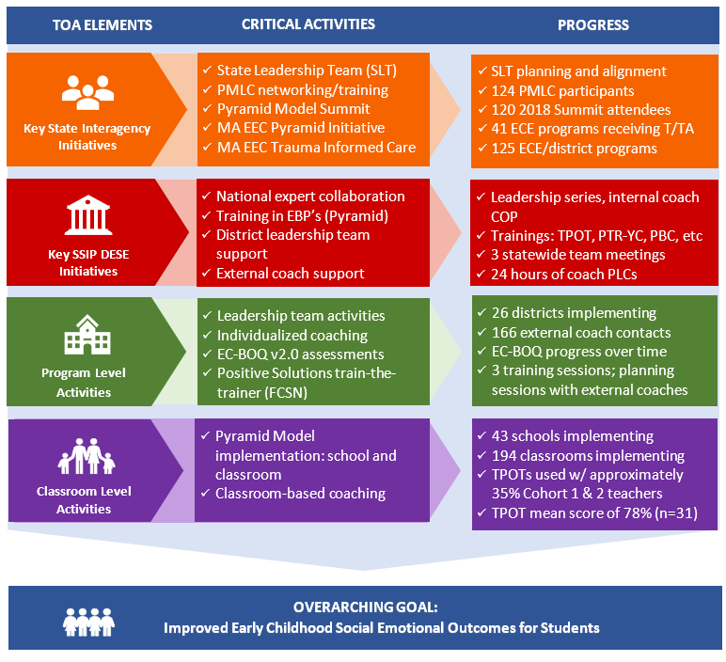
(March 2018 – February 2019)
Broader Statewide Infrastructure Related to the TOA
This section includes other state-level inter- and intra-agency initiatives designed to strengthen early childhood special education across the Commonwealth.
Early Childhood Special Education initiatives (Related to the red bar of the TOA)
Preschool Development Grant Birth-Five (PDG B-5) Planning Grant
The PDG B-5 planning grant is a joint project between the Massachusetts Executive Office of Education (MA EOE) – which includes MA EEC, MA DESE, and the Children’s Trust (MA CT) – and the Massachusetts Executive Office of Health and Human Services (MA EOHHS) which includes the Department of Public Health (MA DPH). The grant supports collaboration and coordination among agencies to create a unified data system for sharing information about children birth to age five (B-5) across all programs, and to deliver information and resources to families and educators more effectively across the Commonwealth. By identifying and addressing gaps in services and efficiencies in coordination, Massachusetts will use this opportunity to ensure that the B-5 mixed delivery system prepares young children for success in the K-12 system while supporting parents in their role as their child’s first teacher.
The proposed key activities include:
- Conducting a comprehensive needs assessment
- Producing an action-oriented strategic plan
- Improving parent choice and knowledge through an online parent portal, and through more effective implementation of screening using the Ages and Stages Questionnaire (ASQ)
- Expanding and coordinating training for all staff working with children
- Developing an integrated data system that will enable us to analyze and track child services and outcomes longitudinally, from home visiting to early intervention to early education, through K-12 education, and into post-secondary.
Building Inclusive Communities in Early Childhood (BIC) Initiative
MA DESE and MA EEC are collaborating on a year-long opportunity for school districts to work with national experts to build local capacity for inclusive practices. The initiative launched with a statewide convening of 10 Massachusetts school and community teams to share their successes and challenges in implementing recommended practices in early childhood inclusive education. Conference activities included:
- Learning with Dr. Richard Villa and Dr. Jacqueline Thousand about a decision-making process for determining where, when, and how to address IEP goals for young children with intensive and pervasive support needs. Understanding of the time-tested process provided participants with a communication tool and a blueprint for collaboratively creating meaningful inclusive opportunities for young children in home, school, early care, and other community settings.
- Previewing chapters from Drs. Villa and Thousand’s upcoming book on inclusive approaches in educating young children in inclusive early education settings.
The second Building Inclusive Community (BIC) conference was held on March 15, 2019. Drs. Richard Villa and Jacqueline Thousand led the conference focusing on the topics described above. The participants who attended the conference represented the mixed delivery system (public schools, early care and education programs, early intervention, head start and Preschool Expansion Grantees). There was also representation from the Departments of Early Education and Care, Elementary and Secondary Education, and Public Health - Early Intervention. The BIC conference was well attended and out of the 177 individuals who registered, 127 participated. Nine out of the 10 BIC teams presented their projects with the attendees to share how they are developing practices to support inclusion and inclusive practices, and how they are including other school district personnel and community partners to support children and families.
In addition to these initiatives, there are numerous Early Childhood Special Education initiatives underway that were described in last year's SSIP report (p. 13), and which are ongoing this year:
Early Childhood Leadership Institute
The Massachusetts Early Childhood Leadership Institute (MA ECLI) is a yearlong program for special educator and early childhood leaders at the school and district level across the state. The Institute focuses on building leadership capacity in areas such as implicit bias and racism, data analysis and program improvement, literacy, social emotional learning and leadership, and others.
Early Childhood Transitions
MA DESE and MA EEC collaborate with MA DPH to provide information, training, and support for successful transitions from Early Intervention (EI) to Early Childhood Special Education (ECSE).
Early Literacy and ECSE
Since FFY 2016, MA EEC has collaborated with MA DESE’s early literacy and ECSE teams to connect early literacy across the agencies and in public school districts and child care settings specifically for ECSE programs to connect social/emotional development with early literacy skills.
Early Learning Network Regional Meetings
In collaboration with staff from the Family and Community Engagement team at MA EEC, MA DESE and MA EEC co-hosted bi-annual, regional early learning network meetings for professional development and networking on early learning topics.
Massachusetts Commission for Deaf and Hard of Hearing Early Education (MA MCDHH)/MA DESE/MA EEC Task Force
The Early Childhood Education-Deaf and Hard of Hearing Task Force is an interagency, multi-disciplinary group that collaborates to analyze data and infrastructure to make recommendations for leveraging existing resources and to identify areas of growth to improve outcomes for young children who are Deaf and Hard of Hearing.
Department of Elementary and Secondary Education Initiatives (Related to the orange bar of the TOA)
2018 Special Education Professional Development Series
The FFY 2017 Special Education Professional Development (PD) Series is organized by six strands: 1) American Sign Language (ASL), 2) Excellence in Education, 3) Inclusive Practice, 4) Role-Based PD, 5) Social Emotional Learning, and 6) Technology (including assistive technology for success in the classroom).
Early Childhood Special Education Discretionary Federal Program Improvement (298) Grant
The Early Childhood Special Education Discretionary Federal Program Improvement Grant is a discretionary grant provided by MA DESE intended to further early childhood special education (ECSE) practices in SSIP districts. All SSIP districts implementing the Pyramid Model are eligible to apply for grant money. The funding from this grant allows these districts to improve educator effectiveness and family engagement, while also working to strengthen their curriculum, instruction, and assessment. Districts who receive this grant money must focus the funding in one of two priority areas:
- instruction to increase children's educational outcomes, and
- systems to engage effectively with families.
For FY 2019, 25 SSIP districts applied for and each received $7000 to implement a range of programs and systems to support family engagement, the implementation of Pyramid Model Strategies (PBS/Pyramid) and evidence-based practices for teaching students with disabilities in early childhood classrooms. To support the work of the SSIP districts, MA DESE has:
- Increased 298 grant funding from $3,000 per district in FY 2018 to $7,000 per district in FY 2019
- Collaborated with district leadership teams in the planning of how to use funding
- Based on district leadership team feedback, increased assistance in developing plans for the use of funds that best align with the districts’ implementation of the Pyramid Model
Early Reading
In FY 2019, MA DESE kicked off the CURATE (Curriculum Ratings by Teachers) project. MA DESE is convening panels of teachers to review the available evidence on curriculum materials and make user-friendly reports available to educators to support them in making well-informed decisions about curriculum. In FY 2019, panels are reviewing and will be releasing reports on preK-2 Literacy curricula. In FY 2020, after those reports are available, we will have the opportunity to support strong curriculum decision-making in districts by publicizing those reports, conducting trainings, supporting districts with curriculum review and selection processes, and convening Networks of educators who use or are adopting the positively reviewed curricula.
Educator Licensure Subject Matter Knowledge (SMK) Requirements
- Over the course of this year, MA DESE engaged a group of experts in the field of literacy education to revise the Subject Matter Knowledge guidelines for the Reading Specialist license.
- The SMK guidelines identify what a candidate for this license needs to know (content knowledge). The SMKs are used by educator preparation programs to design their curriculum, and they also determine what content appears on the MTEL.
- The revised SMKs will reflect up-to-date, research-based understandings of child development and the components of literacy.
- Having these improved SMKs will strengthen the workforce of available reading specialists serving young children in Massachusetts, supporting early literacy skills, recognizing diversity in reading acquisition, and identifying children at risk for learning disabilities, including dyslexia.
Family Engagement Consortium
With support from Council of Chief State School Officers (CCSSO), members from MA DESE, MA EEC, and MA DPH began meeting in September 2017 to plan for the development of the Birth to Grade 12 family engagement framework, which includes collaboration with internal and external stakeholders and promotes building social/emotional developmental practices.
Promoting Racial Equity and Dismantling Racism
MA DESE is leading efforts to eliminate explicit and implicit bias and disproportionality in special education identification, placement, and removals for children of color. This multifaceted initiative includes work for MA DESE personnel as well as with MA DESE districts and schools. MA DESE has contracted with PMC to bring the Pyramid Equity Project (PEP) to Massachusetts. The PEP will be tailored to the Massachusetts landscape to increase the use of data tools, materials, and procedures to explicitly address implicit bias, implement culturally responsive practices, and use data systems to understand potential discipline equity issues through the implementation of the Pyramid Model for Promoting the Social Emotional Competence of Infants and Young Children. A three-pronged approach will be supported with SSIP districts in Massachusetts who are implementing EC-PBS thorough Pyramid Model Practices: 1) enhancing the professional development offerings to the workforce in the SSIP districts, 2) working with the external coaches to increase their skills in utilizing the Pyramid Model Equity Coaching Guide, and 3) supporting the collection and use of data to help SSIP districts and program-wide leadership teams address implicit bias and disproportionality in their schools.
Rethinking Discipline
The Rethinking Discipline initiative commenced during the 2016-2017 school year as part of a comprehensive statewide plan. The goal of the initiative is to make systemic change to local practices and procedures in order to reduce disciplinary exclusions, address disciplinary disparity, and improve school climate.
Social and Emotional Learning
With funding from MA EEC’s Race to the Top/Early Learning Challenge Grant, staff from MA DESE and MA EEC worked with a selected vendor to develop Preschool and Kindergarten Social and Emotional Learning standards as well as Approaches to Play and Learning Standards.

2. Stakeholder Involvement in SSIP Implementation
This section of the report addresses both:
(a) How stakeholders have been informed of the ongoing implementation of the SSIP, and
(b) How stakeholders have been involved in decision-making regarding ongoing implementation
By design, the MA SSIP provides multiple opportunities for key stakeholders at the state, district, program/classroom, and community levels to learn about the SSIP including the project philosophy and goals, the provision of project training events and embedded supports, and the availability of resources to support and extend implementation. Stakeholders also participate in decision-making about the direction of the project by rating the quality and relevance of professional development events, providing updates on progress, articulating needs at the local level for moving forward with implementation, and by making suggestions about needed changes or improvements. As described below, the stakeholder groups include the State Leadership Team, Special Education Advisory Panel, external coaches, district leadership teams, district and school staff, and students and families.
Key aspects of the feedback structures include sharing information and gathering feedback via state-level leadership and steering committee meetings with stakeholders, and by providing mechanisms for frequent feedback both formally and informally from participants within the SSIP districts and from the external coaches who support them. There were several new approaches put in place this past year, which include a monthly eNewsletter that MA DESE produces devoted to EC-PBS/Pyramid, social media sites created and managed by external coaches, and two new evaluation surveys – an External Coach Survey, and a Pyramid Model Teacher Survey to gather feedback from practitioners.
State PBS/Pyramid Model Leadership Team
Massachusetts is one of 32 states that has a statewide, cross-sector Pyramid Model Leadership Team. DESE plays an active role on the on the Leadership Team to both support the broader Implementation of Pyramid Model across the state, as well as to solicit feedback that helps to refine implementation efforts and to identify opportunities for collaboration within MA DESE sites. As describe above, the team currently includes representatives from MA DPH, MA EEC, MA DMH, Connected Beginnings Training Institute (CBTI), University of Massachusetts (UMASS) Boston, the Federation for Children with Special Needs, and the Head Start Training and Technical Assistance agency. Over the past year, these collaborations have led to new initiatives and professional development opportunities within the context of the EC-PBS/Pyramid framework, including topics devoted to equity in education through culturally responsive practices to reduce implicit bias, disproportionality, suspensions, and expulsions; trauma informed care; and early literacy, among others.
Special Education Advisory Panel (SEAP) and Special Education Steering Committee
The SEAP (formerly the Special Education Advisory Council), established under state law, is comprised of members appointed by the Commissioner on behalf of the MA Board of Education; over half of the voting members are individuals with a disability or a parent of a child with a disability. The SEAP also has representation from the state’s Parent Training and Information (PTI) Center through the Federation for Children with Special Needs. The Special Education Steering Committee is composed of members of the SEAP plus representatives of advocacy organizations, other state agencies, and statewide partners in special education, consistent with the requirements for advisory bodies established in the Individuals with Disabilities Education Act (IDEA). These groups continue to be valued stakeholders, as MA DESE seeks out opportunities to discuss and share information about the department’s vision and direction for strengthening early childhood initiatives. This past year the MA DESE collaborated with the SEAP on resetting targets for Indicator 7.
External Coach Feedback
External coaches have a key role in supporting district and school personnel in moving toward implementation of EC-PBS through Pyramid strategies. Since these individuals make direct contact with district teams on a regular basis, they are in the best position to determine some of the ways the initiative might be improved at the local level, and to understand challenges to implementation. MA DESE maintains ongoing communication primarily through monthly PLCs, as well as by email and phone. Coaches also continue to complete an online External Coach Contact Record (log form) to capture information about each instance of technical assistance they provide to districts. Links to real-time summary reports for state leaders allow access to aggregate district- and state-level log data on an ongoing basis.
New this year, an External Coach Survey was distributed to coaches prior to the new school year to gather feedback about the project’s leadership and communication structures, to identify coaches’ professional development needs for the coming year, and to solicit input on how to address some of the common challenges toward implementation identified by the district teams. During a fall 2018 kick-off meeting, MA DESE and MA EEC project leaders, PMC, external coaches, and the external evaluator discussed the survey results, as well as evaluation findings from FFY 2016, and made decisions about the focus and direction of the project in the 2018-19 school year.
District Leadership Team Feedback
MA DESE visits a sample of EC-PBS/Pyramid school districts each year to observe activities, and to learn from administrators and staff about the progress being made. Leadership teams also have an opportunity each year to provide feedback through the Mid-Year Leadership Team Survey. This year, the online survey was completed in January-February by 58 leadership team members (40 individuals from Cohorts 1 and 2, and 18 from Cohort 3) across 21 school districts. As in prior years, the survey gave team members an opportunity to describe their progress toward implementation of the EC-PBS/Pyramid Model, the facilitating factors, ongoing challenges, and requests for ongoing support from both external coaches and MA DESE. This year’s survey also addressed stakeholder perceptions of the project’s impact on teacher/staff knowledge and skills, and benefits for children and families. A summary of survey responses with all open-ended comments was shared with project leaders shortly after the survey was conducted, and discussed to identify next steps for the initiative. Results from the survey are presented in Section E.
Teacher Feedback
New this year, lead teachers from Cohorts 1 and 2 who are engaged in implementation were asked to complete the Pyramid Model Teacher Survey. The online survey was completed in January-February by 64 teachers across 12 districts. The survey addressed progress toward implementation, challenges and needs for expansion, and overall feedback about the initiative. The survey also included a self-assessment of key practices aligned with the TPOT (retrospective pre/post), and perceptions of project benefits. A summary of survey responses with all open-ended comments was shared with project leaders shortly after the survey was conducted, and discussed to identify next steps for the initiative. Results from the survey are presented in Section E.
Training Participant Feedback
MA DESE and the PMC continue to collect evaluation feedback from participants at each training and at statewide meetings for leadership teams and external coaches. The feedback forms allow MA DESE, the PMC, and external coaches to gauge the general quality of the sessions, usefulness of the information, and ideas for strengthening the events going forward. Last year, training-specific learning objectives were added to the forms to provide more pertinent information about the extent to which each training was meeting its goals. This year, a retrospective pre/post item was incorporated to gauge the extent to which participants made gains on the learning objectives. Results are regularly summarized by the evaluator and shared with training facilitators, project leaders, external coaches, and other key stakeholders such as MA EEC personnel. Participants’ suggestions are reviewed and considered for future sessions; suggestions this year have included ideas for alternate meeting locations, ensuring the availability of handouts and resources, and considerations for balancing presentation time vs. time for peer-to-peer collaboration and learning.
Other Communication Structures
MA DESE produces a monthly eNewsletter which is distributed via email to the EC-PBS/Pyramid community. These newsletters provide project updates, highlight EC-PBS/Pyramid district implementation activities, provide information about the external coaches, and contain training registration links.

C. Data on Implementation and Outcomes

1. How the State Monitored and Measured Outputs to Assess Effectiveness
The evaluation plan developed during Phase II has largely been carried out as planned during Phase III, with some refinements for FFY 2016. Over the past year, the plan was reviewed and revised further with MA DESE and its partners, in coordination with the evaluator, to allow for updates that reflect the evolution of the project. In particular, the evaluation questions and intended outcomes were reviewed to ensure alignment with the data sources. The benefit of the revision has been to clarify the purpose of each data source, thereby informing instrument revisions/development, and to identify areas where the plan should be extended. Two evaluation questions were added, along with intended outcomes and data sources:
- To what extent is MA DESE making the intended improvements to the workforce development structure as identified through the evaluation and outlined in its annual reports? (Question EQ1c)
- To what extent do district and school personnel perceive benefits of implementing EC-PBS/Pyramid strategies for children? (Question EQ4a)
Finally, MA DESE, stakeholders, and the evaluator are currently discussing approaches for measuring student outcomes associated with the SSIP in the coming year, in addition to Indicator 7 data. This plan is discussed in Section F.
The external evaluator continues to collaborate with project personnel and stakeholders to carry out this plan by refining data collection tools, designing new instruments and data reporting processes, managing data collection and supporting stakeholders in that effort, and analyzing and summarizing data for formative updates and annual reports. This past year, several instruments were modified including the Training Feedback Forms, the Mid-Year Leadership Team Survey, the EC-BoQ v2.0 database, and the Pyramid Implementation Profile. New activities this year included an External Coach Survey, Pyramid Model Teacher Survey, and the development of a system for coding and reporting de-identified teacher TPOT results. The evaluator manages the online administration of all data collection tools, and is able to provide project leaders with access to summary data for stakeholder feedback throughout the year. Finally, the evaluator participates in external coach PLC meetings and EC-PBS/Pyramid state-level Leadership Team meetings to discuss data use for both internal progress monitoring and for the evaluation, and to review data collection procedures and due dates.
(a) How the evaluation measures align with the Theory of Action
The SSIP Theory of Action articulates activities at the state level with respect to infrastructure for principal activities, as well as ongoing interagency collaboration to support the SSIP. The next level of activities engages districts/programs, followed by classrooms and students. Across these four levels, the plan incorporates key questions to help focus the evaluation, as well as appropriate short, intermediate, and long term outcomes to assess progress and impact of the SSIP. Data collection instruments have been selected or developed, and processes for collecting data at regular intervals have been put into place. Table 2 displays the SSIP evaluation plan, including key questions at each level of the Theory of Action, as well as the intended outcomes and data sources. New questions, intended outcomes, and data sources are indicated.

Table 2. MA SSIP Evaluation Plan
Evaluation Questions | Intended Outcomes | Data Sources
State Level Infrastructure
EQ1a  In what ways is MA DESE using the SSIP, including statewide implementation of EC-PBS through Pyramid strategies, to build state-level capacity to support improved social emotional outcomes for young children with disabilities? | S1. Short Term and Intermediate  In order to build state capacity, MA DESE will…  - provide statewide and regional training on EC-PBS through Pyramid strategies to district administrators and educators, including Leadership Team Academies, Practices Trainings, and Coaches’ Trainings. Participants will become familiar with the tenets of PBS and PBS through Pyramid strategies and classroom and program-wide implementation.  - leverage the cadre of PBS external coaches to support districts and communities;  - collaborate with community and social services agencies to provide additional training and support to families. | - Extant project documents (e.g., state and district meeting notes, inter-agency meeting minutes, external coach meeting notes)  - Statewide training and meeting data (i.e., internal project records and sign-in sheets)  - Statewide training and meeting evaluation feedback forms  - External Coach Contact Records
EQ1b  To what extent is implementation of EC-PBS through Pyramid strategies in MA integrated with other early childhood and/or MA DESE initiatives at the community/local and state levels? | S2. Intermediate  MA DESE will…  - engage in ongoing collaboration with colleagues in Part C and K-12 PBIS initiatives to build community liaison and data sharing to promote effective transitions and improve social emotional outcomes.  - engage in ongoing collaboration to continue to identify strategies and actions to promote local level integration of PBS. | - Extant project documents (e.g., state and district meeting notes, inter-agency meeting minutes, external coach meeting notes, inter-agency planning and evaluation documents)
EQ1c (NEW QUESTION)  To what extent is MA DESE making the intended improvements to the workforce development structure as identified through the evaluation and outlined in its annual reports? | S3. Short Term and Intermediate  (In 2018-19) MA DESE will…  - Build internal coach capacity through communities of practice and coach training sessions  - Broaden support for districts and schools (i.e., through monthly eNewsletters, social media)  - Reinforce and streamline data collection structures, use, and reporting | - Statewide training data/documentation (re: internal coach support structures)  - Extant project documents (e.g., meeting minutes, eNewsletters, Data Collection Guidelines, and other MA DESE guidance documents)  - Mid-Year Leadership Team Survey
Program/District Infrastructure
EQ2a  Is the state-level plan resulting in the number of districts, schools, and classrooms participating in EC-PBS through Pyramid strategies growing over time? | S4. Long Term  MA DESE will provide adequate training and support in EC-PBS/Pyramid Model strategies so that participating districts build capacity to expand the number of schools and classrooms participating. The number of participating districts will also expand each year to the extent that the state has resources to sustain support for additional sites. | - EC-PBS/Pyramid Implementation Profile (replaced the PBS/Pyramid Model Implementation Database)  - Mid-year Leadership Team Survey
EQ2b  To what extent are districts developing systems to support and sustain program-wide EC-PBS through Pyramid strategies? (Assess facilitating factors, challenges, and ongoing needs.) | D2. Intermediate  The participating districts have established a system-wide approach to implementing and sustaining EC-PBS/Pyramid strategies as aligned with the Early Childhood Program-Wide PBS Benchmarks of Quality (i.e., established leadership teams, gained staff buy-in, designed and implemented staff support plans, established family involvement, monitor progress, etc.). | - External Coach Contact Records  - EC-BoQ v2.0 assessments  - Mid-year Leadership Team Survey
Classroom Level
EQ3a  To what extent are teachers implementing EC-PBS through Pyramid strategies in their classrooms? | D3. Intermediate  Teachers will be able to implement EC-PBS through Pyramid strategies with fidelity to improve the social/emotional development of young children with disabilities. | - Mid-year Leadership Team Survey  - New – Pyramid Model Teacher Survey  - New – De-identified teacher TPOT results
EQ3b  Does the fidelity of classroom implementation improve over time? | D4. Long Term  Teachers will demonstrate improved implementation fidelity over time.
Student Level
EQ4a (NEW QUESTION)  To what extent do district and school personnel perceive benefits of implementing EC-PBS/Pyramid strategies for children? | C1. Long Term  Children of teachers implementing EC-PBS/Pyramid strategies will demonstrate improved social/emotional competencies and other academic benefits. | - Mid-year Leadership Team Survey  - Pyramid Model Teacher Survey
EQ4b  Is the number of children in MA, aged 3-5, with disabilities, exiting from preschool with age-expected social emotional functioning increasing? | C2. Long Term  Children with disabilities, aged 3-5, will exit preschool with social/emotional competencies that will allow them to access and participate in the general curriculum and in all aspects of the school. | - Indicator 7 data - Child Outcomes Summary (COS): Summary Statement 2  Collected by SSIP districts annually
EQ4c  Is the number of children in MA, aged 3-5, with disabilities, exiting from preschool with greater than expected growth in their social emotional functioning increasing? |  | - Indicator 7 data - Child Outcomes Summary (COS): Summary Statement 1  Collected by SSIP districts annually

(b) Data sources for each key measure
Data are collected by MA DESE, external coaches, and the external evaluator according to this plan. External coaches were provided with Data Collection Guidelines that specify each data collection activity for which they are responsible, links to online reporting tools, and due dates. Across the data sources, results are made available by the evaluator for timely review by project leaders and stakeholders. The data sources, purpose of each, and response rates where applicable, are summarized below (see the SSIP Phase III, Year 1 report, p.22 for more information about data sources from prior years of the project).
Extant Project Documents – Project documentation (i.e., interagency meeting minutes, external coach PLC meeting notes, training participation data, etc.) is reviewed to determine progress toward project goals.
Training Feedback Forms – Feedback forms are designed to assess the quality and usefulness of the training sessions, progress on learning objectives, and to solicit suggestions for improvements going forward. The forms were updated this past year to include a retrospective pre/post item associated with the learning objectives for each event to better gauge participant learning. Response rates for these events typically range from 65% to 85% of participants.
External Coach Contact Record – External coaches complete this online log form each time they provide support to a school district. The log tracks the mode of contact (e.g., site visit, phone call, email, etc.), the type of support provided, district progress toward EC-PBS/Pyramid Model implementation, and district data use. External Coach Contact Records provided insight into the types of support that coaches are providing to their districts for implementation. From March 2018 to February 2019, a total of 166 external coach events across 24 districts were recorded in the External Coach Contact Record database. Thirty-six of these contacts were with the new group of six Cohort 3 districts during the 2018-19 school year.
EC-PBS Benchmarks of Quality (EC-BoQ v2.0) – The EC-BoQ v2.0 is used by district leadership teams, often in coordination with external coaches, to assess program-wide EC-PBS/Pyramid Model Implementation across seven critical elements. Teams are guided to use the measure at least twice each school year, but the timing of the EC-BoQ is ultimately up to district staff. The new version introduced to the project this year incorporates benchmarks associated with culturally responsive practices to ensure equity. For this report, data were received from 20 of the 26 districts, for a 77% overall response rate. This included 9 of the 15 Cohort 1 districts (60%), all 5 of the Cohort 2 districts (100%), and all 6 of the Cohort 3 districts (100%).
Mid-year Leadership Team Survey – The annual survey captures district teams’ assessment of progress toward implementation, the contribution of external coaches, challenges, needs for support from MA DESE and external coaches moving forward, and sustainability plans. This year’s survey also addressed perceived benefits of the initiative for staff, and for children and families. The online survey link was distributed to 124 team members across 26 districts during January-February 2019. Responses were received from 58 team members across 21 districts for response rates of 47% (team members) and 81% (districts).
Pyramid Model Teacher Survey – The survey addresses progress toward implementation at the classroom level, challenges and needs for moving forward, and overall feedback about the initiative. The survey also includes a self-assessment of key practices aligned with the TPOT, and perceived benefits of EC-PBS/Pyramid for children and families. The online survey link was shared with Cohort 1 and 2 leadership teams for distribution to all lead teachers participating. The estimated number of lead teachers is 138 across the 20 districts. Responses were received from 64 teachers across 12 districts for response rates of 46% (teachers) and 60% (districts). It should be noted that 33% of the teacher surveys came from one district.
EC-PBS/Pyramid Implementation Profile (PIP) – The online form captures the total numbers of schools and classrooms with preschool programs in each district, as well as the numbers of schools, classrooms, and teachers implementing the EC-PBS/Pyramid Model. This year’s form also captured the number of teachers who had received TPOTs as of February to determine the extent to which the fidelity measure is being used. Updates to last year’s implementation numbers were received for 23 of 26 districts (88%) in February 2019.
Teaching Pyramid Observation Tool (TPOT) – The TPOT is a measure of implementation fidelity in the classroom, and consists of a two-hour classroom observation and subsequent interview with a teacher to assess implementation of EC-PBS/Pyramid Model practices. Baseline data were collected this year from 31 teachers across 11 of the Cohort 1 and 2 districts. These numbers represent 55% of the possible 20 districts reporting, and 22% of Cohort 1 and 2 lead teachers (based on 138 teachers implementing as indicated in the Pyramid Implementation Profile).
Indicator 7 data – SPP Indicator 7 data collected via the Child Outcomes Summary (COS) process are reported annually for monitoring progress toward child outcomes statewide, and within SSIP districts. For the statewide analysis, usable records (i.e., records that contained complete entry and exit data) were received for 651 children across 124 districts. For the 20 SSIP districts participating at the time data were reported for FFY 2017, usable records were received for 172 children across 16 districts.
(c) Description of baseline data for key measures
Training Participation and Quality
Ongoing training data provide information on the scope and sequence of training activities during the reporting period. By examining the order of training activities, participant engagement as measured by the number of districts attending, and the revisions to the training schedule based on participant and national trainer feedback, these data provide information on the ways in which MA DESE approaches statewide implementation. A summary of findings on the quality and usefulness of the Year 1 and 2 training sessions was presented in prior reports. Results from selected statewide sessions are presented in Section E; specifically, participant self-reported gains on each session’s learning objectives and overall session ratings.
District EC-PBS Benchmarks of Quality
In prior years, baseline data on the EC-BoQ self-assessment had been collected from Cohort 1 and 2 districts. Last year’s report presented baseline results, as well as Cohort 1 gains over baseline for the 15 districts that had submitted data from at least three points in time. Results showed steady growth in all areas. This year, the EC-BoQ v2.0 was introduced to all cohorts, and therefore the results present a new baseline measure. These results show that districts who have been participating longer are more likely to have the seven Critical Elements “in place”, suggesting progress over time. In terms of baseline results, the EC-BoQ uses a three-point scale where 0 = not in place, 1 = partially in place, and 2 = in place. The overall means were 1.1, 1.0, and .6 for Cohorts 1, 2, and 3 respectively. Cohorts 1 and 2 are strongest in the following critical elements: Establish Leadership Team, and Staff Buy-in; Cohort 3 is strongest in Procedures for Responding to Challenging Behavior, and Establish Leadership Team.
Teaching Pyramid Observation Tool (TPOT)
Baseline data were collected this year from 31 teachers across 11 of the Cohort 1 and 2 districts. While this is not the first year of the initiative for these districts, the measure this year is considered baseline and will serve as the basis for comparison going forward. On average, results suggest teachers are moving toward fidelity (i.e., 80%) on many of the key practice, and overall across the assessment; the overall baseline was 78%.
Indicator 7: Child Outcomes
Data for Indicator 7 across SSIP districts (FFYs 2016 and 2017) are presented in Section E, as are statewide results over the past four years. Baseline data for Indicator 7 (FFY 2013) statewide were 85.44% and 44.49% for Summary Statements 1 and 2 respectively.
(d) Data Collection Procedures and Associated Timelines
The data collection procedures described above are carried out per the schedule shown in Table 3.
Table 3. Data Collection Plan
Data Sources | Process | Timeline
Extant Project Documents: MA DESE and SLT meeting notes | Meeting minutes prepared following each meeting | Ongoing
Statewide Training Data  (i.e., internal project records and sign-in sheets) | Collected by project leaders and/or training facilitators at each meeting | Ongoing
Statewide Training/Meeting Evaluation Forms | Completed by participants at conclusion of each statewide training or meeting; collected by external coaches | Ongoing
EC-PBS Benchmarks of Quality (EC-BoQ) Assessment v2.0 | Completed by leadership teams and external coaches at leadership meetings; results uploaded to evaluation database by external coaches | Bi-Annually
External Coach Contact Records | Online form completed by external coaches after each substantive contact with a district | Ongoing
External Coach Survey | All external coaches invited to complete online survey annually | Annually
Mid-year Leadership Team Survey | All leadership team members invited to complete online survey | Annually
Pyramid Model Teacher Survey | All teachers invited (via leadership teams) to complete online survey | Annually
EC-PBS/Pyramid Implementation Profile (PIP) | Online form completed by external coaches in consultation with district leaders | Annually
Teaching Pyramid Observation Tool (TPOT) | Conducted at the local level for teachers implementing EC-PBS/Pyramid Model; de-identified results uploaded to evaluation database by external coaches | Annually / Bi-Annually (as available)
Indicator 7 Student Outcomes | As of FFY 2016, districts began collecting data for Indicator 7 for new students in classrooms implementing the PBS/Pyramid Model. Data collection process managed by MA DESE and supported by evaluator | Annually in spring

(e) Sampling Procedures
Sampling procedures are not being been used in the collection of evaluation data. All data used to assess progress toward implementation and to assess outcomes are conducted with all participants as appropriate, including training evaluation forms, surveys, fidelity measures, and documentation of technical assistance provided by external coaches. Indicator 7 data are currently collected statewide using the state’s approved cohort model, as well as for SSIP districts annually.
(f) Planned data comparisons
Several data comparisons are included in this report including analysis of results/responses over time, retrospective pre vs. post measures, and comparison of progress across cohorts. These comparisons include the following:
- Analysis of Results/Responses over Time: Indicator 7 data are reported for students statewide (using the state’s cohort model; see FFY 2014 SPP/APR page 43) and are compared over time. Results are presented for FFY 2013 – FFY 2017. SSIP districts are also reporting Indicator 7 data; however, planned comparisons were not carried out due to varied response rates by district year to year. As such, data were not deemed comparable. Additionally, several of the Mid-Year Leadership Team Survey items and External Coach Contact Record results are compared to last year for context, and to assess year to year developments.
- Retrospective Pre vs. Post Measures: Items in the revised Training Evaluation Feedback Forms for statewide events this past year allowed for a comparison of participant gains on the session-specific learning objectives. Retrospective pre/post measures were also used in the Pyramid Model Teacher Survey allowing for a comparison of teachers’ self-ratings of key practices aligned the TPOT before the initiative, and currently.
- Progress across Cohorts: With the introduction of the EC-BoQ v2.0 this year, the data represent the first set of results on this measure. Going forward, the EC-BoQ will continue to be completed by district teams bi-annually (or at intervals most useful for the leadership teams), and results will be compared over time in the aggregate across all cohorts. In this report, the results across cohorts are viewed in comparison simply to observe whether more time in the initiative may be contributing to program-wide implementation structures. Selected survey items are also compared across cohorts to identify differences in the challenges and needs associated with implementation for more experienced districts (Cohorts 1 and 2) vs. new districts (Cohort 3).
(g) How data management and data analysis procedures allow for assessment of progress toward achieving intended improvements
MA DESE put in place several data collection procedures during Phase II that allowed an assessment of progress early in the project, and that continue to be refined and expanded throughout Phase III. Findings can be found in Section E. For example:
- The External Coach Contact Records allow for an ongoing assessment of implementation activities in district. Links to online summary reports by district and statewide are available to project leaders for assessing progress, and for end of year analysis.
- The External Coach Survey conducted in summer 2018 allowed coaches to share feedback and suggestions about district needs for scaling up implementation, addressing some of the most persistent challenges (i.e., internal coach capacity), and identifying some of their own professional development needs for the coming year. Data were analyzed and summarized in time for a fall kick-off meeting with project leaders and stakeholders, and decisions were made about the focus for the coming year. During this meeting the team also reviewed the FFY 2016 SSIP report findings to help inform the discussion.
- The Mid-year Leadership Team Survey results allow MA DESE to address the needs of district leadership teams with respect to the content and format of future training sessions, and by supporting external coaches for responding to district needs. New items related to perceived benefits for children and families provide insight into progress toward overall goals.
- The Pyramid Model Teacher Survey results allow MA DESE to better understand progress at the classroom level, and to consider additional supports for district teams, internal and external coaches, and for school staff to move implementation forward. Items related to teachers’ skills in key practice areas, and perceived benefits children and families, provide insight into progress toward the overall goals.
- Training Evaluation Feedback Forms distributed at the conclusion of each training session and statewide meeting allow MA DESE and PMC to modify training as needed to meet the needs of participants. This feedback is typically summarized after each event and shared with the EC-PBS/Pyramid Leadership Team and external coaches for timely review. New self-assessment items related to event learning objectives have been helpful in gauging the effectiveness of each session. Participant feedback continues to inform refinements to the content, logistics, and format of the sessions.
- Indicator 7 data review allows MA DESE to monitor progress toward child outcomes. Efforts to increase Indicator 7 data collection and use by SSIP districts continues to be supported by MA DESE, and was recently the focus of this year’s mid-year statewide Leadership Team Meeting.
As of this year, the external evaluator manages all online data collection tools, with the exception of Indicator 7 SmartForms which are managed by MA DESE. The evaluator provides aggregate summaries of data to MA DESE project leaders and stakeholders for timely review and decision-making, and MA DESE project leaders continue to share and discuss data with project stakeholders. As described above, there have been several opportunities for presenting results to stakeholders for discussion, and the team continues to explore other ways to make use of data as it becomes available. All data sources then serve to inform the annual SSIP report and other communication materials and presentations for communicating progress.

2. How the State has Demonstrated Progress and Made Modifications to the SSIP
Over the past year, the MA DESE made a number of improvements to the SSIP implementation strategy based on the ongoing review of evaluation data and ongoing feedback from key stakeholders. Key data sources and resulting changes and improvements are described in this section.
(a) How the State has reviewed key data that provide evidence regarding progress toward achieving intended improvements to infrastructure and the SIMR, and
(b) How data support changes that have been made to implementation and improvement strategies
Indicator 7 Data Collection and Use - Based on MA DESE site visits this year, discussions with district leadership teams and feedback from external coaches, challenges have been identified around 7 data collection and reporting processes. Additionally, there is a sense that Indicator 7 may, in some cases, be viewed primarily as a required reporting activity, rather than an important functional assessment that can be used for formative assessment and program improvement. To address these issues, MA DESE has planned and conducted the following activities.
- Planned Professional Development and Technical Assistance related to:
  - the COS process and Indicator 7 data collection,
  - integration of Indicator 7 data into the IEP process and early childhood instruction for students with disabilities, and
  - effective and functional data collection and analysis in ECSE.
- Supported districts in their reporting processes, resulting in increased reporting rates. For example, Indicator 7 reporting rates have increased over the past two years. Among SSIP districts, FFY 2016 included 12 LEAs, 83 students; FFY 2017 included 16 LEAs, 172 students, a 107% increase in usable data files. For Indicator 7 statewide, FFY 2016 included 398 students; FFY 2017 included 651 students, a 64% increase in usable data files.
- Made Indicator 7 the focus of the statewide Leadership Team Meeting in March 2019. During this event, districts were provided the opportunity to learn in greater detail about the COS process, how to use Indicator 7 data as part of their everyday teaching of preschool children with disabilities, and to discuss with job alike peers how they can integrate Indicator 7 into their work. To complete the day, district leadership teams spent time planning for the increased use and integration of this data into their teaching and instruction.
- Quarterly emails providing details about data collection and reporting to district personnel
- Individualized guidance and technical assistance to support to district and school teams
- Streamlined process for submitting data to the MA DESE
Building Internal Coach Capacity - Feedback over the past year through training feedback, surveys, and from external coaches continues to highlight that districts need support for increasing internal coach capacity as they work toward implementation fidelity. Activities underway to address this need include the following.
- As in prior years, a two-day Practices Based Coaching event was conducted in December 2018 to continue to prepare internal coaches for their roles. Internal and external coaches attended the event. Additional PBC sessions are planned for the coming year, such as embedding the Coaching Equity Guide into Practice Based Coaching.
- A statewide event devoted to Practice Based Coaching in a Group was then provided in January of this year. The PBC group model presents another approach to the internal coaching role, and ideally will help alleviate time constraints that have been identified.
- PMC is providing a monthly internal coach Community of Practice forum, as of December 2018. Internal coaches can share successes and challenges, get input and insight from other coaches, and received guidance from national experts for PBC.
Assessing Implementation Fidelity – Based on aggregate TPOT data submitted last year for a modest number of SSIP districts, MA DESE and the evaluation team identified the need for a revised reporting system. This year the evaluation team created a coding and reporting process that allows external coaches to submit di-identified teacher-level data for statewide analysis. External coaches received detailed instructions and webinar walk-throughs of the process during coach PLC meetings. This system will remain in place to assess progress toward fidelity over time.
Increased Communication for Districts from MA DESE and Partners - Project leaders learned through surveys and feedback from coaches that districts are interested in more opportunities for communication with MA DESE and partners. The enhancements describe below have been put in place this past year and will continue in FFY 2018.
- Ongoing communication via a monthly eNewsletter, which includes MA DESE department updates, EC-PBS/Pyramid district profile and contact information, external coach biographical sketches, announcements with links to training events, and information about evaluation activities.
- Site visits by MA DESE staff, along with MA EEC staff and external coaches. MA DESE project leaders visited the six Cohort 3 districts for leadership launch events in fall 2018, and six Cohort 1 and 2 districts have been visited to learn about progress and to tour classrooms.
- Individualized TA and guidance are provided to districts as needed.
More Collaborative Leadership Team Meetings - Feedback from Leadership Team Meeting feedback forms last year and in fall 2018 pointed to districts’ appreciation for peer-to-peer collaboration opportunities, and for districts to have a chance to connect with each other. This approach continues to guide planning for all statewide meetings.
(c) Evidence of change to baseline data for key measures
At the program/district level, the EC-BoQ v2.0 was put in place this year which provides a new baseline measure against which future progress will be measured. The EC-BoQ (original version) used over the prior three years indicated district-level progress in all Critical Elements that comprise the assessment. At the practitioner level, TPOT data collected this year represent the first statewide measure against which future progress will be measured. At the student level, SIMR data aligned with Summary Statements 1 and 2 showed progress over baseline (from FFY 2013 to FFY 2017) – results are presented on page 3 of this report. During the most recent reporting period there was a decrease of 3 percentage points for Summary Statement 1, deemed not to be a meaningful year-to-year difference, and Summary Statement 2 results remained consistent.
(d) How data are informing next steps in the SSIP implementation
With respect to next steps, MA DESE is looking closely at the implementation status and needs of each district based on feedback and information provided by participants and external coaches, as well as through visits and informal communications with district personnel. Indicator 7 data, survey results, extant data, and qualitative data are expressly driving the plan for future implementation (see Section F). MA DESE envisions the following areas of focus going forward:
- Eliminating implicit bias and ensuring equitable access
- Implementation fidelity (building internal capacity, supporting TPOT use and reporting)
- Family Engagement
- Supporting Leadership Teams to use data and plan for sustainability. Data sources include: BIR, BoQ, indicator 7, TPOT
(e) How data support planned modifications to intended outcomes (including the SIMR)
There are no planned modifications to intended outcomes at this time.

3. Stakeholder Involvement in the SSIP Evaluation
Stakeholder involvement in the SSIP evaluation has included ongoing input and feedback from participants at the state, district/program, school, and classroom levels. Much of this information has been shared in Section B (2) of this report, with respect to how stakeholders have been informed about the SSIP, and the ways in which they have provided input toward implementation and evaluation. The following list are examples of the ways in which stakeholders have been directly involved in the evaluation.
- How stakeholders have been informed of the ongoing evaluation of the SSIP
- Direct communication from the evaluation team to SSIP district teams through informational emails about evaluation purpose, activities, and timeline; ongoing support for data collection (i.e., online surveys, Indicator 7)
- Data collection procedures and purpose of evaluation have been shared during site visits with districts
- Direct communication with external coaches is ongoing via monthly PLCs, Data Collection Guidelines, ongoing email and phone support, and sharing findings throughout the year
- Information about the evaluation purpose, timeline, and methods have been shared at leadership team meetings; the SSIP statewide infographic has been updated and shared
- A three-page summary of the MA DESE and MA EEC collaboration – the EC-PBS Pyramid Model Community Overview – was shared with executive level staff at MA DESE and MA EEC
- Provided evaluation updates and data analysis at MA PBS/Pyramid State Leadership Team meetings, Networking meetings, and EC Leadership meetings
- Evaluation purpose and plan has been shared with the Special Education Steering Committee; the same information has been shared with the Special Education Advisory Panel, including discussion of resetting Indicator 7 targets
- Evaluation purpose and plan has been shared at ECSE leadership team meetings, and with EC-PBS Leadership Team (MA DESE, MA EEC, PMC, and evaluator)
- Ongoing communication with MA DPH and MA EEC regarding SSIP evaluation as part of alignment with MA Part C SSIP
- How stakeholders have had a voice and been involved in decision-making regarding the ongoing evaluation of the SSIP
MA DESE continues to solicit feedback from SSIP participants, as well as from the larger statewide stakeholder group, about the direction of the project. With respect to data collection tools specifically, MA DESE works to refine and improve each tool to ensure its relevance and alignment with project goals with the input of stakeholders as appropriate. For example, external coaches have contributed to refining tools such as the External Coach Contact Record to ensure its utility for coaches as well as for the evaluation. Coaches have also contributed to refining data collection processes, such as for reporting TPOT results. Beyond these examples, decisions about the ongoing evaluation are primarily made by project leaders in coordination with the external evaluator. Throughout the evaluation, feedback about project effectiveness and future direction of the initiative are solicited from stakeholders. Feedback mechanisms include the following:
- Leadership Team Meeting Feedback Forms
- Mid-year Leadership Team Surveys
- Pyramid Model Teacher Surveys
- Training Evaluation Forms distributed to all participants at statewide events - TPOT, PTR-YC, PBC, PBC in a Group, and others
- Informal feedback from implementation sites via communication with MA DESE, PMC staff, and external coaches
- External Coach Contact Records
- External Coach Surveys
- MA DESE ECSE Leadership Team meetings and informal communications (feedback solicited from other MA DESE offices)
- Ongoing work with MA EEC and MA DPH on alignment with Part C SSIP via the Interagency Coordinating Council (ICC)
- Feedback from the Federation for Children with Special Needs (FCSN) via the SLT and stakeholder meetings

D. Data Quality Issues

1. Data Limitations, Implications, and Plans for Improving Data Quality
This section addresses:
- Limitations related to the quality or quantity of the data used to report progress or results
- Implications for assessing progress or results, and
- Plans for improving data quality
Last year, MA DESE conducted an initial review of the project’s data limitations, implications for assessing progress, and plans for improving data quality by using the IDEA Data Center (IDC) Working Principles of High-Quality IDEA Data framework as a lens for review. This review has been updated, as presented in Table 4. The data elements being considered include Training Feedback Forms, External Coach Contact Records, Mid-Year Leadership Team Survey, Teacher Survey, EC-BoQ assessment, TPOT, and Indicator 7 child outcomes data.
Table 4. Data Limitations, Implications, and Plans for Improvement
IDC Principles of  Data Quality | Summary of Preliminary Review and Updates:  Limitations, implications, and improvement plans
Timely  Current per a specific period of time | There are no particular limitations with respect to timeliness of data that allow for an assessment of SSIP activities during the annual reporting period. Some data are collected more frequently than others as appropriate (e.g., Training Feedback Forms, External Coach Contact Records) to allow for assessment of progress during the year, and for adjusting the implementation approach.
Accurate  Consistent across time, methods, and locations (reliable) and represent what they intend to measure (valid) | Indicator 7: Ensuring the validity of data collected via the Child Outcomes Summary process continues to be a focus for MA DESE. The implication of data that are not valid is an inaccurate assessment of child outcomes. To help ensure validity, MA DESE continues to offer supports, including on-line modules and technical assistance guidance such as FAQs, SmartForms, and support from external coaches.  UPDATE - TPOT: Last year, the reliability of TPOT data was cited as a potential challenge, with respect to raters’ preparedness for conducting the observations. This year, all reported TPOT data were indicated to be derived from an observation with a TPOT reliable rater (as indicated by external coaches when data were submitted). To continue to ensure accuracy within the TPOT process, external coaches continue to work with internal coaches to serve as co-raters, and to help ensure reliability across TPOT administrations. Ongoing TPOT trainings will also help increase the number of raters prepared at the local level.
Complete  Represent the expected population and subgroups  Complete  Represent the expected population and subgroups (continued) | UPDATE - TPOT: Ideally, participating teachers are expected to participate in TPOT assessments twice annually (beginning and end of year). At this time, we have some indication of the percentage of teachers who have received TPOTs so far this school year (approximately 35% of Cohort 1 and 2 lead teachers). Based on these estimates, it is still the case that TPOTs are not being conducted as often as anticipated by project leaders. One known challenge is the preparedness/availably of internal coaches to collect these data. It is also possible that local contract issues are impacting the ability of coaches to conduct TPOTs. As mentioned throughout this report, efforts have been underway to help bolster internal coach capacity, and by extension, local capacity for collecting this fidelity measure at regular intervals.  The implications of incomplete data include lack of feedback for teachers at the local level for their classroom practice (for those who do not receive TPOTs), limited information for coaches to identify the areas of support teachers need most, and inability of state level personnel to obtain an accurate sense of fidelity across participating districts.  UPDATE - Indicator 7: For the past two years, MA DESE requested that all participating districts provide Indicator 7 data annually for all classrooms implementing EC-PBS/Pyramid. For FFY 2017, data were reported by 16 of the 20 districts implementing at that time. Going forward, MA DESE would like to see reporting among all participating districts annually. In addition, there are still considerations to be confronted by the SSIP team and stakeholders such as how the state can best support the collection, use, and reporting of high-quality data via the Child Outcomes Summary to inform Indicator 7. Addressing these limitations will include continuing to offer other resources including FAQs, SmartForms, and support from external coaches. Indicator 7 data collection, reporting, and use was the topic of the most recent Statewide Leadership Team Meeting.  Pyramid Model Teacher Survey: The addition of a Teacher Survey this year has created an avenue for feedback from practitioners, providing valuable insight into implementation at the local level. While all Cohort 1 and 2 districts were invited to participate, only approximately half of the districts did so. Going forward, new survey distribution strategies, such as a Teacher Survey flyer, will be put in place to help increase response rates and therefore the completeness of data for this measure.
Secure  Collected and stored with consideration to maintaining confidentiality; electronic and physical protections | MA DESE takes great strides to ensure data security. Oversight and policy direction for all IT activities, including data security, is provided by the Commonwealth’s Executive Office of Technology Services and Security (MA EOTSS), headed by the Commonwealth Chief Information Officer. MA DESE activities must conform to the Commonwealth’s Technical Security Policies and Practices, which in turn are based on ISO-27000 and NIST industry standards. More information is available on the EOTSS website.
Accessible  Readily available in format that are understandable, user-friendly, and practical | UPDATE - TPOT: TPOT accessibility was addressed this year with a new process for external coaches to submit de-identified data, clear guidelines for the data collection process and timelines, and continued assurances of confidentiality and protections for teachers in the process.
Usable  Support decision-making for sound management, strong governance, and improvement of child outcomes | No apparent limitations. Data analysis are being conducted as planned for decision-making, assessing progress, and determining next steps.

E. Progress in Achieving Intended Improvements

1. Assessment of Progress toward Achieving Intended Improvements
This section of the report addresses MA DESE’s progress toward achieving the intended improvements of the SSIP at the state, district, and school/classroom levels to support EC-PBS through Pyramid strategies, specifically within the 26 school districts directly involved in evaluation activities. The findings address the key questions as described in Section C with an emphasis on documenting progress over time. Fidelity measures are also highlighted with respect to progress toward implementation at both the district and classroom levels.
(a) Infrastructure changes that support SSIP initiatives
Evaluation Question 1a: In what ways is MA DESE using the SSIP, including statewide implementation of EC-PBS/Pyramid strategies, to build state-level capacity to support improved social emotional outcomes for young children with disabilities?
(Findings in this section align with Intended Outcomes S1a., b., and c. from the Evaluation Plan.)
KeY Finding: SSIP project leaders, in collaboration with national experts, continue to deliver high-quality statewide training events, leadership team meetings, and ongoing external coach supports to advance the implementation and sustainability of the EC-PBS/Pyramid Model in Massachusetts schools.
MA DESE, in collaboration with its partner the Pyramid Model Consortium (PMC), successfully carried out the statewide training sessions to support the use of EBP’s that were planned for this year. Statewide trainings included PTR-YC, Practice Based Coaching (PBC), TPOT Reliability training, and PBC in a Group, among others. Regional Pyramid Model practices trainings were also conducted by external coaches to continue to build local capacity among practitioners. Additionally, three statewide Leadership Team meetings were conducted during the current reporting period – spring 2018 (End of Year), fall 2018 (Beginning of Year), and most recently, the March 12, 2019 Leadership Team event.
SSIP project leaders also continue to work toward building capacity through ongoing external coach PLCs, which are monthly two-hour meetings with PMC, MA DESE and MA EEC staff, and the external evaluator. In turn, external coaches provided one-on-one support to district and school staff to assist programs in scaling up EC-PBS/Pyramid Model implementation at their sites. The focus and findings from these coach contacts are discussed in the next section.
All training events, statewide meetings, and other state-level support activities conducted from March 2018 through February 2019 are shown in Table 5. As indicated, the number of participating districts varied by event. District attendance was highest at the Beginning of Year Leadership Team Meeting in October 2018 (14 districts), and at PBC in a Group in January 2019 (13 districts). It is not expected that all districts attend all trainings, as many participating staff have had access to similar events in prior years of the project. Project leaders are currently reviewing attendance patterns by district to determine where additional training may be warranted. Some of the challenges related to attendance at statewide trainings is addressed in later section.
Finally, while Section E of this report is largely focused on progress among the 26 participating districts, personnel across both the MA DESE and MA EEC EC-PBS/Pyramid initiatives now have access to most of the professional development events offered by PMC as the work becomes further integrated across the public school and community contexts. These integrated events are noted in the table below.
Table 5. Year 3 Training and Supports for Practitioners and Coaches
(March 2018 - February 2019)
Date | Activities | Audience | Outputs/Attendees
Ongoing | Communication with Pyramid Model Consortium staff | NA | Ongoing communication and planning; on-site trainings
Ongoing | External Coach support contacts provided to districts (in-person, phone, email) | District leadership teams, internal coaches, school staff | 166 district contacts logged by external coaches
Ongoing (monthly) | External Coaches Professional Learning Community (PLC) | External coaches | 24 hours of meeting time with coach support
Ongoing (monthly) | Internal Coaches’ Community of Practice (COP) Virtual Convening | Internal coaches | 6 coaches attended since December 2018
Ongoing | Site visits by MA DESE and MA EEC staff to participating districts | District leadership teams, external coaches, teachers | 12 visits (6 Cohort 1 & 2 district visits, 6 Cohort 3 launch visits)
3/1/18 | Prevent, Teach, Reinforce - Young Children (PTR-YC) | Behavior specialists, external coaches | 37 attendees  7 districts
3/18/18 | Pyramid Practices Training (District-based) | Practitioners (teachers), and paraprofessionals | 32 attendees
3/19/18 | End of Year Leadership Team Meeting (MA DESE Cohorts 1 and 2) | District leadership teams, external coaches | 41 attendees  8 districts
4/3/18 | Pyramid Practices Training (District-based) | Practitioners | 19 attendees
5/1 -  5/2/18 | *TPOT Reliability Training | Internal coaches, external coaches | 35 attendees
5/9/18 | * Prevent, Teach, Reinforce – Young Children (PTR-YC) | Behavior specialists, external coaches | 37 attendees
6/7/18 | *Culturally Responsive Practices to Reduce Implicit Bias, Disproportionality, Suspensions and Expulsions | District leadership teams, external coaches, other staff | 58 attendees
6/20/18 | Pyramid Practices Training (District-based) | Practitioners | 33 attendees
8/23/18 | Pyramid Practices Training (District-based) | Practitioners | 11 attendees
9/6/18 | Pyramid Practices Training (District-based) | Practitioners | 27 attendees
10/11/18 | Beginning of Year Leadership Team Meeting (MA DESE Cohorts 1 and 2) | District leadership teams, external coaches | 51 attendees  14 districts
10/2018 | Pyramid Practices Training (District-based) | Daycare and afterschool staff | 10 attendees
10/23/18 | Pyramid Practices Training (District-based) | Practitioners | 15 attendees
11/6/18 | Pyramid Practices Training (District-based) | Practitioners | 43 attendees
11/7 - 11/8/18 | *TPOT Reliability Training | Internal coaches, external coaches | 31 attendees  5 districts
12/4- 12/5/18 | *Practice Based Coaching | Administrators, teachers, external and internal coaches | 23 attendees  5 districts
1/15- 1/16/19 | *Practice Based Coaching in a Group | Internal coaches, external coaches | 35 attendees  13 districts
1/18/19 | Pyramid Practices Training (District-based) | Teachers, paraprofessionals | 24 attendees
2/15/19 | Practice Based Coaching for Leaders  Four-part webinar series (February - May) | District teams/administrators, external coaches | 3 districts registered
*Integrated event with MA EEC EC-PBS/Pyramid Initiative Early Childhood Education sites
KeY Finding: Professional development events to support EC-PBS/Pyramid Model strategies have been high-quality, relevant, and useful for participants. The majority of participants indicated having met the learning objectives for each session, and where a retrospective pre/post measure was used, substantial gains were reported.
Training Feedback Forms are collected at statewide and regional events. The forms address progress toward each event’s learning objectives, the quality and usefulness of the sessions, and suggestions for improvements going forward. Findings across several statewide events are provided in this section. For most statewide training events conducted this past year, a retrospective-pre/post item was used to assess progress on each event’s unique learning objectives. Participants were asked to rate their knowledge of the material prior to the event, and then after using a five-point scale, where 1 = no knowledge, and 5 = full knowledge.
As shown in Table 6, participants reported gains on every learning objective for every session. Participants of the TPOT Reliability Training event reported the greatest gains, where overall mean ratings increased from 1.49 (pre) to 4.28 (post). The PBC in a Group event resulted in mean ratings of 2.01 (pre) and 4.29 (post), followed by Practice Based Coaching means of 2.43 (pre) and 4.34 (post). The overall mean ratings after training each event around content (with the exclusion of the leadership team meeting) were 4.24 or higher, suggesting that participants came away with a solid understanding of the Pyramid Model concepts and strategies by the conclusion of each event.
Table 6. Participant Pre/Post Ratings of Learning Objectives across Statewide Events:
Mean Ratings on a Five-Point Scale
Training Events and Learning Objectives | PRE | POST | Gain
Prevent, Teach, Reinforce - Young Children (May 2018, n=30) | Overall Mean |  | 1.82
 | 2.47 | 4.29
My understanding of the connection between PTR-YC and the Pyramid Model | 1.90 | 4.13 | 2.23
My knowledge of the content and steps of the PTR-YC process | 1.77 | 4.07 | 2.3
The importance of understanding functions of behavior in developing behavior plans | 3.33 | 4.57 | 1.24
Using data to track behaviors and inform decision-making | 2.87 | 4.40 | 1.53
Culturally Responsive Practices to Reduce Implicit Bias, Disproportionality,  Suspensions and Expulsions (June 2018, n=17) | Overall Mean |  | 0.81
 | 3.43 | 4.24
My understanding of how culturally responsive practices link to social emotional development | 3.41 | 4.35 | 0.94
My skills in being responsive to each child’s unique culture | 3.41 | 4.06 | 0.65
My understanding of how culturally responsive practices help schools and classrooms ensure that behavioral expectations are aligned with those of the family and community | 3.47 | 4.29 | 0.82
Leadership Team Meeting - Cohorts 1 and 2 (October 2018, n=37) | Overall Mean |  | 1.12
 | 2.16 | 3.28
I am familiar with the Program-wide Benchmarks of Quality version 2 | 2.16 | 4.03 | 1.87
I am aware of implicit bias and the resources available to my district | 2.50 | 3.66 | 1.16
I understand how to use EC-BoQ data, THINK and ACT to action plan | 2.32 | 2.92 | 0.60
I have a contact from a different district that I can problem-solve with related to my role on the leadership team | 1.68 | 2.50 | 0.82
TPOT Reliability Training (November 2018, n=27) | Overall Mean |  | 2.79
 | 1.49 | 4.28
How to prepare and administer a TPOT | 1.59 | 4.22 | 2.63
How to complete the TPOT observation | 1.56 | 4.33 | 2.77
How to complete the TPOT teacher interview | 1.42 | 4.41 | 2.99
How to score the TPOT assessment | 1.37 | 4.15 | 2.78
Practice Based Coaching (December 2018, n=21) | Overall Mean |  | 1.91
 | 2.43 | 4.34
Identify the key components of PBC | 2.05 | 4.05 | 2.00
Describe the characteristics of collaborative partnerships | 2.60 | 4.45 | 1.85
Create shared goals and prepare an action plan for achieving them | 2.45 | 4.40 | 1.95
Conduct a focused observation and reflection/feedback on an action plan | 2.60 | 4.45 | 1.85
Practice Based Coaching in a Group (January 2019, n=23) | Overall Mean |  | 2.28
 | 2.01 | 4.29
Understand the PBC-Group coaching process as one delivery format for PBC | 2.26 | 4.35 | 2.09
Describe characteristics of an effective PBC-Group facilitator | 2.22 | 4.35 | 2.13
Use materials to plan PBC-Group meetings | 1.74 | 4.30 | 2.56
Practice facilitation of a PBC-Group meeting | 1.83 | 4.17 | 2.34
Figure 5 shows the overall pre and post means of participants’ self-reported gains for each event.
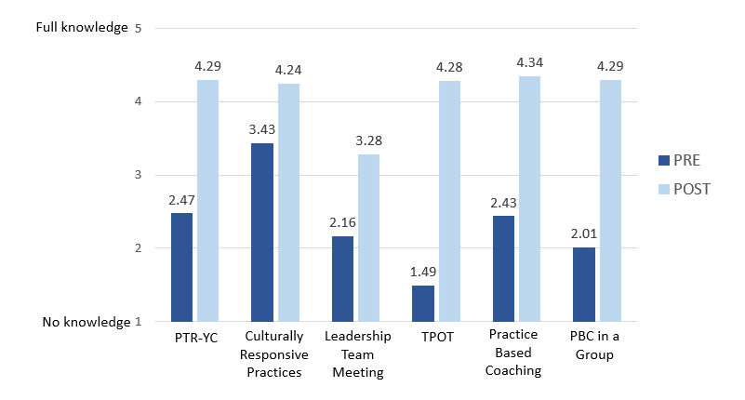
Figure 5. Participant Pre/Post Ratings of Learning Objectives across Statewide Events:
Overall Mean Ratings
With respect to the overall quality of the SSIP statewide trainings, leadership team meetings, and regional events, the vast majority of respondents reported that the delivery of the material was effective, and that the information was relevant and useful to their professional practice. These results are on par with prior years of the project. To provide an overall assessment of event quality, participants used a five-point rating scale where 0 = poor, 1 = fair, 2 = good, 3 = very good, and 5 = excellent. Mean ratings of the statewide content-based events above ranged from 4.48 to 4.75. The Leadership Team meeting was rated slightly lower overall at 3.86 (these means are not shown in table above).
It is worth noting that following each of the statewide events, data are summarized and shared with event facilitators and project leaders for review and decision making. Feedback from the March 2018 leadership team meeting, for example, indicated that district teams were most appreciative of the time they had to learn from each other – during that meeting, districts shared their experiences around TPOT administration and use, among other topics. This feedback has been considered by project leaders and the 2019 March meeting was designed to include district roundtable discussions of this year’s topic area, Indicator 7 data collection and use. Feedback from other events has indicated the need for handouts and resources to be more readily available, and more recent results indicate that this suggestion has been put in place by PMC event facilitators.
KeY Finding: External coaches continue to provide individualized support to districts, which is most frequently provided through site visits. Support is most often focused on supporting leadership teams, but also extends to Pyramid Model practices training sessions, and building capacity for internal coaching and TPOT administration.
External Coach Contact Records provided insight into the types of support that coaches are providing to their districts to help advance implementation. From March 2018 to February 2019, 166 coach contacts were logged across 24 districts. Thirty-six of these contacts were with the new group of six Cohort 3 districts during the 2018-19 school year. According to these records, 24 of the 26 districts received coaching during that time; among those, the number of contacts ranged from 1-18 for each district. Coaches most often met with district and school staff in-person during site visits (68% of contacts), followed by meeting at training events (16%). These results are consistent with the prior year.
Figure 6 below shows the types of support typically provided by external coaches. As shown, two-thirds of the supports were provided to leadership teams. A quarter were related to TPOT and/or internal coach support (often focused on TPOT administration and use). Nearly as many contacts were devoted to providing practices training to team members and staff.
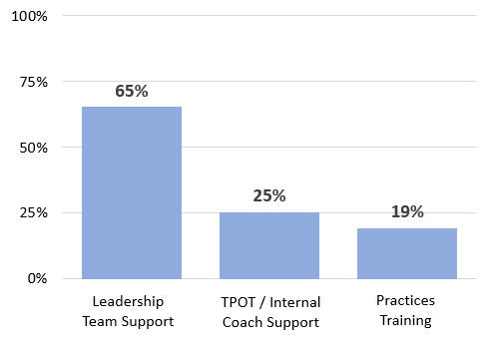
Figure 6. Types of Support Provided by External Coaches
(Question Allowed “check all that apply”)
The support provided to Leadership teams most frequently included:
- Attending meetings (69%)
- Assisting team leaders in building meeting agendas/processes (45%)
- Locating resources (19%)
- Assisting with the completion of the EC-PBS Benchmarks of Quality (16%)
- Assisting with professional development/coaching (15%)
A review of coach logs across the cohorts pointed to the varied level of focus among districts, with respect to their progress in the initiative. For example, as Cohort 1 and 2 districts are moving toward increased use of fidelity measures, their teams were much more likely to have received support for using TPOT (20% of contacts) than Cohort 3 teams (3%). For these more experienced districts, the log entries included many examples of coaches’ work administering and co-rating TPOTs, working with internal coaches on reviewing spreadsheet summary data, and reviewing results to plan next steps for coaching. As Cohort 3 teams are just beginning implementation efforts, support was more often focused on helping to configure and develop processes for leadership teams. Log entries for Cohort 3 included examples of participating in project launch events, setting meeting ground rules, reviewing benchmarks, and developing implementing plans.
Finally, survey responses from leadership team members across all cohorts indicated high levels of satisfaction with coaching, with respect to coaches’ professionalism, knowledge of Pyramid Model content and strategies, and their understanding of districts’ unique needs.
KeY Finding: MA DESE is providing several avenues of support to districts for their work with families, and for increasing family engagement. This approach includes both partnering with community organizations, especially the state’s Parent Training and Information Center (PTI), and external coaches’ work with districts to support Positive Solutions for Families. District participation has been modest to date, though leadership team members are interested in additional information and support going forward.
Based on training feedback forms and information supplied by project leaders, the following activities have been conducted by the state’s Parent Training and Information (PTI) Center, which is part of the Federation for Children with Special Needs (FCSN). This work has been carried out with support from MA DESE.
- The FCSN developed a Professional Development format for Positive Solutions, and conducted training sessions on November 6, 27, and 28, 2018. Participants included parents, social workers, school and family support counselors, program administrators, and others. FCSN also offered a Positive Solutions train the trainer sessions at an EC-PBS/Pyramid districts on January 18, 2019.
- Additionally, the FCSN presented at the Early Childhood Special Education Leadership Institute in August 2018 on the topic of Positive Solutions and Family Engagement.
- The FCSN has also met with participating districts at Pyramid Model trainings to promote Positive Solutions, and met with one of the external coaches to plan Positive Solutions professional development for train the trainer events in western Massachusetts.
Information reported in the External Coach Contact Records over the past year also indicated several instances of support for districts planning family engagement activities or for assisting in planning family training events around Positive Solutions. In one case, the coach reviewed Module One of Positive Solution for Families to help prepare team members for an upcoming family training event planned for March 2019.
Additional context for districts’ work related to Positive Solutions for Families was provided in the Mid-Year Leadership Team Survey (Figure 7). A small proportion of respondents (22%) indicated their school’s/district’s participation in train the trainer sessions related to Positive Solutions. Just 10% indicated that family training sessions had been conducted. Sixty percent indicated that their school/district would like to learn more.
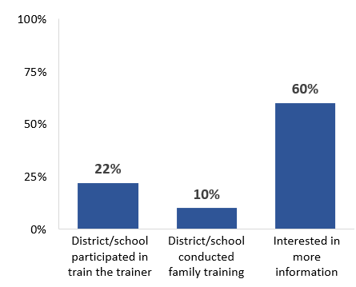
Figure 7. Mid-Year Leadership Team Survey Responses Related to Positive Solutions for Families Training (n=58)
leadership team voices
“We provide quarterly progress meetings with parents; back to school night in September, four Positive Solutions training sessions with families; monthly Coffee and Conversation with parents; winter student performance; Listening Walk at the Zoo”
“We are currently delivering Positive Solutions curriculum and area awaiting a training for the trainers to be scheduled.”
“We invite families in for parenting workshops, we present PBS to families, we have family engagement literacy events with families.”

Evaluation Question 1b: To what extent is the implementation of EC-PBS through Pyramid strategies in MA integrated with other early childhood and/or MA DESE initiatives at the community/local and state levels?
(Findings in this section align with Intended Outcomes S2a. and b.)
KeY Finding: MA DESE continues to integrate the work of the SSIP across interagency initiatives related to early childhood special education, moving toward a community-wide vision for the work. In particular, MA DESE is collaborating with MA EEC on multiple initiatives that support implementation of the Pyramid Model framework, equity, and inclusion across school district and community contexts.
As evidenced though EC-PBS Leadership Team meeting notes, project documentation, and MA DESE communications with school districts and Early Childhood Education (ECE) programs, a variety of interagency initiatives are underway to expand the reach of EC-PBS through Pyramid strategies in the state, and to move toward a more cohesive community-wide structure and philosophy.
Some of the key initiatives and indicators of progress include the following:
- The Early Education and Care EC-PBS/Pyramid Model Training Initiative is now comprised of 41 Early Childhood Education (ECE) programs: 20 Cohort 1 programs that began implementation in spring 2018, and 21 Cohort 2 programs that launched in winter 2018. Leadership teams have been formed at all ECE programs and have access to many of the same statewide training events as their MA DESE district counterparts. ECE programs receive external coaching and are also supported by PMC – there are currently 12 coaches, 7 of whom are also supporting the 26 MA DESE school districts. Evaluation measures and data collection procedures are being streamlined across these initiatives which will allow for a statewide look at progress going forward.
- EC-PBS/Pyramid Model Learning Communities (PMLCs) to support the EC-PBS Pyramid Model are now sponsored by MA EEC, and organized by PMC. These regional training and networking sessions are offered across five regions of the state throughout the year. During the current school year, the focus has been on Trauma Informed Care. Since last’s years report, approximately 124 individuals have taken part across five regions of the state. Organizers collect feedback at each session.
- The EC-PBS/Pyramid Model Partnership Summit provides an annual forum for educators across the state to learn and network about the EC-PBS/Pyramid Model. The 2018 Summit was attended by approximately 120 individuals and feedback from the event evaluations was shared with the SLT. Planning for the 2018 Summit is underway – this year’s focus is Trauma Informed Care, as an extension of the PMLC work described above.
Evaluation Question 1c: To what extent is MA DESE making the intended improvements to the workforce development structure as identified through the evaluation and outlined in its annual reports?
(Findings in this section align with Intended Outcomes S3a. and b.)
KeY Finding: As planned, MA DESE has put in place additional professional development events and support structures for building internal coach capacity, and for broadening the support it provides to districts and schools. Some benefits have been documented, though greater awareness of several of these improvements is needed among participating districts.
Based on last year’s findings, MA DESE and its partners identified several improvements to be put in place during FFY 2017. Several of the specific plans for this year and status of each include the following:
Building Internal Coach Capacity
- Internal coaches now have access to a virtual PBC Community of Practice (COP) each month, facilitated by PMC staff. The meetings began in December 2018. Participation has been modest so far, having been attended by six coaches. Feedback on the Mid-Year Leadership Team Survey suggest that many internal coaches, especially among Cohorts 1 and 2, are not yet aware of the COP meetings.
- PMC provided PBC in a Group training in January, which was attended by 35 individuals. Feedback and gains on learning objectives were very positive, as shown on page 41.
- PMC is also conducting a four-part leadership webinar series which includes a “homework” component and support from external coaches. Three districts have registered for this webinar series to date.
Broadening Support for Districts and Schools
- As of September 2018, MA DESE has been distributing a monthly eNewsletter to the EC-PBS/Pyramid community. The issues contain department updates, profiles of school districts and community implementation sites, biographical sketches of the external coaches and other partners, and information and registration links for upcoming training events. Fifty-percent of survey respondents across all cohorts indicated being aware of the eNewsletter; among those, most have found it to be an effective means of communicating about the project.
- Social media sites (i.e., Facebook, Pinterest) have been designed and launched by external coaches, and shared at statewide meetings. While 65% of Cohort 1 and 2 survey respondents are aware of the social media sites, only 24% of Cohort 3 respondents indicated the same.
- The ePyramid Modules created by PMC have been made available to districts/schools for self-paced Pyramid Model practices training. At the time of this report, PMC reported that seven districts had begun using the modules.
- Training on topics related to significant disproportionality, implicit bias and dismantling racism related to EC-PBS/Pyramid model are in planning stages, including offerings through the MA EEC Pyramid Model initiative, and a new MA DESE initiative getting underway.
(b) Evidence that SSIP’s evidence-based practices are being carried out with fidelity and having desired effects
Evaluation Question 2a: Is the state-level plan resulting in the number of schools and classrooms participating in EC-PBS through Pyramid strategies sample growing over time?
(Findings in this section align with Intended Outcome S4.)
KeY Finding: The MA DESE initiative continues to expand, as the numbers of districts, schools, and classrooms implementing EC-PBS through Pyramid strategies have all increased substantially over the past year. There are currently 43 schools and 194 classrooms that have adopted EC-PBS/Pyramid, representing an 83% increase in classrooms over last year.
Table 7 below shows the progress in the expansion of the initiative over the past two years as documented by external coaches in coordination with district personnel, and reported in the EC-PBS/Pyramid Implementation Profile database. There are currently 43 schools and 194 classrooms working toward implementation across the 26 participating districts. This represents increases of 34% and 83% over last year’s numbers of schools and classrooms respectively. This year, participating classrooms include 172 PreK, 19 Kindergarten, and 3 First Grade classrooms. The percentage of preschools within the participating districts has also increased from 20% last year to 26% this year. Among the 433 preschool classrooms in these districts, 40% (172) are reportedly working toward EC-PBS/Pyramid implementation.
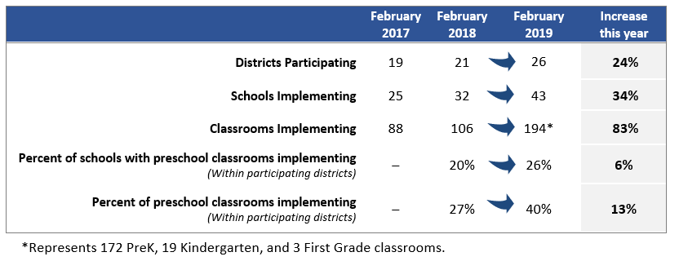
Table 7. EC-PBS/Pyramid Participation among Districts, Schools, and Classrooms: 2017 to 2019
Evaluation Question 2b: Are districts developing systems to support sustainable training and coaching practices at the local level?
(Findings in this section align with Intended Outcome D2.)
KeY Finding: District results on the EC-BoQ v2.0 across Cohorts 1, 2, and 3 suggest that participation in the initiative is contributing to the development of systems to support program-wide implementation.
District leadership teams are guided to use the EC-BoQ at least two times annually to assess their progress toward EC-PBS/Pyramid Model implementation at the district/program level, and to guide action planning. Results on the EC-BoQ have consistently shown district-level progress over time, over the past two years. This year, the project shifted to the updated EC-BoQ v2.0, which incorporates quality indicators for culturally responsive practices, as well as other changes. As such, this year’s EC-BoQ data represent the first measure using this new tool. Results are shown in Table 8, and discussed on the next page.
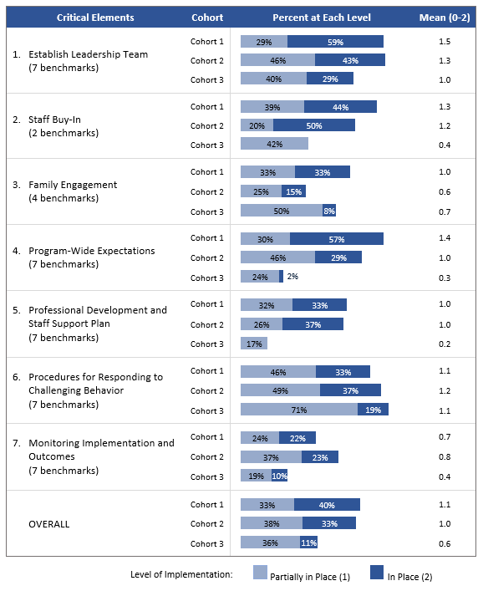
Table 8. EC-BoQ v2.0 Ratings of Critical Elements 1 through 7 and Overall

The new version of the EC-BoQ includes ratings of 41 benchmarks across seven critical elements, each rated on a scale of 0-2, where 0 = not in place, 1 = partially in place, and 2 = in place. While there are no data for comparison from prior years, results across Cohort 1 (n=9 districts), Cohort 2 (n=5), and Cohort 3 (6 districts) show that districts who have been participating longer are more likely to have reported the seven Critical Elements “in place”, suggesting progress over time. As shown, across all 41 indicators, Cohort 1 reported 40% “in place”, and Cohort 2 reported 33% in place. The baseline for Cohort 3 was 11% of indicators in place.
In reviewing the results, is important to note that some Cohort 1 and 2 districts have added new schools into the initiative this year. As such, the EC-BoQ ratings may reflect fewer elements in place as the new schools are gaining traction. For Cohort 3, the ratings represent a true “baseline” measure at the time of project start-up.
Based on these results, Cohort 1 and 2 districts are strongest in the following Critical Elements:
- Establish Leadership Team
- Staff Buy-in
- Program-Wide Expectations
- Procedures for Responding to Challenging Behavior
Cohorts 1 and 2 have the most work to do in Monitoring Implementation and Outcomes, and Family Engagement.
Based on the baseline results for Cohort 3 districts, these teams are launching the project strongest in the following elements:
- Procedures for Responding to Challenging Behavior
- Establish Leadership Team
- Family Engagement
Cohort 3 districts have the most work to do in Professional Development and Staff Support Plan, and Program-Wide Expectations. It is worth noting that on Mid-Year Leadership Team Survey, Cohort 3 survey respondents indicated having made the most progress to date in two of these areas: generating staff buy-in, and fostering an effective leadership team.
KeY Finding: District leadership teams identified several factors contributing to their progress that include a combination of ongoing efforts by school staff, as well as district- and state-level supports.
The Mid-year Leadership Team Survey provided insight into the factors contributing to districts’ progress over the past year (or past months, for Cohort 3). Across all cohorts, two-thirds or more of survey respondents indicated that the following factors were contributing to a “moderate” or “great extent”:
- Ongoing work done by teachers, internal coaches, and staff at the local level
- Support from their external coach
- Participation in training sessions (Pyramid practices, TPOT, PTR-YC, etc.)
- Support and buy-in from district administrators
Many of the survey comments from Cohort 1 and 2 leadership teams mentioned the work of their leadership teams, as well as external coaching and training opportunities. Cohort 3 survey comments were similar, with an emphasis on external coaching and training opportunities. A sample of comments is shown below.
Leadership team voices
factors most important to progress…
“Having a solid leadership team, setting up yearly meetings and action steps are making this HAPPEN!!”
“We are a small but dedicated team, with a flexible and supportive coach. We’re all committed to making this work.”
“The most important factor has been our staff planning time. Our planning has helped to increase family engagement.”
“Our external coach has continued to be a valuable resource. She has trained almost our entire staff in Pyramid Model practices. This has helped our implementation success. I think it was important to have her help with training for many reasons…her expertise and delivery method proved to be extremely helpful gaining buy-in.”
“Participation in training sessions with other partners that have implemented PBS gives me assurance that we are on the right track and also we learn from their experiences.”
“Support from our external coach has been critical to moving this project forward. She has identified training sessions and assisted us in developing a conceptual framework that fits our district.”

KeY Finding: The primary challenge to implementation is common across all cohorts – lack of time and/or availably of classroom-based coaching. Other top challenges include developing internal coach capacity, and access to substitutes for training. Cohort 3 in particular cited lack of knowledge/understanding of the Pyramid Model, pointing to the need for additional training opportunities.
Table 9 below shows the greatest challenges reported by leadership team members; the top three challenges are shaded for each cohort. Last year’s survey results from Cohort 1 are also shown for comparison. The November 2017 survey was completed by 34 individuals, and while not the same respondent group as the 2019 survey, the findings can serve to point to overall project trends. The state’s plans for addressing these and other project challenges/needs identified in this report are addressed in Section F.
Table 9. Mid-Year Leadership Team Survey:
Greatest Challenges to Implementation
Greatest Challenges to Implementation | Cohorts 1 & 2  (n=40) | Cohort 3  (n=18) | Last Year (Cohort 1, n=34)
Lack of time/availability for classroom-based coaching | 80% | 65% | 88%
Difficulty in developing internal coaching capacity to support teachers | 58% | 35% | 70%
Lack of substitutes to allow teachers to attend training | 53% | 41% | 61%
Finding time for the leadership team to meet and plan | 38% | 35% | 42%
Insufficient funding | 35% | 6% | 52%
Lack of time to implement the Pyramid Model in the classroom | 33% | 29% | 27%
Difficulty attending statewide training opportunities | 28% | 29% | 27%
A lack of knowledge/understanding of the Pyramid Model | 23% | 41% | 9%*
*Worded differently last year: “Lack of understanding of the Pyramid Model”.
As shown, teams find the greatest challenge to be the time needed for classroom-based coaching. This is in keeping with 2017, though percentages are slightly lower than last year. For Cohorts 1 and 2, developing internal coaching capacity was indicated by 58% of survey respondents, compared to 70% last year. This difference suggests progress being made in this critical area to support implementation. By comparison, only 35% of Cohort 3 team members indicated this to be a great challenge – this may be because these districts are just ramping up on that aspect of the project.
All cohorts indicated that finding substitutes to allow teachers to attend training is a challenge. This is also down slightly from last year. Finally, among the top challenges to implementation for Cohort 3 specifically is a lack of knowledge/understanding of the Pyramid Model, suggesting that these new districts in particular need additional training opportunities in the foundation for the framework.
Survey comments reiterated districts’ challenges around time and finding approaches to build internal coach capacity within staffing and time constraints. Other comments from Cohort 1 and 2 districts mentioned:
- Plans to double the number of classrooms and add a grade level require significant planning/training
- Difficulty changing the systems to allow for time to support full implementation
- Funding to support ongoing parent workshops and support groups for families
With respect to challenges attending regional practices training and/or statewide training events specifically, the results were similar across cohorts:
- Availability of substitutes (indicated by 58% of Cohorts 1 and 2, and 65% of Cohort 3)
- Time out of district to attend training (45% of Cohorts 1 and 2, 53% of Cohort 3)
- Location of statewide events (40% of Cohorts 1 and 2, 35% of Cohort 3)
KeY Finding: District leadership teams indicate needing assistance in several areas to expand implementation efforts. The greatest need is related to district-based Pyramid Model practices training for teachers, administrators, and other staff, followed by guidance on how to build internal coach capacity.
As shown in Figure 8, 59% - 68% of respondents across cohorts indicated the need for district-based practices training for all staff – teachers, administrators, paraprofessionals, etc. – to expand implementation. For Cohorts 1 and 2, there is a relatively strong need (48%) for additional access to the ePyramid Modules for Pyramid Model practices training, while Cohort 3 indicated a need for more regional trainings (59%). A third or more also pointed to guidance on scaling up internal coach capacity.
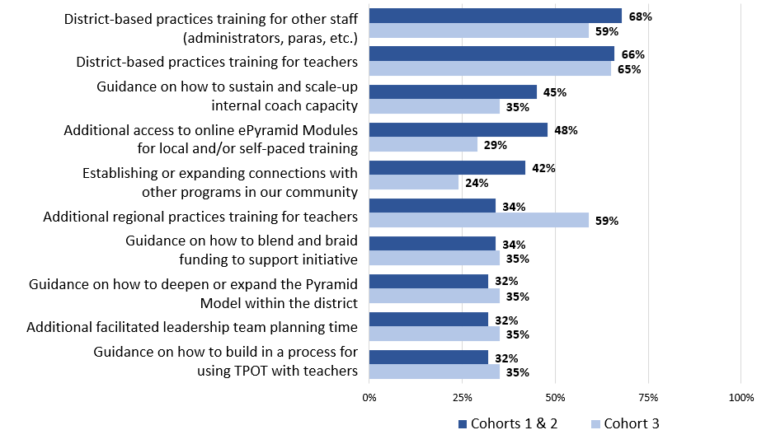
Figure 8. Types of Assistance Needed to Expand Implementation
(c) Outcomes regarding progress toward short-term and long-term objectives that are necessary steps toward achieving the SIMR
Evaluation Question 3a: Are teachers implementing EC-PBS through Pyramid strategies in their schools?
(Findings in this section align with Intended Outcome D3.)
KeY Finding: The TPOT has been used to assess fidelity of implementation with approximately a third of teachers in Cohorts 1 and 2 so far this school year. Results received at the state level suggest that on average, teachers are demonstrating implementation fidelity on many of the key practices.
Processes were put in place this year which allowed external coaches to report de-identified TPOT results for teachers. Data were received for 31 teachers across 11 Cohort 1 and 2 districts, and the TPOTs were understood to have been conducted by “TPOT reliable raters” in all cases. Table 10 shows average ratings in the 14 Key Practices (which are comprised of 114 indicators in total across the practices) and overall. A score of 80% is considered implementation fidelity on this tool. As shown, teachers were observed to be strongest in interventions for children with challenging behavior, transitions between activities, and providing directions. On average, teachers have the most room for growth on teaching behavior expectations, teaching social skills and emotional competencies, and teaching problem solving.
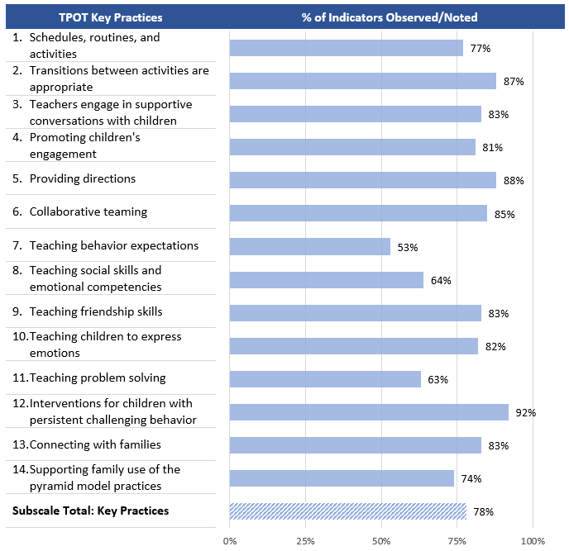
Table 10. Aggregate TPOT Results Across the Key Practices and Overall (n=31)
KeY Finding: Based on individual teacher TPOT results, nearly half of teachers demonstrated fidelity on the overall key practices scale, while the vast majority scored at 60% or above.
Figure 9 shows individual scores for the 31 teachers plotted by cohort. Scores ranged from 54% to 96%. Fourteen teachers (45%) reached fidelity at 80%. As would be expected, Cohort 1 teachers were more likely to have reached this mark. Going forward, the coding system will allow for matching individual teachers’ scores for tracking progress over time.
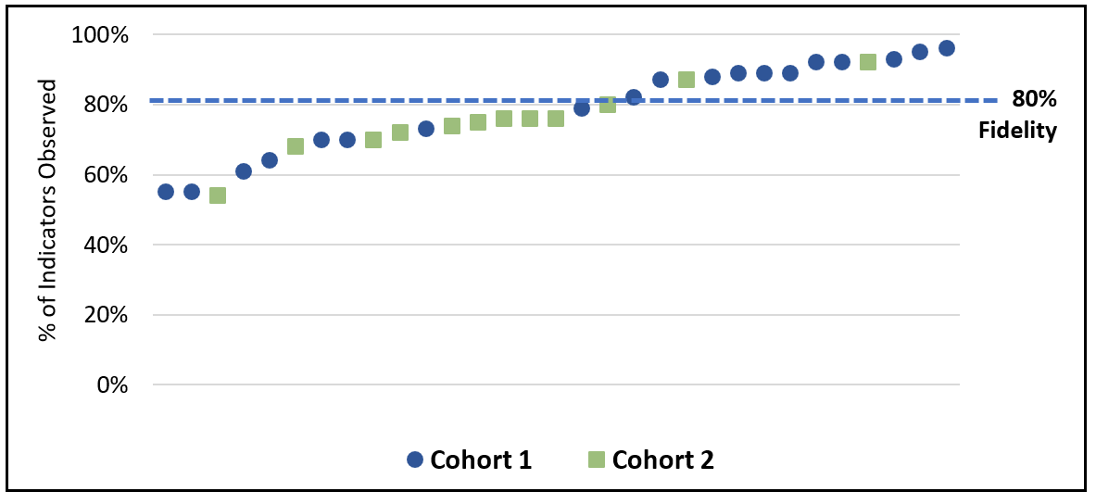
Figure 9. Individual TPOT Results on Key Practices – Overall Percentage (n=31)
Evaluation Question 3b: Does the fidelity of classroom implementation improve over time?
(Findings in this section align with Intended Outcome D3.)
KeY Finding: Teacher self-ratings in key practices associated with Pyramid Model implementation reveal their confidence in their own growth toward fidelity over time. The reported gains were statistically significant.
Because this was the first year that TPOT results were collected at the state level, data are not available to assess the fidelity of implementation over time using that measure. To address this question for FFY 2017, the Pyramid Model Teacher Survey (for Cohort 1 and 2 teachers) included a self-rating of 11 areas associated with the TPOT Key Practices scale. Teachers used a scale from 0 to 5, where 5 indicated “implementation fidelity” to rate each skill area before the initiative, and now (December/January). As shown in Table 11, teachers indicated confidence in growth since they began the Pyramid Model Initiative – these results represent the 63 teachers who responded to the survey. The largest reported area of growth was teaching social skills and emotional competencies, while the area of the least reported growth was connecting with families.
Table 11. Teachers’ Self-Rating of Key Practices Before the Initiative and Now (n=63)
Key Practices Aligned with TPOT | BEFORE | NOW | Gain
 | Overall Mean |  | 1.0
 | 3.25 | 4.25
Effective use of schedules, routines, and activities | 3.7 | 4.5 | .8*
Engaging in supportive conversations with children | 3.4 | 4.3 | .9*
Promoting children’s engagement | 3.6 | 4.4 | .8*
Teaching behavior expectations | 3.5 | 4.6 | 1.1*
Teaching social skills and emotional competencies | 3.1 | 4.4 | 1.3*
Teaching friendship skills | 3.3 | 4.4 | 1.1*
Teaching children to express emotions | 3.2 | 4.3 | 1.1*
Teaching problem solving | 3.1 | 4.2 | 1.1*
Designing and implementing interventions for children with persistent challenging behavior | 3.2 | 4.3 | 1.1*
Connecting with families | 3.6 | 4.2 | .6*
Supporting family use of the Pyramid Model practices | 2.0 | 3.1 | 1.1*
*Reported gains in all key practice areas were statistically significant at p<.0001 based on paired sample t-tests. Effect sizes calculated using Cohen’s D ranged from .87 to 1.37, which is considered a large effect (i.e., educationally meaningful).
On the survey, teachers also described some of their greatest successes implementing Pyramid Model strategies:
- Relationships: Teachers mentioned being cognizant of the importance of building and maintaining positive relationships, and building personal connections with students and families.
- Expectations: Teachers appreciate having a consistent approach, universal language around behavior expectations, and using PBS language consistently with students. Teachers mentioned the creation of a positive learning environment in which children are aware of the expectations, and creating an atmosphere of community and friendship. Some teachers are seeing the positive results of students following the behavior expectations, and others mentioned the effectiveness of the Super Friends model.
- Teaching social skills: Teachers described success teaching children to identify and express emotions, teaching problem solving skills, and explicit teaching of skills around social/emotional learning.
With respect to challenges to implementation, teachers most often identified lack of time/availability for classroom based coaching (44%), and lack of time to implement Pyramid Model in the classroom (32%). Some teachers also indicated difficulty attending regional or statewide trainings (21%).
Finally, teachers described the additional supports they need to keep moving forward successfully, as shown below.
teacher voices
“Continued training ‘check-ins’. Shorter, ongoing training opportunities during grade level meetings to exchange ideas, success stories, and learn 1-2 new techniques/strategies per training. This would keep the Pyramid Model fresh in our minds and hopefully an integrated part of our daily curriculum.”
“I think more focus on school-wide implementation and consistency language across all environments. Everyone is trying to do PBS in their own way. I would like more time to share ideas and learn from other teachers.”
“More modeling of social stories and lessons may be helpful. Possible newsletter with suggestions and strategies that support emotional and social development.”
“More time to create school based specific lessons that are interactive and engaging for the students.”
“We have no clear guidelines for how to respond to the most challenging behavior at the preschool level. Where Elementary Schools have clear protocols in place for dealing with challenging behavior we do not at the preschool level.”
“Time is the biggest constraint as we are planning for general ed and special ed students, overseeing IEPs and writing reports as well as taking and analyzing data. We have planned to set aside time each month for internal coaching.”

vide quarterly progress meetings with parents; back to school night in September, four Positive Solutions training sessions with families; monthly Coffee and Conversation with parents; winter student performance; Listening Walk at the Zoo”
“We are currently delivering Positive Solutions curriculum and area awaiting a training for the trainers to be scheduled.”
“We invite families in for parenting workshops, we present PBS to families, we have family engagement literacy events with families.”
-District Leadership Team Members
-
(d) Measurable improvements in the SIMR in relation to targets
Evaluation Question 4a: To what extent do district and school personnel perceive benefits of implementing EC-PBS/Pyramid strategies for children?
(Findings in this section align with Intended Outcome C1.)
KeY Finding: Many school and district personnel indicate that as a result of EC-PBS/Pyramid strategies, children are demonstrating improved social emotional competencies. Some personnel have also noticed academic benefits, and decreased rates of suspension and expulsion.
Leadership teams and participating teachers across Cohorts 1 and 2 were asked to rate the extent to which the Pyramid Model initiative has led to benefits for children and families. Across all areas, teachers were more likely to report benefits than team members. Figure 10 shows the percent of respondents that selected to a “moderate” or “great extent” among both groups.
As shown, the majority of teachers (84%) and team members (65%) report that children are demonstrating improved social emotional competencies, the main goal of the SSIP. For all of the other items shown in the figure, there was a substantial percentage of survey respondents who selected “not sure” – this percentage ranged from 13% to 44%. Among these other items, some portion of both groups also noted academic benefits, including greater progress in early literacy; decreased rates of in-school suspension and expulsion; and benefits for families. A sample of survey comments is shown on the following page.
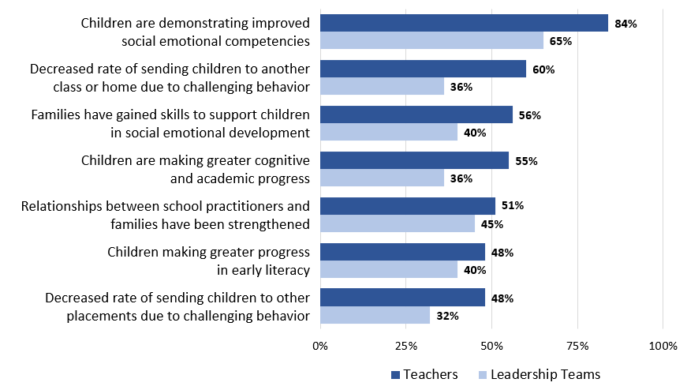
Figure 10. Benefits of Pyramid Model Classrooms:
Percent of Team Members and Teachers Selecting to a “moderate” or “great extent”

Evaluation Question 4b: Is the number of children in MA, aged 3-5, with disabilities, exiting from preschools with age-expected social emotional functioning increasing?
teacher and team member voices
Benefits of Participation…
“Children have learned to solve problems independently using the strategies they have learned.”
“Children have developed the ability to identify their feelings and use taught strategies to self-regulate and form friendships with their classmates. Families have reached out and received support from me with managing the child’s behavior at home.”
“I think that the children in my class are more aware of what it means to be kind to another person and safe in their environment. They are also more aware, with some adult help, of how to solve a problem in a play situation.”
“I have heard and seen families using the language and expectations in their home. We have also been able to provide Positive Solutions for interested families.”
“The amount of kindness between students has been one of the largest benefits.”
“Learning to engage in behaviors that will help them to learn across the life span – build social emotional skills in a positive way, increased confidence and accountability.”

(Note: Key Findings in this section align with Intended Outcome C2.)
KeY Finding: The statewide percentage of preschool children with disabilities functioning within age expectations by the time they turned 6 or exited the program remained consistent over the past year.
The State Identified Measurable Result (SIMR) for the MA DESE SSIP is the improvement of social emotional outcomes for young children with disabilities, aged 3-5. The first way in which MA DESE is measuring achievement of the SIMR is by assessing over time the percent of preschool children functioning within age expectations in positive social-emotional skills by the time they turn 6 years of age or exit the program. These data are collected via the Child Outcomes Summary (COS) process designed by the Early Childhood Outcomes Center as a way for states to summarize data on children’s movement toward age expectations in specific outcome areas.
As shown in Table 12, the state’s SIMR (for Summary Statement 2) remained consistent at 47.00% in FFY 2017, compared to 47.74% in FFY 2016. This result is two percentage points below the newly-established target for this indicator (49%).
Table 12. SPP Indicator 7 Data: Summary Statement 2 (Statewide)
SIMR Data | FFY 2013 | FFY 2014 | FFY 2015 | FFY 2016 | FFY 2017
 | n=472 | n=479 | n=420 | n=398 | n=651
The percent of preschool children who were functioning within age expectations in Outcome A (positive social-emotional skills) by the time they turned 6 years of age or exited the program. | 44.49% | 47.81% | 53.57% | 47.74% | 47.00%
Target | -- | 90% | 90% | 90% | 49%
Note: Summary Statement 2 is calculated by: # of preschool children reported in progress category (d) plus # of preschool children reported in progress category (e) divided by [the total # of preschool children reported in progress categories (a) + (b) + (c) + (d) + (e)] times 100.

Evaluation Question 4c: Is the number of children in MA, aged 3-5, with disabilities, exiting from preschool with greater than expected growth in their social emotional functioning increasing?
KeY Finding: The statewide percentage of students with disabilities who substantially increased their rate of growth by the time the turned 6 or exited the program decreased by three percentage points from FFY 2016 to FFY 2017. The proportional difference year-to-year was not found to be significant, suggesting results have remained consistent over the past year.
The second way MA DESE is measuring achievement of the SIMR is by assessing over time the percent of preschool children who entered the preschool program below age expectations in positive social emotional skills who substantially increased their rate of growth by the time they turned 6 years of age or exited the program, as measured by the Child Outcomes Summary. As shown in Table 13, the percentage decreased by three percentage points from FFY 2016 to FFY 2017, from 88.70% to 85.61%. A subsequent analysis of proportional differences found this year-to-year change was not statistically significant, based on a 90% confidence interval. These results suggest that the statewide gains made from FFY 2015 to 2016 have remained consistent through FFY 2017. The analysis of proportional difference is based on the overall results on the measure and the number of students represented in the calculation each year.
Table 13. SPP Indicator 7 Data: Summary Statement 1 (Statewide)
SIMR Data | FFY 2013 | FFY 2014 | FFY 2015 | FFY 2016 | FFY 2017
 | n=419 | n=422 | n=350 | n=398 | n=651
Of those preschool children who entered the preschool program below age expectations in Outcome A (positive social emotional skills), the percent who substantially increased their rate of growth by the time they turned 6 years of age or exited the program. | 85.44% | 87.20% | 79.14% | 88.70% | 85.61%
Target | -- | 100% | 100% | 100% | 85%
Note: Summary Statement 1 is calculated by: # of preschool children reported in progress category (c) plus # of preschool children reported in category (d) divided by [# of preschool children reported in progress category (a) plus # of preschool children reported in progress category (b) plus # of preschool children reported in progress category (c) plus # of preschool children reported in progress category (d)] times 100.
As of last year, all participating districts were required to submit their COS data for Indicator 7 annually. This is a change from prior years when SSIP districts, like all other districts in the state, followed a cohort cycle of reporting every four years according to Massachusetts’ approved sampling plan. The objective is to monitor progress and trends in child outcomes for districts specifically, in addition to monitoring statewide progress on Indicator 7A. It is important to note that this information will not be sufficient to examine the impact of SSIP activities on student outcomes, but is instead intended as a form of progress monitoring within the districts directly receiving SSIP training and supports.
With this plan in place, a partial set of data have been collected from SSIP districts over the past two years. For FFY 2016, 83 usable student records were received from 12 Cohort 1 districts. For FFY 2017, 172 usable records were received from 16 Cohort 1 and 2 districts. These two data sets have only eight districts in common, and among these districts, the number of usable records varied widely each year. For these reasons, the results on the Indicator 7 outcome measures cannot be compared over time to examine progress across SSIP districts at this stage. MA DESE continues to support districts in fulfilling this requirement, and for using Indicator 7 data at the local level for progress monitoring and program planning.
Results for outcome 7A across SSIP school districts for which data were submitted the past two years are shown in Tables 14 and 15.
Table 14. FFY 2016 Indicator 7A Data: 12 Cohort 1 Districts
FFY 2016
(12 Districts)
 | n=83
Summary Statement 1  Percent of children who substantially increased their rate of growth by the time they turned 6 years of age or exited the program. | 82.60%
Summary Statement 2  The percent of preschool children who were functioning within age expectations by the time they turned 6 years of age or exited the program. | 50.60%

Table 15. FFY 2017 Indicator 7A Data: 16 Cohort 1 and 2 Districts
FFY 2017
(16 Districts)
 | n=172
Summary Statement 1  Percent of children who substantially increased their rate of growth by the time they turned 6 years of age or exited the program. | 77.20%
Summary Statement 2  The percent of preschool children who were functioning within age expectations by the time they turned 6 years of age or exited the program. | 40.70%
As shown, Indicator 7A results from a subset of SSIP districts for FFYs 2016 and 2017 show substantially different results each year. As indicated above, these results cannot be compared to assess progress across the SSIP districts as they represent different sets of districts with little overlap, and within varied contexts (e.g., district size, student demographics, level of EC-PBS/Pyramid implementation, etc.). Going forward, MA DESE continues to support SSIP districts in reporting data annually which will increase the data available for the evaluation. Additionally, the evaluator will collaborate with project leaders, district leadership teams, and external coaches to identify and incorporate new approaches to assessing student outcomes associated with EC-PBS/Pyramid participation.

F. Plans for Next Year

1. Additional Activities to be Implemented Next Year (with timeline)
After a thorough review of the current implementation data, MA DESE has identified a number of strengths and areas for continued growth which will drive the activities for next year (see Table 16 for timelines). Adjustments to data collection, use, and reporting are also planned. Each of these areas is described below.
- Activities that will be continued with little or minor adjustments:
- Actively engage with state and district stakeholders
- Strengthen state infrastructure, including intra- and inter-agency collaboration
- Build capacity of external coaches and support their work with district leadership teams and staff
- Encourage additional family engagement and evaluation of Positive Solutions
- Provide individualized training for teachers and coaches regionally or in districts
- Continue to provide discretionary grant funds to support costs associates with training and implementation, including stipends, substitutes, supplies, and materials
- Continue MA DESE visits to sites to each implementing school at least once per year, and more frequently as needed
- Activities that address areas for continued growth:
MA DESE is committed to supporting schools and districts to provide equal access and high-quality early childhood special education for children with disabilities. MA DESE and its partners will continue to analyze the infrastructure and available resources for most effectively expanding and sustaining the EC-PBS/Pyramid foundation that has been established. This includes supporting the ongoing scale up to new schools within implementing districts, as well as assessing the extent to which resources allow for new districts to begin training and coaching activities toward adopting the model. In all cases, the focus will remain on moving toward implementation fidelity and sustainability where implementation is underway.
After an analysis of the data provided by the external evaluator, MA DESE, along with stakeholders, will commit to the following areas of focus moving forward by:
- Supporting initiatives to address significant disproportionality in the identification, placement and removals of children of color, implicit bias and ensure equitable access, including:
  - Providing districts with online data collection tools to analyze Behavior Incident Reports (BIRs) for district personnel to analyze both corrections and praise for children
  - Launching the Pyramid Equity Project in Massachusetts to support district personnel to identify and address implicit bias.
- Committing to professional development and coaching supports to promote implementation fidelity in schools and districts.
- Expanding opportunities for authentic family engagement.
- Supporting Leadership Teams to use data and plan for sustainability by:
  - Creating data-based Action Plans based on the analysis and synthesize of data, including BIR, BoQ, indicator 7, and TPOT data
  - Supporting Practice-Based Coaching
  - Building capacity for supporting challenging behaviors and writing effective behavior intervention plans
  - Promoting acquisition of early literacy and numeracy skills
Data Collection, Use, and Reporting
- Develop plan and process to assess child outcomes – identify indicators, data sources, and data collection processes
- Review all data collection tools to ensure data utility; refine as needed, and continue alignment with MA EEC Pyramid Model initiatives for assessing statewide progress
- Continue to build in processes for stakeholder review and processing of data for decision-making
- Continue to reinforce and streamline systems for data collection for the SSIP evaluation
- Pilot online app that integrates School Wide PBIS and PBS/Pyramid data
- Reinforce state-level guidance for reporting de-identified TPOT data; support districts to increase reporting rates
- Continue to increase training for data-based decision making (state, district, classroom and child level) using Indicator 7 data and other local level district data
- Develop statewide disaggregated data analysis for indicator 7
- Provide Indicator 7 training
- Provide guidance about integration of literacy screener from Early Literacy Expert Panel and pilot intensive interventions in literacy / math (tier 3) in K-3
Table 16. SSIP Implementation: February 2019 – Spring 2020
Date | Activities | Audience
Ongoing and Continuing | Communication with Pyramid Model Consortium staff | N/A
Ongoing and Continuing | External Coach Contact Records completed as substantive contacts with districts occur | N/A
Ongoing and Continuing | Site visits by MA DESE staff at participating districts, including intensive support for Indicator 7 data collection | District leadership teams, external coaches, teachers
Ongoing and Continuing | Monthly Professional Learning Community (PLC) meetings | External coaches
Ongoing and Continuing | State-level Leadership Team Meetings | MA DESE, MA EEC, and MA DPH staff
3/12/19 | End of Year Leadership Team Meeting | District leadership teams and external coaches
3/18 & 3/27/19 | Implicit Bias Webinar Series | Teachers, internal coaches, behavior specialists, and external coaches
3/21-3/22/19 | TPOT (Teacher Pyramid Observation Tool) Training | Internal coaches and external coaches
3/28/19 | Prevent Teach, Reinforce – Young Children (PTR-YC) | Teachers, internal coaches, behavior specialists, and external coaches
5/30/19 | Prevent Teach, Reinforce – Young Children (PTR-YC) | Teachers, internal coaches, behavior specialists, and external coaches
6/17/19 | Linking Social-Emotional and Early Literacy | Teachers, internal coaches, behavior specialists, and external coaches
Ongoing and Continuing | Coaches’ Community of Practice:  - in-depth data-based decision making (using indicator 7)  - fidelity measures  - integration of literacy and numeracy instruction  - support for family engagement | Internal coaches and external coaches
Ongoing and Continuing | Positive Solutions train-the-trainer w/MA EEC and FCSN | Teachers, internal coaches, behavior specialists, and external coaches
FY 2020
Summer-Monthly | Implicit Bias/Disproportionality | Monthly Peer Learning Group
Summer/Early Fall | New staff “ramp up” | District leadership teams, internal coaches, and teachers
Monthly | Coaches’ Community of Practice | Internal coaches
Fall | Beginning of the Year Leadership Meeting, to include:  - BoQ  - implementation planning  - data-based decision making  - support for family engagement  - Behavior Incident Reports – Equity/Disproportionality data | District leadership teams and external coaches
 | Practices Training | Teachers
Fall | Embedding Equity Guide into Practice Based Coaching | Internal coaches and external coaches
 | Positive Solutions Train-the-trainer | Teachers, internal coaches, behavior specialists, and external coaches
 | TPOT (Teacher Pyramid Observation Tool) Training | Internal coaches and external coaches
 | Prevent Teach, Reinforce – Young Children (PTR-YC) | Teachers, internal coaches, behavior specialists, and external coaches
Spring | Practices Training | Teachers, paraprofessionals, other staff
 | Positive Solutions Train-the-trainer | Teachers, internal coaches, behavior specialists, and external coaches
 | TPOT (Teacher Pyramid Observation Tool) Training | Internal coaches and external coaches
 | Prevent Teach, Reinforce – Young Children (PTR-YC) | Teachers, internal coaches, behavior specialists, and external coaches
 | End of Year Leadership Team Meeting | District leadership teams and external coaches

2. Planned Evaluation Activities Including Data Collection, Measures, Expected Outcomes
The evaluation approach for the coming year will be consistent with the plan presented in Section C of this report. In the coming year, MA DESE will continue to collaborate with internal and external stakeholders to monitor and refine this plan including the key questions, intended outputs, and data collection processes. In particular, the external evaluator will work with MA DESE, project partners, and key stakeholders to identify indicators, data sources, and data collection processes for assessing child outcomes associated with the EC-PBS Pyramid/strategies initiative.
In coordination with the external evaluator, MA DESE will continue to fine-tune data collection tools and procedures to ensure high response rates, and a continued focus on valid and reliable data across all measures. The IDC Framework for High-Quality Data, as referenced in Section D, will continue to serve as a guide. MA DESE will continue to review all data as they become available to continue its cycle of inquiry for continuous improvement. Table 17 shows the evaluation plan for the coming year including key questions and an abbreviated list of intended outcomes, as well as data sources and timelines.
Table 17. SSIP Evaluation Plan: March 2019 – February 2020
Evaluation Questions | Intended Outcomes | Data Sources | Anticipated Timeline
State Level Infrastructure
EQ1a  In what ways is MA DESE using the SSIP, including statewide implementation of EC-PBS through Pyramid strategies, to build state-level capacity to support improved social emotional outcomes for young children with disabilities? | S1. Short Term and Intermediate  In order to build state capacity, MA DESE will…  - Provide statewide and regional training on PBS through Pyramid strategies  - leverage the cadre of PBS external coaches to support districts and communities;  - collaborate with community and social services agencies to provide additional training and support to families. | - Extant project documents  - Statewide training and meeting data, feedback forms  - External Coach Contact Records; External Coach Survey | - All ongoing throughout the year  - Fall 2019
EQ1b  To what extent is implementation of EC-PBS through Pyramid strategies in MA integrated with other early childhood and/or MA DESE initiatives at the community/local and state levels? | S2. Intermediate  MA DESE will…  - engage in ongoing collaboration with colleagues in Part C and K-12 PBIS initiatives  - engage in ongoing collaboration to continue to promote local level integration of PBS. | - Extant project documents | - Ongoing
EQ1c (NEW QUESTION)  To what extent is MA DESE making the intended improvements to the workforce development structure as identified through the evaluation and outlined in its annual reports? | S3. Short Term and Intermediate  (In 2019-20) MA DESE will…  - Build internal coach capacity  - Support teams in data use toward sustainably  - Provide training and build skills related to implicit bias, equity | - Extant project documents  - Statewide training data  - Mid-Year Leadership Survey | - Ongoing  - December 2019
Program/District Infrastructure
EQ2a  Is the state-level plan resulting in the number of districts, schools, and classrooms participating in PBS through Pyramid strategies growing over time? | S4. Long Term  MA DESE will provide adequate training and support in EC-PBS/Pyramid Model strategies so that participating districts build capacity to expand implementation. | - EC-PBS/Pyramid Implementation Profile  - Mid-Year Leadership Survey | - February 2020  - December 2019
EQ2b  To what extent are districts developing systems to support and sustain program-wide EC-PBS through Pyramid strategies? | D2. Intermediate  The participating districts have established a system-wide approach to implementing and sustaining PBS/Pyramid strategies as aligned with the EC-BoQ | - EC-BoQ v2.0 assessments  - Mid-year Leadership Team Survey | - Fall and spring  - December 2019
Classroom Level
EQ3a  To what extent are teachers implementing EC-PBS through Pyramid strategies in their classrooms? | D3. Intermediate  Teachers will be able to implement PBS through Pyramid strategies with fidelity to improve the social/emotional development of young children with disabilities. | - Mid-year Leadership Team Survey  - Pyramid Model Teacher Survey  - TPOT results | - December 2019
EQ3b  Does the fidelity of classroom implementation improve over time? | D4. Long Term  Teachers will demonstrate improved implementation fidelity over time. |  | - February 2020
Student Level
EQ4a  To what extent do district and school personnel perceive benefits of implementing EC-PBS/Pyramid strategies for children? | C1. Long Term  Students of teachers implementing EC-PBS/Pyramid strategies will demonstrate improved social/emotional competencies and other academic benefits. | - Mid-year Leadership Team Survey  - Pyramid Model Teacher Survey | - December 2019
EQ4b (NEW QUESTION)  To what extent are student benefits reflected in classroom/school level assessment/performance data? |  | - (NEW) Measures and data sources TBD | - February 2020
EQ4b  Is the number of children in MA, aged 3-5, with disabilities, exiting from preschool with age-expected social emotional functioning increasing? | C2. Long Term  Children with disabilities, aged 3-5, will exit preschool with social/emotional competencies that will allow them to access and participate in the general curriculum and in all aspects of the school. | - Indicator 7 data | - Annually in spring
EQ4c
Is the number of children in MA, aged 3-5, with disabilities, exiting from preschool with greater than expected growth in their social emotional functioning increasing?

3. Anticipated Barriers and Solutions
MA DESE has planned for the following contingencies in implementing the next steps of the MA SSIP, shown in Table 18.
Table 18. Anticipated Barriers and Solutions
Anticipated Barrier | Solution
Greater requests from districts to join the cohort than current state infrastructure can accommodate. | - Create model districts and support leadership teams to become mentors  - Through support of national TA centers, train highly effective external coaches to build “in-state” experts.
Attrition of trained local staff (ongoing concern). | Provide new staff “ramp up” training and support at the beginning of the school year. Further, there is a statewide initiative getting underway to recruit and retain effective teaching staff.  In addition, efforts by the MA EEC to provide Massachusetts educators with access to the ePyramid Modules through its Learning Management System in the coming year will help address training needs.
State model does not adequately account for diverse local level needs. | Stakeholders engage in continuous feedback loop and data analysis to address diverse community needs and provide responsive, individualized supports for district staff and families.  Additionally, continued networking across districts and community programs will serve to connect staff at the local level who have similar needs/experiences; the peer-to-peer support model will build capacity.
Internal coach capacity with respect to “best practice” of PBS/Pyramid Model implementation, i.e., hours of support recommended vs. feasibility at local level due to staffing and time constraints. | Implement additional internal coach supports as described above; continue to explore needs and solutions with district teams. Increase awareness among internal coaches of Community of Practice meetings and other coach capacity building activities to ensure full participation.

4. State’s Need for Additional Support/TA
MA DESE relies on the technical assistance and support from OSEP directly and from OSEP-funded TA centers, including, the IDEA Data Center (IDC), the National Center for Systemic Improvement (NCSI), the Early Childhood Technical Assistance Center (ECTA). MA DESE participated in a variety of individualized, targeted, and universal TA, most notably, support from the IDC to reset targets for Indicator 7.
MA DESE has been accepted for an intensive TA opportunity with the National Center for Pyramid Model Innovations (NCPMI) to build internal state expertise in the Pyramid model and engage in high leverage coaching activities.

APPENDIX
- Massachusetts’ Early Childhood Positive Behavior Supports (PBS) Pyramid Model Community Overview
- Early Childhood Program-Wide PBS Benchmarks of Quality, version 2.0
- Massachusetts Department of Early Education and Care Pyramid Model Training Initiative Evaluation: June 2018 Report excerpt

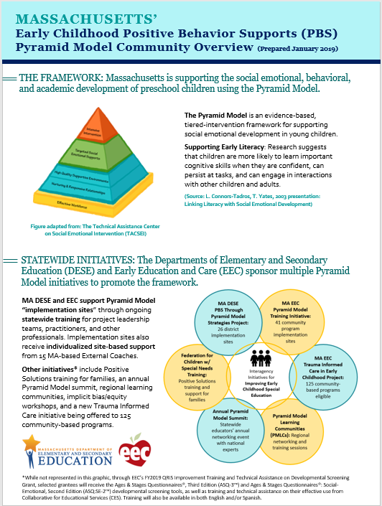
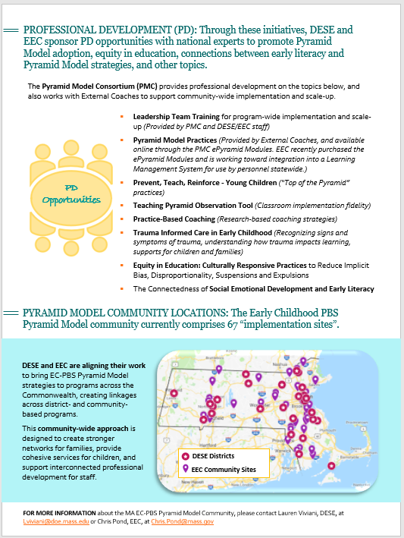
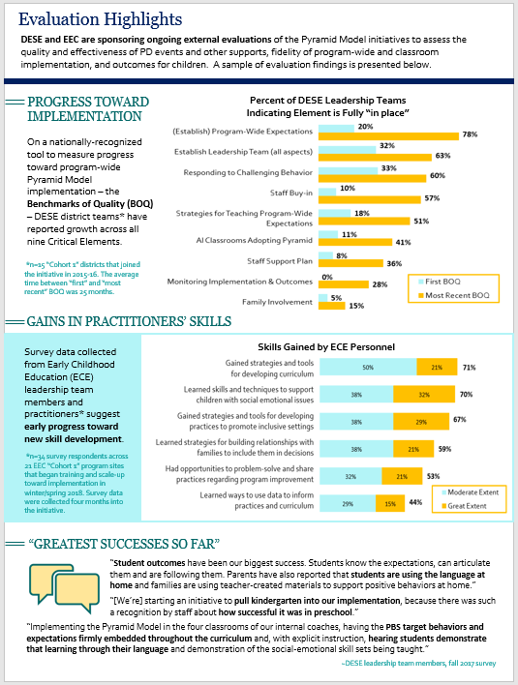

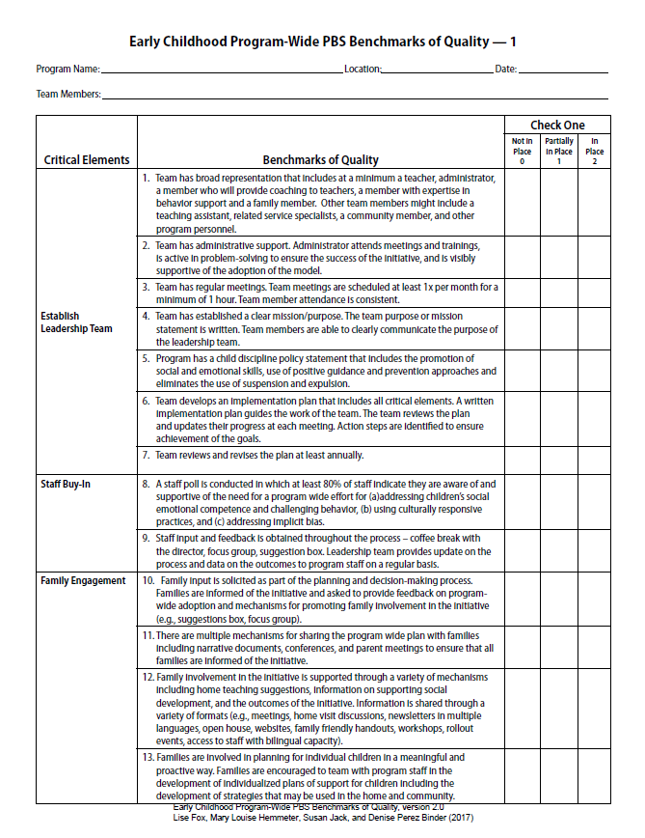
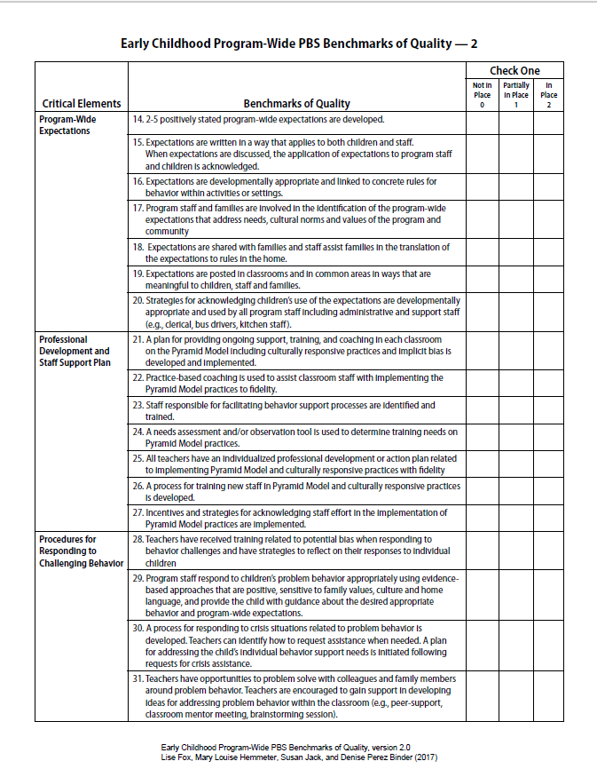
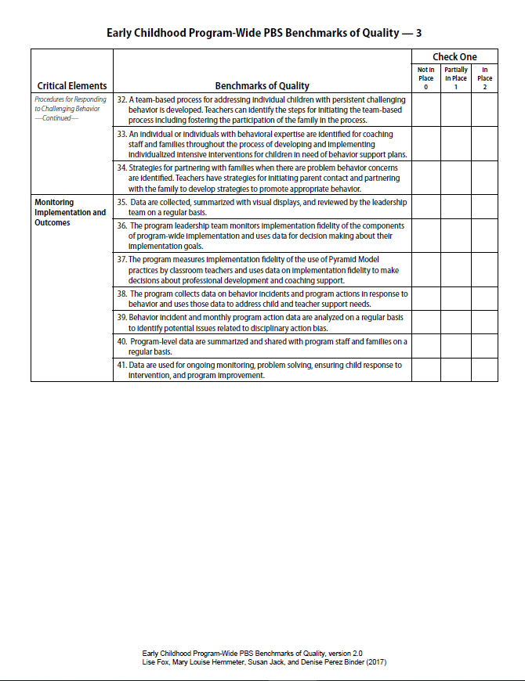

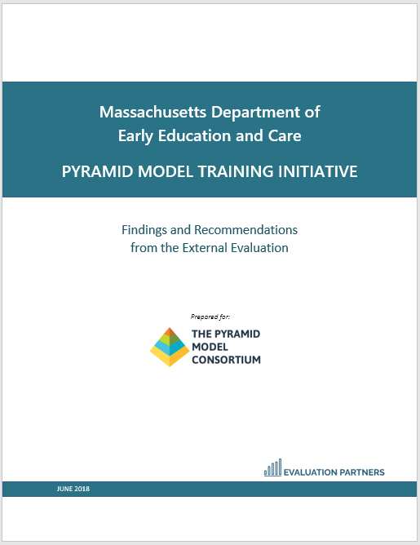

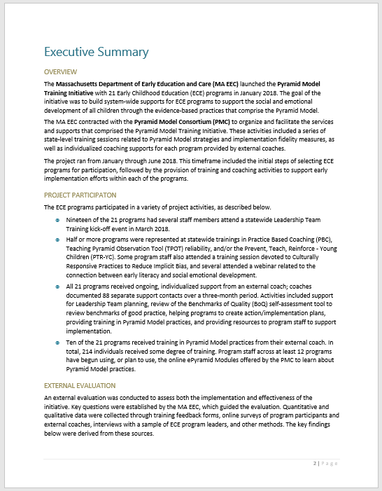
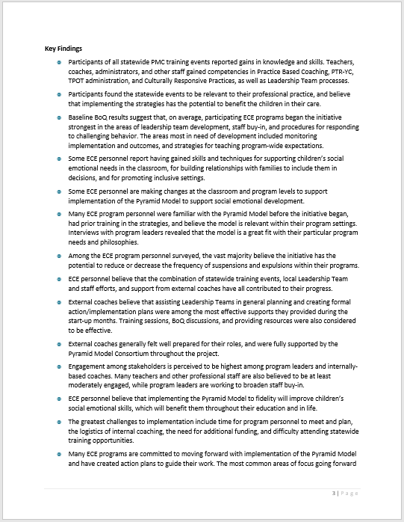

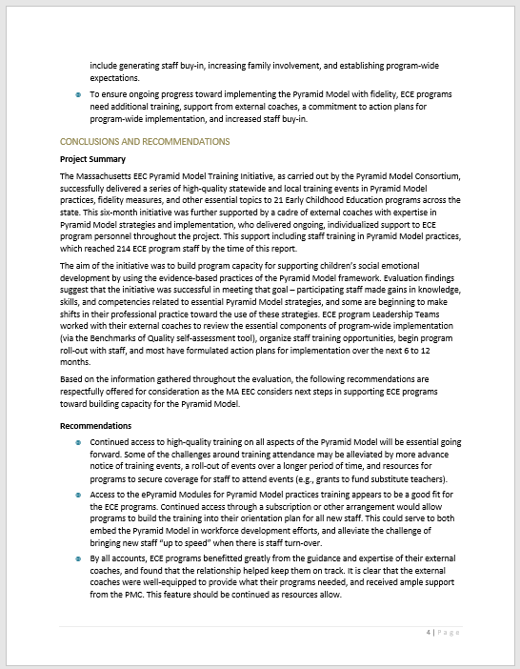
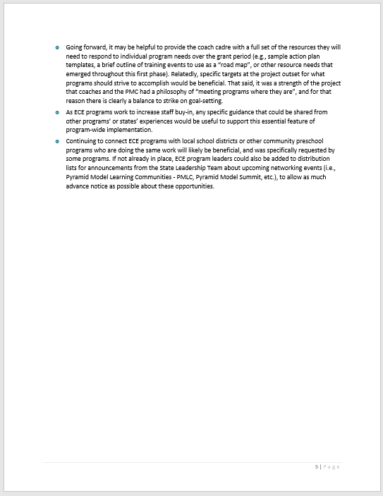

Further detailed information about summary statement calculations, data collection samples, methods, and tools can be found in MA DESE’s FFY 2017 Part B State Performance Plan (SPP)/Annual Performance Report (APR).
During the clarification period following the submission of this report to OSEP, MA DESE updated FFY 2017 to be the new baseline year for Indicator 7, thereby removing the FFY 2017 targets. Additionally, the Indicator 7 B1 targets were updated for FFYs 2018 and beyond. These adjustments will be discussed with stakeholders in the coming year. With respect to the SSIP SIMR based on A1 and A2 results, the FFY 2018 targets remain at 86% and 50% respectively. Additional information can be found in MA DESE’s FFY 2017 Part B SPP/APR.
Early Childhood Program-wide PBS Benchmarks of Quality (2010), Lise Fox, Mary Louise Hemmeter, and Susan Jack.
Early Childhood Program-wide PBS Benchmarks of Quality, version 2.0 (2017), Lise Fox, Mary Louise Hemmeter, Susan Jack, and Denise Perez Binder.
Teaching Pyramid Observation Tool (TPOT) for Preschool Classrooms (2014), Lise Fox, Mary Louise Hemmeter, and Patricia Snyder.
The framework can be accessed at https://ideadata.org/working-principles
Three participating districts did not supply updates this year; the overall totals reflect the February 2018 numbers for those districts.
Differences were assessed using the Early Childhood Technical Assistance (ECTA) Center’s Child Outcomes Year-to-Year Meaningful Differences Calculator for States.

