Massachusetts Department of
Elementary and Secondary Education (MA ESE)

State Systemic Improvement Plan (SSIP)
Phase III, Year 2 Report

FFY 2016
Submitted March 30, 2018

Table of Contents
A. Summary of Phase III Year 2 2
1. Massachusetts SIMR and Theory of Action 2
2. Summary of Improvement Strategies 4
3. Evidence-Based Practices Implemented to Date 6
4. Evaluation Activities, Measures, and Outcomes 6
5. Highlights of Changes to Implementation and Improvement Strategies 8
B. Progress in Implementing the SSIP 9
1. Description of the State’s SSIP Implementation Progress 9
2. Stakeholder Involvement in SSIP Implementation 20
C. Data on Implementation and Outcomes 22
1. How the State Monitored and Measured Outputs to Assess Effectiveness 22
2. How the State has Demonstrated Progress and Made Modifications to the SSIP 28
3. Stakeholder Involvement in the SSIP Evaluation 30
D. Data Quality Issues 32
1. Data Limitations 32
E. Progress in Achieving Intended Improvements 34
1. Assessment of Progress toward Achieving Intended Improvements 34
F. Plans for Next Year 48
1. Additional Activities to be Implemented Next Year (with timeline) 48
2. Planned Evaluation Activities Including Data Collection, Measures, Expected Outcomes 51
3. Anticipated Barriers and Solutions 53
4. State’s Need for Additional Support/TA 53
APPENDIX 54

Tables and Figures
TABLES
Table 1. Indicator 7A Reported Data (FFY 2013 – FFY 2016) 3
Table 2. FFY 2016 – FFY 2018 Targets 3
Table 3. MA SSIP Evaluation Plan 22
Table 4. Data Collection Plan 26
Table 5. Data Limitations, Implications, and Plans for Improvement 32
Table 6. Year 2 Training and Supports for Pracitioners and Coaches (February 2017 - February 2018) 35
Table 7. Relevance/Usefulness of Regional Practices Trainings: Average Ratings on 4-Point Agreement Scale 36
Table 8. Learning Objectives and Relevance/Usefulness of Beginning of Year Leadership Team Meetings: Average Ratings on 4-Point Agreement Scale 37
Table 9. PBS/Pyramid Participation among Districts, Schools, and Classrooms: 2017 to 2018 39
Table 10. BOQ Ratings of Critical Elements 1 through 5: Comparison of First, Mid, and Last BOQ Results 40
Table 11. BOQ Ratings of Critical Elements 6 through 9: Comparison of First, Mid, and Last BOQ Results 41
Table 12. SPP Indicator 7 Data: Summary Statement 2 (Statewide) 46
Table 13. SPP Indicator 7 Data: Summary Statement 1 (Statewide) 47
Table 14. SPP Indicator 7 Data: Summary Statements 1 and 2 (12 Cohort 1 SSIP Districts) 47
Table 15. SSIP Implementation: February 2018 – Spring 2019 50
Table 16. SSIP Evaluation Plan: February 2018 – January 2019 51
Table 17. Anticipated Barriers and Solutions 53

FIGURES
Figure 1. MA SSIP Theory of Action 4
Figure 2. Massachusetts PBS/Pyramid Model Sequence and Supports 10
Figure 3. Interagency Initiatives Related to PBS/Pyramid Model 11
Figure 4. Statewide SSIP Progress Aligned with the MA ESE SSIP Theory of Action (February 2017 – February 2018) 19
Figure 5. Percent Reporting Benchmarks “In Place”: Comparison of First and Last BOQ Results 42
Figure 6. 2017 Mid-year Leadership Team Survey: Factors Contributing to Progress 43
Figure 7. 2017 Mid-year Leadership Team Survey: Types of Assistance Needed to Expand Implementation 43
Figure 8. Types of Support Provided by External Coaches (Question Allowed “check all that apply”) 44

A. Summary of Phase III Year 2
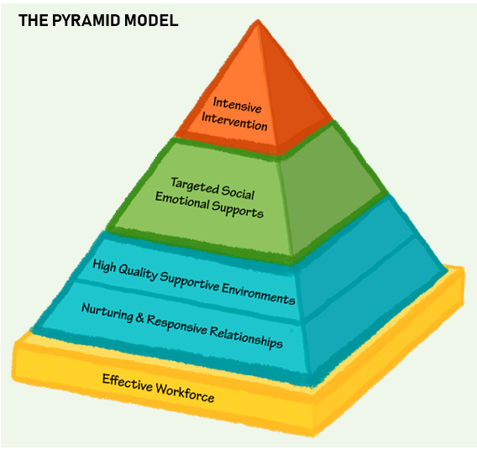
Massachusetts’ State Systemic Improvement Plan (MA SSIP) is devoted to improved social emotional outcomes for preschool children with IEPs. In collaboration with key stakeholders, the Massachusetts Department of Elementary and Secondary Education (MA ESE) selected the implementation of Preschool Positive Behavior Supports (PBS) through Pyramid Model strategies (PBS/Pyramid) as its evidence-based practice (EBP) to achieve this goal, and to positively impact students.
Now in the second year of Phase III, MA ESE is directly engaged in supporting implementation of the PBS/Pyramid Model with 21 school districts. Most of these districts are in their third year of implementation, while several came on board this past school year. To support PBS/Pyramid Model implementation in these districts, and to continue to build statewide infrastructure, MA ESE has been engaged with national experts from the Pyramid Model Consortium (PMC) since the outset of the SSIP. PMC staff collaborates with state personnel to provide training and to assist in building capacity among external coaches, practitioners, and other educators for implementing the model with fidelity. Over the past year, the PMC has also taken on a lead role in overseeing the external coaches’ professional learning community (PLC), providing a direct line of support for implementation, and is involved in key aspects of project coordination with MA ESE.
In addition to the targeted work of the SSIP within these school districts, the Massachusetts PBS/Pyramid Model Statewide Leadership Team (SLT), of which the MA ESE is an active member, continues to collaborate on broadening the scope and reach of PBS/Pyramid Model adoption through several additional statewide initiatives. These initiatives include statewide training opportunities and learning forums, PBS/Pyramid Model demonstration sites, and parent involvement activities, among others. In addition, MA ESE continues to build the foundation for this infrastructure through an array of department initiatives related to positive social emotional outcomes for all students. These initiatives are further described in this report.
Finally, MA ESE continues to collaborate with an external evaluator to help manage and analyze data related to the implementation and achievement of outcomes, to assist in communicating results to stakeholders, and to provide support for data collection systems.

1. Massachusetts SIMR and Theory of Action
Massachusetts SIMR
To assess progress toward its State-identified Measurable Result (SIMR), MA ESE uses statewide results obtained for Indicator 7: Preschool Outcomes; Outcome A: Percent of preschool children aged 3 through 5 with IEPs who demonstrate improved positive social-emotional skills (including social relationships).
Indicator 17: SSIP – State Identified Measurable Result (SIMR)
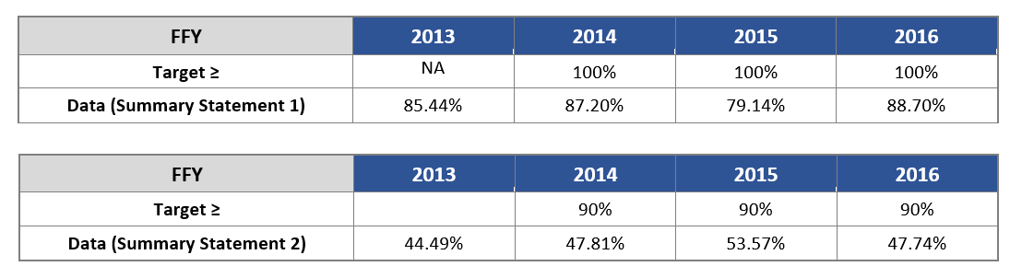
Table 1. Indicator 7A Reported Data (FFY 2013 – FFY 2016)
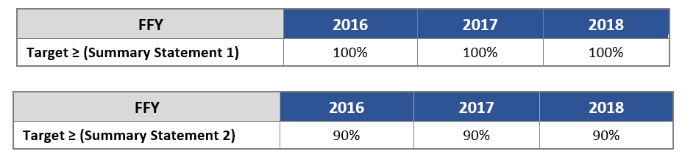
Table 2. FFY 2016 – FFY 2018 Targets
Description of Measure for SIMR
To address Indicator 7, child level data are collected via the Child Outcomes Summary (COS) process. Results are then analyzed to address two Summary Statements.
- Summary Statement 1: Of those preschool children who entered or exited the preschool program below age expectations in Outcome A, the percent who substantially increased their rate of growth by the time they turned 6 years of age or exited the program.
- Summary Statement 2: The percent of preschool children who were functioning within age expectations in Outcome A by the time they turned 6 years of age or exited the program.
Table 1 above shows statewide SIMR results for federal fiscal year 2016 in comparison to the three prior years. As shown, outcomes for Massachusetts preschool children with disabilities increased over baseline (FFY 2013 to FFY 2016) for both summary statements. In the most recent reporting period (FFY 2015 to FFY 2016) notable progress was made for Outcome A, Summary Statement 1, where results show a gain of nearly 10 percentage points (79.14% to 88.70%). Slippage was noted for Summary Statement 2, however, with a decrease of nearly 6 percentage points observed from FFY 2015 to FFY 2016 (53.57% to 47.74%).
MA ESE posits that student growth, coupled with improved and more accurate functional assessment techniques by educators, resulted in improvement Indicator 7A1 and slippage in 7A2. Student progress that might have in the past been reported to be age level is now better recognized and more accurately reported. Further, this performance indicator is the primary focus of MA ESE's SSIP and improvement activities associated with the project which may explain the overall improvement in this indicator.
MA SSIP Theory of Action
The MA ESE continues to use the MA SSIP Theory of Action (TOA) as a guide for its work toward implementation of the SSIP. The TOA, shown in Figure 1 below, is based on a cascading structure of collaboration and support that flows from the state level (interagency initiatives, MA ESE Early Childhood Special Education (ECSE) initiatives), to programs, classrooms, and students. Family engagement is a focus throughout, as is an ongoing process of inquiry and improvement. Figure 2 on page 10 provides a graphic summary of statewide SSIP progress as it aligns with this Theory of Action.
Figure 1. MA SSIP Theory of Action
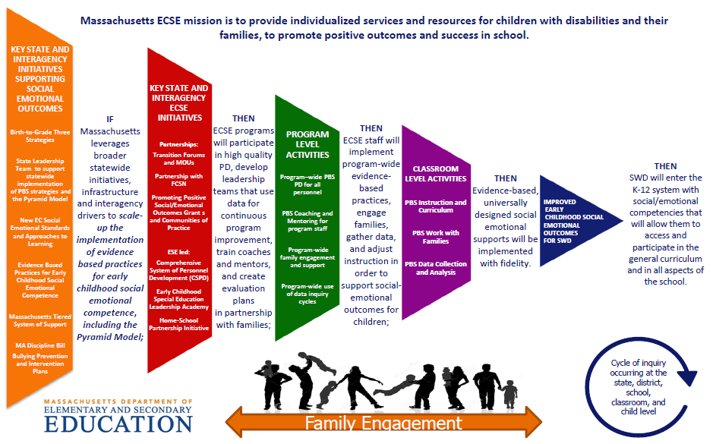

2. Summary of Improvement Strategies
Principal Activities for Implementation of Evidence-Based Practices
The principal activities related to PBS through Pyramid Strategies implementation began in spring 2015 and continue to be conducted across the state, district, school, and community levels as they align with MA ESE’s Theory of Action. These activities include building state infrastructure through collaborating with national experts to prepare and support district leadership teams for implementing the PBS/Pyramid Model; supporting external coaches to help guide district efforts; training practitioners; and providing support for implementation and family involvement at the local level. Updates since last year’s report include the following.
- National Expert Support: MA ESE expanded the role of the Pyramid Model Consortium this past year to provide greater access to experts who can help support district leadership teams across the 21 participating districts, and to provide additional guidance for external coaches.
- Statewide Coaching: MA ESE continues to fund eight external coaches with PBS/Pyramid Model experience to support participating districts’ implementation of the model in their schools and classrooms, and coach supports provided by the PMC have been further enhanced this year. Additionally, the State Leadership Team is in the initial stages of expanding the cadre of coaches to an additional 15 individuals across the state.
- District Leadership Teams: District leadership teams have been formed among the four Cohort 2 districts that joined this past year. Like Cohort 1, these teams plan and guide PBS/Pyramid Model implementation in their districts and schools.
- Training Practitioners: At the core of building statewide infrastructure for implementing PBS through Pyramid strategies is the provision of high-quality trainings to build capacity at the local level. This year saw the continued expansion to additional teachers, coaches, behavior specialists, administrators, paraprofessionals, and other staff.
- Training District-Based Internal Coaches: District-based internal coaches attended a two-day Practices-based coaching event, “Coaches Day”, to help prepare them for their roles working with teachers to implement PBS/Pyramid strategies with fidelity.
Broader Infrastructure Activities
The MA ESE is engaged in numerous statewide activities related to the implementation of the PBS/Pyramid Model more broadly across Massachusetts. Key activities are listed below, with an indication of whether the work has been expanded (indicated by) during this reporting period or is a new initiative (indicated by). These activities are fully described in Section B.
Interagency Initiatives
PBS/Pyramid related:
- Massachusetts PBS/Pyramid Model State Leadership Team (SLT) -
- PBS/Pyramid Model Learning Communities (PMLC) -
- PBS/Pyramid Model Summit -
- PBS/Pyramid Model Demonstration (DEMO) Sites -
- Early Education and Care (EEC) PBS/Pyramid Model Training Initiative -
- Positive Solutions for Families -
Early Childhood Special Education related:
- Early Childhood Leadership Institute -
- Building Inclusive Communities in Preschool (BIC) -
- Early Literacy and ECSE -
- Early Childhood Transitions -
- K-3 Policy Academy -
- Massachusetts Commission for Deaf and Hard of Hearing Early Education (MCDHH)/ESE/EEC Task Force -
- Early Learning Network Regional Meetings -
- Safe and Supportive Learning Environment Professional Development Series -
- Resources for Families, Teachers, and Administrators: Integrating social emotional and early literacy skills in early childhood programs to promote inclusive environments -
Department of Elementary and Secondary Education Initiatives
- 2017 Special Education Professional Development Series -
- Family Engagement Consortium -
- Social and Emotional Learning -
- Promoting Racial Equity and Dismantling Racism -
- Accountability and Monitoring – Tiered Focused Monitoring: A New Approach -
- Grants -
- Rethinking Discipline -

3. Evidence-Based Practices Implemented to Date
Implementation of PBS through Pyramid Strategies is built upon evidence-based practices, namely the PBS/Pyramid Model, to support the social and emotional development of preschool students. Implementation is further supported by research-based practices such as the requirement for district leadership teams to plan and lead the work, ongoing support from classroom and district coaches, and the use of data for decision-making.
With respect to the fidelity of implementation of EBPs at the program and classroom levels, results derived from the Benchmarks of Quality (BOQ) (district level) suggest steady progress over time. Processes for collecting aggregate data from the Teaching Pyramid Observation Tool (TPOT) assessments (classroom level) are being put in place, and baseline data are beginning to be collected. Results of these activities are referenced below and discussed in detail in Section E.

4. Evaluation Activities, Measures, and Outcomes
During Phase II, MA ESE worked closely with internal partners and key stakeholders to develop an evaluation plan for the SSIP that is well-aligned with its Theory of Action. During Phase III, this plan has been revisited with key stakeholders to keep them informed.
The external evaluator continues to collaborate with project personnel to carry out this plan through helping to refine data collection tools, assisting with data collection, and analyzing and summarizing data for the annual report. The evaluation questions address both implementation and outcomes, and can be summarized as follows:
- To what extent was the SSIP implementation carried out as planned?
(i.e., trainings delivered, adequate participation levels, integration with other related initiatives, district-level planning and implementation, classroom implementation of PBS/Pyramid strategies.)
- To what extent have intended outcomes have been achieved?
(i.e., high-quality training to increase coach and practitioner knowledge and skills, increased district capacity to implement, increased number of classrooms implementing, improved student outcomes as aligned with the SIMR.)
A summary of data collection activities to support the evaluation include:
- Extant review of project documentation (e.g., training participation, inter-agency meeting notes, etc.),
- Statewide Training Evaluation Forms,
- External Coach Contact Records,
- Benchmarks of Quality (BOQ) Assessments,
- Mid-year Leadership Team Survey,
- TPOT aggregate data summaries, and
- Indicator 7A data via the Child Outcomes Summary (COS) process.
With respect to early outcomes of the SSIP in the second year of Phase III, Key Findings prepared by the external evaluator are shown below. Section E of this report describes the findings in more detail.
- KEY FINDING: MA ESE continues to successfully organize and deliver an array of statewide trainings, leadership team meetings, and ongoing external coach supports to advance the implementation and sustainability of the PBS/Pyramid Model in Massachusetts school districts.
- KEY FINDING: Trainings in PBS/Pyramid Model strategies continue to be high-quality with respect to delivery, relevance, and usefulness for participants. The majority of participants indicated having met the learning objectives of the sessions. Participants have provided some suggestions for improvements along the way.
- KEY FINDING: MA ESE continues to integrate the work of the SSIP within interagency initiatives related to early childhood special education through active participation on the State Leadership Team, while MA ESE initiatives are also being expanded to further support positive social emotional outcomes for all students.
- KEY FINDING: The numbers of districts, schools, and classrooms implementing PBS through Pyramid strategies have all increased over the past year. There are currently 32 schools that have adopted PBS/Pyramid, representing a 28% increase over last year.
- KEY FINDING: District leadership teams continue to report progress across all critical elements of the Benchmarks of Quality Assessment, a measure of implementation fidelity. The areas of greatest improvement over the most recent term were in strategies for teaching program-wide expectations, and monitoring implementation and outcomes.
- KEY FINDING: While steady progress has been reported on the BOQ, all critical elements are currently below 80% “in place”, averaging across districts and benchmarks. Those areas most in need of growth are Family Involvement, Monitoring implementation and outcomes, and Staff Support Plan.
- KEY FINDING: District leadership teams identified several factors that are contributing to their implementation progress, including ongoing efforts by local staff and state-level support.
- KEY FINDING: District leadership teams indicate needing assistance in several areas to move their implementation efforts forward. The greatest need is related to building internal coach capacity, followed by additional district-based Practice training sessions, and access to substitutes to allow teachers to participate in training.
- KEY FINDING: External coaches continue to provide individualized support to their districts, which is most frequently provided through site visits. Support is most often focused on supporting leadership teams, but also extends to Practices trainings, and working with internal coaches including assistance with TPOT administration and/or scoring.
- KEY FINDING: The TPOT is being used to assess fidelity of PBS/Pyramid Model implementation in some classrooms. External coaches continue to support local staff in the TPOT process, and ongoing TPOT reliability trainings are helping to prepare additional raters at the district level.
- KEY FINDING: The statewide percentage of preschool children with disabilities functioning within age expectations by the time they turned 6 or exited the program decreased by nearly 6 percentage points from FFY 2015 to FFY 2016.
- KEY FINDING: The statewide percentage of students with disabilities who have substantially increased their rate of growth increased substantially from FFY 2015 to FFY 2016, with a gain of nearly 10 percentage points.
5. Highlights of Changes to Implementation and Improvement Strategies
Over the past year, MA ESE continued to build upon last year’s work by making several improvements to its SSIP implementation strategy. These changes have been based on a review of evaluation data and ongoing conversations with key stakeholders; a full description of each is presented in Section C.
- Increased access to national experts: Increased access to national experts in the PBS/Pyramid Model (through their expanded role on the project) to foster increased fidelity of implementation.
- Tailored PBS/Pyramid Model Practices trainings: Regional trainings tailored for different roles among district and school staff.
- Building internal coach capacity: Activities included “Coaches Day” and networking activities for the March Leadership Team meeting.
- Refining external coach PLCs: More formal district-by-district updates to allow for tiered supports based on level of need within each district.
- More collaborative Leadership Team meetings: Meetings adjusted to allow for more peer-to-peer learning and networking.
- Increased communication for Districts from MA ESE and partners: New approaches for keeping the field informed include monthly communication via email newsletter updates, site visits by ESE staff, and individualized TA and guidance.

B. Progress in Implementing the SSIP

1. Description of the State’s SSIP Implementation Progress
- Description of extent to which the State has carried out its planned activities with fidelity; accomplishments and milestones; and adherence to intended timeline
This section is organized around two major areas of planned SSIP activities: 1) Principal Activities for Implementation of Evidence-Based Practices – these are the primary implementation activities currently being conducted with 21 school districts, and 2) Broader Infrastructure Activities – activities underway to support and expand use of PBS/Pyramid Model strategies statewide. Updates since last year’s report are below.
Principal Activities for Implementation of Evidence-Based Practices
Phase III began ahead of schedule, with 19 districts committing to participation in 2015-2016; this group represents Cohort 1 and was described in last year’s report. This past year, four new districts joined the initiative forming Cohort 2. Simultaneously, two districts from Cohort 1 have chosen to temporarily suspend their implementation efforts, bringing the total to 21 districts currently participating. Among these, there are 31 schools and 103 classrooms engaged in implementing the PBS/Pyramid Model. The principal activities that are being carried out with these districts are described below with respect to updates since last year.
National Expert Support
MA ESE expanded the role of the Pyramid Model Consortium this past year to provide greater access to experts who can help support district leadership teams across the 21 participating districts, and to provide additional guidance for external coaches. PMC continues to provide specialized training in “top of the pyramid” practices, i.e., Prevent, Teach, Reinforce - Young Children (PTR-YC) for behavior specialists and other school staff; and reliability training for internal coaches and other professionals for using the Teaching Pyramid Observation Tool (TPOT) to assess PBS/Pyramid Model implementation fidelity in the classroom.
Statewide Coaching
MA ESE continues to fund eight external coaches with PBS/Pyramid Model experience to support participating districts’ implementation of the model in their schools and classrooms. While there has been some turnover in the coach role this past year, the majority of coaches have been engaged with the project since its inception. External coaches continue to participate in statewide training activities with their districts and support them in using fidelity measures such as the Benchmarks of Quality (BOQ) and TPOT, and are helping to build local capacity by delivering Practices training to school and district personnel. The State Leadership Team is in the initial stages of expanding the cadre of coaches to an additional 15 individuals across the state.
District Leadership Teams
District leadership teams have been formed among the four Cohort 2 districts that joined this past year. Like Cohort 1, these teams plan and guide PBS/Pyramid Model implementation in their districts and schools. Each team ideally consists of a district-based administrator, a special education administrator, and early childhood administrator or principal, a teacher, an educator with behavior expertise, and an internal (i.e., classroom) coach for the district. This past year leadership teams participated in three state-led leadership events with MA ESE and the PMC to discuss roles and responsibilities, work on action plans for implementing the PBS/Pyramid Model, review fidelity measures, and share their knowledge and experience across districts.
Training Practitioners
At the core of building statewide infrastructure for implementing PBS through Pyramid strategies is the provision of high-quality trainings to build capacity at the local level. The SSIP continues to offer regional trainings in PBS/Pyramid Model Practices, and statewide trainings in TPOT and PTR-YC. There have been approximately 195 participants (classroom teachers, external and internal coaches, behavior specialists, paraprofessionals, and other district and school staff) across training events during this reporting period (this count may represent duplicates).
Training District-Based Internal Coaches
In the fall of 2017, MA ESE and the PMC hosted a two-day Practices-Based Coaching event or “Coaches Day”; approximately 30 internal coaches attended. External coaches are also currently providing on-site support to internal coaches including co-scoring TPOTs, helping them to develop implementation plans, and creating coaching plans.
Figure 2 below, which was created this past year by the PMC as a guide for project participants, shows the design and role of leadership teams, and the sequence of trainings and supports for PBS/Pyramid Model implementation at the local level. The data identified for progress monitoring, including implementation fidelity and child outcome progress measures, are also indicated. Ultimately, the goal of the SSIP at the state and local levels is geared toward classroom implementation of PBS through Pyramid strategies, with a focus on fidelity to the model.
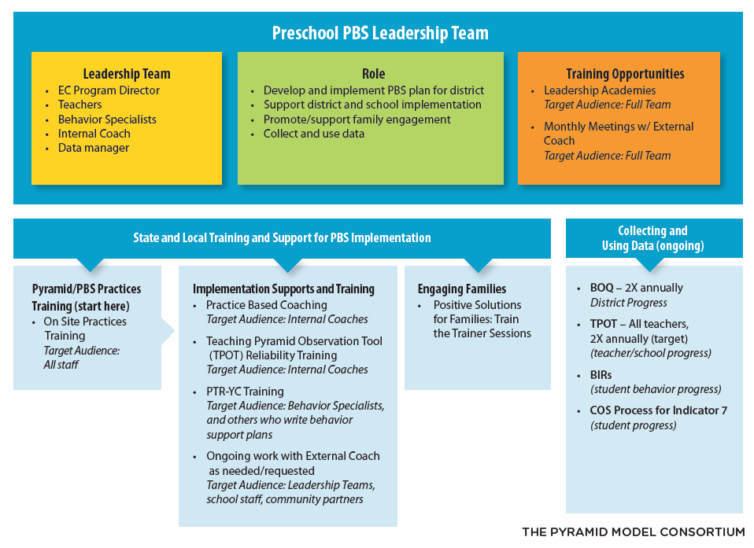
Figure 2. Massachusetts PBS/Pyramid Model Sequence and Supports
Broader Infrastructure Activities
The MA ESE continues to leverage and extend a range of statewide activities to promote and support the PBS/Pyramid Model in Massachusetts. The PBS/Pyramid Model Statewide Leadership Team (SLT), which meets monthly, serves as a forum for updates and collaboration across these activities. MA ESE is committed to continuously building infrastructure activities through an array of department initiatives related to positive social emotional outcomes for all students, with and without disabilities. These initiatives, coupled with the PBS/Pyramid model, provide various entry points for local school districts to engage their systems to promote improved outcomes for children with disabilities. Progress during Phase III is described below with respect to initiatives that have been expanded, and those that are new this year.
Interagency Initiatives
PBS/Pyramid related:
Figure 3 below shows several key interagency initiatives devoted to improving early childhood special education through the PBS/Pyramid Model, inclusive of the MA ESE work in PBS through Pyramid Strategies with 21 districts. Each is described below.
Figure 3. Interagency Initiatives Related to PBS/Pyramid Model
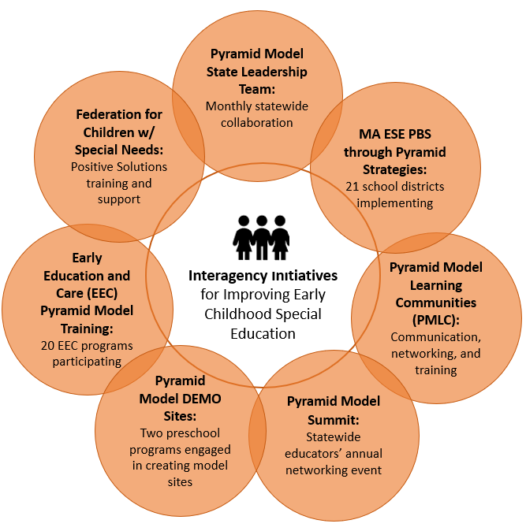
Massachusetts PBS/Pyramid Model State Leadership Team (SLT) -
MA ESE staff continue to play a significant role on the state’s PBS/Pyramid Model State Leadership Team (SLT), which typically meets for two hours each month to collaborate on initiatives to support the adoption of PBS/Pyramid Model strategies throughout the state. This team of approximately 12 individuals also includes representatives from the MA Department of Public Health (MA DPH), MA Department of Early Education and Care (MA EEC), the Department of Mental Health (MA DMH), Connected Beginnings Training Institute (CBTI) at Wheelock College, University of Massachusetts (UMASS) Boston, and the Head Start Technical Assistance agency. The SLT works to expand its membership and welcomed new members from the Federation for Children with Special Needs (FCSN), the Home for Little Wanderers, and UMASS this year.
The key initiatives of focus this past year include the launch of the Massachusetts PBS/Pyramid Model Website by CBTI designed for practitioners, parents, and the community; ongoing PBS/Pyramid Model Learning Communities (PMLC) training events; the annual Massachusetts PBS/Pyramid Model Partnership Summit; the selection and launch of two Demonstration (DEMO) sites; training and support for working with families via Positive Solutions trainings; and the kick-off of a 20-program EEC training and technical assistance initiative. The SLT has also begun work toward selecting and preparing a new Master Cadre of PBS/Pyramid Model trainers/technical assistance providers (up to 15) who can support PBS/Pyramid Model implementation in schools and programs across the state.
PBS/Pyramid Model Learning Communities (PMLC) -
PBS/Pyramid Model Learning Communities (PMLC) have been offered throughout the state since 2016, funded by DPH and ESE. The stated purpose of the PMLC is to convene regional stakeholders in the effort to effectively implement the PBS/Pyramid Model throughout the Commonwealth. These meetings give participants across various program affiliations and professional roles the opportunity to discuss their use and knowledge of the PBS/Pyramid Model in practice. The broad learning objectives of the trainings include 1) connecting with other professionals about PBS/Pyramid Model work, 2) learning how the PBS/Pyramid Model informs practices to support social emotional development in all young children, and 3) learning how the PBS/Pyramid Model practices support the development of nurturing responsive relationships with all young children. Since it began, 367 individuals (217 in 2016-17, and 150 so far in 2017-18) have taken part in trainings offered across five regions of the state.
PBS/Pyramid Model Partnership Summit -
The Connected Beginning Training Institute organizes an annual Massachusetts PBS/Pyramid Model Partnership Summit to foster education and networking among practitioners across the state. The fifth annual Summit was offered in April 2017 designed around the theme: Building an Inclusive Environment to Support all Children and Families. The Summit included a keynote from the PBS/Pyramid Model Consortium, as well as panel and break-out sessions, and poster presentations. The 2017 Summit was attended by 132 individuals and feedback from the event was shared with the SLT. The sixth annual Summit is schedule for April 2018 with a community-building theme of Building the Massachusetts PBS/Pyramid Together. The event will include a keynote from the PMC, and PMLC regional meetings promoting community networking, communication of training events, and data collection around community needs. Plans for other sessions include presentations by PBS/Pyramid Model DEMO sites (see below) and break-out sessions.
PBS/Pyramid Model Demonstration (DEMO) Sites -
In fall 2017, the SLT launched the PBS/Pyramid Model Demonstration (DEMO) initiative in two full-day early childhood programs. The intent of the DEMO sites is to further develop implementation of the PBS/Pyramid Model in community programs that can help to bridge the link between community and public school programs. Sites were first nominated through the SLT and then assessed for readiness through site visits from project leaders. Participation required conditions such as prior experience with the PBS/Pyramid Model; interest in expansion; a commitment to training and coach support; and a commitment of at least three years toward implementation. Training opportunities include Preschool modules, Positive Solutions for Facilitators, Top of the Pyramid Skills (TOPS) or PTR-YC, and TPOT reliability. External coaches are shared with the SSIP project and as such can help build community between these PBS/Pyramid project sites.
Early Education and Care (EEC) PBS/Pyramid Model Training Initiative -
The Department of Early Education and Care recently contracted with the PMC to provide PBS/Pyramid Model training and external coach supports to 20 EEC programs across Massachusetts. This initiative is similar to the SSIP in its principal activities, which include the provision of statewide trainings, regional Practices trainings, and individualized external coach supports for each program. This project further supports SSIP in that SSIP district and school personnel will have access to trainings where space permits, and external coaches common to both projects are anticipated to help build connections for the PBS/Pyramid Model between community programs and public schools.
Positive Solutions for Families -
ESE is currently working with external coaches and the Federation for Children with Special Needs (FCSN) to provide Train the Trainer opportunities for professionals interested in implementing Positive Solutions for Families in their schools and districts. Positive Solutions for Families is an evidence-based training series that has been developed to provide families and caregivers information and strategies to promote children’s social and emotional skills using positive approaches. Positive Solutions can be used independent of any district adopted program or as a companion to the Positive Behavioral Support: Pyramid Model. Additionally, ESE has partnered with the EEC to provide opportunities for discussion and training on Positive Solutions for Families to providers through networking meetings and professional learning groups.
Early Childhood Special Education related:
Early Childhood Leadership Institute -
The Massachusetts Early Childhood Leadership Institute (MA ECLI) is a yearlong program for special educator and early childhood leaders at the school and district level across the state. Participants attending the Institute fall into one or more of the following roles: early childcare/ preschool coordinator, principal, assistant principal, directors of student services, early childcare director, special education administrator, and/or school psychologist.
The Institute focuses on building leadership capacity in content and skill specific areas including but not limited to implicit bias and racism, data analysis and program improvement, literacy, social emotional learning and leadership. Since July 2017, Cohort 1 has gathered with Institute faculty both in-person and virtually to receive content instruction, to network with other participants, and to engage in a community of practice for ongoing discussions of issues related to early childhood special education. The 29 participants currently enrolled are required to complete homework assignments including readings, discussion board posts and a Capstone project which identifies a strategy area for program improvement, the majority of which include local systemic improvements related to social/emotional development.
Building Inclusive Communities in Preschool (BIC) -
In the spring of 2016, MA EEC, MA ESE, and the Technical Assistance partners for Head Start worked together to provide statewide conferences, webinars and local technical assistance for participating regions to build strong, inclusive communities for young children with disabilities.
In FFY 2017, the Collaborative for Educational Services (CES) was hired to facilitate the ongoing professional development and a Steering Committee was convened to advise CES on the content and format of the professional development. The steering committee includes various stakeholders, state and federal partners, and representatives from local communities.
Ten community teams from the mixed delivery system (public schools, Head Start programs, community-based preschools, and Preschool Expansion Grant [PEG] programs) were recruited to participate in this series to support children, families, educators and administrators to embed practices that promote quality inclusion practices, including developmentally appropriate literacy, numeracy, and social emotional skill instruction in natural early childhood environments.
Early Literacy and ECSE -
Since FFY 2016, MA EEC collaborated with MA ESE’s early literacy and ECSE teams to connect early literacy across the agencies and in public school districts and child care settings specifically for ECSE programs. The goals of the ECSE strand are to prepare teachers to:
- Promote early literacy skills and behaviors that children with disabilities need to be prepared to learn, to read, and to write in school.
- Learn multiple opportunities to support young children with disabilities to practice these early literacy skills and behaviors.
- Implement modifications and adaptations to support the inclusion of children with disabilities to practice and master new early literacy skills and behaviors.
- Engage families in understanding ways to support early literacy at home.
During the face to face conferences, large group training is followed by an ECSE breakout which focuses on literacy instruction to promote inclusive opportunities for children with disabilities. Finally, monthly coaching is provided for each classroom teacher and administrators for the school year. This coaching supports local school districts to utilize instructional practices aligned with Universal Design for Learning (UDL), targeted instruction, and intensive interventions, as appropriate. This work supports the SSIP by promoting the development of language related to social/emotional development.
Early Learning Network Regional Meetings -
In collaboration with staff from the Family and Community Engagement team at MA EEC, MA ESE and MA EEC co-hosted bi-annual, regional early learning network meetings. At these events, community teams were invited with representation from public preschool, public kindergarten, community-based early education and care programs, Head Start and Coordinated Family and Community Engagement (CFCE) coordinators for a day of professional development and networking on early learning topics. To date, panel presentations have included topics such as family engagement, transitions between preschool and kindergarten, safe and supportive LGBTQ practices in the early years, social and emotional learning and trauma informed practices.
We plan to convene the network meetings again this spring to continue discussions on creating safe and supportive learning environments for young children and their families.

Massachusetts Commission for Deaf and Hard of Hearing Early Education (MCDHH)/ESE/EEC Task Force -
The Massachusetts Commission for Deaf and Hard of Hearing (MCDHH), in collaboration with MA ESE, convened a Task Force relevant to Deaf and Hard of Hearing (DHH) children in early childhood beginning in the spring of 2017.
The Early Childhood Education-Deaf and Hard of Hearing Task Force is an interagency, multi-disciplinary group that collaborates to analyze data and infrastructure to make recommendations for leveraging existing resources and to identify areas of growth to improve outcomes for young children who are Deaf and Hard of Hearing. Specifically, the Task Force discusses:
- Strategies for ensuring early literacy and language acquisition and school-readiness among Deaf and Hard of Hearing children aged 0-5.
- Ways to link resources related to the MA State Systemic Improvement Plan (SSIP) to improve outcomes for children who are DHH.
- Leveraging the expertise of MCDHH Children’s Specialists to support improved outcomes for young children in public schools and the mixed delivery system.
Early Childhood Transitions -
MA ESE and MA EEC collaborate with MA DPH to provide information, training and support for successful transitions from Early Intervention (EI) to Early Childhood Special Education (ECSE). In collaboration with MA EEC and MA DPH, MA ESE has provided educators and EI provides opportunities for networking, training on Early Childhood transition law, regulations, requirements, and best practices in supporting developmentally appropriate social/emotional and early literacy skills. MA ESE has partnered with MA EEC and MA DPH to develop a Stakeholder Group to assist in the development of guidance related to ECSE transition regulations, policies, and practices.
K-3 Policy Academy -
In the spring of 2017, MA ESE was approached by the Education Commission of the States (ECS) to engage in a national technical assistance opportunity focused on Kindergarten through Grade 3 Policy Levers. In response to a report issued by ECS entitled K-3 Policymakers’ Guide to Action: Making the Early Years Count, Massachusetts agreed to participate in an 18-month process with support from national TA partners, Center for Enhancing Early Learning Outcomes (CEELO) and the New America Foundation, to explore opportunities to focus on early literacy and social/emotional developmental appropriate practices through the lens of workforce development and curriculum and instruction. With a focus on K-3, the state team also includes participation from MA EEC and the Massachusetts Department of Higher Education (MA DHE) to ensure alignment of workforce development efforts, including pre-service and in-service professional development.
Safe and Supportive Learning Environment Professional Development Series -
Participants in the first early learning network meeting co-hosted by MA EEC and MA ESE in November/December 2016, requested training on trauma informed practices. Simultaneously, the MA ESE’s work through the Rethinking Discipline (see information below) initiative and the Safe and Supportive Schools Grant identified a similar professional development need. As a result, a state planning team consisting of staff from MA EEC, MA ESE, the Collaborative for Educational Services (CES) and Massachusetts Advocates for Children(MAC) worked together to design a one-day professional development opportunity in May 2017 called, Safe and Supportive Learning Environments: Bringing Together Social and Emotional Learning, Trauma Sensitivity and Positive Behavioral Supports.
As a result of the positive response to this one-day opportunity and the request for additional follow-up, the state planning team moved forward to create a yearlong professional development series on these important topics. The yearlong professional development series includes webinars, winter and spring regional meetings and a statewide conference.
Resources for Families, Teachers, and Administrators: Integrating social emotional and early literacy skills in early childhood programs to promote inclusive environments -
Through funding provided by MA ESE, and in collaboration with MA EEC and the Federation for Children with Special Needs (FCSN), the Institute for Community Inclusion (ICI) at the University of Massachusetts Boston has developed the following resources, using the Division for Early Childhood (DEC) Recommended Practices:
- Early Childhood Inclusion Project, a website. Here you will find research-based resources on inclusive classroom practices for Preschool and Kindergartens, with links to articles, journals and other websites. Content includes: inclusion, standards and curriculum, progress monitoring and assessment, collaboration, a Teaching Toolkit, and more. See: http://tiny.cc/EarlyInclusion
- Family Engagement in Inclusive Early Childhood Settings. This course is designed for professionals in early childhood classrooms, is fully online, and is eligible for 15 Professional Development Points (PDP’s). It features narration, videos, reflections, and planning activities. See: http://tiny.cc/familyEngagement
- Presentation for Families: "Supporting Your Child's Development." There are three sessions to engage families in interactive dialogue, or for families to use independently. See: http://tiny.cc/SupportChildDevelopment
  - How families impact children’s learning,
  - Supporting your child’s development at home, and
  - Building partnerships to support your child’s development.
Department of Elementary and Secondary Education Initiatives
Family Engagement Consortium -
In the summer of 2017, MA ESE signaled interest to participate in the opportunity to build a Birth to Grade 12 family engagement framework with support from Council of Chief State School Officers (CCSSO) as well as two selected TA partners, the National Association of Family, School and Community Partnerships as well as the Policy Equity Group. Members from MA ESE, MA EEC, and MA DPH began meeting in September 2017 to plan for the development of the Birth to Grade 12 family engagement framework, which includes collaboration with internal and external stakeholders and promotes building social/emotional developmental practices.
Social and Emotional Learning -
With funding from MA EEC’s Race to the Top/Early Learning Challenge Grant, staff from MA ESE and MA EEC worked with a selected vendor to develop Preschool and Kindergarten Social and Emotional Learning standards as well as Approaches to Play and Learning Standards.
In FFY 2016 the two agencies worked together to plan for the ongoing availability of the modules through ESE’s use of Blackboard, an online platform used for professional development. In FFY 2017, a small number of trainers that participated in the train-the-trainer series were selected to provide the training modules through Blackboard to groups of 20 early childhood professionals. Three courses have been offered thus far with more planned for the spring. Additionally, with the courses filling up quickly and additional unmet demand for the courses still existing, we have requested additional slots in FFY 2018 to continue to offer the course.
Promoting Racial Equity and Dismantling Racism -
MA ESE’s commitment to educational access and equity means that:
- All students, and especially our most vulnerable students — inclusive of low-income students, minority students, and students with disabilities (SWDs) — have access to high quality educational opportunities and the expectation of meeting high standards;
- All educators are culturally proficient and honor as well as leverage diversity in their education practices;
- All families and caregivers are valuable partners and help to create a rich educational experience for students; and
- ESE will lead efforts to eliminate explicit and implicit bias within ESE, districts, and schools.
MA ESE has shown this commitment by contracting with Pacific Education Group (PEG) for the purpose of developing and accelerating the state’s capacity to engage in systemic equity transformation and eliminate racial educational bias and disparities. This series includes training, coaching, and support is focused on deepening the will, skill, knowledge and capacity of MA ESE leaders to oversee, lead and manage the dynamic process of systemic racial equity transformation.
Further, MA ESE has worked with the Pyramid Model Consortium to access the knowledge and skills of experts involved in the Pyramid Equity Project (PEP). The PEP is developing tools, materials, and procedures to explicitly address implicit bias, implement culturally responsive practices, and use data systems to understand potential discipline equity issues. The participating SSIP districts have access and training throughout the year.
2017 Special Education Professional Development Series -
The FFY 2016 Special Education Professional Development (PD) Series is organized by five strands, one of which was exclusively designed for social/emotional learning, two of which focused on ECSE. The strands include:
- Excellence in Education
- Inclusive Practice
- Role-Based PD
- Social Emotional Learning
- Technology
Accountability and Monitoring - Tiered Focused Monitoring: A New Approach -
Based on stakeholder input, MA ESE’s Office of Public School Monitoring (PSM) recently restructured the Coordinated Program Review (CPR) process to give intensive support in special education and civil rights to districts in a more differentiated manner based upon need, and to support other districts in ways that are a better fit for their record on compliance and student outcomes. This new approach is called Tiered Focused Monitoring (TFM). As the name suggests, through TFM districts will now be grouped into one of four “tiers” for the purposes of monitoring. Districts will receive more or less PSM monitoring intensity depending on the tier. A district is placed in a specific tier based on the accountability results and determinations of need for special education technical assistance or intervention, Problem Resolution System complaint data, and PSM report data.
Districts in every tier will continue to receive support from PSM, such as general guidance, regional meetings, and district-specific support. PSM will continue to work in concert with other DESE offices to streamline and target the work of assistance and accountability statewide. In this way, DESE seeks to be responsive to the needs of the schools and districts by providing cohesive supports, while promoting improved statewide student outcomes. Please see the Appendix for more information about TFM.
Grants -
The purpose of the Early Childhood Special Education (ECSE) grant program is to support preschool district activities to ensure that eligible children with disabilities, ages 3-5, receive a free and appropriate public education that includes special education and related services designed to meet their individual needs, and that is provided in natural/least restrictive environments. This grant is intended to further district-level early childhood special education (ECSE) practices that align with priorities identified by MA ESE and MA EEC and is only available to districts participating in the PBS/Pyramid Model implementation as part of the SSIP project.
Rethinking Discipline -
The Rethinking Discipline initiative commenced during the 2016-2017 school year as part of a comprehensive statewide plan. The goal of the initiative is to make systemic change to local practices and procedures in order to reduce disciplinary exclusions, address disciplinary disparity, and improve school climate. MA ESE developed the initiative in response to a new state law that requires the agency to annually identify schools that suspend or expel a significant percentage of students for more than 10 cumulative days in a school year, as well as schools and districts with significant disparities in suspension and expulsion rates among different racial and ethnic groups or among students with and without disabilities. The state law also requires MA ESE to recommend models that can help districts reduce the use of suspension or expulsion when appropriate and help improve school climate. In June 2016, the Department initiated the Rethinking Discipline Professional Learning Network (PLN) for more than three dozen schools and districts that MA ESE identified as having some of the highest rates of suspension and expulsion and/or the most disproportionate rates of suspension/expulsion based on the 2013-2014, 2014-2015 and 2015-2016 data used to calculate significant discrepancy under Indicators 4A and 4B.
Districts commenced the Rethinking Discipline initiative with a series of focused targeted assistance conversations with staff from the MA ESE Offices of Student and Family Support, Special Education Planning and Policy, and Charter School and School Redesign. This engagement included discussion of school/district specific data, as well as information about successful strategies that schools and districts have implemented and challenges they are facing related to student discipline practices. Subsequently, MA ESE convened districts teams at a series of PLN meetings where participants heard from local experts on best practice, participated in breakout sessions during which they discussed challenges and options with other district teams using a case consultancy model of engagement, explored the MA ESE and federal resources for identifying student needs, and learned about creation and implementation of tiered systems of support for students, among other things. Participating schools and districts were required to create and submit to MA ESE a series of Action Plans documenting identified courses of action to address the identified root causes of discrepancy in disciplinary removal of students.
The new state and federal reporting and data analysis requirements have resulted in a heightened level of awareness and a critical examination of the use of suspensions that is not unique to Massachusetts. National and Massachusetts data shows that black students, Hispanic students and students with disabilities are suspended at greater rates than students overall, and research has found that suspended students are more likely to drop out. School leaders in Massachusetts and across the country have found that supports and strategies that reinforce positive behavior, include conflict resolution, and improve classroom management not only reduce suspensions but also promote school safety, decrease the need for out-of-class discipline referrals, and improve academic success.
- Intended outputs that have been accomplished as a result of the activities
The MA SSIP continues to carry out activities across all components outlined in its Theory of Action as described above and to track progress. Figure 4 provides a summary of critical activities as they align with the TOA elements and progress across each element. Note, this graphic is meant only as a “snapshot” of project activities and should be viewed in the larger context of the details and findings presented throughout this report.
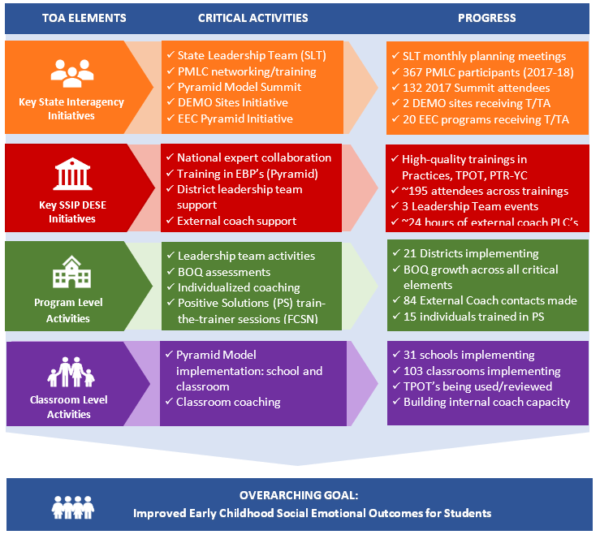
Figure 4. Statewide SSIP Progress Aligned with the MA ESE SSIP Theory of Action
(February 2017 – February 2018)

2. Stakeholder Involvement in SSIP Implementation
This section of the report addresses both:
(a) How stakeholders have been informed of the ongoing implementation of the SSIP, and
(b) How stakeholders have been involved in decision-making regarding ongoing implementation
By design, the MA SSIP provides multiple opportunities for key stakeholders at the state, district, program/classroom, and community levels to learn about the SSIP such as project philosophy and goals, the provision of project training events and embedded supports, and the availability of resources to support and extend implementation. Stakeholders also have occasion to participate in decision-making about the direction of the project as it progresses. Key aspects of this design include sharing information and gathering feedback, via state-level leadership and steering committee meetings, with stakeholders who are working toward the common purpose of improving the social and emotional outcomes for preschool children; and by providing mechanisms for frequent feedback both formally and informally from participants within the SSIP districts. Methods for communicating with and responding to feedback from stakeholder groups are described below.
State PBS/Pyramid Model Leadership Team
Through MA ESE’s active role on the PBS/Pyramid Model State Leadership Team (as described above), progress on the SSIP is communicated on a monthly basis to this board group of stakeholders whose feedback helps to refine implementation efforts, and to identify opportunities for collaboration.
Special Education Advisory Council (SAC), and Special Education Steering Committee
The SAC, established under state law, is comprised of members appointed by the Commissioner on behalf of the MA Board of Education; over half of the voting members are individuals with a disability or a parent of a child with a disability. The Special Education Steering Committee is composed of members of the SAC plus representatives of advocacy organizations, other state agencies, and statewide partners in special education, consistent with the requirements for advisory bodies established in the Individuals with Disabilities Education Act (IDEA). These groups continue to be valued stakeholders, as MA ESE seeks out opportunities to discuss and share information about the department’s vision and direction for strengthening early childhood initiatives.
Mid-year Leadership Team Survey Feedback
The 2017 Leadership Team Survey was completed in November by 36 leadership team members across 19 school districts. As in prior years, the survey gave team members an opportunity to indicate their progress toward implementation of the PBS/Pyramid Model over the past school year, facilitating factors associated with their progress, ongoing challenges, and requests for ongoing support from both external coaches and MA ESE. A summary of survey responses with all open-ended comments was shared with state-level project leaders and external coaches shortly after the survey was conducted. Findings were discussed internally by project leaders, and during a coach PLC meeting. Ideas for how best to respond to district implementation challenges were also discussed. One of the greatest challenges districts indicated is the need for building capacity among their internal coaches, as well as finding resources to support the coaching component. To begin to address this challenge, the March 2018 Leadership Team being facilitated by the PMC devoted time to discussing this topic. Approaches to group coaching in the coming year are also being explored. Selected results from the survey (for 34 respondents from the Cohort 1 districts specifically) are presented in Section E.
Participant Feedback at Trainings
MA ESE and the PMC continue to collect evaluation feedback forms from participants at each training and at statewide meetings for leadership teams and external coaches. The feedback forms allow MA ESE, the PMC, and external coaches to gauge the general quality of the sessions, usefulness of the information, and ideas for strengthening the events going forward. This year, training-specific learning objectives were added to the forms to provide more pertinent information about the extent to which each training was meeting its goals. Feedback forms are shared with training facilitators, as well as with the evaluator for the statewide study.
External Coach Feedback
External coaches have a key role in supporting district and school personnel in moving toward implementation of PBS through Pyramid strategies. Since these individuals are making direct contact with district teams on a regular basis, they are in the best position to determine some of the ways the initiative might be improved at the local level, and to understand challenges to implementation.
MA ESE maintains ongoing communication primarily through monthly PLCs, as well as by email and phone. Coaches also continue to complete an online External Coach Contact Record (i.e., log form) to capture information about each instance of technical assistance they provide to districts. Based on feedback from coaches, the online form is now set up to provide copies of each entry directly to coaches for tracking district progress. In addition, links to real-time summary reports for state leaders allow access to aggregate data on an ongoing basis.

C. Data on Implementation and Outcomes

1. How the State Monitored and Measured Outputs to Assess Effectiveness
During Phase II, MA ESE worked closely with internal partners and key stakeholders to develop a comprehensive evaluation plan for the SSIP. Data collection instruments were also developed and/or selected at that time. This evaluation plan was presented in the Phase II report and has largely been carried out as planned during Years 1 and 2 of Phase III.
Since February 2017, MA ESE has been working with an external evaluator to help refine the evaluation plan and data collection systems, review and analyze data, and contribute to report writing. This past year, for example, several instruments were modified slightly to reflect the evolution of the project, including the Training Evaluation Forms, External Coach Contact Record, and Mid-year Leadership Team Survey. The evaluator also began managing the online administration of these latter two instruments, and in doing so was able to provide project leaders with access to data for stakeholder feedback more readily. Finally, the evaluator participated in several external coach PLC meetings to discuss data use for both internal progress monitoring and for external evaluation, data collection procedures, and ideas for capturing aggregate TPOT data to begin to assess implementation fidelity at the classroom level.
(a) How the evaluation measures align with the Theory of Action
The SSIP Theory of Action articulates activities at the state level with respect to infrastructure for principal activities, as well as ongoing interagency collaboration to support the SSIP. The next level of activities engages districts/programs, followed by classrooms and students. Across these four levels, the plan incorporates key questions to help focus the evaluation, as well as appropriate short, intermediate, and long term outcomes to assess progress and impact of the SSIP. Data collection instruments have been selected or developed, and processes for collecting data at regular intervals have been put into place. Table 3 below displays the SSIP evaluation plan, including key questions at each level of the Theory of Action, as well as the intended outcomes and data sources. Updates from last year are indicated.
Table 3. MA SSIP Evaluation Plan
Evaluation Questions | Intended Outcomes  (Key: S = State level, D = District level,  C = Classroom level) | Data Sources
State Level Infrastructure
EQ1a  In what ways is MA ESE using the SSIP, including statewide implementation of PBS through Pyramid strategies, to build state-level capacity to support improved social emotional outcomes for young children with disabilities? | S1. Short Term and Intermediate  In order to build state capacity, MA ESE will…  - leverage the cadre of PBS external coaches to support districts and communities;  - collaborate with community and social services agencies to provide additional training and support to families;  - engage in ongoing collaboration with colleagues in Part C and K-12 PBIS initiatives to build community liaison and data sharing to promote effective transitions and improve social emotional outcomes. | - Extant project documents (e.g., state and district meeting notes, inter-agency meeting minutes, implementation notes and planning tools)  - Statewide training data (i.e., internal project records and sign-in sheets)  - Statewide training and meeting evaluation forms
EQ1b  To what extent is implementation of PBS through Pyramid strategies in MA integrated with other early childhood and/or MA ESE initiatives at the community/local and state levels? | S2. Intermediate  MA ESE will…  - support the implementation of the newly created PBS/PBIS crosswalk designed to promote state level collaboration to create a seamless model of Positive Behavior Supports (PBS) for preschool through secondary schools; and  - will engage in ongoing collaboration to continue to identify strategies and actions to promote local level integration of PBS. | - Extant project documents (e.g., state and district meeting notes, inter-agency meeting minutes, implementation notes and planning tools)
Program/District Infrastructure
EQ2a  Is the state-level plan resulting in the number of schools and classroom participating in PBS through Pyramid strategies growing over time? | S3. Long Term  MA ESE will provide adequate training in PBS/Pyramid Model strategies so that local school district leadership teams, teachers, and classroom coaches are participating in PBS/Pyramid Model trainings provided by district classroom coaches and other staff.  D1. Short Term  District administrators and educators will participate in statewide trainings on PBS through Pyramid strategies including Leadership Team Academies, Practices Trainings, and Coaches’ Trainings to become familiar with the tenets of PBS and PBS through Pyramid strategies and classroom and program-wide implementation. | - External Coach Contact Records  - Benchmarks of Quality (BOQ) assessments  - Mid-year Leadership Team Survey  - Statewide training data  - Statewide training evaluation forms  - Extant documents (e.g., state and district meeting notes, inter-agency meeting minutes, implementation notes and planning tools)  - PBS/Pyramid Model Implementation Database
EQ2b  Are districts developing systems to support sustainable training and coaching practices at the local level? | D2. Intermediate  The participating districts have built sustainable internal capacity to train additional teachers to implement PBS/Pyramid strategies in their classrooms and sustainable improvement plans to support implementation of PBS through Pyramid and PBIS strategies. | - External Coach Contact Records  - BOQ assessments  - Mid-year Leadership Team Survey
Classroom Level
EQ3a  Are teachers implementing PBS through Pyramid strategies in their classrooms? | D2. Intermediate  The participating districts have built sustainable internal capacity to train additional teachers to implement PBS/Pyramid strategies in their classrooms and sustainable improvement plans to support implementation of PBS through Pyramid and PBIS strategies. | - External Coach Contact Records  - Mid-year Leadership Team Survey  - TPOT training session data  - Benchmarks of Quality assessments  - PBS/Pyramid Model Database
EQ3b  Does the fidelity of classroom implementation improve over time? | D3. Long Term  Teachers will be able to implement PBS through Pyramid strategies with fidelity to improve the social/emotional development of young children with disabilities. | - TPOT  *New in 2017 - Districts have begun to share aggregate TPOT data to allow for an analysis of implementation fidelity.
Student Level
EQ4a  Is the number of children in MA, aged 3-5, with disabilities, exiting from preschool with age-expected social emotional functioning increasing? | C1. Long Term  Children with disabilities, aged 3-5, will exit preschool with social/emotional competencies that will allow them to access and participate in the general curriculum and in all aspects of the school. | - Indicator 7 data - Child Outcomes Summary (COS): Summary Statement 2  *New in 2017 – collected by SSIP districts annually
EQ4b  Is the number of children in MA, aged 3-5, with disabilities, exiting from preschool with greater than expected growth in their social emotional functioning increasing? |  | - Indicator 7 data - Child Outcomes Summary (COS): Summary Statement 1  *New in 2017 – collected by SSIP districts annually

(b) Data sources for each key measure
Data are collected by MA ESE, external coaches, or the external evaluator according to a plan updated during the past year of the project. In each case, results are available for timely review by project leaders and also shared with the external evaluator for analysis and reporting. The data sources and the purpose of each are summarized below (see the SSIP Phase III, Year 1 report, p.22 for more information).
Extant Project Documents – Project documentation (i.e., interagency meeting minutes, implementation notes and planning tools, training participation data, etc.) is reviewed to determine progress toward project goals.
Training Evaluation Forms – Training evaluation forms are designed to assess the quality and usefulness of the sessions, and to solicit suggestions for improvements going forward. The forms were updated this past year to include learning objectives specific to each meeting or training.
External Coach Contact Record – External coaches complete this online form each time they provide support to record the mode of contact (e.g., site visit, phone call, email, etc.), the type of support provided, and district progress toward PBS/Pyramid Model implementation. Updates were made this year based on coach feedback.
District Benchmarks of Quality (BOQ) – The Benchmarks of Quality tool, developed by the PMC, is used by implementing districts to assess PBS/Pyramid Model Implementation across nine critical elements.
Mid-year Leadership Team Survey – This annual survey captures district teams’ assessment of their progress toward implementation, the contribution of external coaches, challenges, and needs for assistance from MA ESE and external coaches as they move forward.
PBS/Pyramid Model Implementation Database – The form captures the total numbers of schools and classrooms with preschool programs in each district, as well as the numbers of schools and classrooms implementing the PBS/Pyramid Model.
Teaching Pyramid Observation Tool (TPOT) – The Teaching Pyramid Observation Tool for Preschool Classrooms (TPOT), developed by Hemmeter, Fox, and Snyder (2013) consists of a two-hour classroom observation and subsequent interview with a teacher to assess implementation of PBS/Pyramid Model practices.
Indicator 7 data – SPP Indicator 7 data collected via the Child Outcomes Summary (COS) process are reported annually for monitoring progress toward child outcomes statewide, and within SSIP districts.
(c) Description of baseline data for key measures
Training Participation and Quality
Ongoing training data provide information on the scope and sequence of training activities during the reporting period. By examining the order of training activities, participant engagement as measured by the number of districts attending, and the revisions to the training schedule based on participant and national trainer feedback, these data provide information on the ways in which MA ESE approaches statewide implementation. A summary of findings on the quality and usefulness of the Year 1 training sessions was presented in last year’s report; results from a sample of this year’s sessions is presented in Section E.
District Benchmarks of Quality
Baseline data on the Benchmarks of Quality self-assessment have been collected from both Cohort 1 and Cohort 2 districts. Among the 17 Cohort 1 districts participating, 15 of them had collected BOQ data at least three points in time and were therefore included in the analysis this year. Baseline results (from BOQs conducted in 2015) indicated that districts began the project strongest in the following critical elements: Staff Buy-in, Establish Leadership Team, and Program-wide Expectations. The areas in which districts had the most work to do going forward included: Family Involvement, Strategies for teaching and acknowledging program-wide expectations, monitoring implementation and outcomes, and Staff Support Plan. Steady growth over baseline has been reported over time -- results are presented in Section E. Cohort 2 districts’ baseline results, recently collected in fall 2017 or early 2018, followed a somewhat different pattern, where the strongest critical elements were: All classrooms demonstrate adoption of the “Teaching Pyramid” (mean of 0.8 on a two-point scale), Procedures for responding to challenging behavior (0.6), and Establish Leadership Team (0.5). BOQ progress for Cohort 2 districts will be available in next year’s report.
Mid-year Leadership Team Survey
Baseline data on this measure, obtained in March 2016, suggested that early in the project districts were beginning to make progress bringing PBS/Pyramid strategies to their schools – at the time of the 2016 survey, 62% reported making “a little progress”, 32% reported “moderate progress”, and 6% felt their teams had made “significant progress”. District team members indicated some of their specific needs for moving forward with implementation, such as more facilitated meeting time with their teams, and additional PBS/Pyramid Practices training for teachers in their districts. Section E provides details about findings from the most recent survey with comparisons to these baseline data as appropriate.
Teaching Pyramid Observation Tool (TPOT)
MA ESE has begun to work with external coaches and participating districts on collecting anonymous, aggregate TPOT data for teachers implementing the PBS/Pyramid Model in their classrooms. At this time, baseline data have been collected on a relatively small sample of teachers; as such, the data are not presented in this report. The limitations and proposed approaches regarding this data element are further discussed in Section D.

Indicator 7: Child Outcomes
Baseline data for Indicator 7 across a sample of 12 Cohort 1 SSIP districts (FFY 2013) are presented in Section E, as are statewide results over the past three years.
(d) Data Collection Procedures and Associated Timelines
The data collection procedures described above are carried out per the schedule shown in Table 4.
Table 4. Data Collection Plan
Data Sources | Process | Timeline
Extant Project Documents: MA ESE and SLT meeting notes | Meeting minutes prepared following each meeting | Ongoing
Statewide Training Data  (i.e., internal project records and sign-in sheets) | Collected by project leaders and/or training facilitators at each meeting | Ongoing
Statewide Training/Meeting Evaluation Forms | Completed by participants at conclusion of each statewide training or meeting | Ongoing
Benchmarks of Quality (BOQ) Assessment | Completed by leadership teams and external coaches at leadership meetings | Bi-Annually
External Coach Contact Records | Completed via electronic form by external coaches after each substantive contact with a district | Ongoing
Mid-year Leadership Team Survey | All leadership team members invited to complete online survey annually | Annually
PBS/Pyramid Model Implementation Database | Completed by external coaches in consultation with district leaders | Bi-Annually
TPOT | Conducted at the local level for teachers implementing PBS/Pyramid Model; aggregate data requested for statewide analysis | Annually
Indicator 7 Student Outcomes | As of FFY 2016, districts began collecting data for Indicator 7 for new students in classrooms implementing the PBS/Pyramid Model | Annually in spring

(e) Sampling Procedures
Sampling procedures are not being been used in the collection of evaluation data. All data used to assess progress toward implementation and to assess outcomes are conducted with all participants as appropriate, including training evaluation forms, surveys, fidelity measures, and documentation of technical assistance provided by external coaches. Indicator 7 data are currently collected statewide, as well as for SSIP districts annually.
(f) Planned data comparisons
A number of data sources are analyzed in comparison to either earlier data collected across the same measures, or in comparison to statewide data (i.e., Indicator 7). These comparisons include the following:
- With Cohort 1 districts having participated in more than two years of implementation by this time, BOQ results were compared across districts’ first, “mid”, and most recent BOQs to assess their progress over time for each of the nine critical elements. Going forward, the BOQ will continue to be completed by district teams bi-annually, and results will be compared over time in the aggregate (for both Cohorts 1 and 2). At the local level, district teams, in coordination with external coaches, compare their own results over time to assess progress.
- The Mid-year Leadership Team Survey is completed annually. Aggregate results for Cohort 1 districts across relevant items are compared over time to assess progress toward implementation, as well as patterns of implementation successes and challenges.
- Indicator 7 data are currently being reported for students statewide (using the state’s cohort model; see FFY 2014 SPP/APR page 43) and are compared over time. This past year, baseline data from classrooms that make up the SSIP cohort implementing the PBS/Pyramid Model have been collected; going forward, year-to year progress will be assessed across the 21 participating districts for whom data are available.
(g) How data management and data analysis procedures allow for assessment of progress toward achieving intended improvements
MA ESE put in place several data collection procedures during Phase II that allowed an assessment of progress early in the project, and that continue throughout Phase III. For example:
- The External Coach Contact Records allow for an ongoing assessment of implementation activities in district.
- The Mid-year Leadership Team Survey results allow MA ESE to address the needs of district leadership teams with respect to the content and format of future training sessions and leadership team meetings, and in supporting external coaches for responding to district needs.
- Training Evaluation Forms, distributed at the conclusion of each training session and statewide meeting, allow MA ESE and PMC to modify training as needed to meet the needs of participants. This feedback has been extremely useful for informing MA ESE about the effectiveness of the sessions; refinements continue to be made to the content, logistics, and format of the sessions.
- Maintaining meeting notes from both inter- and intra-agency meetings and internal implementation progress logs allows the MA ESE team to track and review their own progress toward SSIP milestones and goals, and the intersection of the SSIP work with the larger infrastructure work in Massachusetts.
- Indicator 7 data review allows MA ESE to monitor progress toward child outcomes.
As of this past year, two of the online data collection tools (the Mid-year Leadership Team Survey and External Coach Contact Records) are being managed by the external evaluator. The evaluator provided aggregate summaries of these data to MA ESE project leaders for timely review. MA ESE project leaders manage all other data collection and share data with the external evaluator for end-of-year reporting and recommendations. MA ESE project leaders continue to share and discuss data with project stakeholders as well, such as sharing progress summaries (i.e., BOQ, Indicator 7) during state Leadership Team Meetings (see Appendix for “Data Snapshot” slides), and via external coaches’ PLCs.

2. How the State has Demonstrated Progress and Made Modifications to the SSIP
(a) How the State has reviewed key data that provide evidence regarding progress toward achieving intended improvements to infrastructure and the SIMR
MA ESE continues to review feedback from statewide training sessions determine the ways in which the content, method of delivery, and/or timing need to be modified to best meet participants’ needs.
Data collected via the External Coach Contact Record (for each district, and for the state as a whole) are available to project leaders and PMC staff to understand the extent to which districts are implementing the PBS/Pyramid Model, the ways in which district teams are using data for decision making, and the challenges they are facing. This information has been used to inform the ways in which external coaches and MA ESE can best support districts going forward. The PMC also has access to these data as they are collected, which can be used to inform the direction of coach PLCs.
Results from the 2017 Mid-year Leadership Team Survey were reviewed by MA ESE, PMC, external coaches, and the external evaluator shortly after the survey was administered in November. The survey contains items related to districts’ progress and facilitating factors, as well as challenges. This information has been used to inform plans for upcoming training sessions, and for the March 2018 Leadership Team meeting in particular.
District progress as measured by the Benchmarks of Quality is reviewed between external coaches and their districts during the process of conducting the self-assessment. These results are intended for use by each team to inform their action plans and next steps. A statewide aggregate analysis is conducted annually by the external evaluator and reviewed by project leaders. Summary statewide results were also shared with district leadership teams at the March 2018 meeting.
TPOT data have historically been reviewed at the local level only, among coaches and teachers. This year, however, MA ESE has begun to put a system in place for collecting anonymous, aggregate TPOT data from districts to allow for a statewide assessment of progress toward implementation fidelity in the classroom. External coaches continue to work with internal coaches and school personnel on co-scoring at least one TPOT with each internal coach to ensure reliability among the ratings.
Indicator 7 data are analyzed and reviewed annually, and efforts continue for collecting annual data from participating SSIP district classrooms for progress monitoring over time.
(b) Evidence of change to baseline data for key measures
At the district level, the BOQ assessment revealed substantial progress toward fidelity by Cohort 1 districts from their initial BOQ results to their most recent results. Steady growth, on average, has been reported for each of the nine critical elements; details are in Section E. At the student level, SIMR data aligned with Summary Statements 1 and 2 revealed progress over baseline (from FFY 2013 to FFY 2016) – results are presented on page 2 of this report. That said, for the most recent reporting period there was slippage of nearly 6 percentage points for Summary Statement 1, while notable growth of nearly 10 percentage points was reported for Summary Statement 2 over the same period.

(c) How data support changes that have been made to implementation and improvement strategies
Over the past year (and building on last year’s work), the MA ESE made a number of improvements to the SSIP implementation strategy based on a review of evaluation data and ongoing conversations with key stakeholders. Improvements included the following:
- Increased access to national experts: MA ESE learned through training feedback forms and feedback from external coaches that districts were in need of more in-depth support for their efforts to scale-up implementation. In order to help strengthen the foundation for district work, MA ESE decided to expand the role of the PMC to meet this need. This expanded role includes overseeing preparation and support of external coaches, as well as developing procedures and supports for helping to build internal coach capacity. The objective is to provide SSIP participants (coaches, district staff, school staff, etc.) with more direct access to national experts in the PBS/Pyramid Model to foster increased fidelity of implementation.
- Tailored PBS/Pyramid Model Practices trainings: Feedback from training sessions and from external coaches indicated the need for more targeted training sessions for practitioners. PBS/Pyramid Practices trainings in Modules 1, 2, and 3, which are conducted regionally by eternal coaches, are now being tailored for different roles among school personnel – teachers, paraprofessionals, instructional assistants, office staff, etc. The objective is to ensure the relevance of trainings for each group.
- Building internal coach capacity: Feedback over the past year through multiple means – training feedback, survey, and conversations with external coaches – suggested that districts need support for increasing internal coach capacity to continue to move toward implementation fidelity. Several activities are underway to address this need:
  - A “Coaches Day” in Practices-based coaching was conducted in fall 2017 to continue to prepare internal coaches for their roles. External coaches also took part in the two-day training and continue to support their districts to address this aspect of implementation at the local level.
  - The March 2018 Leadership Team Meeting devoted part of the day to discussing coach capacity, among other topics; a series of breakout sessions allowed participants to discuss challenges and solutions with their colleagues, department staff, and trainers.
  - Project leaders are also exploring the feasibility of a group coaching model, and/or virtual coaching. At least one district has begun group coaching based on teachers’ TPOT scores.
- Refining external coach PLCs: MA ESE project leaders participate in the monthly external coaches Professional Learning Community (PLC) meetings, and as such continue to work with the PMC and coaches to refine the meeting approach. For example, district-by-district implementation progress is being documented using a rubric of green, yellow, red and related updates to allow for tiered supports for implementation based on level of need. Based on these updates, MA ESE staff connect with and/or visit districts as needed to provide guidance.
- More collaborative Leadership Team meetings: Feedback from Leadership Team Meeting feedback forms from fall 2017 pointed to the need for teams to have more planning time at meetings, and for more interaction among participants. Going forward, the meetings have been re-envisioned to allow for more peer-to-peer learning and networking, as opposed to being viewed as a “training session” for teams.
- Increased communication for Districts from MA ESE and partners: Project leaders have learned that districts are interested in increased communication from MA ESE and partners. New approaches for keeping the field informed include monthly communication via email newsletter updates, site visits by ESE staff, and individualized TA and guidance.
(d) How data are informing next steps in the SSIP implementation
With respect to next steps, MA ESE is looking closely at the implementation status and needs of each district based on feedback and information provided by participants and external coaches, as well as through MA ESE site visits and informal communications with district personnel. Indicator 7 data, extant data, and qualitative data are expressly driving the plan for future implementation (see Section F).
Based on evaluation findings as presented in Section E, MA ESE envisions two primary and related areas of focus going forward: 1) Continuing to support districts in scaling up to implementation fidelity, and 2) Working with districts to bolster their internal coach capacity.
In addition, review of this year’s data point to several other areas of focus going forward, which include: supporting districts in garnering more support from administrators; working with districts on sustainability plans; improving communication between MA ESE and districts and between districts, (i.e., developing social media pages maintained by PMC and a monthly newsletter); and efforts to streamline the data collection process.
(e) How data support planned modifications to intended outcomes (including the SIMR)
There are no planned modifications to intended outcomes at this time.

3. Stakeholder Involvement in the SSIP Evaluation
Stakeholder involvement in the SSIP evaluation has included ongoing input and feedback from participants at the state, district/program, school, and classroom levels. Much of this information has been shared in Section B (2) of this report, with respect to how stakeholders have been informed about the SSIP, and the ways in which they have provided input toward implementation and evaluation. The following list are examples of the ways in which stakeholders have been directly involved in the evaluation.
(a) How stakeholders have been informed of the ongoing evaluation of the SSIP
- Information about the evaluation purpose, timeline, and methods have been shared at leadership team meetings
- Provided evaluation updates and data analysis at MA PBS/Pyramid State Leadership Team meetings, Networking meetings, and EC Leadership meetings
- Data collection procedures and purpose of evaluation have been shared during site visits with districts
- Evaluation purpose and plan has been shared with the Special Education Steering Committee; the same information has been shared with the Special Education Advisory Council (SAC)
- MA ESE staff working on the SSIP have shared through updates to other MA ESE offices such as the Office of District and School Turnaround (ODST), Systems for Student Success Office (SSSO), Special Services (including Special Education), System Accountability, Data and Accountability, Center for Curriculum and Instruction, and Student Support
- Evaluation purpose and plan has been shared at ECSE leadership team meetings
- Ongoing communication with MA DPH and MA EEC regarding SSIP evaluation as part of alignment with MA Part C SSIP
(b) How stakeholders have had a voice and been involved in decision-making regarding the ongoing evaluation of the SSIP
MA ESE continues to solicit feedback from SSIP participants, as well as from the larger statewide stakeholder group, about the direction of the project. With respect to data collection tools specifically, MA ESE works to refine and improve each tool to ensure its relevance and alignment with project goals, with the input of stakeholders as appropriate. Feedback mechanisms include the following:
- Leadership Team Meeting feedback forms
- Practice-based Coaching feedback forms
- Mid-year Leadership Team Surveys
- Training Evaluation Forms distributed to all participants at statewide events
- Informal feedback from implementation sites via communication with MA ESE, PMC staff, and external coaches
- External Coach Contact Records
- MA ESE ECSE Leadership Team meetings and informal communications (feedback solicited from other MA ESE offices)
- Ongoing work with MA EEC and MA DPH on alignment with Part C SSIP via the Interagency Coordinating Council (ICC)
- Feedback from the Federation for Children with Special Needs (FCSN) via the SLT and stakeholder meetings

As discussed previously, the evaluation plan had been established during Phase II and has continued as planned. Stakeholders do, however, play an ongoing role in the review and use of data for program improvement and making recommendations for next steps – this is an area of continued focus for MA ESE and its partners. For example, BOQ data are discussed among external coaches and district teams to help inform their project action plans. District leadership teams are continually encouraged to review other data sources such as teachers’ progress toward fidelity (TPOT) and child outcomes (Indicator 7), among other sources, to inform their implementation efforts. MA ESE also provides summaries of evaluation findings to facilitate communication within districts and schools – see the Appendix for an infographic created for this purpose. A similar infographic template was created for districts to use to describe their own local progress, and to help foster support from district administrators. In this way, evaluation data is used to help garner support and enthusiasm, so the project can continue successfully.

D. Data Quality Issues

1. Data Limitations
This section addresses:
- Limitations related to the quality or quantity of the data used to report progress or results
- Implications for assessing progress or results, and
- Plans for improving data quality
MA ESE has begun to assess data limitations, implications for assessing progress, and plans for improving data quality by using the IDEA Data Center (IDC) Working Principles of High-Quality IDEA Data framework as a lens for review. The data elements being considered include Training Feedback Forms, External Coach Contact Records, Mid-Year Leadership Team Survey, BOQ assessment, TPOT, and Indicator 7 child outcomes data. The overall principles, as written by the IDC, are presented in Table 5 below along with a summary of this preliminary review.
Table 5. Data Limitations, Implications, and Plans for Improvement
IDC Principles of  Data Quality | Summary of Preliminary Review:  Limitations, implications, and improvement plans
Timely  Current per a specific period of time | There are no particular limitations with respect to timeliness of data that allow for an assessment of SSIP activities during the annual reporting period. Some data are collected more frequently than others as appropriate (e.g., Training Feedback Forms, External Coach Contact Records) to allow for assessment of progress during the year, and for adjusting the implementation approach.
Accurate  Consistent across time, methods, and locations (reliable) and represent what they intend to measure (valid) | TPOT: One potential limitation is the reliability of TPOT data depending upon the preparedness of the rater. The implication is that TPOT results may or may not serve as an accurate measure of implementation fidelity over time. To improve accuracy, external coaches are working with internal coaches to serve as co-raters, and to help ensure reliability across TPOT administrations. Ongoing TPOT trainings will also help increase the number of raters prepared at the local level.  Indicator 7: Ensuring the validity of data collected via the Child Outcomes Summary process continues to be a focus for MA ESE. The implication of data that are not valid is an inaccurate assessment of child outcomes. To help ensure validity, MA ESE offers supports, including on-line modules and technical assistance guidance such as FAQs, SmartForm, and support from external coaches.
Complete  Represent the expected population and subgroups | TPOT: Ideally, participating teachers are expected to participate in TPOT assessments twice annually (beginning and end of year). At this time, TPOTs are not being conducted as often as anticipated by project leaders. One known challenge is the preparedness/availably of internal coaches to collect these data. It is also possible that local contract issues are impacting the ability of coaches to conduct TPOTs.  The implications of incomplete data include lack of feedback for teachers at the local level for their classroom practice (for those who do not receive TPOTs), limited information for coaches to identify the areas of support teachers need most, and inability of state level personnel to obtain an accurate sense of fidelity across participating districts.  As mentioned throughout this report, efforts are underway to help bolster internal coach capacity, and by extension, local capacity for collecting this fidelity measure at regular intervals. MA ESE will also continue to assess the challenges at the local level and provide support via external coaches for this important process.  Indicator 7: Last year, MA ESE requested that all participating districts begin providing Indicator 7 data annually for all classrooms implementing PBS/Pyramid. In turn, these data were reported this past summer by a sample of 12 Cohort 1 districts for FFY 2016. Going forward, MA ESE would like to see reporting among all 21 participating districts annually. In addition, there are still considerations to be confronted by the SSIP team and stakeholders such as establishing the criteria used to define “implementing” classrooms, as well as how the state can best support the collection and reporting of high-quality data via the Child Outcomes Summary to inform Indicator 7 as mentioned above.  Addressing these limitations will include clear guidelines to be put forth by MA ESE for identifying “implementing” classrooms, and continuing to offer other resources including FAQ, SmartForm, and support from external coaches.
Secure  Collected and stored with consideration to maintaining confidentiality; electronic and physical protections | ESE takes great strides to ensure data security. Oversight and policy direction for all IT activities, including data security, is provided by the Commonwealth’s Executive Office of Technology Services and Security (EOTSS), headed by the Commonwealth Chief Information Officer. ESE activities must conform to the Commonwealth’s Technical Security Policies and Practices, which in turn are based on ISO-27000 and NIST industry standards. More information is available on the EOTSS website.
Accessible  Readily available in format that are understandable, user-friendly, and practical | TPOT: In late 2017, MA ESE requested that districts submit anonymous (i.e., in which teachers were not identified), aggregate TPOT data for a statewide assessment of implementation fidelity at the classroom level. As this process is just getting underway, limited data have been submitted to date.  There are potential limitations, however, with respect to completeness of data as noted above, or due to other conditions at the district level. Going forward, MA ESE will work with district leadership teams and external coaches to understand the challenges, set forth clear guidelines for the data collection process and timelines, and reiterate assurances of confidentiality and protections for teachers in the process.
Usable  Support decision-making for sound management, strong governance, and improvement of child outcomes | No apparent limitations. Data analysis are being conducted as planned for decision-making, assessing progress, and determining next steps.

E. Progress in Achieving Intended Improvements

1. Assessment of Progress toward Achieving Intended Improvements
This section of the report addresses MA ESE’s progress toward achieving the intended improvements of the SSIP at the state, district, and school/classroom levels to support PBS through Pyramid strategies. The findings address the key evaluation questions as described in Section C with an emphasis on documenting progress over time. Fidelity measures are also highlighted with respect to progress toward implementation. This summary has been prepared by the external evaluator based on a review and analysis of multiple data sources collected by MA ESE project leaders and the external evaluator.
(a) Infrastructure changes that support SSIP initiatives
Evaluation Question 1a: In what ways is MA ESE using the SSIP, including statewide implementation of PBS through PBS/Pyramid strategies, to build state-level capacity to support improved social emotional outcomes for young children with disabilities?
(Note: Key Findings in this section align with Intended Outcomes S1a., S1b., S3, and D1 from the Evaluation Plan.)
KeY Finding: MA ESE continues to successfully organize and deliver an array of statewide trainings, leadership team meetings, and ongoing external coach supports to advance the implementation and sustainability of the PBS/Pyramid Model in Massachusetts schools.
MA ESE, in collaboration with its partner the Pyramid Model Consortium, successfully carried out the statewide trainings sessions to support the use of EBP’s that were planned for this year. Statewide trainings included PTR-YC, Practices-Based Coaching, and TPOT. Regional Practices trainings were also conducted by external coaches to continue to build local capacity among practitioners. Additionally, three statewide Leadership Team meetings were conducted during the current reporting period – spring 2017 (End of Year), fall 2017 (Beginning of Year), and most recently, the March 18, 2018 Leadership Team event.
SSIP project leaders continue to work toward building capacity through ongoing external coach PLCs, monthly two-hour meetings with ESE staff and/or the PMC. In turn, external coaches provided one-on-one support to district and school staff to assist programs in scaling up PBS/Pyramid Model implementation at their sites. Since the time of the last report, a total of 94 district support contacts were recorded in the External Coach Contact Record database.
All training events, statewide meetings, and other state-level support activities conducted from February 2017 through February 2018 are shown in Table 6. For training events and statewide meetings, the approximate numbers of participants/districts are indicated.

Table 6. Year 2 Training and Supports for Pracitioners and Coaches
(February 2017 - February 2018)
Date | Activities | Audience | Output/Progress
Ongoing | Communication with Pyramid Model Consortium staff | N/A | Ongoing communication; on-site trainings conducted as planned
Ongoing | External Coach Contact Records completed as substantive contacts with districts occur | N/A | 84 External Coach district contacts were logged
Ongoing (monthly) | External Coaches Professional Learning Community Meetings | External Coaches | ~24 hours of External Coach support via PLCs
3/1/17 | Prevent/Teach/Reinforce Young Children (PTR-YC) Training (1 Day) | Behavior Specialists and External Coaches | ~25 individuals participated
5/25/17 | End of Year Leadership Team Meeting | District leadership teams and External Coaches | 15 districts participated
3/29, 4/6, 4/27/17 | PBS/Pyramid Practices Training – Westwood (3 Days) | Practitioners (teachers), Paraprofessionals, other staff | 5 individuals participated
6/9, 6/16, 6/23/17 | PBS/Pyramid Practices Training – Fall River (3 Days) | Practitioners (teachers), Paraprofessionals, other staff | 11 individuals participated
8/14- 8/17/17 | Positive Solutions for Families of Preschool Children: Train the Trainer Events | Early Childhood educators, program coordinators, other staff  (Trainings by The Federation for Children with Special Needs) | 15 individuals participated
9/11, 10/2, 11/6/17 | PBS/Pyramid Model Strategies for Social Emotional Competence – Worcester Regional Training (3 Days) | Instructional Assistants, Behavior Specialists, Practitioners (teachers) | ~15 individuals participated
10/13/17 | Beginning of Year Leadership Team Meeting – New districts | District leadership teams and External Coaches | 3 districts participated  (~ 9 individuals)
11/17/17 | Beginning of Year Leadership Team Meeting – Returning Districts | District leadership teams and External Coaches | 48 individuals/16 districts
11/28-11/29/17 | Practices-Based Coaching (2 Days) | Internal Coaches and External Coaches | 37, 31 individuals participated  (Day 1, 2)
1/10, 1/24/18 | PBS/Pyramid Practices Training – Rockland (Days 1 and 2, of 3) | Practitioners (teachers), Paraprofessionals, Internal Coaches, Behavior Specialists | 9, 8 individuals participated  (Day 1, 2)
1/25- 1/26/18 | TPOT Training (2 Days) | Internal Coaches and External Coaches | ~22 individuals participated
2/2/18 | Practices – Fall River (Module 1) | Practitioners (teachers), and Paraprofessionals | 42 individuals participated
2/16/18 | Practices – Arlington (Module 1) | Practitioners (teachers), Paraprofessionals, other staff | 24 individuals participated

KeY Finding: Trainings in PBS/Pyramid Model strategies continue to be high-quality with respect to delivery, relevance, and usefulness for participants. The majority of participants indicated having met the learning objectives of the sessions. Participants have provided some suggestions for improvements along the way.
MA ESE and external coaches regularly collected Training Feedback Forms at statewide and regional training events. The forms are designed to assess the quality and usefulness of the sessions, and to solicit suggestions for improvements going forward. This past year, forms used at statewide events were modified slightly to allow for event-specific learning objectives to be added to each form. A sample of findings across this year’s events are shown below.
With respect to the overall quality of the SSIP trainings, respondents generally reported that the materials provided were useful and sufficient, and that the amount of information presented was appropriate for the time allocated. The focus of the summary tables below is specifically on the relevance and usefulness of the events.
Table 7 shows participant feedback from a sample of regional Practices training sessions over the past year. For each item, the average score across a four-point agreement scale is shown where 1 = strongly disagree, 2 = disagree, 3 = agree, and 4 = strongly agree. While some items were common across surveys, “NA” indicates that a particular item did not appear on the survey. As shown, all ratings indicated agreement with the statements – average ratings ranged from 3.17 to 4.00.
Table 7. Relevance/Usefulness of Regional Practices Trainings:
Average Ratings on 4-Point Agreement Scale
Survey Item | Pyramid Model Practices  (3 Days) | Pyramid Model Practices  (3 Days) | Pyramid Model Practices  (Day 1 only) | Pyramid Model Practices  (Day 1 only)
 | n=5 | n=9 | n=31 | n=23
The sessions provided helpful information that will be useful for my work | 3.46 | 3.89 | 3.19 | 3.35
The sessions were well-paced and easy to follow | 3.62 | 4.00 | 3.35 | 3.33
Day 1 helped me to understand the foundation of the PBS/Pyramid model and why this is an important piece of my work with students and families | 3.67 | 4.00 | NA | 3.41
Day 2 helped me to understand how to use targeted social emotional supports in my classroom in an intentional way | 3.60 | 3.78 | NA | NA
Day 3 helped me to understand how the PBS/Pyramid Model supports children with persistent challenging behaviors | 3.80 | 4.00 | NA | NA
As a result of the training I have learned activities and strategies that I can use in my work | NA | NA | 3.17 | NA

It is worth noting that based on the regional Practices trainings provided to date, MA ESE recently received a request from one participating district to discuss trainings in the coming year for all personnel in its Preschool and Kindergarten settings across 33 elementary schools. The potential reach of this expanded PD would be 94 Kindergarten teachers, 67 Kindergarten Instructional Assistants (IAs), 32 Preschool Teachers, 32 Preschool IA’s, as well as principals and coaches across the 33 schools.
Table 8 shows feedback from the two beginning of year Leadership Team Meetings, one for new districts (Cohort 2) and one for returning districts (Cohort 1). The same four-point agreement scale was used. On average, participants indicated having met the learning objectives for each session, with ratings ranging from 3.00 to 3.46. As shown, the focus for new districts was on the fundamentals of adopting the PBS/Pyramid Model, while returning districts learned about developing a practices-based coaching model.
With respect to relevance and use, ratings by Cohort 2 also showed on-average agreement across the items, while feedback from Cohort 1 was slightly lower (ranging from 2.75 to 3.13). Comments from the latter meeting suggested that while the information gained about coaching was useful, the meeting time was not sufficient for action planning among the teams on their plans more generally. Project notes and plans for the March 2018 meeting suggest that these comments were addressed by project leaders.
Table 8. Learning Objectives and Relevance/Usefulness of Beginning of Year Leadership Team Meetings:
Average Ratings on 4-Point Agreement Scale
Survey Item | Leadership Team  Meeting  (Cohort 2 Districts) | Leadership Team  Meeting  (Cohort 1 Districts)
 | 10/2017  n=6 | 11/2017  n=24
Learning Objectives:
As a result of this meeting I have a better understanding of…
The elements of program-wide adoption of Preschool PBS | 3.17 | NA
The Benchmarks of Quality tool | 3.17 | NA
How my district will develop an implementation plan based on the BOQ | 3.00 | NA
How our leadership team will function to implement Preschool PBS | 3.17 | NA
The importance of matching professional development strategies to the desired outcome | NA | 3.38
The practices-based coaching model | NA | 3.38
System requirements for successful implementation of coaching | NA | 3.46
Next steps for implementation of coaching in my program | NA | 3.08
Relevance/Use
The meeting provided helpful information that will be useful for Preschool PBS implementation in my program or classroom | 3.17 | 3.13
I have found the activities and planning time with my team useful to the development of our Preschool PBS action plan | 3.17 | 2.75
As a result of attending this even our team is better able to implement Preschool PBS through Pyramid strategies | 3.00 | 2.88

Evaluation Question 1b: To what extent is the implementation of PBS through Pyramid strategies in MA integrated with other early childhood and/or MA ESE initiatives at the community/local and state levels?
(Note: Key Findings in this section align with Intended Outcomes S1c., and S2b. from the Evaluation Plan.)
KeY Finding: MA ESE continues to integrate the work of the SSIP within interagency initiatives related to early childhood special education through active participation on the State Leadership Team, while ESE department initiatives are also being expanded to further support positive social emotional outcomes for all students.
As evidenced though SLT meeting minutes, project documents, and SSIP communications with the field, there are a variety of interagency initiatives that are underway to expand the reach of PBS through Pyramid strategies in the state.
MA ESE continues to be active member of the PBS/Pyramid Model State Leadership Team, regularly taking part in monthly planning meetings across approximately ten agencies. Through this association, the SSIP work is integrated within the larger mission of the Massachusetts SLT and interagency initiatives are expanded for capacity building across districts, schools, and community programs. Some of the key initiatives and indicators of progress include the following:
- PBS/Pyramid Model Learning Communities (PMLC), co-sponsored by MA ESE and DPH, present training/networking opportunities across five regions of the state. Since this work began in 2016, 367 individuals have taken part in trainings across five regions of the state (217 in Year 1, and 150 between October 2017 and February 2018). Organizers collect evaluation feedback from participants at each session and report progress to the SLT.
- The PBS/Pyramid Model Partnership Summit provides an annual forum for educators across the state to learn and network about the PBS/Pyramid Model. The 2017 Summit was attended by 132 individuals and feedback from the event evaluations was shared with the SLT. Planning for the 2018 Summit is underway by the SLT.
- PBS/Pyramid Model Demonstration Sites were selected this past year. Two full-day community preschool programs were selected based on readiness to implement the model and training activities are underway. Participating teachers have completed TPOT’s and receive support from external coaches.
- The Early Education and Care PBS/Pyramid Model Training Initiative has begun across 20 EEC programs; more than 40 individuals took part in the launch meeting for new Leadership Teams. Modeled much like the SSIP, the two projects have four external coaches in common.
- Positive Solutions for Families – The Federation for Children with Special Needs (FCSN) is working with ESE to provide training to school district personnel who, in turn, teach families about strategies to promote children’s social and emotional skills. This past year, 15 program coordinators, educators, and other staff attended a three-day training event. The FCSN provides outreach and follow-up support to districts, and seeks opportunities to provide additional trainings. The MA ESE has been exploring ways to expand the evaluation of this aspect of the SSIP.

(b) Evidence that SSIP’s evidence-based practices are being carried out with fidelity and having the desired effects
Evaluation Question 2a: Is the state-level plan resulting in the number of schools and classrooms participating in PBS through Pyramid strategies sample growing over time?
(Note: Key Findings in this section align with Intended Outcomes S3 and D1 from the Evaluation Plan, in that building capacity via statewide trainings has in turn led to increased school and classroom participation numbers. These same Outcomes are directly addressed in the Key Findings for Evaluation Question 1a above.)
KeY Finding: The numbers of districts, schools, and classrooms implementing PBS through Pyramid strategies have all increased over the past year. There are currently 32 schools that have adopted PBS/Pyramid, representing a 28% increase over last year.
Table 9 below shows the progress in the expansion of the SSIP over the past year as documented by external coaches in coordination with district personnel and reported in the PBS/Pyramid Model Implementation Database. As shown, there are 32 schools and 106 classrooms implementing across the 21 participating districts. This represents increases of 28% and 20% over last year’s numbers of schools and classrooms, respectively.
Results from the 2017 Mid-year Leadership Team Survey also suggest that efforts continue at the local level for expanding the initiative – 61% of respondents indicated having made “moderate” or “significant progress” going deeper with the model in PBS/Pyramid classrooms, and/or extending to additional classrooms over the past year. In terms of the percentages of schools and classrooms implementing PBS/Pyramid among the possible opportunities (i.e., among all possible schools with preschools, and preschool classrooms in these districts), this year’s data suggest 20% of schools implementing, and 27% of classrooms implementing. These results are not being compared with last year since the data were incomplete on these measures in Year 1.
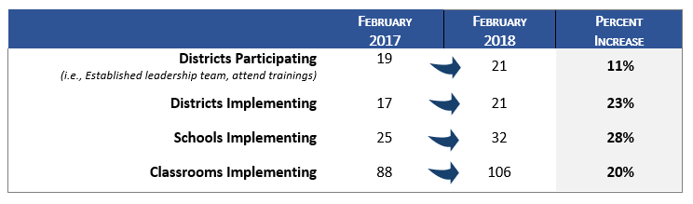
Table 9. PBS/Pyramid Participation among Districts, Schools, and Classrooms: 2017 to 2018
Evaluation Question 2b: Are districts developing systems to support sustainable training and coaching practices at the local level?
(Note: Key Findings in this section align with Intended Outcome D2 from the Evaluation Plan.)
KeY Finding: Cohort 1 district leadership teams continue to report progress across all critical elements of the Benchmarks of Quality Assessment, a measure of implementation fidelity. The areas of greatest improvement over the most recent term were in strategies for teaching program-wide expectations, and monitoring implementation and outcomes.
District leadership teams are guided to use the BOQ at least two times annually to assess their progress toward PBS/Pyramid Model implementation at the district/program level. The BOQ includes ratings of 47 benchmarks across nine critical elements, each rated on a scale of 0-2, where 0 = not in place, 1 = partially in place, and 2 = in place. Please see the Appendix of the SSIP Phase III, Year 1 report for the full BOQ assessment tool.
Tables 10 and 11 below present average ratings for each critical element on BOQ assessments. This analysis was conducted using data from the 15 Cohort 1 districts that had reported data at least three times since they began the project. To assess SSIP progress since the beginning of the initiative, the data used in the analysis included each district’s first BOQ, one BOQ from their “mid-point” of participation, and their most recent (“last”) BOQ. For all except two districts, the most recent BOQ was conducted in Spring 2017 or more recently. The percentages in the tables represent average ratings across each element, and the last column provides the mean on the 0-2 scale. Results show steady progress across all nine critical elements across three points in time. The greatest amount of growth during from the “mid” to “last” BOQ was made in the following areas:
- Strategies for teaching and acknowledging program-wide expectations: 13% reported “in place” at mid-point, vs. 51% at last
- Monitoring implementation and outcomes: 9% (mid) vs. 28% (last)
- (Establishing) program-wide expectations: 50% (mid) vs. 78% (last)
Table 10. BOQ Ratings of Critical Elements 1 through 5:
Comparison of First, Mid, and Last BOQ Results
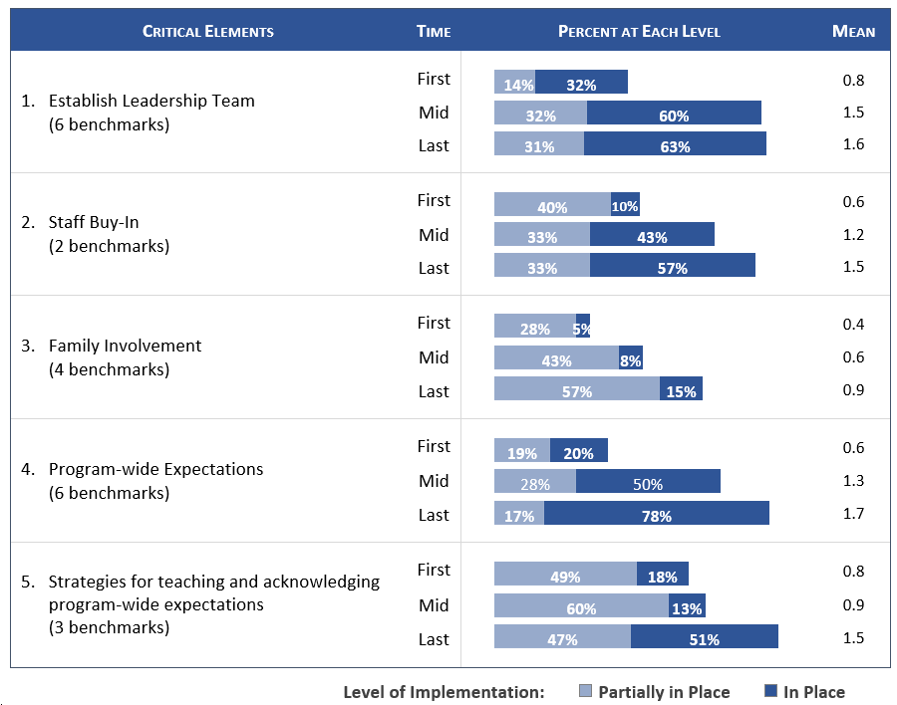
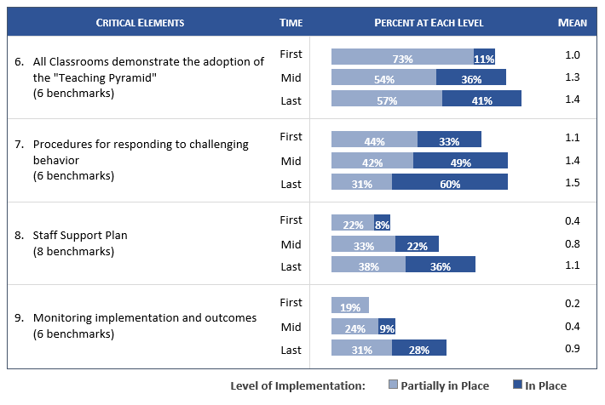
Table 11. BOQ Ratings of Critical Elements 6 through 9:
Comparison of First, Mid, and Last BOQ Results

KeY Finding: While steady progress has been reported on the BOQ, all critical elements are currently below 80% “in place”, averaging across districts and benchmarks. Those areas most in need of growth are Family Involvement, Monitoring implementation and outcomes, and Staff Support Plan.
Figure 5 below shows the progress districts have made putting each of the critical elements “In Place” (see the blue circle at the top of each bar). As shown, element 4: Program-wide Expectations, is in place at 78% of districts, followed by all benchmark indicators around a fully engaged leadership team (63%). And while progress has been made in the areas of both family involvement and monitoring implementation and outcomes, these are the elements least likely to have been put in place by this time (15% and 28%, respectively).
With respect to family involvement, it is worth mentioning that interest in expanding this piece is strong, based on feedback collected via the Mid-year Leadership Team Survey. The November 2017 survey was disturbed to all leadership team members, and responses were received from 36 individuals. Data presented in this section of the report represent the 34 individual responses from 17 Cohort 1 districts specifically, since the Cohort 2 districts had only recently joined the project at the time of the survey. Regarding family involvement:
- 77% reported that their district is interested in learning more about Positive Solutions for Families, and
- 84% indicated having staff available to promote family engagement opportunities.
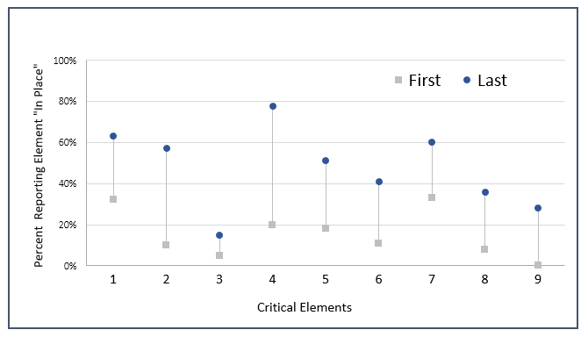
Figure 5. Percent Reporting Benchmarks “In Place”:
Comparison of First and Last BOQ Results
Critical Elements
- Establish Leadership Team  - Staff Buy-in  - Family Involvement  - Program-wide Expectations | - Strategies for teaching and acknowledging program-wide expectations  - All classrooms demonstrate the adoption of the “Teaching Pyramid” | - Procedures for responding to challenging behavior  - Staff Support Plan  - Monitoring implementation and outcomes

KeY Finding: District leadership teams identified several factors that are contributing to their implementation progress, including ongoing efforts by local staff and state-level support.
The Mid-year Leadership Team Survey provided some insight into the factors that have contributed to districts’ progress toward implementation over the past year. As shown in Figure 6 on the following page, the greatest contributors to district progress (to a “moderate” or “great extent”) were:
- Ongoing work done by teachers, internal coaches, and staff at the local level (88%)
- Participating in training sessions in EBP’s, and leadership team efforts (76%),
- Support from their external coach (61%)
State-led leadership team meetings were indicated by 53% of survey respondents. It should be noted that 42% of respondents also reported needing additional facilitated team meeting time for planning.

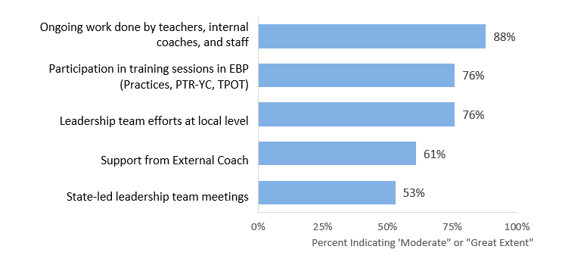
Figure 6. 2017 Mid-year Leadership Team Survey:
Factors Contributing to Progress

KeY Finding: District leadership teams indicate needing assistance in several areas to move their implementation efforts forward. The greatest need is related to building internal coach capacity, followed by additional district-based Practice training sessions, and access to substitutes to allow teachers to participate in training.
As shown in Figure 7 nearly three quarters of respondents (73%) indicated the need for additional guidance on how to sustain and scale-up internal coaching capacity. Nearly two thirds (61%) need additional Practices training for teachers in their districts. Other areas of need include guidance on funding to support the initiative, and additional resources for district leaders to help communicate the importance of early childhood PBS.
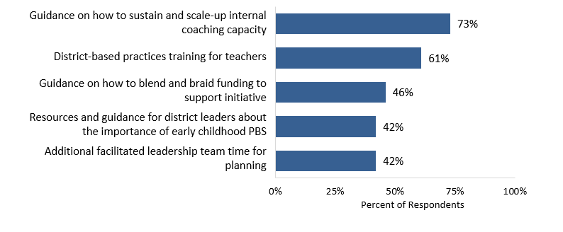
Figure 7. 2017 Mid-year Leadership Team Survey:
Types of Assistance Needed to Expand Implementation

With respect to the challenges districts are facing, they closely mirrored these same areas of need. Results below show the greatest challenges noted by respondents in 2017, compared to 2016. The 2016 survey was completed by 52 individuals, and while not the same respondent group overall as the 2017 survey, the findings can serve to provide a sense of overall project trends. Challenges included:
- Lack of time/availability for classroom coaching (88% in 2017, not asked in 2016)
- Difficulty developing internal coaching capacity to support teachers (70% in 2017, not asked in 2016)
- Lack of substitutes for teachers to attend training (61% in 2017, not asked in 2016, but indicated in 25% of open-ended comments)
- Lack of funding (52% in 2017, 29% in 2016)
- Finding time for the leadership team to meet and plan (42% in 2017, 62% in 2016)
KeY Finding: External coaches continue to provide individualized support to their districts, which is most frequently provided through site visits. Support is most often focused on supporting leadership teams, but also extends to Practices trainings, and working with internal coaches including assistance with TPOT administration and/or scoring.
External Coach Contact Records provided insight into the types of support that coaches are providing to their districts for implementation. Eighty-four coach contacts were logged from February 2017 to February 2018 (compared to 59 contacts during the previous reporting period). According to these records, 18 of the 21 districts received coaching during that time; among those, the number of contacts ranged from 1-18 for each district, while the average number of contacts was four.
This data collection tool was revised to some extent in fall 2017 and therefore the analysis that follows pertains specifically to the 66 coach contacts that were logged between September 2017 and February 2018. Records revealed that coaches most often met with district and school staff in person during site visits (70% of contacts), followed by training events (18%). These results differed from the prior year, where 56% of contacts were made in person, while 33% were made via phone or email. Figure 8 below shows the types of support typically provided by external coaches. As shown, 64% of contacts included leadership team support, 29% were related to Practices training, and 24% included TPOT support.
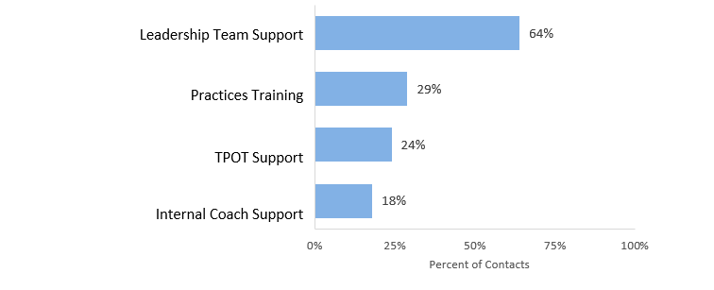
Figure 8. Types of Support Provided by External Coaches
(Question Allowed “check all that apply”)
Leadership team support most frequently included:
- Attending meetings (45%)
- Assisting with professional development/coaching (31%), and
- Assisting with locating resources (21%)
In keeping with feedback from district leadership team members that internal coach capacity is a challenge, it is worth noting that 42% of contacts included work with internal coaches or were related to the TPOT. Some examples of how external coaches described their work with internal coaches include the following:
“Helped the internal coach begin to understand the TPOT tool, and the process for coaching using TPOT data.”
“Supported the internal coach as she introduced the TPOT and ongoing coaching to the teachers. The internal coach will now set the TPOT administration schedule.”
“Assisted coaches as they introduced this year’s PBS activities to teachers. I provided background as to why supporting children’s emotional literacy is important to PBS and answer questions about Pyramid Model practices.”
“Discussed ways to use the external coach to support running TPOTs and the flexibility in different ways to coach.”
Finally, the quality of services provided by external coaches is well-regarded – 100% of those who responded to the Mid-year Leadership Team Survey indicated wanting to continue working with their current coach.
- Outcomes regarding progress toward short-term and long-term objectives that are necessary steps toward achieving the SIMR
Evaluation Question 3a: Are teachers implementing PBS through pyramid strategies in their schools?
Evaluation Question 3b: Does the fidelity of classroom implementation improve over time?
(Note: Key Findings in this section align with Intended Outcomes D2 and D3 from the Evaluation Plan.)
KeY Finding: The TPOT is being used to assess fidelity of PBS/Pyramid Model implementation in some classrooms. External coaches continue to support local staff in the TPOT process, and ongoing TPOT reliability trainings are helping to prepare additional raters at the district level.
With respect to measures of fidelity of implementation in the classroom, the TPOT continues to be administered and reviewed for some participating teachers for purposes of teacher reflection and program improvement. That said, the extent to which this fidelity measure is being used among teachers and their coaches is not known. Late in 2017, project leaders put in place guidelines for collecting aggregate TPOT data from participating districts for statewide progress monitoring, ensuring that all data would be submitted without identifying information about teachers. This process is just getting underway, and challenges related to the process for collecting and reporting these data are being addressed. As the data received to date represent relatively few participating districts and teachers, baseline results are not presented here.
Over the past year external coaches have done considerable work supporting school staff in carrying out the TPOT process, as documented within the External Coach Contact Record. In some cases, eternal coaches are administering the TPOTs; in others, they are co-rating TPOTs alongside internal coaches.
MA ESE and the PMC continue to offer statewide trainings in TPOT administration to ensure reliability among raters. Following the most recent TPOT reliability training, feedback from 22 participants indicates that 91% came away feeling “moderately well prepared” (64%) or “very well prepared” (27%) to conduct a TPOT in a classroom.
(d) Measurable improvements in the SIMR in relation to targets
(Note: Key Findings in this section align with Intended Outcome C1 from the Evaluation Plan.)
Evaluation Question 4a: Is the number of children in MA, aged 3-5, with disabilities, exiting from preschools with age-expected social emotional functioning increasing?
KeY Finding: The statewide percentage of preschool children with disabilities functioning within age expectations by the time they turned 6 or exited the program decreased by nearly 6 percentage points from FFY 2015 to FFY 2016.
The State Identified Measurable Result (SIMR) for the MA ESE SSIP is the improvement of social emotional outcomes for young children with disabilities, aged 3-5. The first way in which MA ESE is measuring achievement of the SIMR is by assessing over time the percent of preschool children functioning within age expectations in positive social-emotional skills by the time they turn 6 years of age or exit the program. These data are collected via the Child Outcomes Summary (COS) process designed by the Early Childhood Outcomes Center as a way for states to summarize data on children’s movement toward age expectations in specific outcome areas. As can be seen in Table 12, the state’s SIMR (for Summary Statement 2) decreased from 53.57% in FFY 2015 to 47.74% in FFY 2016, nearly 6 percentage points.
Table 12. SPP Indicator 7 Data:
Summary Statement 2 (Statewide)
SIMR Data | FFY 2013 | FFY 2014 | FFY 2015 | FFY 2016
 | N=472 | n=479 | n=420 | n=398
The percent of preschool children who were functioning within age expectations in Outcome A (positive social-emotional skills) by the time they turned 6 years of age or exited the program. | 44.49% | 47.81% | 53.57% | 47.74%
Target | -- | 90% | 90% | 90%
Note: Summary Statement 2 is calculated by: # of preschool children reported in progress category (d) plus # of preschool children reported in progress category (e) divided by [the total # of preschool children reported in progress categories (a) + (b) + (c) + (d) + (e)] times 100.

MA ESE has set targets for Indicator 7 based on the state’s expectation that a majority of young children should be functioning within age expectations in each outcome by the time they exit the preschool program or turn six; that target remains at 90% for Summary Statement 2.
Evaluation Question 4b: Is the number of children in MA, aged 3-5, with disabilities, exiting from preschool with greater than expected growth in their social emotional functioning increasing?
KeY Finding: The statewide percentage of students with disabilities who have substantially increased their rate of growth increased substantially from FFY 2015 to FFY 2016, by nearly 10 percentage points.
The second way MA ESE is measuring achievement of the SIMR is by assessing over time the percent of preschool children who entered or exited the preschool program below age expectations in positive social emotional skills who substantially increased their rate of growth by the time they turned 6 years of age or exited the program, as measured by the Child Outcomes Summary. As can be seen in Table 13 below, the percentage increased approximately 10 percentage points from FFY 2015 to FFY 2016, from 79.14% to 88.70%.
Table 13. SPP Indicator 7 Data:
Summary Statement 1 (Statewide)
SIMR Data | FFY 2013 | FFY 2014 | FFY 2015 | FFY 2016
 | n=419 | n=422 | n=350 | n=398
Of those preschool children who entered or exited the preschool program below age expectations in Outcome A (positive social emotional skills), the percent who substantially increased their rate of growth by the time they turned 6 years of age or exited the program | 85.44% | 87.20% | 79.14% | 88.70%
Target | -- | 100% | 100% | 100%
Note: Summary Statement 1 is calculated by: # of preschool children reported in progress category (c) plus # of preschool children reported in category (d) divided by [# of preschool children reported in progress category (a) plus # of preschool children reported in progress category (b) plus # of preschool children reported in progress category (c) plus # of preschool children reported in progress category (d)] times 100.
Finally, as of 2017, all participating SSIP districts were required to submit their COS data for Indicator 7 annually (corresponding with FFY 2016 data). This is a change from prior years when SSIP districts, like all other districts in the state, followed a Cohort cycle of reporting every four years according to Massachusetts’ approved sampling plan.
This annual data collection cycle for SSIP districts will allow for progress monitoring of child outcomes within SSIP districts specifically, in addition to monitoring statewide progress on Indicator 7A. It is important to note that this information will not be sufficient to examine the impact of SSIP activities on student outcomes, but is instead intended as a form of progress monitoring within the districts directly receiving SSIP training and supports. Baseline results (FFY 2016) for 7A within the 12 SSIP school districts for which data were submitted in summer 2017 are presented below in Table 14.
Table 14. SPP Indicator 7 Data:
Summary Statements 1 and 2 (12 Cohort 1 SSIP Districts)
 | FFY 2016
 | n=83
Summary Statement 1 | 82.61%
Summary Statement 2 | 50.60%

F. Plans for Next Year

1. Additional Activities to be Implemented Next Year (with timeline)
After a thorough review of the current implementation data, MA ESE has identified a number of strengths and areas for continued growth which will drive the activities for next year (see Table 15 for timelines).
- Activities that will be continued with little or minor adjustments:
- Actively engage with state and district stakeholders
- Strengthen state infrastructure, including intra- and inter-agency collaboration
- Strength intra-agency collaboration to provide guidance and additional alignment between Positive Behavior Intervention and Supports (PBIS) and PBS/Pyramid for districts implementing initiatives PreK - 12
- Build capacity of external coaches and support their work with district leadership teams and staff
- Encourage additional family engagement and evaluation of Positive Solutions
- Provide individualized training for teachers and coaches regionally or in districts
- Continue to provide discretionary grant funds to support costs associates with training and implementation, including stipends, substitutes, supplies, and materials
- Continue ESE visits to sites to each implementing school at least once per year, and more frequently as needed

- Activities that address areas for continued growth:
Building Internal Coach Capacity
- PMC will provide tertiary model for supporting internal coaches, including
  - Monthly, virtual Communities of Practices for all interested coaches
  - Targeted, short-term Professional Learning Community calls to enhance specific skills, as requested by internal coaches
  - Individualized supports for internal coaches
- Expand paradigm of internal coaches and move toward Practice Based coaching –– PMC/external coaches to facilitate group coaching and peer-to-peer formats
- Support district leaders to build systems of support for internal coaches, including additional training and technical assistance related to operational supports for promoting internal coaches
Broadening Support for Districts and Schools
- Increase communication structures between districts and state partners; examples include:
  - monthly e-newsletters (with topics related to coaching, district highlights, PMC updates, ESE announcements, etc.)
  - social media platforms for virtual collaboration
- Leverage ePyramid, online learning modules for training and coaching staff
- Set targets for external coaches with respect to number of visits, frequency, and types of contacts to be conducted with districts/schools
- Address sustainability planning with district leadership teams/external coaches
- Continue to build state infrastructure to support local level integration of early literacy initiatives, including providing additional training on recently created social/emotional and literacy modules using evidence-based instructional strategies
- Increase engagement of EEC staff and Coordinated Family and Community Engagement (CFCE) staff
- Include training on topics related to implicit bias and dissimilating racism related to PBS/Pyramid model through the Pyramid Equity Project (PEM)
Data Collection, Use, and Reporting
- Reinforce and streamline systems for data collection for SSIP evaluation
- Pilot online app that integrates School Wide PBIS and PBS/Pyramid data
- Reinforce state-level guidance for reporting anonymous, aggregate TPOT data; support districts in this process
- Develop improved data collection methods for qualitative data – streamline open-ended items on all data collection tools to facilitate summary of common themes
- Increase training for data-based decision making (state, district, classroom and child level) using Indicator 7 data and other local level district data
- Develop statewide disaggregated data analysis for indicator 7
- Provide Indicator 7 training
- Provide guidance about integration of literacy screener from Early Literacy Expert Panel and pilot intensive interventions in literacy /math (tier 3) in K-3
Explore Early Literacy Pilot to address 3rd Grade Proficiency Gaps for Students with Disabilities
- With stakeholders, discuss and plan for the possible development of an early literacy project to:
  - Identify a method of screening children for low phonemic awareness and other risk factors for dyslexia
  - Provide for the enrollment of children identified as having risk factors in a reading program staffed by teachers trained in evidence-based reading instruction and multisensory structured language instruction, including students exhibiting risk factors for dyslexia
  - Include a methodology for evaluating the reading program's effects on the children's identified risk factors
  - Develop guidance about integration of literacy screener and pilot intensive interventions in literacy /math (tier 3) in grades K-3
  - Develop guidance related to dyslexia and other reading-based disabilities
  - Support the development of state and local structures to address student challenges in learning to read and write
  - Develop online modules related to individual dyslexia and other reading disorders, identifying dyslexia, analyzing student data, and choosing targeted and intensive interventions
  - Develop recommendations and guidance related to targeted and intensive interventions
  - Collaborate with IHEs to provide aligned pre-service and in-service training for general and special educations
  - Create resource guide related to Dyslexia and other reading disabilities
  - Expand Special Education Professional Development series to include courses related to teaching students with reading disabilities
Table 15. SSIP Implementation: February 2018 – Spring 2019
Date | Activities | Audience
Ongoing and Continuing | Communication with Pyramid Model Consortium Staff | N/A
Ongoing and Continuing | External Coach Contact Records completed as substantive contacts with districts occur | N/A
Ongoing and Continuing | Site Visits by MA ESE Staff at participating districts, including intensive support for Indicator 7 data collection | District Leadership Team, External Coaches, Teachers
Ongoing and Continuing | Monthly Professional Learning Community (PLC) meeting | External Coaches
Ongoing and Continuing | State-level Leadership Team Meetings | MA ESE, MA EEC, and MA DPH staff
3/1/18 | Prevent Teach, Reinforce – Young Children (PTR-YC) | Teachers, Internal Coaches, Behavior Specialists, and External Coaches
3/19/18 | End of Year Leadership Team Meeting | District Leadership Teams and External Coaches
Monthly beginning May 2018 | Coaches’ Virtual Convening, to include:  - in-depth data-based decision making (using indicator 7)  - fidelity measures  - integration of literacy instruction  - support for family engagement | Internal Coaches and External Coaches
5/1-5/2/18 | TPOT (Teacher Pyramid Observation Tool) Training | Internal Coaches and External Coaches
5/9/18 | Prevent Teach, Reinforce – Young Children (PTR-YC) | Teachers, Internal Coaches, Behavior Specialists, and External Coaches
Ongoing and Continuing | Positive Solutions Train-the-trainer w/MA EEC and FCSN | Teachers, Internal Coaches, Behavior Specialists, and External Coaches
FY 19
Summer/Early Fall | New Staff “ramp up” | District Leadership Teams, Internal Coaches, and Teachers
Monthly | Coaches’ Virtual Convening | Internal Coaches and External Coaches
Fall | Beginning of the Year Leadership Meeting, to include:  - BoQ  - implementation planning  - data-based decision making  - support for family engagement | District Leadership Teams and External Coaches
 | Practices Training | Teachers
 | Positive Solutions Train-the-trainer | Teachers, Internal Coaches, Behavior Specialists, and External Coaches
 | TPOT (Teacher Pyramid Observation Tool) Training | Internal Coaches and External Coaches
 | Prevent Teach, Reinforce – Young Children (PTR-YC) | Teachers, Internal Coaches, Behavior Specialists, and External Coaches
Spring | Practices Training | Teachers
 | Positive Solutions Train-the-trainer | Teachers, Internal Coaches, Behavior Specialists, and External Coaches
 | TPOT (Teacher Pyramid Observation Tool) Training | Internal Coaches and External Coaches
 | Prevent Teach, Reinforce – Young Children (PTR-YC) | Teachers, Internal Coaches, Behavior Specialists, and External Coaches
 | End of Year Leadership Team Meeting | District Leadership Teams and External Coaches

2. Planned Evaluation Activities Including Data Collection, Measures, Expected Outcomes
The evaluation plan for the coming year will be consistent with the plan originally developed during Phase II, and presented in Section C of this report. In the coming year, MA ESE will continue to collaborate with internal and external stakeholders to monitor and refine this plan including the key questions, intended outputs, and the process of data collection. In coordination with the external evaluator, MA ESE will consider fine-tuning some of the data collection tools and procedures to help ensure high response rates, and a continued focus on valid and reliable data across all measures. The IDC Framework for High-Quality Data, as referenced in Section D, will serve as a guide. MA ESE will continue to review all data as they become available to continue its cycle of inquiry for continuous improvement, and data will also be provided to the external evaluator throughout the year for analysis and reporting.
Table 16 shows the evaluation plan for the current year including key questions and an abbreviated list of intended outcomes, as well as data sources and timelines, based on the previous evaluation pan with slight modifications.
Table 16. SSIP Evaluation Plan: February 2018 – January 2019
Evaluation Question |  | Intended Outcomes | Data Sources | Anticipated Timeline
 | State Level Infrastructure
EQ1a  In what ways is MA ESE using the SSIP, including statewide implementation of PBS through Pyramid strategies, to build state-level capacity to support improved social emotional outcomes for young children with disabilities? |  | Build state capacity, including:  - leverage cadre of PBS external coaches  - collaborate with social service agencies to providing training/support to families  - collaborate in Part C and K-12 PBIS initiatives | - Extant project documents (e.g., state and district meeting notes, inter-agency meeting minutes, implementation notes and planning tools)  - Statewide training data and evaluation forms | - Ongoing  - At each training
EQ1b  To what extent is implementation of PBS through Pyramid strategies in MA integrated with other early childhood and/or ESE initiatives at the community/local and state levels? |  | MA ESE will:  - Support implementation of newly created PBS/PBIS crosswalk to promote state level collaboration, and  - Engage in ongoing collaboration to continue to identify strategies to promote integration of PBS | - Extant project document review | - Ongoing
 | Program/District Infrastructure
EQ2a  Is the state-level plan resulting in the number of schools and classroom participating in PBS through Pyramid strategies sample growing over time? |  | - MA ESE will provide adequate training in PBS/Pyramid Model strategies to promote district-levels trainings  - District administrators and educators participate in statewide trainings  - Families participate in Positive Solutions Training | - External Coach Contact Records  - Benchmarks of Quality (BOQ)  - Mid-year Leadership Team Survey  - Statewide training data and evaluation forms  - PBS/Pyramid Model Database | - Ongoing  - Bi-annually  - Annually in March  - At each training  - Bi-annually
EQ2b  Are districts developing systems to support sustainable training and coaching practices at the local level? |  | - Participating district have built internal capacity to train additional teachers in PBS/Pyramid strategies | - External Coach Contact Records  - Benchmarks of Quality (BOQ)  - Mid-year Leadership Team Survey | - Ongoing  - Bi-annually  - Annually in March
 | Classroom Level
EQ3a  Are teachers implementing PBS through PBS/Pyramid strategies in their classrooms? |  | - Participating districts have built internal capacity to training additional teachers in PBS/Pyramid strategies  - Family engagement increased over time | - External Coach Contact Records  - Benchmarks of Quality (BOQ)  - Mid-year Leadership Team Survey  - PBS/Pyramid Model Database | - Ongoing  - Bi-annually  - Annually  - Bi-annually
EQ3b  Does the fidelity of classroom implementation improve over time? |  | - Teachers will be able to implement PBS through Pyramid strategies with fidelity | - Teaching Pyramid Observation Protocol (TPOT) | - Annually
 | Student Level
EQ4a  Is the number of children in MA, aged 3-5, with disabilities, exiting from preschool with age-expected social emotional functioning increasing? |  | - Children with disabilities, aged 3-5, will exit preschool with social/emotional competencies that will allow them to access and participate in the general curriculum and in all aspects of the school. | - Indicator 7 data – Child Outcomes Summary (COS): Summary Statement 2  (statewide and SSIP districts) | - Annually in spring
EQ4b  Is the number of children in MA, aged 3-5, with disabilities, exiting from preschool with greater than expected growth in their social emotional functioning increasing? |  |  | - Indicator 7 data – Child Outcomes Summary (COS): Summary Statement 1  (statewide and SSIP districts) | - Annually in spring

3. Anticipated Barriers and Solutions
MA ESE has planned for the following contingencies in implementing the next steps of the MA SSIP, shown in Table 17.

Table 17. Anticipated Barriers and Solutions
Anticipated Barrier | Solution
Attrition of External Coaches. | State staff recruits early childhood experts throughout the region.
Attrition of trained local staff. | Provide new staff “ramp up” training and support at the beginning of the school year.
State model does not adequately account for diverse local level needs. | Stakeholders engage in continuous feedback loop and data analysis to address diverse community needs and provide responsive, individualized supports for district staff and families.
Internal coach capacity with respect to “best practice” of PBS/Pyramid Model implementation, i.e., hours of support recommended vs. feasibility at local level due to staffing and time constraints. | Implement additional internal coach supports as described above; continue to explore needs and solutions with district teams.
Access to anonymous (i.e., teachers and schools not identified) aggregate district-level TPOT data for state-level view of implementation fidelity. | Provide guidance and support for data collection procedures.

4. State’s Need for Additional Support/TA
MA ESE relies on the technical assistance and support from OSEP directly and from OSEP-funded TA centers, including, the IDEA Data Center (IDC), the National Center for Systemic Improvement (NCSI), the Early Childhood Technical Assistance Center (ECTA). MA ESE participated in a variety of individualized, targeted, and universal TA, most notably, the IDC Interactive Institute. The expertise of these organizations, coupled with the dissemination of information via Grads 360 and OSEP TA calls, has proved invaluable for ongoing implementation and progress monitoring for Phase III, Year Two.
Moving forward, MA ESE would appreciate updated and streamlined, OSEP-approved guidance documents for writing the SSIP report, especially the suggested outline. The current structure tends to create redundancy in the reporting of progress.
MA ESE plans to continue to participate in cross state learning communities, as offered by IDC and NCSI. Further, MA ESE looks forward to continuing our partnership with the Pyramid Model Consortium and the newly funded National Center for Pyramid Model Innovations.

APPENDIX
- Tiered-Focused Monitoring: A New Approach
- Year 1 MA ESE SSIP State-level Infographic
- March 2018 Leadership Meeting - State Update: “Data Snapshot”

Tiered Focused Monitoring: A New Approach
For the Office of Public School Monitoring (PSM), your input has recently resulted in a reimagining of the Coordinated Program Review (CPR) process, to give intensive support in special education and civil rights to districts in a more differentiated manner based upon need, and to support other districts in ways that are a better fit for their record on compliance and student outcomes. This new approach is called Tiered Focused Monitoring (TFM).
How does TFM work?
As the name suggests, districts will now be grouped into “tiers” for the purposes of monitoring. Districts will receive more or less PSM monitoring intensity depending on the tier. A district is placed in a specific tier based on the accountability results, Problem Resolution System complaint data, and PSM report data.
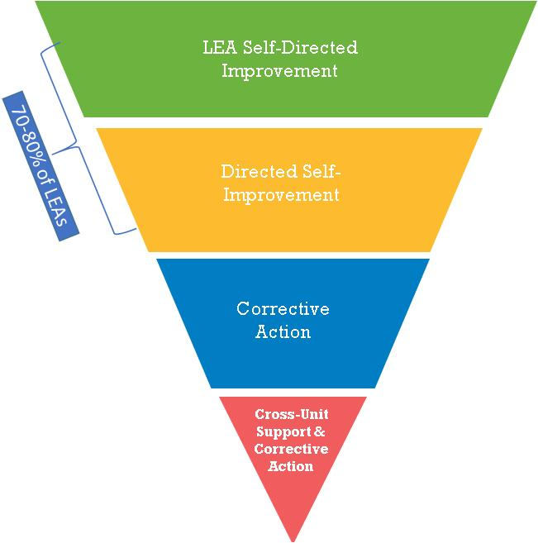
70 – 80% of districts will fall into the Tier 1 (green) and Tier 2 (yellow) tiers. Tier 1 districts are considered to meet requirements, and Tier 2 are low risk. Tier 3 districts (blue) are moderate risk, and Tier 4 (known as Chronically Underperforming in DESE’s accountability system), are high risk (red).

As in the past, PSM staff will use monitoring criteria, each linked to a specific regulation, to guide district monitoring. For example, PSM staff will make sure that districts follow proper IEP development procedures under the Individuals with Disabilities Education Act (IDEA) and state law.
As in the past, all districts will begin the monitoring process by conducting a self-assessment, submitted through PSM’s Web-Based Monitoring System (WBMS). WBMS has a library of resources that districts can use to inform their self-assessment. In addition, PSM sends out parent surveys in each district.
At this point, the system differentiates based on tier. Since the districts in Tiers 1 and 2 have demonstrated that there is either a low risk or no risk in areas associated with student outcomes, the onsite monitoring will be less extensive than the monitoring occurring in Tiers 3 and 4, which have moderate to high risk in those same areas. Onsite monitoring includes record review, parent surveys, and interviews and observations, depending on the monitoring criteria.
For Tiers 1 and 2, PSM will provide written feedback, and districts will then develop and implement a Continuous Improvement and Monitoring Plan (CIMP). As time passes, Tier 1 districts will complete a check-off in the WBMS to show that they are completing the requirements of their CIMP; Tier 2 districts will submit written progress reports on their CIMP.
For Tiers 3 and 4, PSM will compile a traditional comprehensive report that delineates a required Corrective Action Plan (CAP). With technical assistance from DESE, Tier 3 districts will complete their CAP, including progress reports. Tier 4 districts will work with a cross-DESE team to conduct a root-cause analysis, and work extensively to build systems and develop district capacity as part of the CAP and regular progress reporting.
Decreasing the intensity of focus by PSM staff on Tiers 1 and 2 will allow PSM staff to offer more intensive, technical assistance to Tier 3 and 4 districts. The chart below shows the tiered process:
Monitoring Steps | Tier 1  District Self-Directed  Improvement | Tier 2  Directed  Self-Improvement | Tier 3  Corrective  Action | Tier 4  Cross-Unit Support & Corrective Action
Self-assessment submitted to PSM through Web-Based Monitoring System (WBMS)
PSM issues parent surveys
PSM record review | One but not  both of these | One but not  both of these
PSM onsite observation
Interviews | Based on criteria | Based on criteria
DESE provides written feedback | Written feedback prior to developing CIMP | Written feedback prior to developing CIMP | Program Review Report | Program Review Report
District develops and implements CIMP
Cross-unit support team analysis of root cause
DESE technical assistance & district development and implementation of CAP
Monitoring | District completes check-off in WBMS to show progressing or complete; PSM monitors CIMP implementation. | District submits written progress updates through WBMS; PSM reviews written reports and monitors CIMP implementation. | District completion of CAP and Progress Reporting activities; reviewed by PSM through WBMS. | Cross-unit support team works with district in building systems and developing in-district capacity. CAP and Progress Reporting activities completed and reviewed through WBMS.

Under TFM, districts will be reviewed every three years on an alternate set of criteria as set forth in the Tiered Focused Monitoring Standards – Group A and B document. Group A Universal Standards focus on the identification process, IEP development, and programming and support services. Group B Universal Standards focus on licensure/professional development, parent/student/community engagement, facilities and classrooms, oversight, time and learning, and equal access. For districts that demonstrate additional areas of concern, as indicated through patterns of complaints or statewide reports, PSM also includes Targeted Standards in their self-assessment.
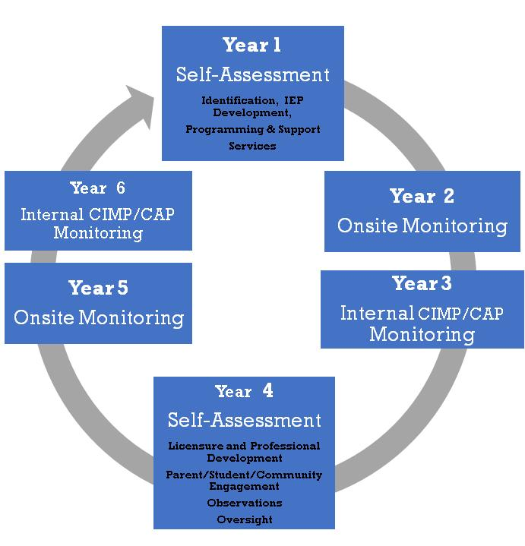
The monitoring cycle, then, might look like this:

Year 1 in the diagram above is the district’s self-assessment year for the Group A Universal Standards; Year 4 is the start of the Group B Universal Standards, also a time for self-assessment. Years 2 and 3 and Years 5 and 6 mirror each other; onsite monitoring is differentiated for each district depending on the tier to which it belongs.
Districts in every tier will continue to receive support from PSM, such as general guidance, regional meetings, and district-specific support. PSM will continue to work in concert with other DESE offices to streamline and target the work of assistance and accountability statewide. In this way, DESE seeks to be responsive to the needs of the schools and districts by providing cohesive supports, while promoting improved statewide student outcomes.

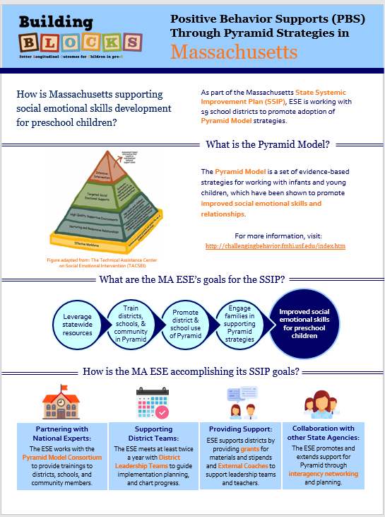
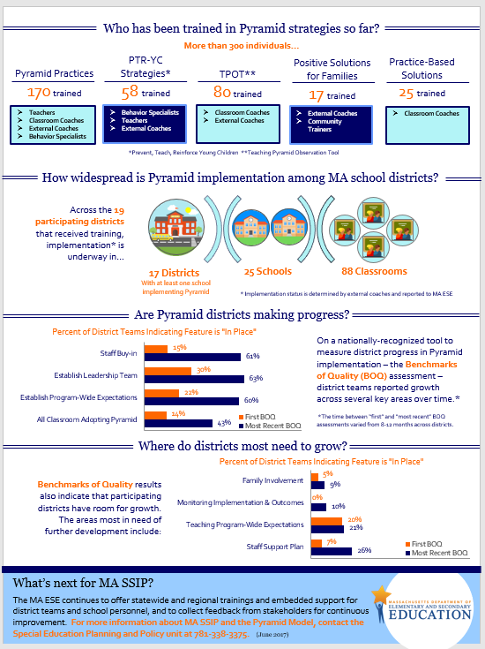

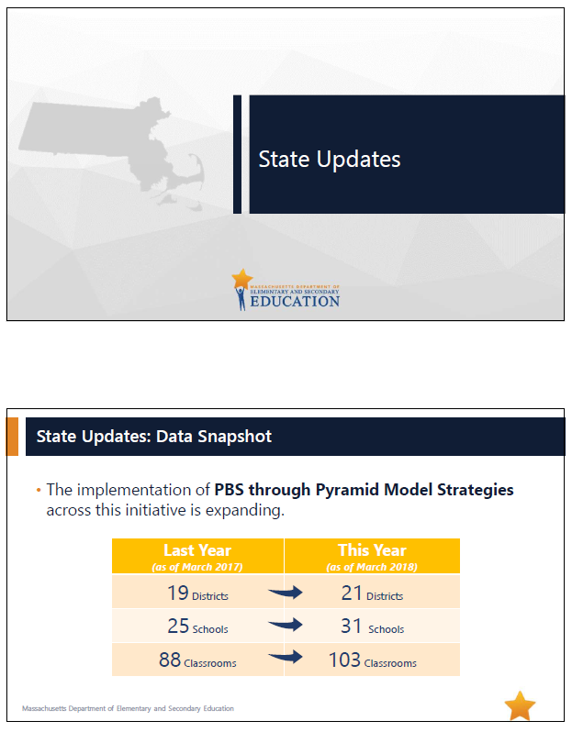
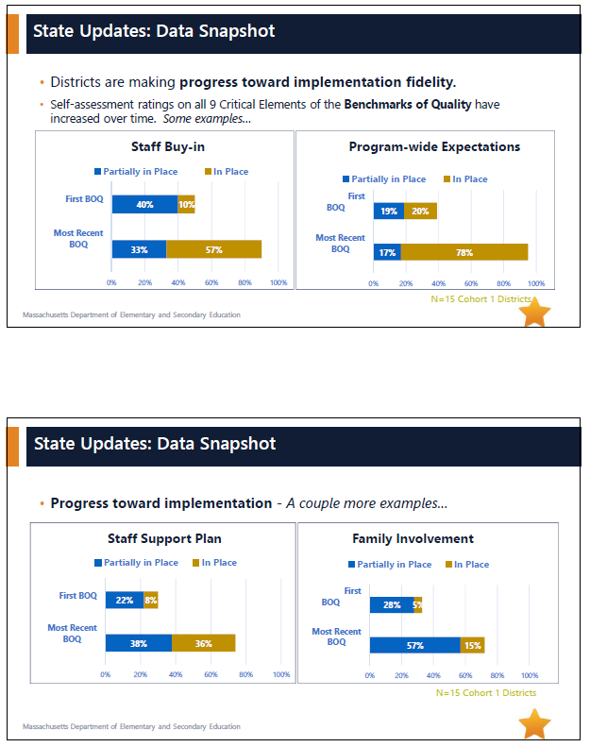

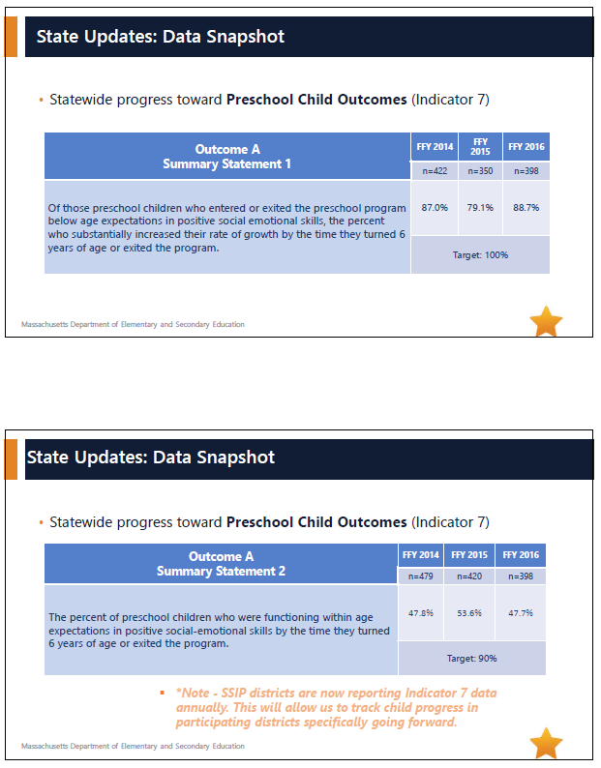

Further detailed information about summary statement calculations, data collection samples, methods, and tools can be found in MA ESE’s FFY 2016 Part B State Performance Plan (SPP)/Annual Performance Report (APR).
Both districts cited competing priorities as the main challenge for continued participation; further, one of the two districts explained that a significant change in district leadership drove the shift in priorities.
The framework can be accessed at https://ideadata.org/working-principles

